CS 421 Wireshark Assignment  
Görkem Kadir Solun 22003214

I will be using Google Public DNS 8.8.4.4

# What to hand in

## 1) List up to 10 different protocols that appear in the protocol column in the unfiltered packet-listing window in step 7 above.

ieee1905, UDP, TLSv1.3, TLSv1.2, TCP, STP, SKYPE, HTTP, DNS, BFCP, ARP

## 2) How long did it take from when the HTTP GET message was sent until the HTTP OK reply was received? (By default, the value of the Time column in the packet listing window is the amount of time, in seconds, since Wireshark tracing began. To display the Time field in time-of-day format, select the Wireshark View pull down menu, then select Time Display Format, then select Time-of-day.)



~0.12 seconds

## 3) What is the Internet address of the gaia.cs.umass.edu (also known as www.net.cs.umass.edu)? What is the Internet address of your computer?

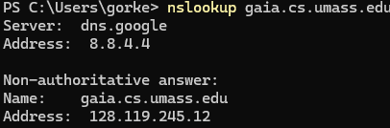My computer: 192.169.1.193

gaia.cs.umass.edu: 128.119.245.12

## 4) Print the two HTTP messages displayed in step 9 above. To do so, select Print from the Wireshark File command menu, and select “Selected Packet Only” and “Print as displayed” and then click OK.

