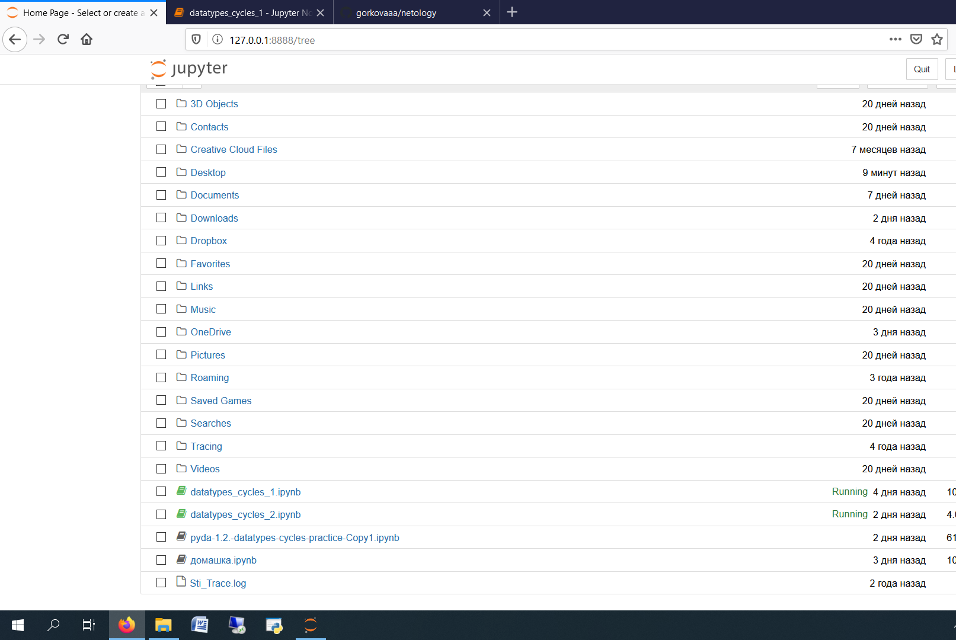

<https://github.com/gorkovaaa/netology>