System identification: report Computer Exercise 1

# Plot of noiseless unit step-impulse response superimposed on the noisy unit step/impulse response

# Code for the intcor function. Plot of the autocorrelation function for prbs(6,4)

## Intcor.m

function [R, h] = intcor(u, y)

L = length(u);

N = length(y);

M = lcm(L, N);

h = 0:M-1;

R = zeros(M, 1);

u = repmat(u, [M/L, 1]);

y = repmat(y, [M/N, 1]);

for i = h

R(i+1) = u'*circshift(y, i);

end

R = R/M;

h = h';

end

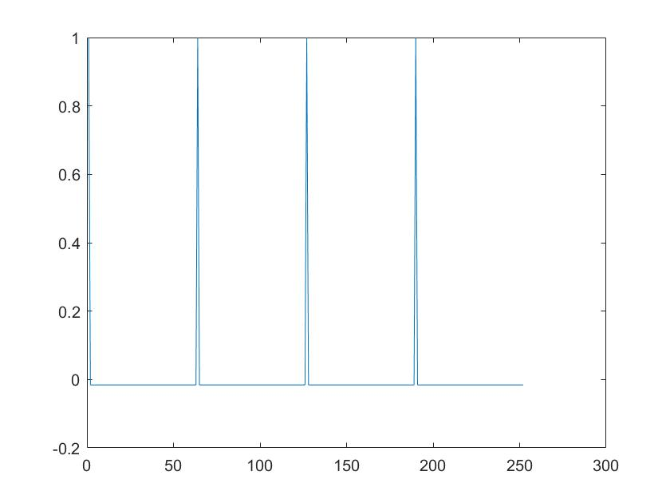

Figure 1: plot of the intcor.m for a prbs(6,4)

# Code for computing the impulse response using intcor. The code when xcorr is used. The plot of the identified impulse responses compared with the true one. Give the 2-norm of the errors. Comment on the different methods based on the 2-norm of the errors.

# Fourier analysis: Give the code and plot the Bode diagram of the identified model compared with the true one.

Spectral analysis:

* Give the code.
* Plot three frequency responses

1. Whole data, no window.
2. Whole data with Hann or Hamming window
3. Averaging

* Compare the identified models with the true one.