Assignment 2 – Trends in Tumblr

1. Team members:

Fernando Gorodscy - 1000234971
Luiz Felipe V. Vercosa - 1000234294
Vanessa Lima - 1000235033
Ystallonne Alves - 1000235480

2. Server information:

CDF Environment:
Server port: 31010

3. The solution:

In order to let the solution taken by the team clear to understand, diagrams have been made. Each of these diagrams are attached to the project code.

3.1. Class diagram:
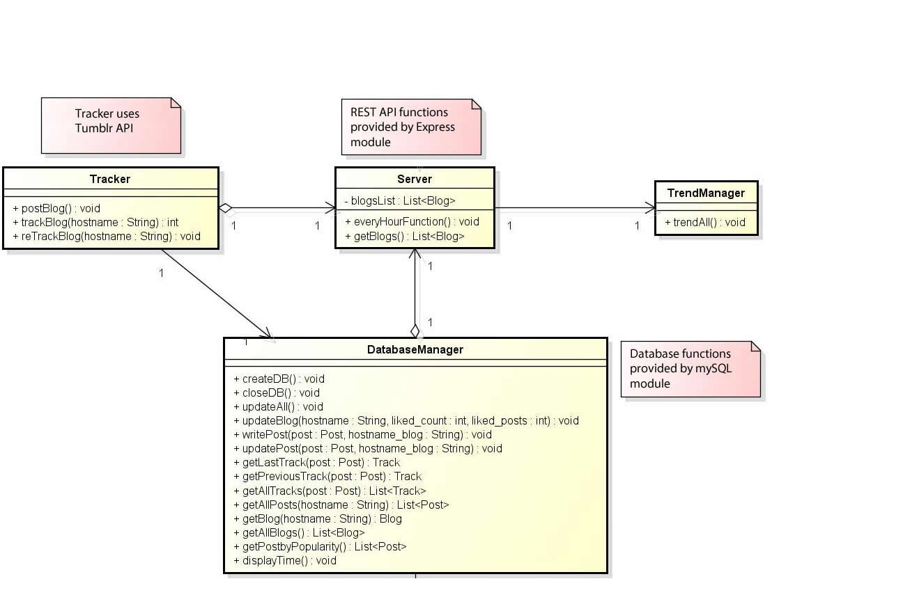
In this solution, a class represents a script. As can be seen, the server is the one that has more associations. In other words, it uses the classes Tracker, DatabaseManager and TrendManager. In addition, the class Tracker also uses the database. This usage relation will be more explained in the sequence diagrams. Every class has the following responsibilities:
Server: theserver listens to GET and POST requests from the client and is also responsible for update the posts (that are being tracked) every hour.

DatabaseManager: this is the only class that connects to the MySQL database, then, providing database access to all other classes.

TrendManager: This class is responsible for managing the connection between the Server and DatabaseManager in regards to all GETS requests.

Tracker: This class is responsible for managing the connection between the Server and DatabaseManager in regards to the POST requests. Moreover, this class is the only one that receives data from Tumblr API.

3.2. Database modelling:

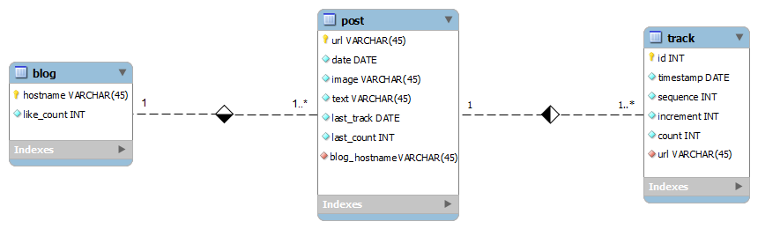

There are three tables: post, blog and track. A blog is a table of blogs being tracked. One blog has one or more posts and each post has one or more tracks (each track happens every hour).

3.3 Sequence diagram:

3.3.1 Get
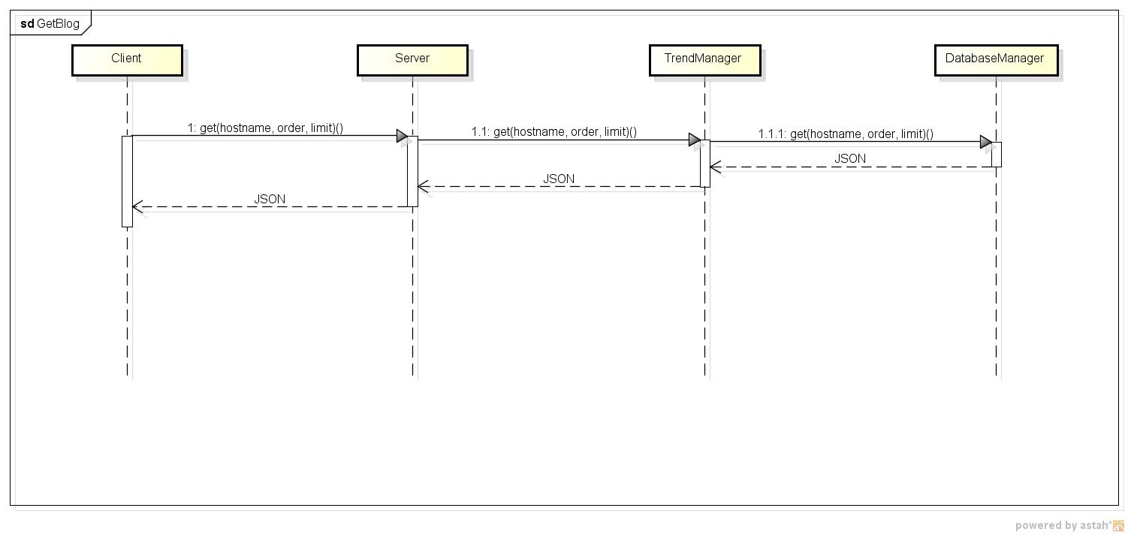
When a client requires a GET, either a specific blog or all of them, this message follows the following sequence: Client, Server, TrendManager and DatabaseManager. The return will be a JSON or an error 404 (in the case the blog does not exist).

3.3.2 Post

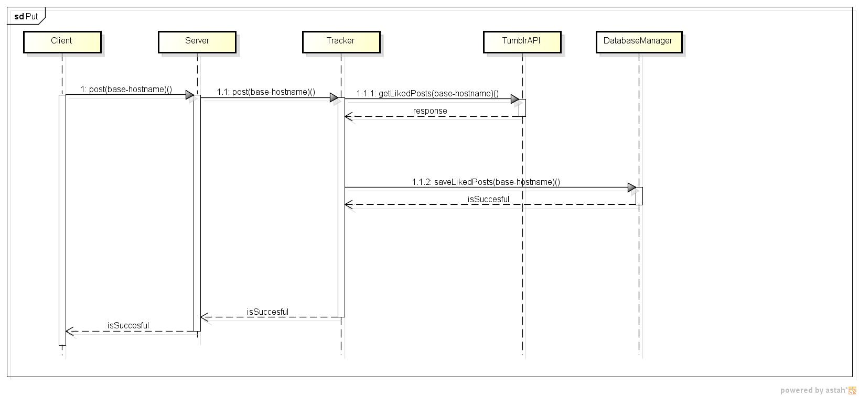
When a client requires a POST, the server communicates to the Tracker, which immediately communicates to the Tumblr API asking for the liked posts for this blog. Next, the Tracker saves the information in the database by calling the DatabaseManager. If the Tumblr API does not provide any data, it means that the blog has an invalid name, and, therefore, an error 404 is returned to the client.

3.3.3 Every hour update

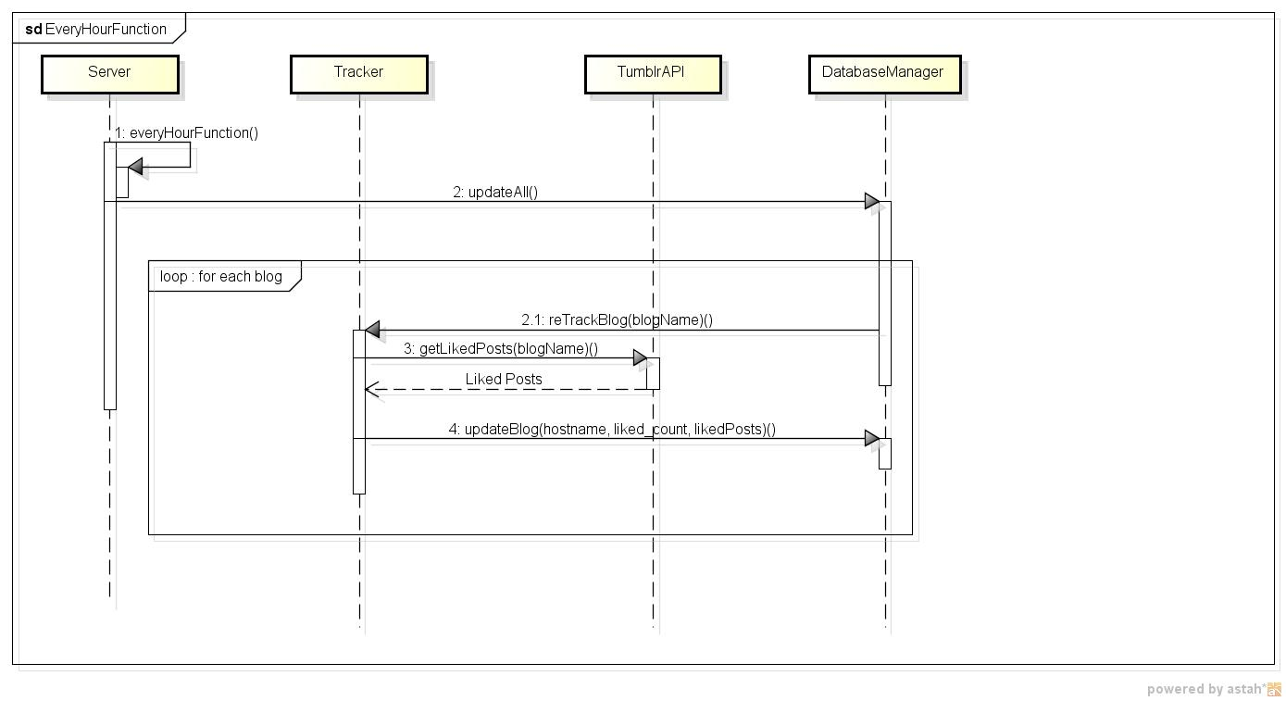
When the server executes the every hour update function, it sends a message to the DatabaseManager, which, in turn, asks the Tracker for updating every tracked blog. Finally, the tracker returns all the new data to DatabaseManager, which stores it in the Database.

4. How to use

To retrieve the list of posts been tracked:

curl –i –X GET http://localhost:31010/blogs/trends/{order}/[limit]

Where {order} should be “trending” or “recent” depending whether the user wants the results to be ordered by most liked post (considering only the last hour of track) or by most recent liked post. Further, the user may define a limit of posts to be displayed ranging from 1 to 20 (optional).

To retrieve the list of posts been tracked by a specific blog:

curl –i –X GET http://localhost:31010/blog/{hostname}/trends/{order}/[limit]

Where {hostname} must be replaced by the hostname of the blog used to retrieve posts.

To add a blog to be add:

curl –X POST –d blog={hostname} http://localhost:31010/blog

Where {hostname} is the blog hostname whose liked posts will be tracked.

4. Commentaries

Despite the fact that there were another diagrams that could be added, the team evaluated the information presented above as enough for the complete understand of the solution created by the team.

