Business Description

Business background
American football gear is important for players at all levels—from kids just starting out to pros in the big leagues. This gear includes helmets, pads, gloves and other accessories that help keep players safe and perform better. Customers can buy these products either online or in physical stores, giving them different ways to shop.
The market is pretty competitive. Success depends on things like brand reputation, product quality, good customer service and pricing. To stay ahead, businesses need to really understand how their products are doing, what customers want and how sales are trending. Collecting and analyzing detailed sales data from both online and offline channels helps with that.

Problems because of poor data management
Without good data management, businesses face some big challenges: They don’t know which products or brands are selling best, it’s hard to compare how online sales stack up against in-store sales, they struggle to spot local or regional trends in what customers want. If the data isn’t organized well, companies can’t respond quickly to changes in the market or customer preferences, which means missed sales and lost revenue.

Benefits from implementing a Data Warehouse
By setting up a data warehouse that brings together sales data from both online and offline sources, businesses can see which brands or product categories bring in the most money, compare how products perform in different regions, stores, keep track of costs versus sales over time, understand how customer preferences differ between online shoppers and those who buy in stores, spot seasonal trends and regional demand patterns by looking at sales over time and location.
Some key questions a data warehouse can help answer include:
- Which types of football gear make the most profit?
- Which cities or states have the strongest in-store sales?
- Are some brands more popular online than in physical stores?
- How do costs and revenues compare across different products?

DATASETS DESCRIPTION
The first dataset contains the following information about offline sales of American football gears.

Product entity:
Product_id: Unique identifier for each product
Brand: The brand or manufacturer of the gear.
Category: The category of the gear (e.g., helmets, protective gears).
Subcategory: Further classification of the gear within the category.
Rating: Customer rating of the product out of 5 stars.

Employee entity:
Employee_id: Unique identifier of employee
Employee_first_name: First name of the employee.
Employee_last_name: Last name of employee.
Gender: Gender of employee
employee_email: Email of employee
employee_phone_number: Phone number of employee
Hire_date: The date employee was hired

Store entity:
Store_ID: Unique identifier for store
Store_Name: Name of the store.
Store_type: Indicates the type of retail store (e.g., superstore, specialized)
State: Location of store in which state it is.
City: In which city the store is.
address: Exact address (street name) of store.

Supplier entity:
Supplier_id: Unique identifier for supplier
Supplier_name: Name of the supplier
Contract_start: Start date of contact
Contract_end: End date of contact
Supplier_email: Email of supplier

Payment entity:
Payment_type_id: Unique identifier for payment type
Payment_method: Name of payment type (cash, card, etc)

Sales Information:
Date: The date of the gear sale.
Cost_amount: Total cost incurred by business for the sold items
Quantity_Sold: The number of units sold.
Amount_sold: Total revenue from the sale
Price: Selling price of the product at the time of sale

The second dataset contains the following information about online sales of American football gears:

Product Information:
Product_id: Unique identifier for each product
Brand: The brand or manufacturer of the gear.
Category: The category of the gear (e.g., helmets, protective gears).
Subcategory: Further classification of the gear within the category.
Rating: Customer rating of the product out of 5 stars.

Supplier entity:
Supplier_id: Unique identifier for supplier
Supplier_name: Name of the supplier
Contract_start: Start date of contact
Contract_end: End date of contact
Supplier_email: Email of supplier

Customer entity:
customer_firstname: First name of the customer.
customer_lastname: Last name of customer.
customer_gender: Gender of customer
customer_email: Customer email address
customer_phone: Phone number of customer
customer_age: Age of customer
signup_date: Date when customer signed up

Shipping entity:
Shipping_method: Method of the shipping
Shipping_price: A price customer paid for shipping
Shipping_state: Delivery state.
Shipping_city: Delivery City
Shipping_address: Exact address of delivery.

Payment entity:
Payment_type_id: Unique identifier for payment type
Payment_method: Name of payment type (credit card, debit card, etc)

Store entity:
Store_id: Unique identifier for store
Store_name: Name of the store
Store_website: Website of store.

Sales Information:
Date: The date of the gear sale.
Cost amount: Total cost incurred by business for the sold items
Quantity Sold: The number of units sold.
Amount sold: Total revenue from the sale
Price: Selling price of the product at the time of sale

The datasets provide a comprehensive view of football gear online and offline. The data supports both strategic and operational analysis of business performance and customer behavior.
In the offline dataset, the non-sales information includes details about the product (such as product ID, brand, category, subcategory and rating), the employee who handled the sale (including full name, gender, contact details, and hire date) and the physical store where the transaction occurred (with attributes like store ID, name, type, state, city, and address). The supplier and payment information are also captured, including contract dates and identifiers.
In contrast, the online dataset shifts focus from store employees to customers and shipping logistics. It includes similar product and supplier attributes as the offline dataset but replaces employee data with customer-related attributes such as first name, last name, gender, email, phone number, age, and signup date. Instead of store addresses, it tracks shipping details — shipping address, city, state and price — which are critical for online fulfillment. While store information still exists, it adds a store website attribute instead of a physical store type or address.
In summary, the offline dataset emphasizes store operations and staff, while the online dataset highlights customer engagement and delivery logistics.

GRAIN / DIM / FACT
Using the four-step dimensional design process:

Step 1- Select the Business Process
I chose to model the sales transactions process because it's a core part of the business — whether it's happening in physical stores (offline) or through the online platform. The goal is to track everything about each sale: which product was sold, who sold or bought it, how it was paid for and who supplied it. For online sales, I also wanted to capture shipping details. This process helps me analyze important performance indicators like total revenue, sales quantity, cost and therefore profit.

Step 2 - Determine the grain
I defined the grain of the fact table as: One row for each individual product transaction. That means each row in my FCT_TRANSACTIONS_DD fact table represents a single sale of a product — including the price, quantity, time, and all related context like employee or customer, store, payment type, etc.

Step 3 - Identify dimensions
To give context to each sale, I connected the fact table to a set of dimension tables: For both offline and online sales, I use: DIM_PRODUCT – to know what product was sold. DIM_STORE – to see where the sale happened. DIM_SUPPLIER – to trace who provided the product. DIM_PAYMENT – to understand how the payment was made. For offline sales specifically: DIM_EMPLOYEE – to record which staff member handled the sale. For online sales: DIM_CUSTOMER – to track who made the purchase. DIM_SHIPPING – to know where the order was shipped. If I need more flexibility with time-based analysis, I can also add a DIM_DATE table later on.

Step 4 - Identify the facts
The main measures I track in the fact table are: PRICE – what the customer paid per unit QUANTITY_SOLD – how many units were sold AMOUNT_SOLD – the total revenue from that sale (price × quantity) COST_AMOUNT – how much the sale cost the business. Later, I can also calculate profit by subtracting cost from revenue.

For offline sales dataset:

Fact Table: FCT_TRANSACTIONS_DD

Column name | Description | Data Type
TRANSACTION_SURR_ID | Unique surrogate identifier for each sale transaction | Bigint
TRANSACTION_SRC_ID | Unique identifier which came from source | VARCHAR
PRODUCT_SURR_ID | Foreign key to the product dimension | bigint
EMPLOYEE_SURR_ID | Foreign key to the employee dimension | bigint
STORE_SURR_ID | Foreign key to the store dimension | Bigint
PAYMENT_SURR_ID | Foreign key to the payment dimension | Bigint
SUPPLIER_SURR_ID | Foreign key to the supplier dimension | Bigint
CUSTOMER_SURR_ID | Foreign key to the customer dimension | Bigint
EVENT_DT | Date of transaction | DateTime
PRICE | Selling price of the product at the time of sale | Numeric(12,2)
QUANTITY_CNT | The number of units sold | Bigint
REVENUE_TOT_AMT | Total revenue from the sale | Numeric(12,2)
COST_AMT | Total cost incurred by business for the sold items | Numeric(12,2)

TRANSACTION_SURR_ID | TRANSACTION_ID | PRODUCT_SURR_ID | EMPLOYEE_SURR_ID | STORE_SURR_ID | PAYMENT_SURR_ID | SUPPLIER_SURR_ID | CUSTOMER_SURR_ID | EVENT_DATE | PRICE | QUANTITY_CNT | REVENUE_TOT_AMT | COST_AMT
1789 | 1 | 1 | 1 | 1 | 1 | 1 | 1 | 7/31/2023 4:54:00 PM | 16.11 | 4 | 64.44 | 29.76

Dimension Table: DIM_PRODUCTS_SCD

Column name | Description | Data Type
PRODUCT_SURR_ID | Unique identifier for each product which is surrogate key | Bigint
PRODUCT_SRC_ID | Unique identifier which came from source | VARCHAR
PRODUCT_NAME | Name of the product | VARCHAR(60)
PRODUCT_BRAND_NAME | Brand of the product | VARCHAR(100)
PRODUCT_CATEGORY_NAME | Category of the product | VARCHAR(70)
PRODUCT_SUBCATEGORY_NAME | Subcategory of the product | VARCHAR(100)
PRODUCT_RATING | RATING of the product | Decimal

PRODUCT_SURR_ID | PRODUCT_ID | PRODUCT_NAME | PRODUCT_BRAND_NAME | PRODUCT_CATEGORY_NAME | PRODUCT_SUBCATEGORY_NAME | PRODUCT_RATING
104 | 1 | Riddell Victor-I Inflation Air Bladder (R9122987TRV) |  | Helmets | Helmet Components | 4.97

Dimension Table: DIM_EMPLOYEES

Column name | Description | Data Type
EMPLOYEE_SURR_ID | Unique identifier for each employee | Bigint
EMPLOYEE_SRC_ID | Unique identifier which came from source | VARCHAR
EMPLOYEE_FIRSTNAME | First name of the employee | VARCHAR(50)
EMPLOYEE_LASTNAME | Last name of the employee | VARCHAR(50)
EMPLOYEE_GENDER | Gender of employee | VARCHAR(6)
EMPLOYEE_EMAIL | Email address of employee | VARCHAR(100)
EMPLOYEE_HIRE_DT | Date the employee was hired | Date

EMPLOYEE_SURR_ID | EMPLOYEE_ID | EMPLOYEE_FIRSTNAME | EMPLOYEE_LASTNAME | EMPLOYEE_GENDER | EMPLOYEE_EMAIL | EMPLOYEE_HIRE_DT
204 | 1 | Rober | Garcia | Male | robert_garcia@email.com | 6/5/2017

Dimension Table: DIM_STORES
Column name | Description | Data Type
STORE_SURR_ID | Unique identifier for store which I surrogate key | Bigint
STORE_SRC_ID | Unique identifier which came from source | VARCHAR
STORE_NAME | Name of the store | VARCHAR(100)
STORE_TYPE | Type of retail store | VARCHAR(50)
STORE_STATE | Location of store in which state it is | VARCHAR(2)
STORE_CITY | In which city the store is | VARCHAR(20)
STORE_ADDRESS | Exact address (street name) of store | VARCHAR(50)

STORE_SURR_ID | STORE_ID | STORE_NAME | STORE_TYPE | STORE_STATE | STORE_CITY | STORE_ADDRESS
404 | 1 | Prime Portland Gear (OR) | specialized | OR | Portland | 20 Fairfield Plaza

Dimension Table: DIM_SUPPLIERS
Column name | Description | Data Type
SUPPLIER_SURR_ID | Unique identifier for supplier which is surrogate key | Bigint
SUPPLIER_SRC_ID | Unique identifier which came from source | varchar
SUPPLIER_NAME | Name of the supplier | VARCHAR(50)
SUPPLIER_EMAIL | Email address of supplier | VARCHAR(100)
SUPPLIER_CONTRACT_START_DT | Start date of contact | Date
SUPPLIER_CONTRACT_END_DT | End date of contact | Date

SUPPLIER_SURR_ID | SUPPLIER_ID | SUPPLIER_NAME | SUPPLIER_EMAIL | SUPPLIER_CONTRACT_START_DT | SUPPLIER_CONTRACT_END_DT
607 | 1 | Balistreri Inc. | alistreri_inc@email.com | 7/16/2022 | 3/20/2026

Dimension Table: DIM_PAYMENTYPES

Column name | Description | Data Type
PAYMENT_TYPE_SURR_ID | Unique identifier for payment type but this is surrogate key | Bigint
PAYMENT_TYPE_SRC_ID | Unique identifier which came from source | VARCHAR
PAYMENT_TYPE_METHOD | Name of payment type | VARCHAR(100)

PAYMENT_TYPE_SURR_ID | PAYMENT_TYPE_SRC_ID | PAYMENT_TYPE_METHOD
1 | cash | cash

Dimension Table: DIM_CUSTOMERS

Column name | Description | Data Type
Customer_SURR_ID | Unique identifier for each employee which is surrogate key | Bigint
CUSTOMER_SRC_ID | Unique identifier which came from source | varchar
CUSTOMER_FIRSTNAME | First name of the customer | VARCHAR(50)
CUSTOMER_LASTNAME | Last name of the customer | VARCHAR(50)
CUSTOMER_GENDER | Gender of customer | VARCHAR(6)
CUSTOMER_EMAIL | Email address of customer | VARCHAR(100)
CUSTOMER_PHONE | Phone number of customer | VARCHAR(20)
CUSTOMER_AGE | Age of customer | Bigint
CUSTOMER_SIGNUP_DT | Date when customer signed up | Date

CUSTOMER_SURR_ID | CUSTOMER_SRC_ID | CUSTOMER_FIRST_NAME | USTOMER_LAST_NAME | CUSTOMER_GENDER | CUSTOMER_EMAIL | CUSTOMER_PHONE | CUSTOMER_AGE | CUSTOMER_SIGNUP_DT
789 | 400002 | Stesha | Peiser | Female | speiserl@squarespace.com | 562-102-4205 | 46 | 05/07/2020

Dimension Table: DIM_SHIPPINGS
Column name | Description | Data Type
SHIPPING_SURR_ID | Unique identifier for shipping which is surrogate key | Bigint
SHIPPING_SRC_ID | Unique identifier that came from source | varchar
SHIPPING_METHOD | Method of the shipping | VARCHAR(40)
SHIPPING_PRICE | Price of shipping | Decimal
SHIPPING_STATE | State where product should be shipped | VARCHAR(2)
SHIPPING_CITY | City where product should be shipped | VARCHAR(20)
SHIPPING_ADDRESS | Exact street address where product should be shipped | VARCHAR(70)

SHIPPING_SURR_ID | SHIPPING_SRC_ID | SHIPPING_METHOD | SHIPPING_PRICE | SHIPPING_STATE | SHIPPING_CITY | SHIPPING_ADDRESS
2 | STANDARD|62 new castle | Standard | 6.9 | LA | New Orleans | 41793 Steven Road

Dimension Table: DIM_DATES
Column name | Description | Data Type
EVENT_DT | Unique identifier for date | date
CALENDAR_YEAR | Year part of the date | Int
MONTH_NUM | Month number | Int
QUARTER_NUM | Quarter of month | Int
WEEK_NUM | Number of week | int
DAY_NUM | number of day | int
DAY_NAME | name of day | varchar(10)
IS_WEEKEND | flag that says if it is weekend or not | boolean

EVENT_DT | CALENDAR_YEAR | MONTH_NUM | QUARTER_NUM | WEEK_NUM | DAY_NUM | DAY_NAME | IS_WEEKEND
26/06/2024 | 2024 | 6 | 2 | 4 | 26 | Wednesday | false

Business Layer 3NF

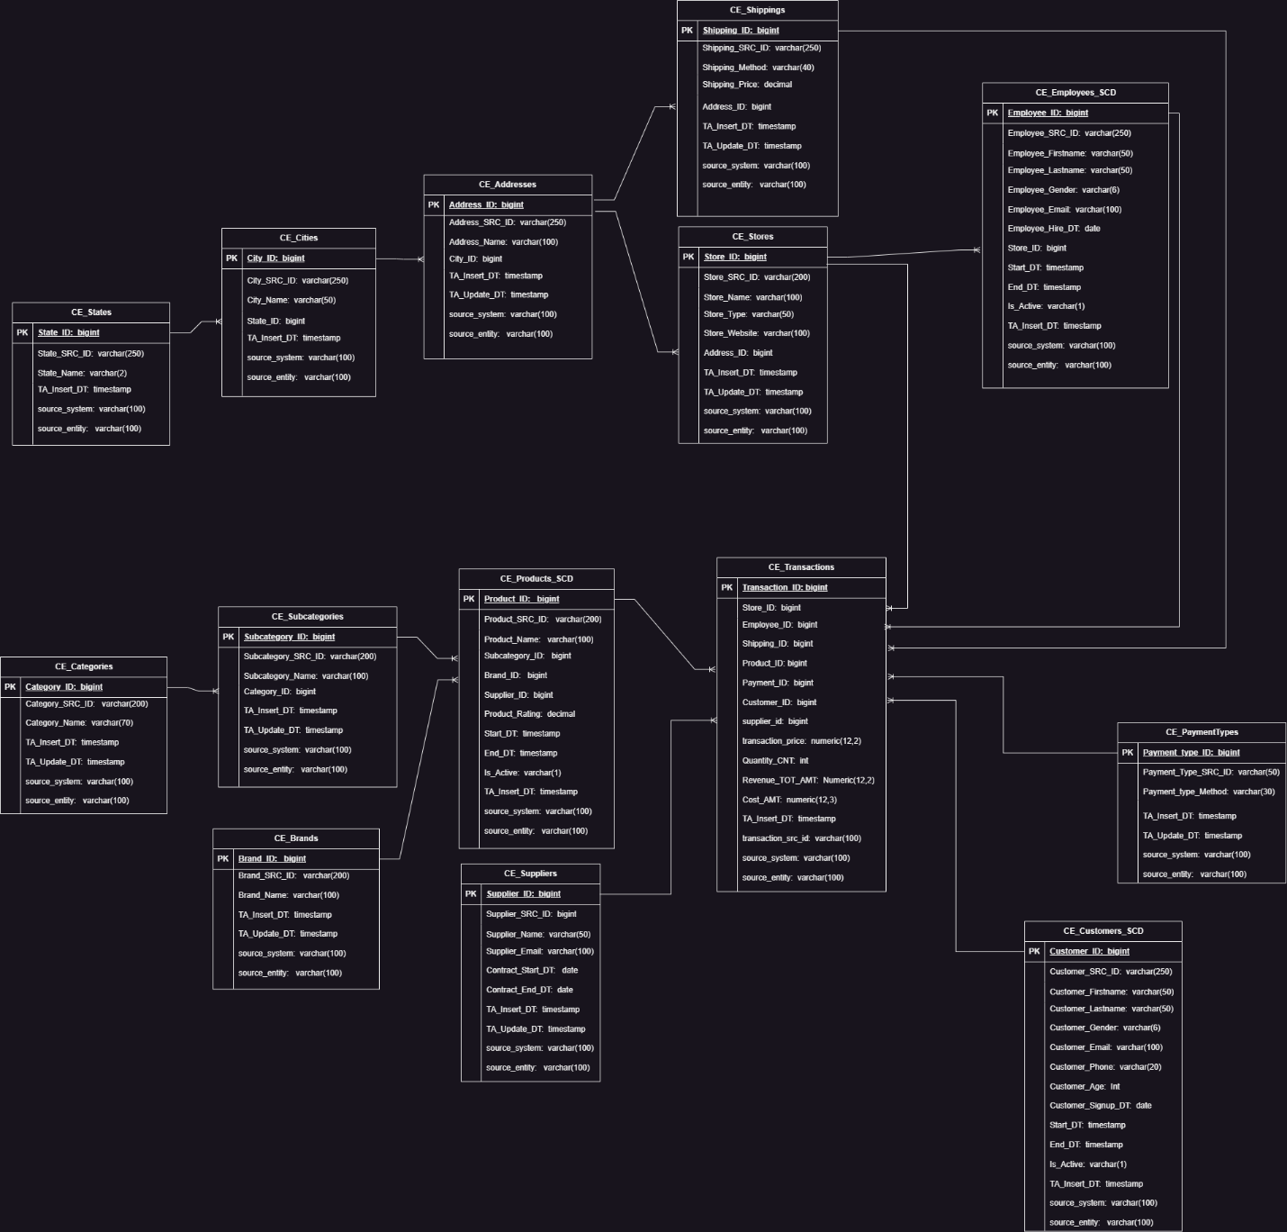

Firstly I identified which tables I needed in order to keep my data normalized and then I created relationships. Therefore I have following tables and I will write description for each of them:

• CE_Transactions
This is the fact table storing each transaction with details like product, customer, store, employee, date, payment type, and shipping method. It has many-to-one (n:1) relationships with almost all dimension tables (Products, Customers, Employees, Stores, Dates, PaymentTypes, and Shipping). Each transaction holds financial metrics like revenue and cost.
• CE_Products_SCD
A slowly changing dimension type 2 (SCD2) that tracks product history over time—any change (e.g., name, supplier, or price) creates a new record while keeping the history. It links n:1 to categories, subcategories, brands, and suppliers.
• CE_Customers_SCD
An SCD2 dimension tracking customer attributes like name, gender, birthdate, and address changes over time. If a customer changes their address or name, a new record is created, preserving historical data. It links n:1 to the CE_Addresses table.
• CE_Employees_SCD
Another SCD2 dimension storing employee details including names, hire dates, and employment status. Any changes in employment (like promotions, name change, or end date) trigger a new row to preserve history. It relates n:1 to CE_Stores.
• CE_Stores
A static dimension (non-SCD) that contains store names and links to the CE_Employees_SCD2 and CE_Transactions tables. It has an n:1 relationship with employees and transactions, meaning multiple employees or transactions can belong to a store.
• CE_Suppliers
This dimension contains supplier information like name and contact details. It connects n:1 to CE_Products_SCD2, meaning multiple products can be supplied by the same supplier.
• CE_Categories
A simple dimension that stores product categories. It has an n:1 relationship with CE_Subcategories.
• CE_Subcategories
Subcategories belong to categories (n:1) and are tied to products (n:1). This hierarchical structure allows categorization at both broad (category) and detailed (subcategory) levels.
• CE_Brands
Stores brand names and links to CE_Products_SCD2 in an n:1 relationship—many products can belong to one brand.
• CE_Dates
A calendar dimension with typical date-related fields. It connects n:1 to CE_Transactions, allowing analysis across different time periods.
• CE_Addresses
Holds address data that can be reused by customers (n:1) and possibly other entities in the future. Rather than storing address inside the customer table, it’s normalized here for consistency.
• CE_Cities
A location dimension storing city names. It links n:1 to CE_Addresses, meaning each address belongs to one city.
• CE_States
Stores state or region information, linked n:1 to CE_Cities. This allows addresses to be organized hierarchically from state → city → address.
• CE_Shipping
This dimension stores shipping methods and their costs. It links n:1 to CE_Transactions since each transaction uses one shipping method.
• CE_PaymentTypes
A payment method dimension (like credit card, cash, etc.) linking n:1 to CE_Transactions—each transaction is associated with one payment type.
From our consultation meeting as you mentioned I have included source triplet (source_system, source_entity, source_id) in each table which serves as a universal tracking mechanism that identifies exactly where each record originated from in my source systems.

Business Layer Dimensional Model

1)
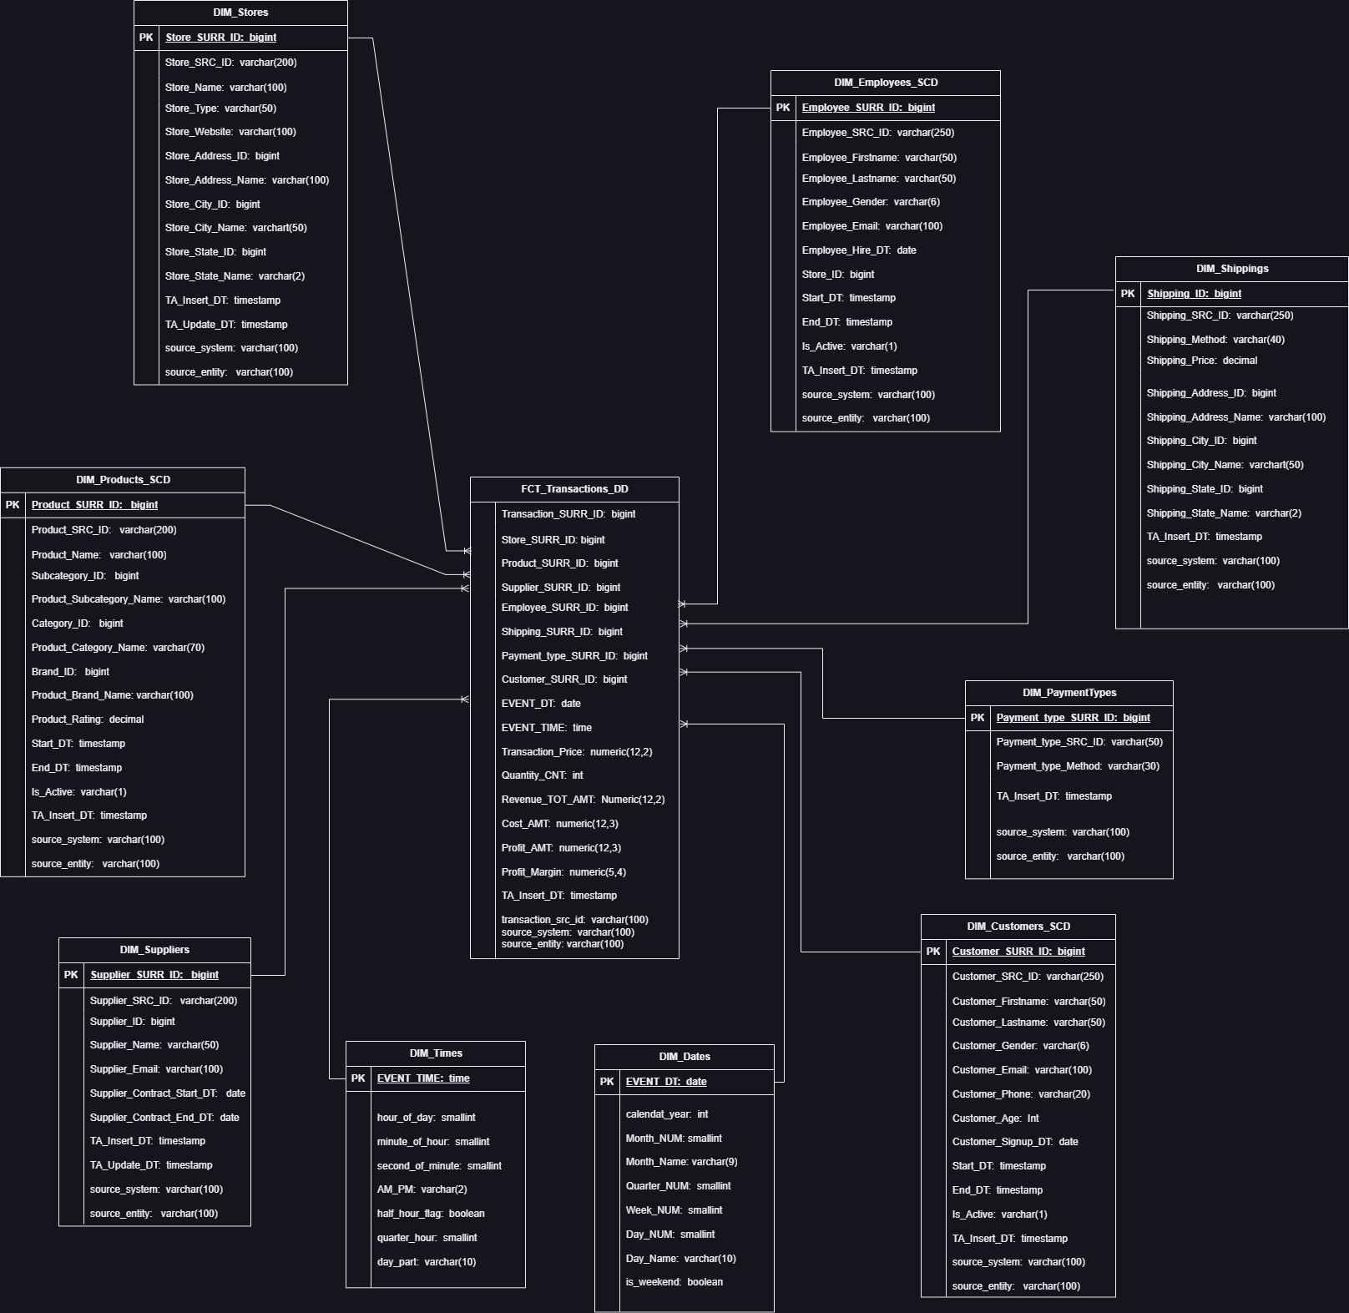
3)
These are my metrics that I already had in my facts table:
Price: Unit price of the product sold.
Quantity_CNT: Number of units sold.
Revenue_TOT_AMT: Total revenue for the transaction (Price × Quantity).
Cost_AMT: Total cost incurred by business for the sold items

We can add following metrics to my facts table:
Profit_AMT = Revenue_TOT_AMT - Cost_AMT
This metric shows the gross profit for each transaction.
Profit_Margin = (Revenue_TOT_AMT - Cost_AMT) / Revenue_TOT_AMT
This is the profit as a percentage of revenue.

Logical Scheme
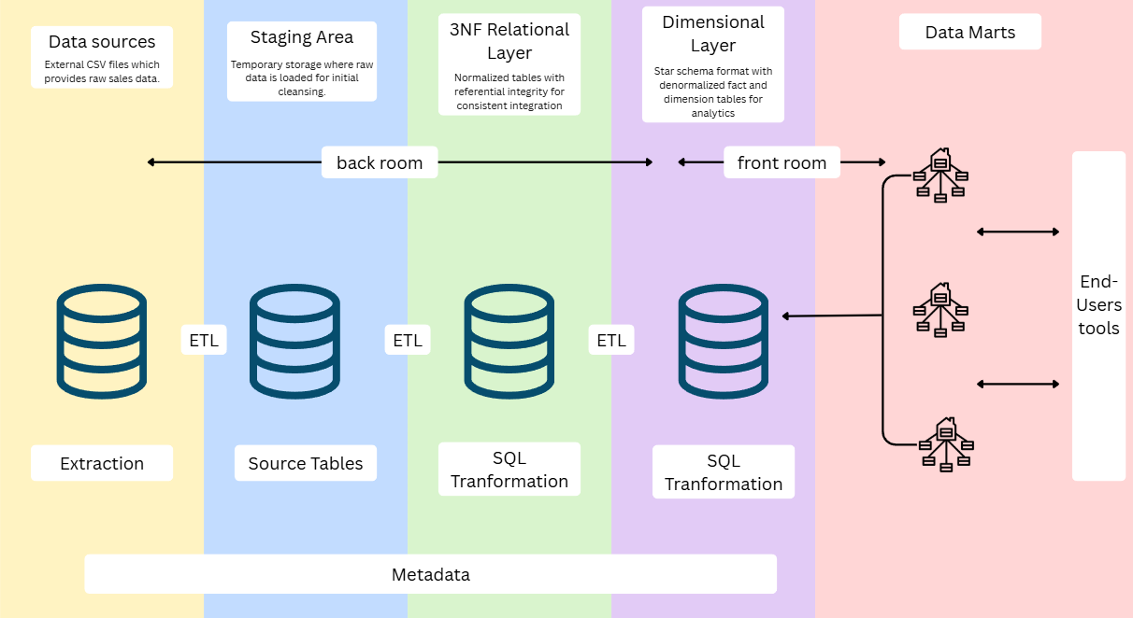

Data Flow
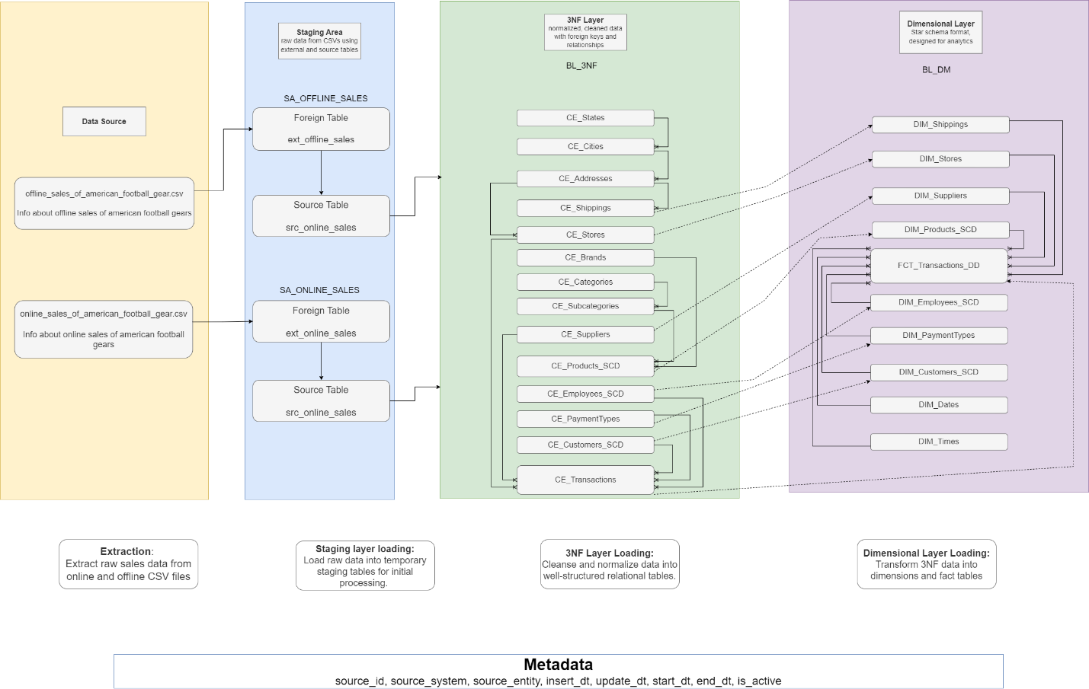

Fact Table Partitioning Strategy

I use quarterly partitioning as a strategy to organize and load transaction data into the fact table efficiently. I start by checking the minimum and maximum event dates in the source table and then I loop through the entire range in 3-month intervals, one quarter at a time. For each quarter I calculate the start and end dates, dynamically generate a partition name like fct_transactions_2024_q1 and then check if that partition already exists. If it doesn’t I create it or if it exists but isn’t attached, I attach it. I then insert only the new records for that quarter into the corresponding partition skipping duplicates.

