  - DESCRIPTION OF THE BUSINESS BACKGROUND
Company Name: GameGear
Industry: Retailer of American Football Gear
Business Overview:
GameGear is a retailer that sells premium American football gear, both through physical stores and online. Whether customers are in need of a helmet, cleats or a full kit, GameGear offers a wide variety of high-quality products. The process starts when a customer either visits one of the company's retail stores or shops online through their e-commerce platform. After browsing through different product options they make a purchase, either in person or through the online store. GameGear works closely with suppliers to stock a range of products, and once an order is made, the logistics team ensures timely shipping and delivery.
At the heart of this process are the customer interactions, the store experience, the online sales process and the behind-the-scenes work involving employees, suppliers, and shipping. GameGear's business thrives on maintaining an efficient flow from the point of sale to product delivery, ensuring customers get what they need, when they need it.
Purpose of the report:
This report’s main goal is to give GameGear a clear picture of its sales and performance metrics. It covers everything from revenue and costs to sales trends and customer buying patterns. With this information, the company can make more informed decisions about inventory, pricing strategies and marketing. The report will help highlight key opportunities, like which products or stores are performing best, and which areas need improvement.
Who will use this report?
Business Executives: To keep an eye on overall business performance and profitability.
Store Managers: To evaluate individual store performance and identify patterns in sales and customer preferences.
Marketing Team: To understand what customers are buying and develop targeted campaigns.
Supply Chain & Operations: To analyze supplier performance, shipping costs and other operational aspects.
Key business questions the report will answer:
The report will help answer questions that matter to the business, such as:
Which stores are performing the best?
Which stores and employees are top performers?
How is my business trending over time?
What products are selling the most and which brands are popular?
How does sales performance vary by product category and customer ratings?
What are the demographics of GameGear's customer base?
How has customer acquisition and shipping revenue evolved over time?
  - CREATING THE REPORT IN POWER BI DESKTOP
From the previous module we had to create DWH for which lastly we had dimensional model which is same as star schema and that is exactly what we need to import in power bi. I had my tables and all the data in PostgreSQL so I connected power BI to PostgreSQL and with import mode loaded necessary tables. But before that I also did some transformations like I removed default rows because that data is irrelevant, also I removed some columns which mostly represent metadata such as insert_dt, update_dt, etc. because I would not have used them in the report.

After loading firstly I looked at data model to make sure that everything was as it should have been and here is how it looks:
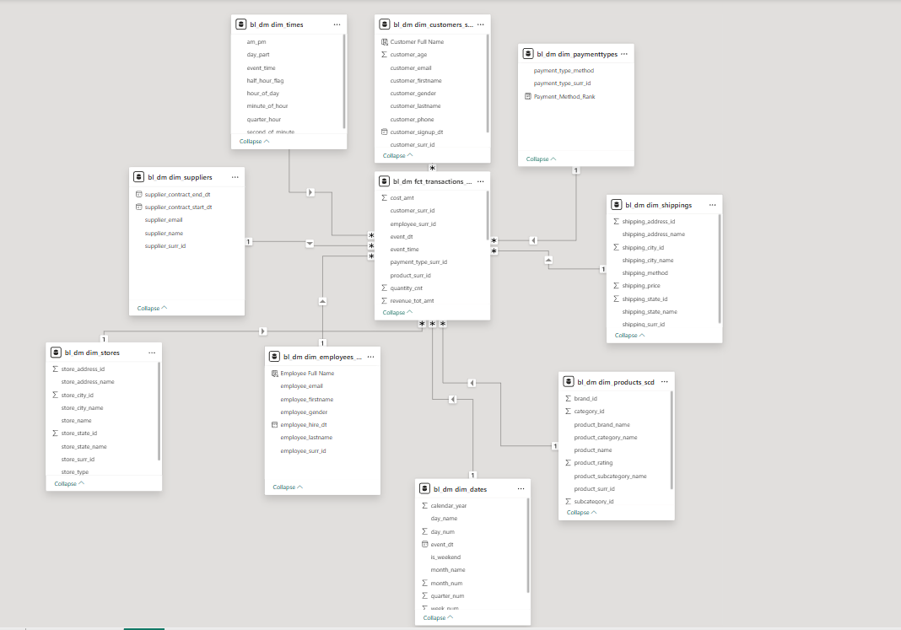

And after that I started building report. Firstly I created logo, company name and defined color pallet that I would have used which is mostly based on purple color.
Then I created some calculated columns and measures which I needed in order to complete my report. Here I will show all the screenshots of DAX code by which I created them.

Calculated Columns:

Measures:
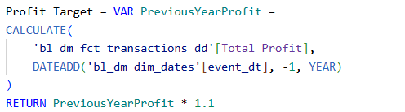
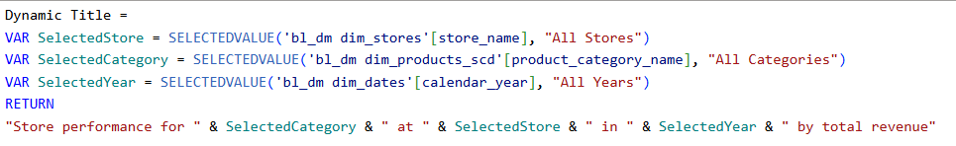

I created 3 unhidden pages where I show some insights about stores, employees, products, brands performance, etc. And I also created 1 hidden page where I have drillthrough information about employees.
This is the first page which is about Stores & Employees performance:
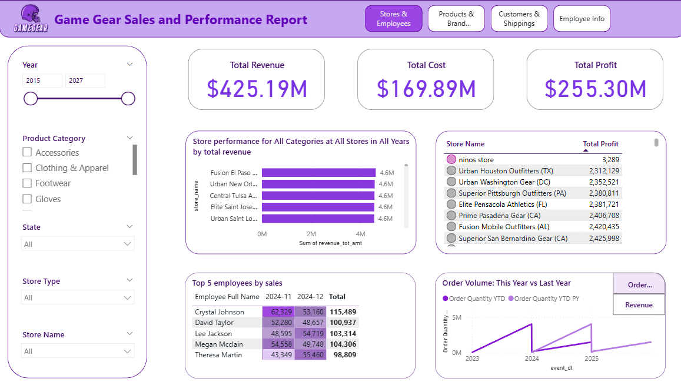
In this report you can see the total revenue, total cost and total profit for the company. I visualize how the stores are performing across all product categories and years with a chart that compares total revenue by store. You can also look at the top 5 employees by sales showing how each performed over the last couple of months. The store profit comparison visual shows the profit for different stores which helps us quickly identify the best performing ones. Lastly the order volume trend lets me compare how order quantity has changed this year versus last year giving me insight into trends in customer demand.
On the Order Volume line chart you can see two buttons (I created these buttons using bookmarks and selection): Order Volume and Revenue. Right now Order Volume is clicked. But if I click Revenue we will see following:
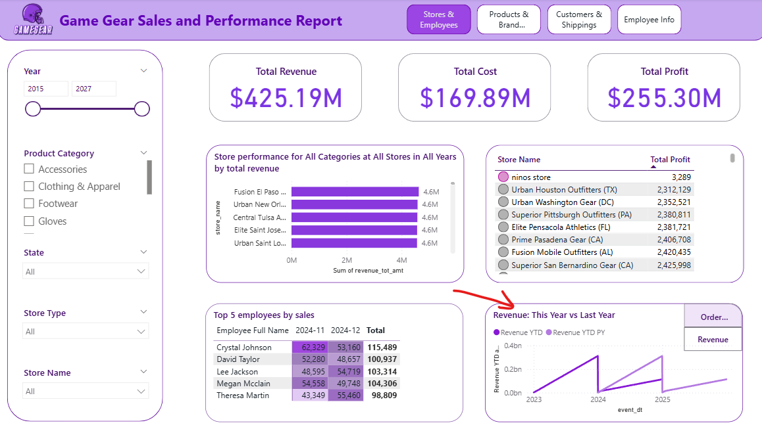

So when we click it we can see how revenue has changed this year vs last year.
Also as you can see I am using conditional filtering for table visuals.
This is for Top 5 employees table:
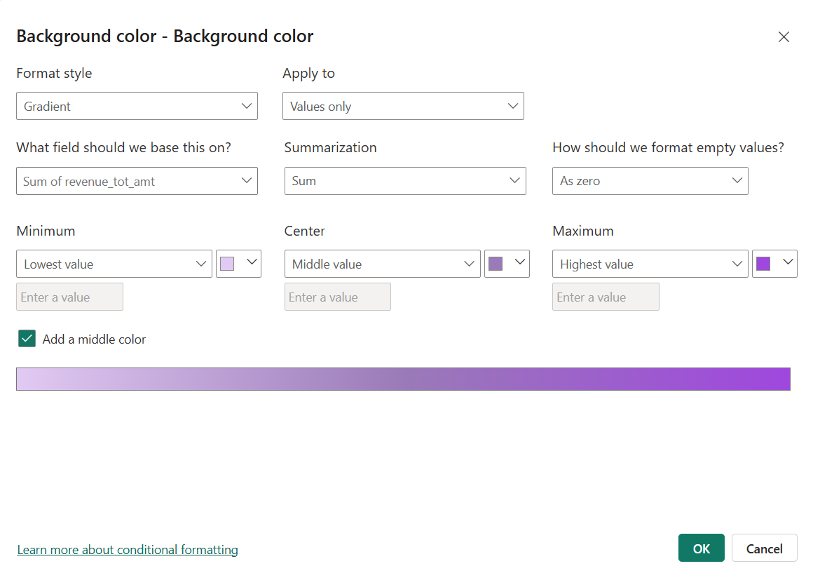
And this is for Store-Profit table:
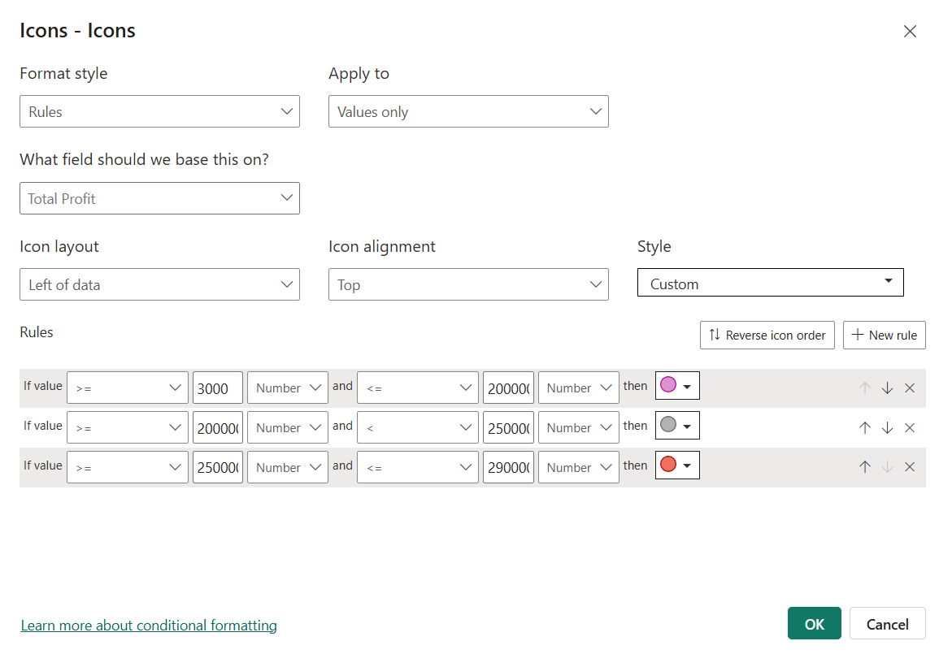

I also implemented visualization title as was asked in the task that dynamically change based on the filters selected by the user:
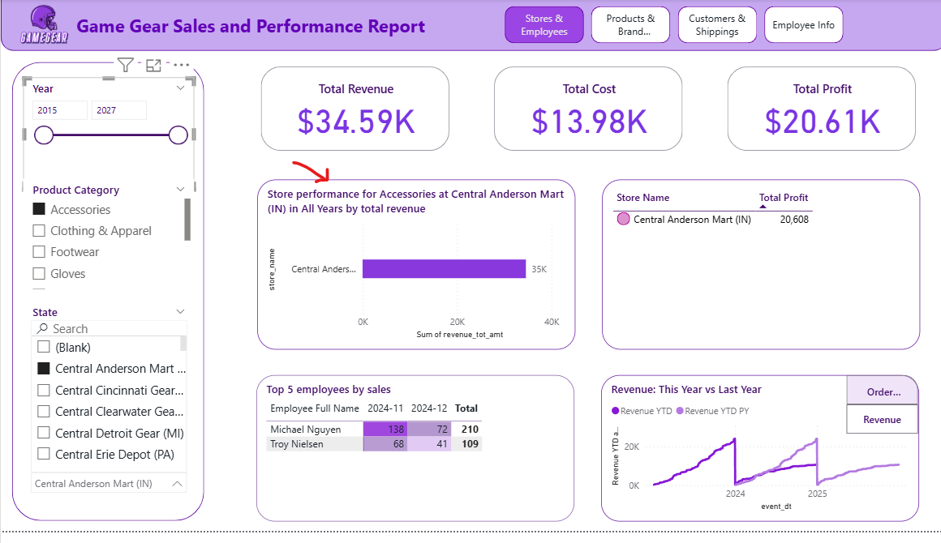
As you can see I checked some boxes in my slicer and title dynamically changed. I implement this Dynamic Title measure I created which is above where I showed screenshots of measures.
And I did this to apply:
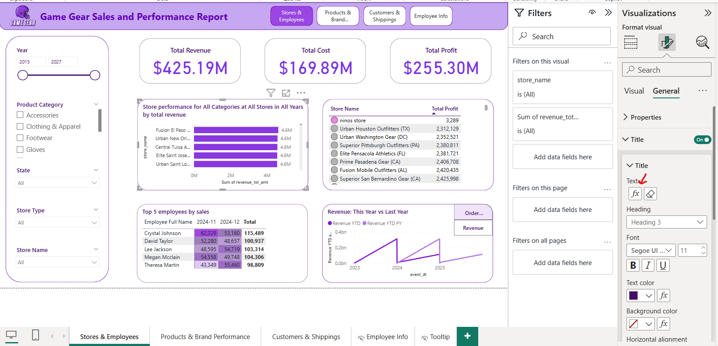
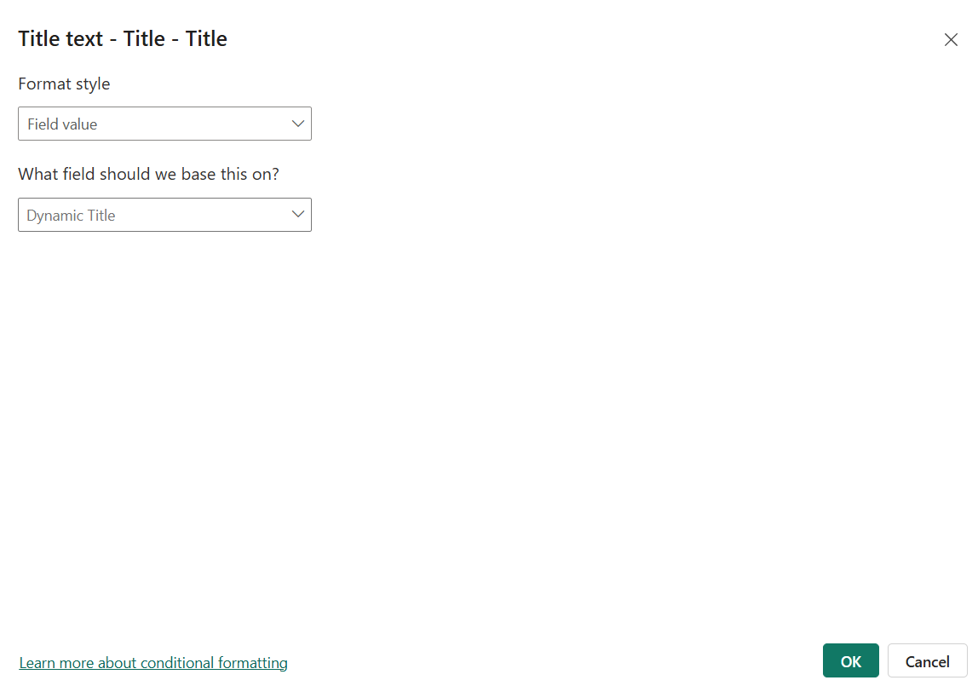

I also created tooltip which in more details show information about profit meaning introducing target profit and actual profit to see if company achieved its goal:
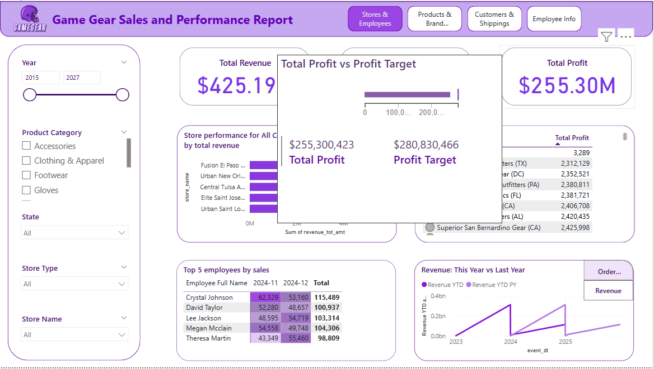
When you hover on Total Profit card you will see that information.

I also enabled drill through option for employees. So when you click employee’s full name from Top 5 employees by sales visual you will be redirected to hidden page where you can see more information about that employee:
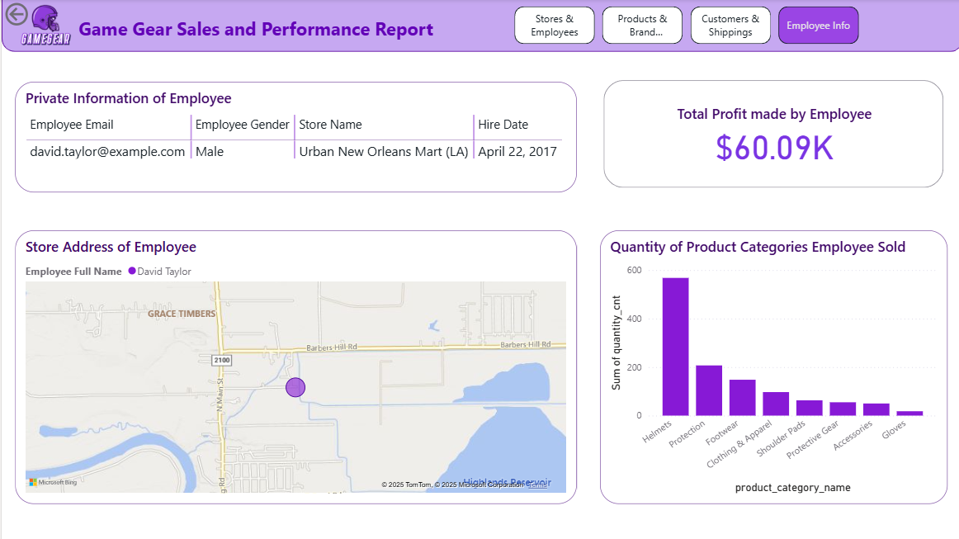
So as you can see you can find information like employee’s email, gender, store where he/she works, hire date, profit which employee made by selling products, quantity of product categories employee sold and also map which shows exact address of store he/she works at.

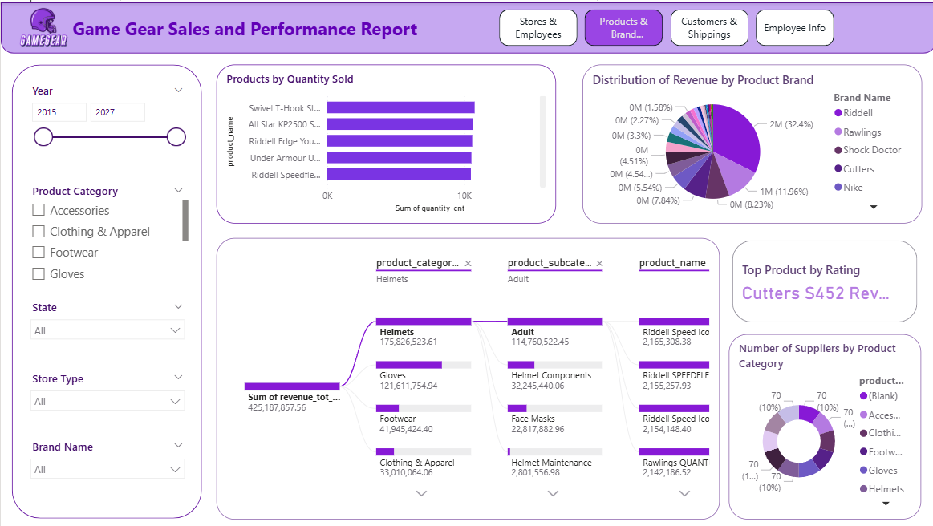
On this page I show analysis regarding products and brands. We can break down the revenue by brand seeing how much each brand contributes to the total sales, with brands like Riddell, Rawlings and Cutters standing out. There's also a view of the top rated product based on average product rating and we can also check out the number of suppliers for each product category. Also tree visualization shows your revenue breakdown by product hierarchy. It displays how total revenue is distributed across different product categories, then further breaks down each category into subcategories and finally shows individual product performance within each subcategory.

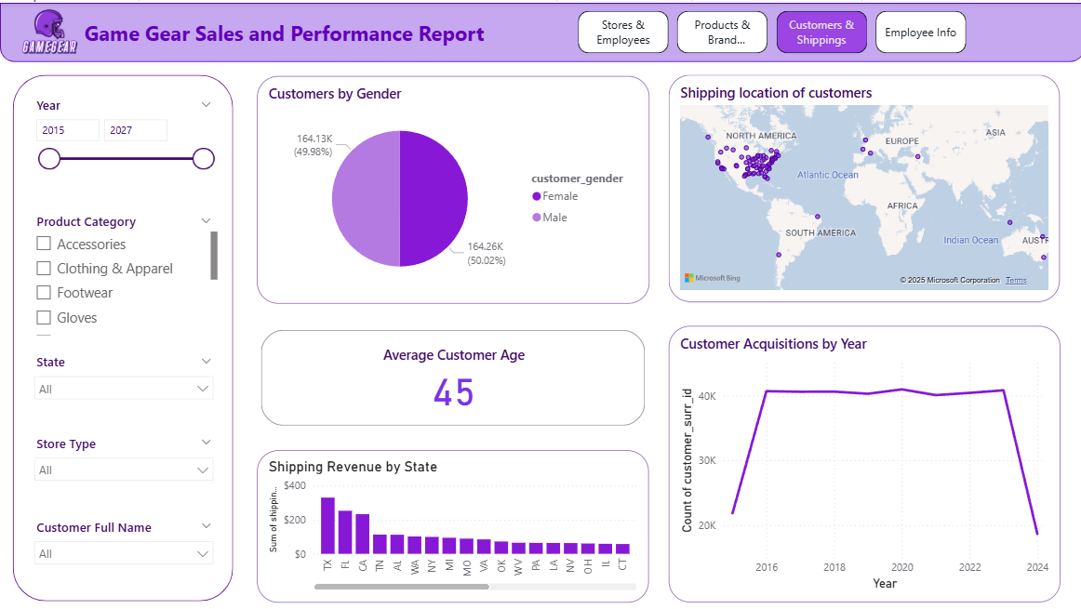
This page of the report provides insights into customer demographics and shipping data for GameGear. It shows the distribution of customers by gender by which we can see that there is a near-equal split between male and female customers. It also highlights the average customer age which is 45 years. The shipping locations map provides a visual of where customers are located globally with a concentration in North America. The shipping revenue by state shows the revenue generated from shipping across different U.S. states with Texas and California standing out. Lastly the customer acquisitions chart displays the number of new customers acquired over the years.

Lastly I published it to my workspace:
