VISUAL BASIC EXAMINATION
SECTION B – QUESTIONS AND ANSWERS

QUESTION 1: Simple Login System.

Question
Design and explain a VB form for a Simple Login System using Labels, TextBoxes, and Buttons. Include brief code to validate username and password.

Answer
A simple login system allows a user to enter a username and password to gain access to an application.
Form controls:
Control | Name | Purpose
Label | lblUsername | Displays username caption
TextBox | txtUsername | Accepts username
Label | lblPassword | Displays password caption
TextBox | txtPassword | Accepts password
Button | btnLogin | Validates login details
Button | btnClear | Clears the fields
Set the password TextBox property UseSystemPasswordChar to True.

VB.NET login validation code 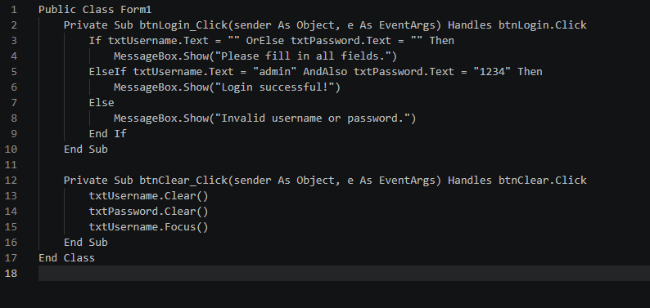SS

Explanation: If checks for empty fields; AndAlso checks that both credentials match; MessageBox.Show displays feedback; Clear removes text; Focus places the cursor in the username field. The credentials are examples only; real applications should securely store credentials and hash passwords.

QUESTION 2: Shopping Mall Discount System.
You are developing a Visual Basic application for a shopping mall. The application calculates discounts based on the total amount spent: less than $100 = no discount; between $100 and $500 = 10% discount; more than $500 = 20% discount. Write a VB code snippet using If, ElseIf, Else to calculate the discount and final amount. Include a loop to process three customers’ purchases. Display the total amount.

Answer
Discount rules:
Purchase total | Discount
Less than $100 | 0%
$100 to $500 inclusive | 10%
More than $500 | 20%

VB.NET code 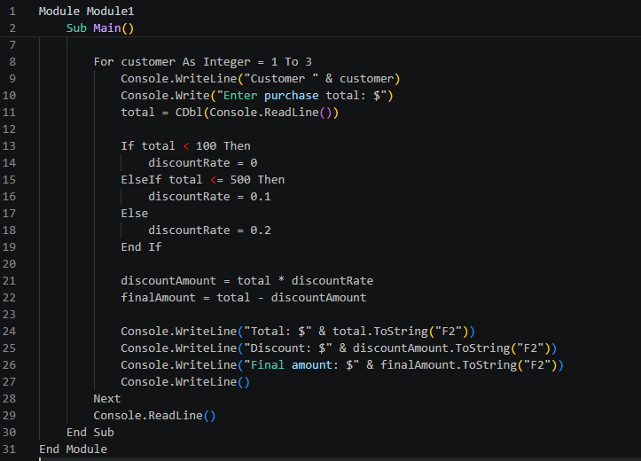

Explanation: The For loop repeats for three customers. CDbl converts input to a number. If…ElseIf…Else selects the rate. The discount is total × rate, and final amount is total − discount. ToString("F2") displays two decimal places.
Example: $80 → $0 discount, $80 final; $300 → $30 discount, $270 final; $600 → $120 discount, $480 final.

QUESTION 3: Object-Oriented Programming.

Question
Define a class and an object in Visual Basic and provide a simple example. Differentiate between inheritance and polymorphism in OOP. What is encapsulation, and why is it important? Describe the purpose of constructors and destructors in VB classes.

Answer

1. Class and object
A class is a blueprint or template defining properties and methods. An object is an instance of a class with its own data. 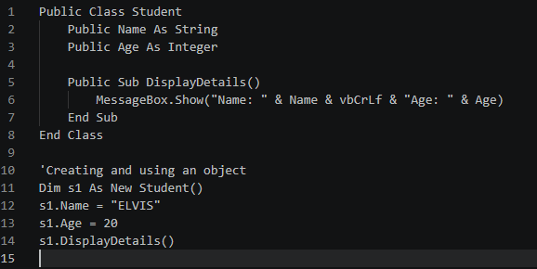

2. Inheritance versus polymorphism.
Inheritance | Polymorphism
A class acquires features of another class. | The same method/interface can have different implementations.
Promotes code reuse. | Promotes flexibility and extensibility.
Uses base and derived classes. | Often implemented through overriding or overloading.
Example: Dog inherits from Animal. | Example: different animals implement Speak() differently.

3. Encapsulation. 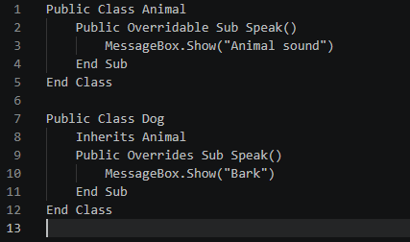
Encapsulation combines data and methods in a class while controlling access to internal data.
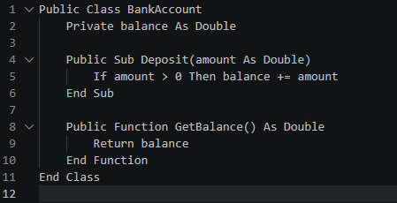
Importance: protects data, prevents invalid changes, improves maintainability and reliability, and hides implementation details.

4. Constructors and destructors.
A constructor runs when an object is created and initializes it. In VB.NET it is written as Sub New().
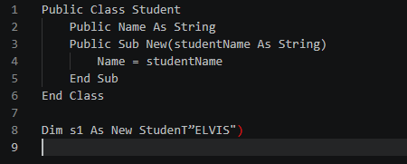
A destructor is associated with cleanup when an object is being destroyed. In VB.NET, Finalize relates to finalization, but garbage collection controls timing. For resources such as files, IDisposable and Dispose() are generally preferred.

QUESTION 4: Collections, Message Boxes and Solution Explorer.

Question
Identify and explain three uses of Collections in VB applications. Write short notes on Message Boxes and their types. Explain how Solution Explorer assists in project management within Visual Studio.

Answer

1. Three uses of collections.
- Storing multiple values: collections keep related items together, e.g. a List(Of String).
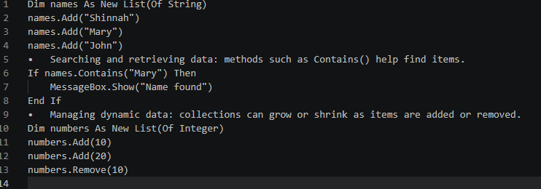
Other collection examples include arrays, dictionaries, stacks and queues.

2. Message Boxes and types.
A Message Box is a dialog box used to display information, warnings, errors or questions. It is displayed using MessageBox.Show().
Type | Purpose
Information | Displays general information.
Warning | Alerts users to a possible problem.
Error | Displays an error message.
Question | Asks the user to make a decision.

3. Solution Explorer.
Solution Explorer is a Visual Studio window showing the structure of a solution and its projects.
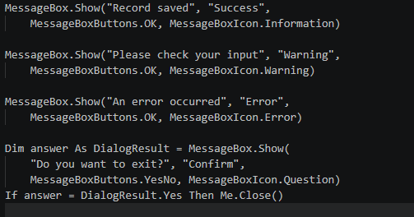
- Organizes forms, classes, modules and other files.
- Allows developers to add, remove, rename and organize project items.
- Provides quick access to source code and form designers.
- Helps view and manage project references and dependencies.
- Provides access to project properties and related operations.
- Makes navigation easier in large applications.

QUESTION 5: Student Grade Management System.

Question.
You are developing a student grade management system for a secondary school. Create a VB application that allows teachers to input student marks and generate performance reports.
a)– Input and Validation (6 marks): Design a form with textboxes for student name and marks in four course units (ICT, Visual Basic, Research Methods, and Cyber & Computer Law). Validate that all fields are filled and marks are numeric value
If marks >= 90 Then
Return "A"
ElseIf marks >= 80 Then
Return "B"
s between 0 and 100, displaying appropriate error messages.
b) – Calculations and Grading (8 marks): Calculate total marks, average percentage, and letter grades (A: 90–100, B: 80–89, C: 70–79, D: 60–69, F: below 60). Determine pass/fail based on average ≥60%. Use proper variables and efficient logic.
c)– Output and Reporting (6 marks): Display formatted results showing student name, subject marks with grades, total, average, overall grade, and pass/fail status. Include buttons to clear fields and save results to a text file with proper file handling.

Answer.

A): Form controls and validation.
Create TextBoxes named txtStudentName, txtICT, txtVisualBasic, txtResearch, and txtCyberLaw. Add Calculate, Clear, and Save buttons, plus a multiline read-only TextBox named txtResults.
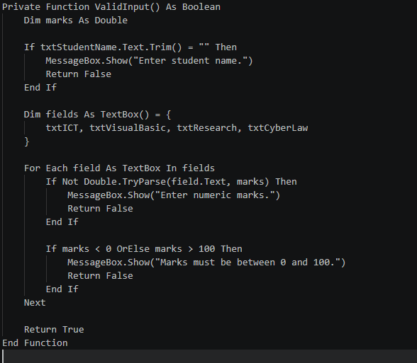

B): Grade calculation.
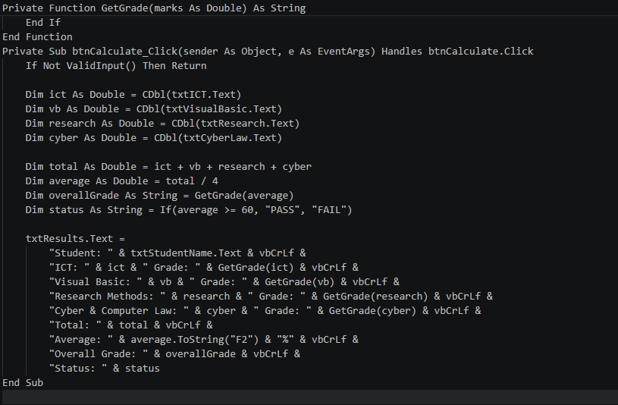

The total is the sum of the four marks. The average is total divided by four. GetGrade returns a letter grade. The student passes when the average is at least 60%.

C): Clear and save results.
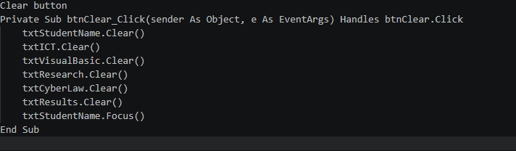

Save button with file handling
Add Imports System.IO at the top of the form.
Path.Combine creates the file path in Documents. StreamWriter writes the report; True appends instead of overwriting. Using closes the file properly. Try…Catch handles file and permission errors. 