Multi-Tenant SaaS Team Project

*Team 18: Abhishek Pandey, Dhaval Kolapkar, Gaurav Bajaj and Saumil Dharia*

*URL to Github Source Tree:*

*URL to Video:*

*URL to Application/Services Running in the Cloud:*

# Nomenclature

# List of Figures Page

# Summary of Team Member's Contributions

# Architecture

# Cloud Services Used

# Design

# Implementation Examples

## Waterfall model: Screenshots

## Dashboard

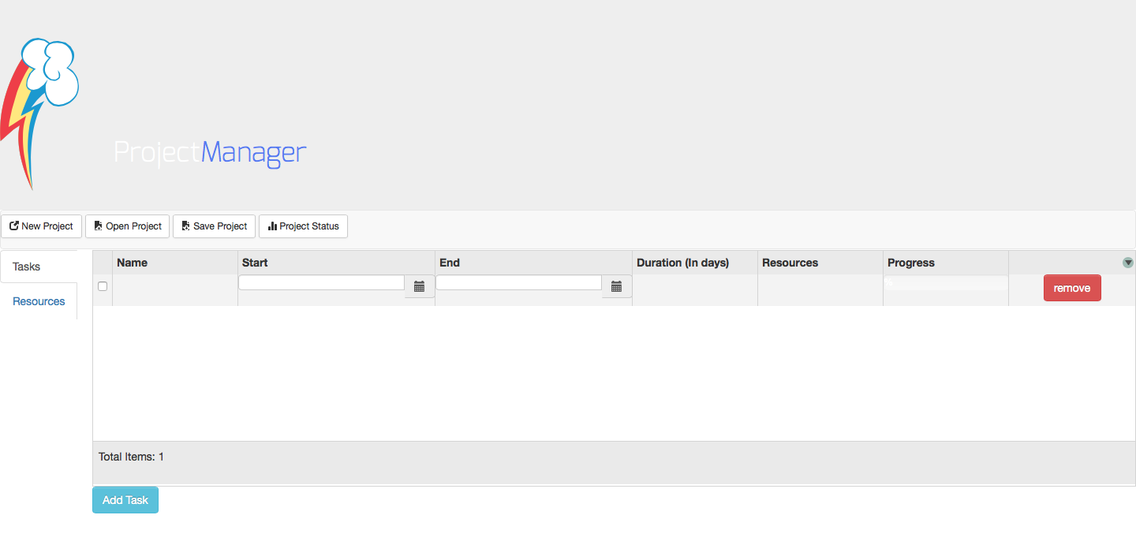

## Create tasks:

To enter a task, simply click on the name column and enter the task. You may add the start and end date for each task.

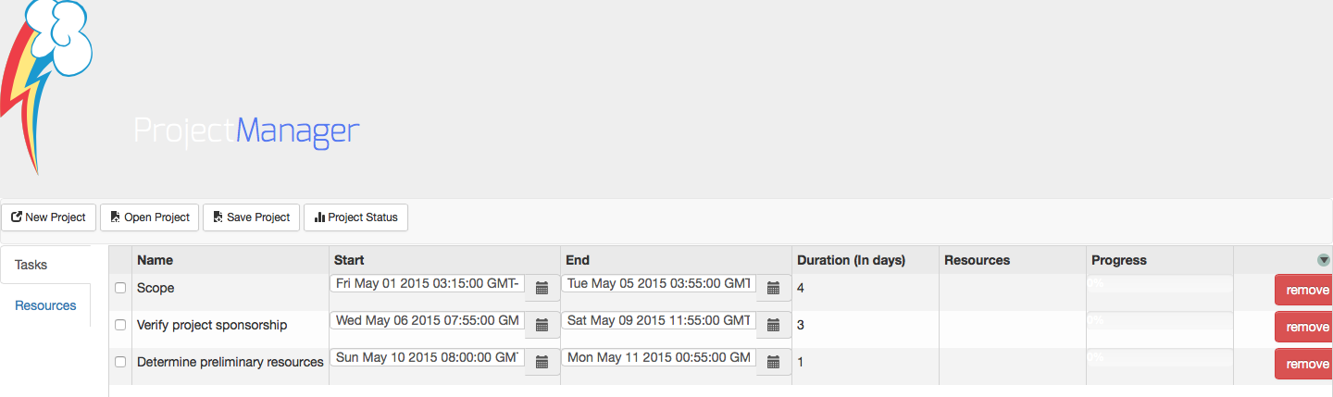

## Create resources:

To establish a relationship between the tasks, add resources using the resource tab.

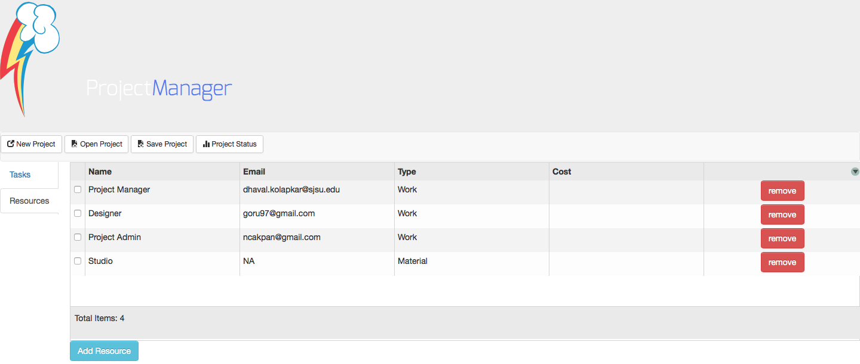

Now, add these resources to the corresponding tasks.

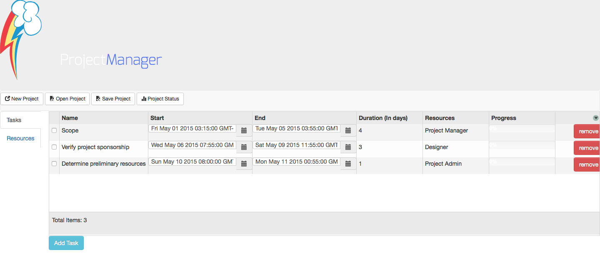

## Save the project:

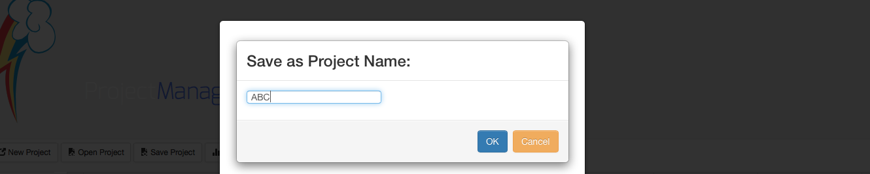

## Project Status:

Task progress will be updated dynamically based on the timeline.

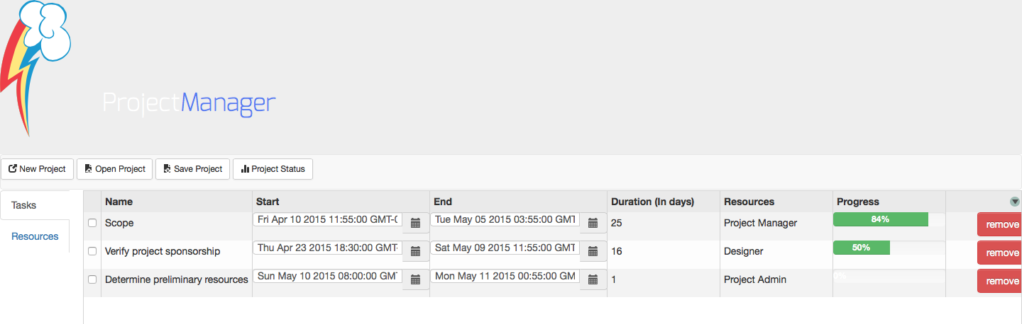

By Clicking on the Project status button, it will give the overall project status.

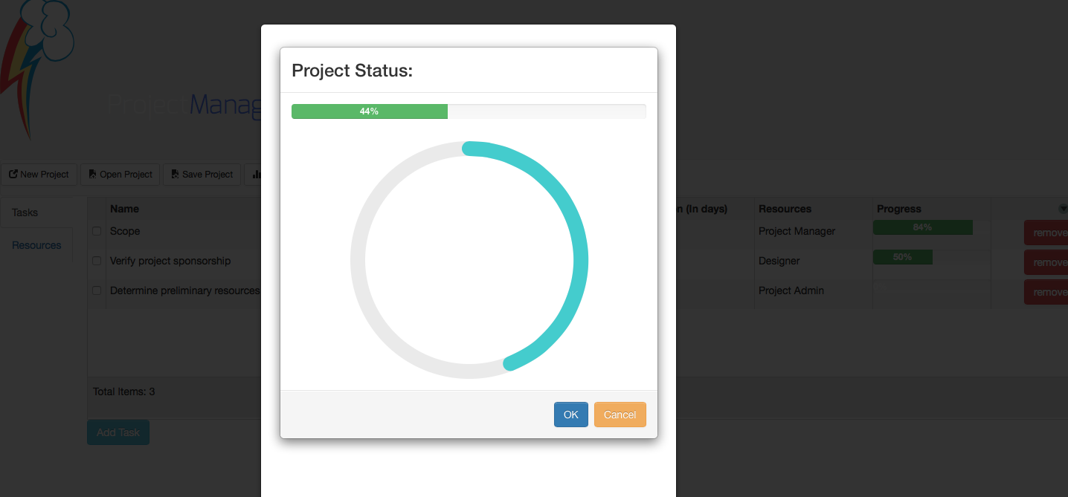

## Waterfall model: Code Snippet



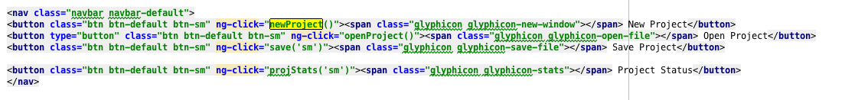

When user clicks on any of the options in the waterfall.html, the corresponding javascript function in waterfall.js is called. If new project is clicked it will reset all the fields , if user enters yes for the question- have you saved your project?

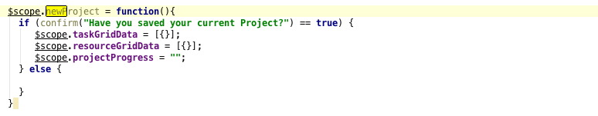

Similarly, for open project, the REST method GET for <http://localhost:8080/api/openProject/> {user} is called. This will return all the projects corresponding to the user and store it in the items variable. Now the script in waterfall.html will loadit to the user and allow choosing any of one:

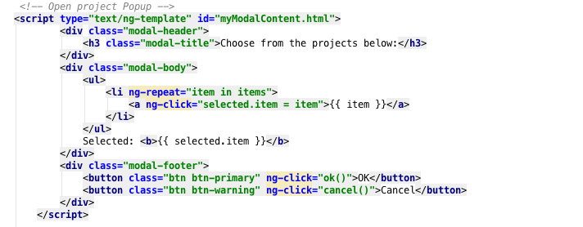

On save project, the script in waterfall model will be called from waterfall.js save function:

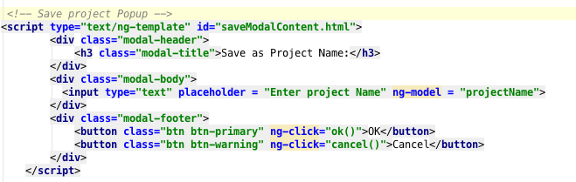

When user enters the name and clicks OK, it will save the project details in mongodb.

