Title of the paper, (ALL CAPITAL IN Times NEW Roman Size 14)

Author 1,ª Author 2^{b}, Author 3^{c}

ª Address,. ^{b}Address, ^{c} Address
E-mail: email@institution.extension
(Underline presenting author)

Keywords: At least four keywords must be included

The subtitles should be bold and in Times New Roman with font size 12.
The text should be in Times New Roman with font size 11. Spacing between the lines should be 1.5.

INTRODUCTION (Bold Font 12)
(Font size 11) (not more than five lines) Brief introduction giving details of the background, rationale and need for undertaking such study.

METHODS (Bold Font 12)
(Font size 11) (not more than four lines)Discuss experimental or theoretical methods employed for the present investigation.

RESULTS AND DISCUSSION (Bold Font 12)
(Font size 11) Give details of the observations/data/calculations. Explain the results clearly. This passage should give an excellent summary of the research/application that will be presented in the conference. Please also include references to your work and general citations. For the references use the format given below. References should be quoted in text within brackets as [1]

The entire contents of the abstract should not exceed two pages, including figure/tables, if space allows. Figures and Tables should be provided with all the necessary details. Unlabelled figures and tables will not be accepted.

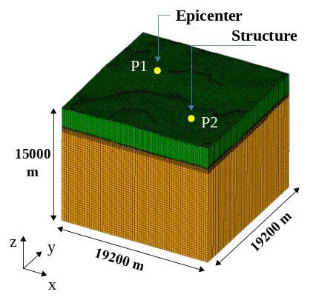
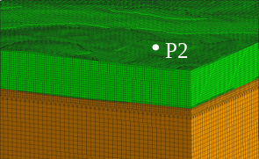
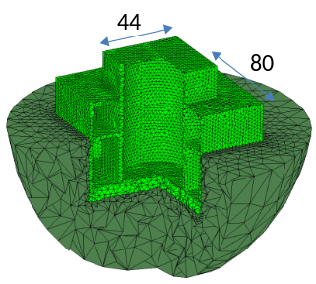
Fig.1: Model figure.
a) entire domain of the system
b) small domain that includes the nuclear power plant
c) close-up view of the nuclear power plant building

CONCLUSIONS (Bold Font 12)
(Font size 11) Give one or two lines of conclusions of the research paper. It should clearly give the outcome of work with possible future applications.

REFERENCES (Bold Font 12)
(Font size 11)
[1] Hori, M., Introduction to computational earthquake engineering, Imperial College Press, London, 2006.
[2] Ichimura, T. and Hori, M., “Structural Seismic Response Analysis Based on Multiscale Approach of Computing Fault-Structure System,” Earthquake Engineering & Structural Dynamics, Vol. 38, pp. 439-455, 2009.

