Go to: <https://azureopensource.azurewebsites.net/>

Click on “Sign in”

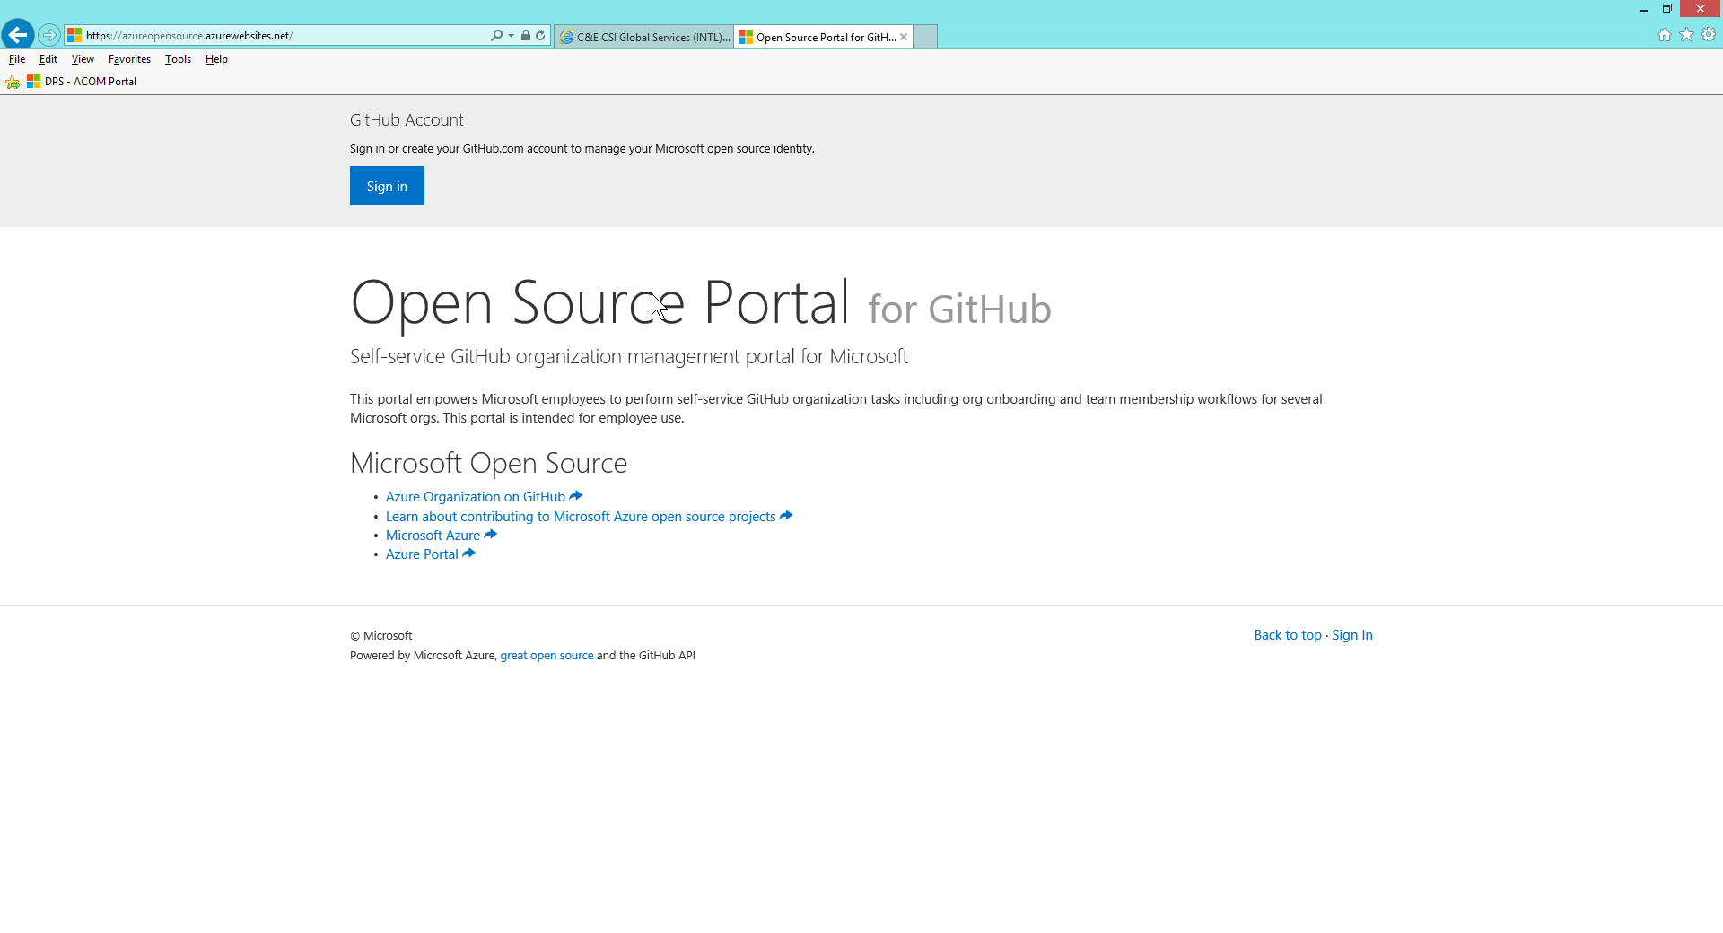

Enter your Github credentials

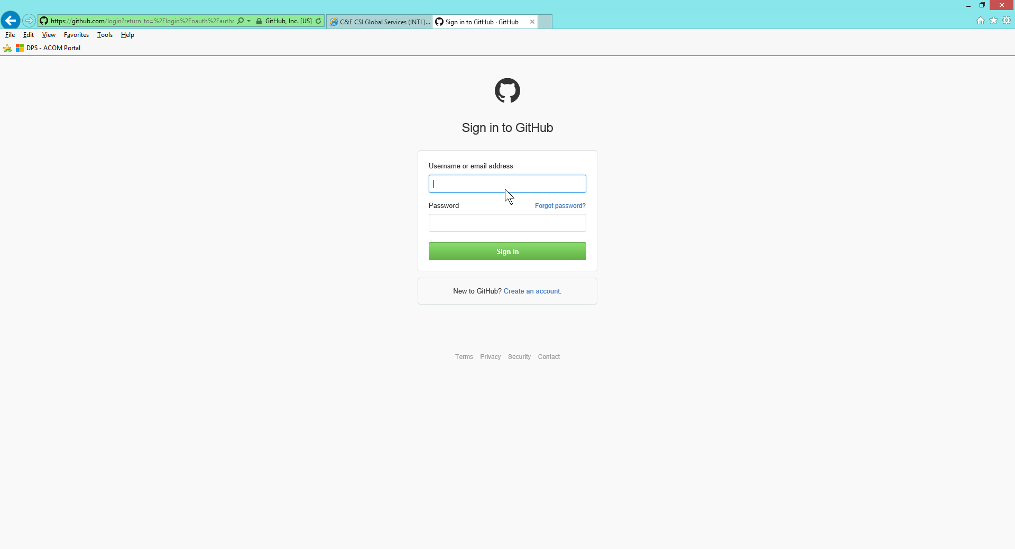

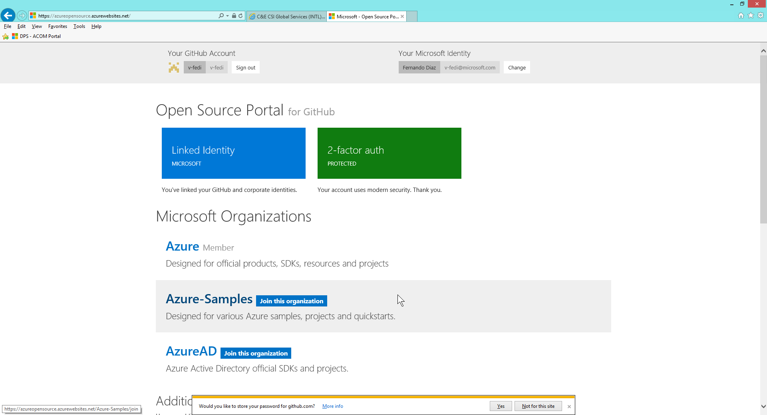

Click on 2-factor auth (green box)

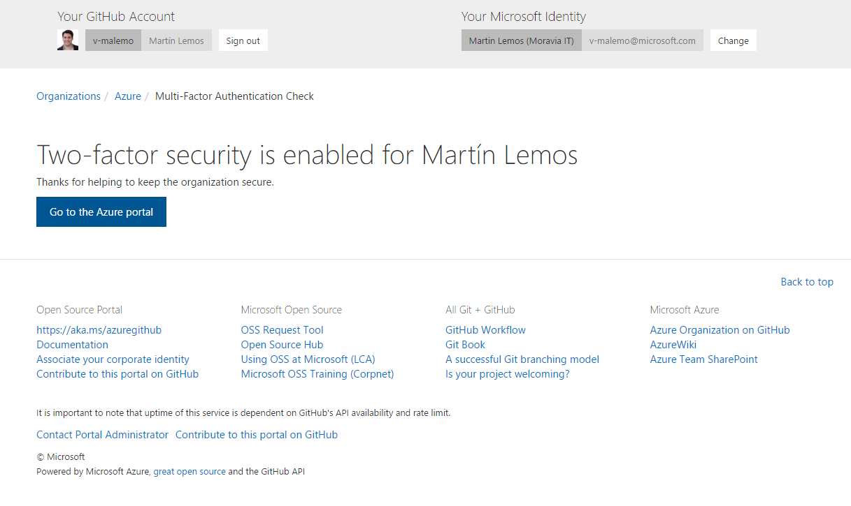

Click on “Go to the Azure portal”

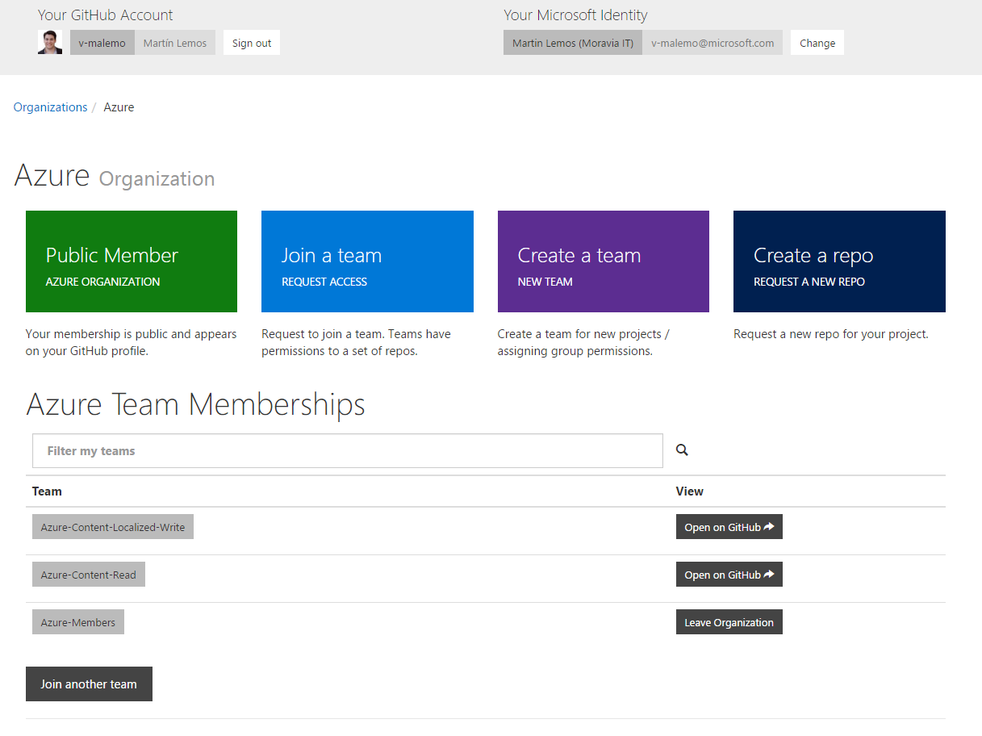

Click on “Join a team”

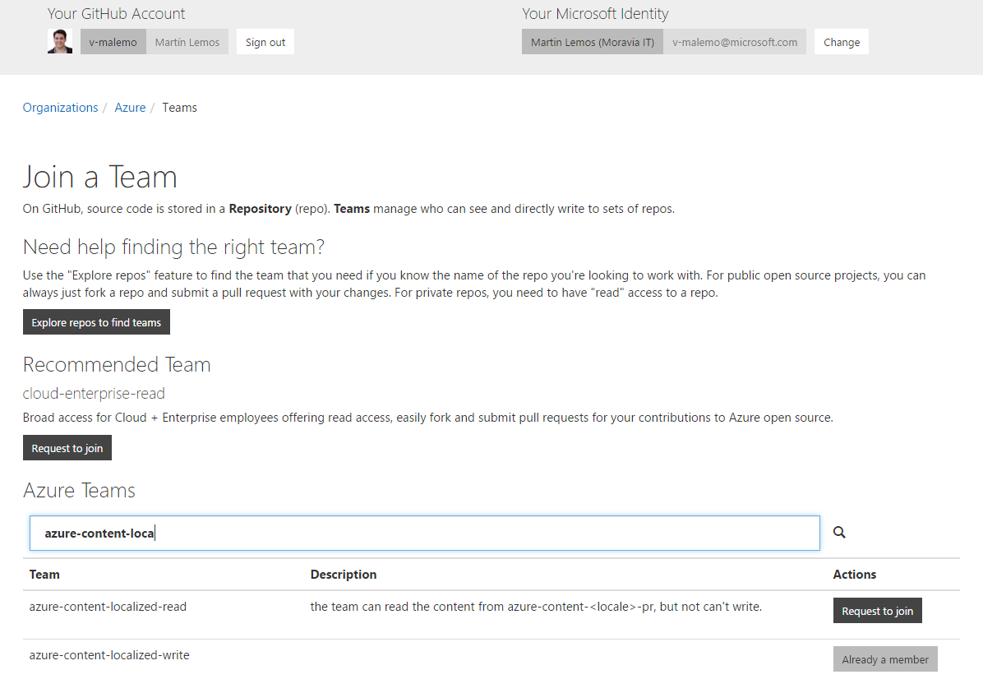

Search for the group azure-content-localized-writer

Click on “Request to join”

You should have perms to these 3 groups:

**‘azure-content-localized-writer’**

**‘azure-members’**

**‘azure-content-read’**