PRODUCT REQUIREMENTS DOCUMENT (PRD)
ML-Based Real-Time Intrusion Detection System
Version 1.0 | Real-Time Network Monitoring | ML-Based Detection

1. Product Overview
The ML-Based Real-Time Intrusion Detection System (IDS) is a defensive cybersecurity platform that continuously observes authorized network traffic, extracts network-flow features, applies machine-learning and anomaly-detection models, and generates real-time security alerts. The system is designed to use genuine live traffic and actual observed IP addresses, ports, protocols, and available domain/URL metadata rather than hardcoded operational data.

2. Product Goal
Build a working, end-to-end IDS that can detect suspicious and malicious network behavior in real time, explain why an event was flagged, preserve the evidence in a database, and present the results through a live security dashboard.

3. Core Product Principles
- Real traffic first: operational detections must originate from live or legitimately captured network traffic.
- No fake operational telemetry: dashboard metrics, alerts, IPs, domains, timestamps, and incidents must come from actual system events.
- Real ML inference: production detection must invoke trained models rather than hardcoded classifications.
- Explainability: analysts should be able to understand the important features behind a prediction.
- Real-time UX: alerts and traffic statistics should update without manual page refresh.
- Defensive and authorized use only: monitoring and response actions must be limited to networks and systems the operator is authorized to manage.

4. Target Users
- Security administrator / SOC analyst
- Network administrator
- System administrator
- Project evaluator / academic reviewer

5. Functional Requirements

5.1 Live Network Traffic Capture
- Capture live packets/flows from a selected authorized network interface.
- Allow the operator to select or configure the monitoring interface.
- Support flow aggregation so individual packets can be converted into meaningful connection/session features.
- Record source IP, destination IP, source/destination port, protocol, packet/byte counts, timestamps, and connection statistics where observable.
- Gracefully handle unsupported, encrypted, malformed, or incomplete traffic.

5.2 Real IP, Domain and URL Intelligence
- Display actual source and destination IP addresses observed in traffic.
- Resolve or enrich IP addresses with available network/host metadata where appropriate.
- Extract domain information when available from observable DNS/TLS/HTTP metadata.
- Display full HTTP URLs only when they are genuinely visible to the sensor.
- Do not claim to reveal HTTPS URL paths when TLS encryption prevents their observation.
- Optionally integrate authorized threat-intelligence feeds for IP/domain reputation.

5.3 Traffic Feature Extraction
- Flow duration.
- Packets per flow and bytes per flow.
- Forward/reverse packet and byte statistics.
- Packet-size statistics.
- Inter-arrival-time statistics.
- TCP flag counts and connection-state information where available.
- Source/destination port behavior.
- Protocol and service information.
- Connection frequency and burst behavior.
- Scanning-related features such as destination-port diversity and connection failure patterns.

5.4 ML-Based Detection
- Binary classification: benign vs suspicious/malicious.
- Multi-class classification for supported attack families.
- Anomaly detection for behavior that does not match known attack classes.
- Prediction confidence/probability score.
- Configurable decision thresholds.
- Model versioning and metadata for reproducibility.
- Support for retraining using newly labeled, authorized traffic data.
- Dataset preprocessing, normalization/encoding, feature selection, and imbalance handling.

5.5 Attack Categories
- Denial-of-Service / Distributed Denial-of-Service patterns.
- Port and network scanning.
- Brute-force and repeated authentication attempts where network evidence supports detection.
- Botnet/C2-like communication patterns.
- Reconnaissance and suspicious connection behavior.
- Web-application attack traffic when the required application-layer visibility exists.
- Other attack classes supported by the selected training dataset and deployed model.
- Unknown/anomalous behavior that cannot confidently be mapped to a known class.

5.6 Real-Time Alerting
- Generate alerts as soon as a detection crosses the configured threshold.
- Assign severity: Low, Medium, High, or Critical.
- Include actual source/destination IPs, ports, protocol, timestamp, detection type, confidence, and relevant evidence.
- Prevent duplicate alert flooding through correlation/deduplication.
- Allow alert acknowledgement and status tracking.
- Support configurable alert rules and thresholds.

5.7 Explainable AI
- Show the primary features contributing to a prediction.
- Provide a human-readable reason for the alert.
- Show model confidence and, where implemented, feature contribution values using an explainability method such as SHAP.
- Clearly distinguish model evidence from external threat-intelligence evidence.

5.8 Threat and Risk Scoring
- Calculate a normalized risk score for each detection.
- Combine ML confidence, severity, recurrence, traffic behavior, and optional reputation signals.
- Prioritize incidents for analyst attention.
- Maintain a risk history for repeated sources or related events.

5.9 Incident Correlation
- Group related alerts into a single incident.
- Correlate events by source IP, destination, time window, port, protocol, or attack pattern.
- Track incident lifecycle: New → Investigating → Contained → Resolved.
- Maintain an evidence timeline for each incident.

5.10 Real-Time Security Dashboard
- Live packets/flows analyzed.
- Benign vs suspicious/malicious traffic.
- Current active alerts.
- Attack categories and severity distribution.
- Top source IPs and destination IPs.
- Top targeted ports/services.
- Protocol distribution.
- Attack timeline.
- ML confidence and risk-score views.
- Live event stream with automatic updates through WebSocket/SSE or an equivalent mechanism.
- Search, filtering, sorting, and date/time range controls.

5.11 Investigation and Event History
- Store detection events and incidents in a persistent database.
- Open an alert to inspect its complete event details.
- Search by IP, domain, port, attack type, severity, time, and incident status.
- View historical activity associated with an IP or incident.
- Export filtered events/reports in a standard format such as CSV/JSON/PDF where implemented.

5.12 Defensive Automated Response (Optional / Controlled)
- Provide a manual response option for an analyst.
- Optionally block or quarantine a source IP through an authorized firewall/network-control integration.
- Support temporary blocking with expiry.
- Log every response action, actor, reason, timestamp, and result.
- Use approval controls for high-impact actions.
- Never perform blocking against systems/networks without explicit authorization.

5.13 Authentication and Administration
- Secure administrator login.
- Role-based access control.
- Configuration of monitoring interfaces and thresholds.
- Model/version visibility.
- Audit logging for administrative actions.
- Health/status monitoring for capture engine, ML service, database, and dashboard.

6. Non-Functional Requirements
- Real-time responsiveness: detection and dashboard updates should occur with low operational latency appropriate to the deployment environment.
- Reliability: temporary failure of one component should not silently corrupt or fabricate security events.
- Scalability: architecture should support increasing traffic volume through asynchronous processing and flow aggregation.
- Security: credentials, APIs, database access, and response integrations must be protected.
- Observability: application logs, model errors, capture errors, and service health must be visible to administrators.
- Traceability: every alert should be traceable to observed traffic/features and a specific model/version.
- Privacy: collect only the network metadata required for the authorized detection purpose and protect stored telemetry.

7. Suggested System Architecture
Authorized Network Interface → Packet/Flow Capture → Flow Aggregator → Feature Extraction → Preprocessing → ML Classifier + Anomaly Detector → Explainability/Risk Engine → Alert & Incident Correlation → Database → WebSocket/SSE → Real-Time Dashboard
Optional enrichment: DNS/HTTP/TLS metadata → IP/domain reputation → threat-intelligence enrichment. Optional response: Incident → Analyst approval → Authorized firewall/network-control integration → response audit log.

8. Recommended Technology Stack
- Capture: Python/Scapy or a higher-performance packet/flow capture mechanism such as libpcap/AF_PACKET/eBPF depending on deployment needs.
- Backend/API: FastAPI.
- Real-time transport: WebSocket or Server-Sent Events.
- ML: scikit-learn plus XGBoost/LightGBM where appropriate; PyTorch/TensorFlow if deep learning is required.
- Explainability: SHAP or an equivalent model-explanation library.
- Database: PostgreSQL for durable event/incident storage; Redis can be added for short-lived real-time state.
- Frontend: React or another modern dashboard framework.
- Deployment: Docker/Docker Compose initially; production deployment can use a cloud VM or Kubernetes where justified.

9. Data Model – Minimum Detection Event
- event_id
- timestamp
- source_ip
- destination_ip
- source_port
- destination_port
- protocol
- domain / URL metadata when observable
- flow statistics
- predicted_class
- prediction_confidence
- anomaly_score where applicable
- severity
- risk_score
- model_version
- explanation
- incident_id
- response_status

10. MVP Scope
- Live traffic capture.
- Actual IP/port/protocol extraction.
- Flow feature extraction.
- Trained ML binary classifier.
- Multi-class attack classifier if dataset/model quality permits.
- Real-time alert generation.
- Persistent event storage.
- Real-time dashboard.
- Search/filter historical events.
- Basic explainability.
- No hardcoded operational alerts.

11. Advanced Scope
- Hybrid ML + anomaly detection.
- Threat-intelligence enrichment.
- Incident correlation.
- IP/domain risk profiles.
- Model drift monitoring.
- Incremental/retraining pipeline.
- Automated response with approval.
- Federated learning or privacy-preserving training as a research extension.
- Distributed/sensor-based deployment.

12. Acceptance Criteria
- When the monitoring service is started on an authorized interface, the system captures genuine network traffic.
- Displayed source/destination IPs and ports match observed traffic rather than predefined demo values.
- A captured flow is transformed into the same feature schema expected by the deployed ML model.
- The ML service returns a real prediction and confidence value for supported traffic.
- A qualifying detection creates a persistent alert containing the observed network metadata.
- The dashboard receives new alerts without requiring a manual browser refresh.
- Historical alerts can be searched and opened from the database.
- The system does not fabricate URLs; application-layer visibility is accurately represented.
- Model version and prediction details can be traced for each ML alert.
- If automated response is enabled, the action is executed only through an authorized integration and is recorded in an audit log.

13. Important Technical Constraints
- HTTPS/TLS encryption can prevent visibility into full URL paths and payload content unless an authorized TLS inspection architecture is deployed.
- Some traffic may be encrypted, tunneled, fragmented, or otherwise unavailable to simple packet-level inspection.
- ML accuracy depends on the quality, representativeness, and freshness of training data.
- Dataset labels do not automatically guarantee that the same attack can be identified reliably in a different real-world network.
- Automated blocking can cause false-positive impact; it should therefore be controlled, auditable, and preferably approval-based in the initial release.

14. Success Metrics
- Detection precision, recall, F1-score, and class-wise performance on a held-out test set.
- False-positive rate on representative benign traffic.
- Detection latency from flow completion/feature availability to alert creation.
- Dashboard update latency.
- Event ingestion reliability and processing throughput.
- Percentage of operational dashboard data sourced from genuine observed events.
- Explainability coverage for ML-generated alerts.

15. Product Definition of Done
The project is considered a working real-time IDS when it can capture authorized live traffic, extract real network-flow information, execute a genuine trained ML detection pipeline, identify and score supported threats, generate and persist real-time alerts, update the dashboard live, provide investigation history and explanations, and accurately communicate visibility limitations for encrypted traffic.

16. Complete Feature Requirements
This section defines the complete functional feature set for the intended real-time implementation. Operational values such as IP addresses, domains, URLs, alerts, timestamps, traffic statistics, and incidents must be generated from actual authorized network observations or legitimate external enrichment services; they must not be hardcoded demo values.
ID | Feature | Requirement
F01 | Real-Time Network Monitoring | Live packet/flow capture; interface selection; flow aggregation; connection/session tracking; live packet/byte/flow rates; actual source and destination IPs.
F02 | Real IP/Port/Protocol Identification | Extract source IP, destination IP, source/destination ports, transport protocol, timestamps, connection state, and traffic statistics from observed traffic.
F03 | Real Domain/URL Visibility | Extract HTTP URLs when visible; observe DNS queries/responses; extract TLS SNI/domain metadata where available; associate domains with observed IPs; explicitly show unavailable fields for encrypted traffic.
F04 | Flow Feature Extraction | Duration, packet/byte counts, directionality, packet-size statistics, inter-arrival times, TCP flags, connection rates, failed connections, port diversity, burst behavior, and protocol/service features.
F05 | ML Binary Detection | Classify supported traffic as benign or malicious using a deployed trained model.
F06 | ML Multi-Class Detection | Classify supported attack families such as DoS/DDoS, scanning, brute force, botnet/C2-like traffic, reconnaissance, and supported web attacks.
F07 | Anomaly Detection | Detect unusual behavior that does not confidently match known attack classes; calculate anomaly score and flag potential unknown attacks.
F08 | Confidence & Risk Scoring | Display prediction confidence and a normalized risk score based on ML confidence, severity, recurrence, anomaly score, and optional reputation evidence.
F09 | Real-Time Alerts | Generate immediate alerts with actual IPs, ports, protocol, domain/URL metadata where observable, attack type, confidence, severity, risk, timestamp, and evidence.
F10 | Alert Deduplication | Reduce alert flooding by grouping repeated equivalent events within configurable time windows.
F11 | Explainable AI | Show the important features/reasons behind a model prediction using feature importance, SHAP, or an equivalent method.
F12 | Threat Intelligence | Optional IP/domain reputation, ASN/organization metadata, IOC enrichment, and threat-feed correlation without fabricating unavailable reputation data.
F13 | Incident Correlation | Group related alerts into incidents using source/destination, time window, port, protocol, attack type, and behavioral relationships.
F14 | IP Investigation | IP profile with first/last seen, alert count, attack types, targets, ports, domains, risk history, and related incidents.
F15 | Real-Time Dashboard | Live traffic metrics, attack statistics, active alerts, severity distribution, top attackers, targeted ports, protocols, domains, timelines, and live event feed.
F16 | Real-Time Data Streaming | Push new detections and telemetry to the UI using WebSocket/SSE without browser refresh.
F17 | Persistent Event Storage | Store actual traffic-flow summaries, predictions, alerts, incidents, IP profiles, model metadata, and audit events in a database.
F18 | Search & Investigation | Search/filter by IP, domain, port, protocol, attack type, severity, incident ID, and time range; open complete event details.
F19 | Incident Management | Lifecycle tracking: New → Investigating → Contained → Resolved; evidence timeline, analyst notes, linked alerts, and ownership.
F20 | Controlled Automated Response | Optional authorized IP blocking/quarantine/rate limiting/firewall integration with approval controls, expiry, result logging, and audit trail.
F21 | Notifications | Dashboard/browser notification and optional email/Slack/Telegram integrations for high/critical events.
F22 | Authentication & RBAC | Admin, Security Analyst, and Viewer roles with permission controls and secure authentication.
F23 | ML Model Management | Dataset handling, preprocessing, feature selection, training, comparison, tuning, evaluation, versioning, deployment, rollback, and retraining.
F24 | Model/Data Drift | Monitor data/model distribution changes and flag degradation or drift requiring review/retraining.
F25 | Reporting | Daily/weekly security summaries, attack reports, incident reports, ML evaluation reports, and CSV/JSON/PDF export where implemented.
F26 | System Health | Capture engine, ML service, database, realtime stream, queue, processing rate, dropped packets, CPU/memory, and model health.
F27 | Audit Trail | Record configuration changes, analyst actions, alert status changes, response actions, model changes, and authentication events.
F28 | Privacy & Visibility Controls | Protect stored telemetry, minimize unnecessary payload collection, and clearly communicate encryption/visibility limitations.

17. User Workflows

17.1 Live Detection Workflow
- Operator selects an authorized network interface.
- Capture engine receives live packets and creates flows.
- Feature extractor calculates the deployed model's required feature schema.
- ML classifier and anomaly detector process each eligible flow.
- Risk engine combines model evidence and optional enrichment.
- A qualifying event creates an alert and/or incident.
- Event is persisted and pushed to the dashboard in real time.
- Analyst investigates and, if enabled, approves an authorized response.

17.2 Analyst Investigation Workflow
- Analyst opens a high/critical alert.
- System shows source/destination, protocol, domain/URL metadata where observable, model prediction, confidence, risk, and evidence.
- Analyst views related alerts and the incident timeline.
- Analyst checks IP/domain enrichment and historical activity.
- Analyst acknowledges, contains, or resolves the incident.
- Every analyst action is recorded in the audit trail.

18. System Diagrams

18.1 High-Level Architecture
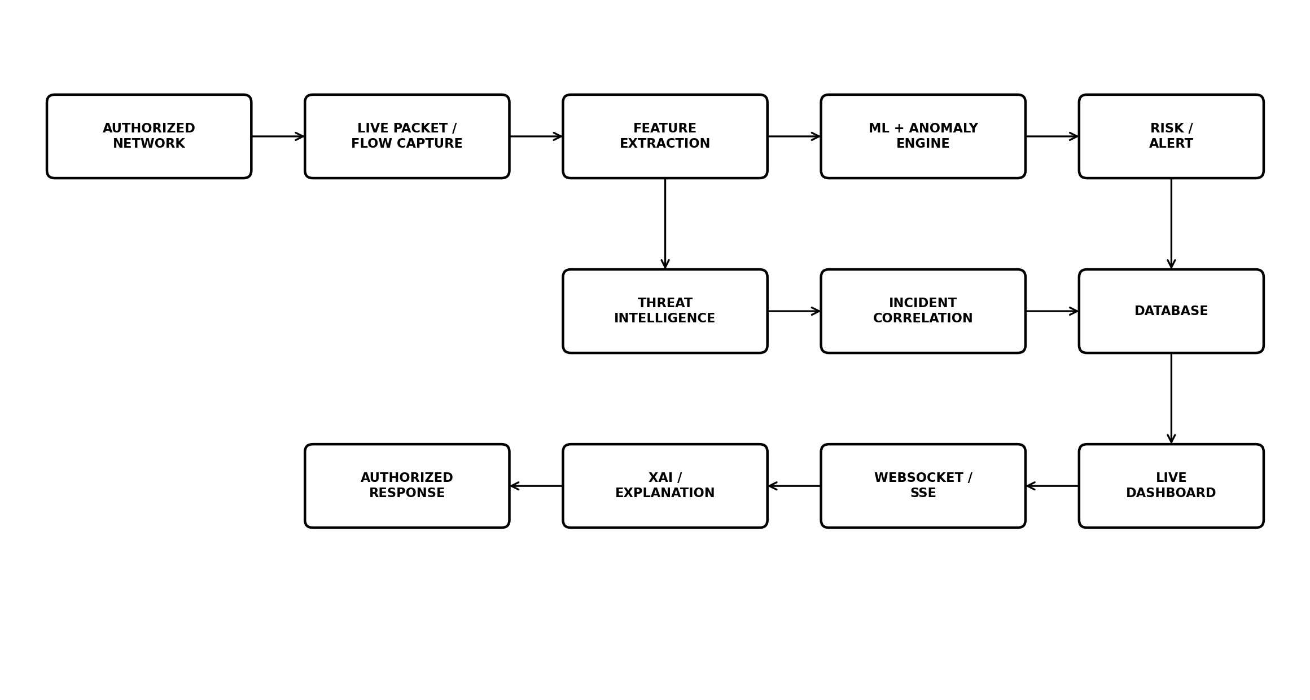
The architecture separates traffic capture, feature engineering, detection, enrichment, correlation, storage, realtime delivery, investigation, and response so each stage can be tested independently.

18.2 Real-Time Detection Pipeline
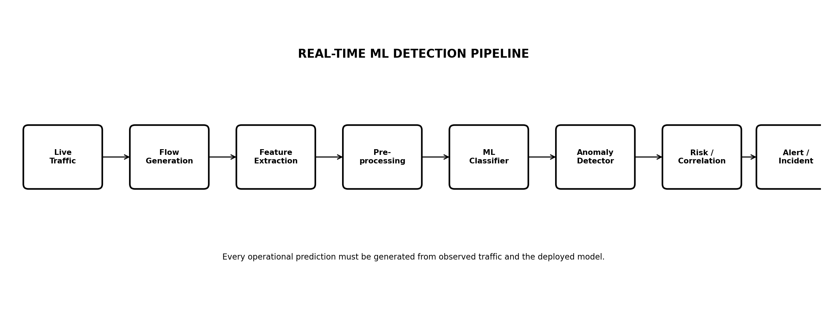

19. Feature Priority
Priority | Features
P0 – Must Have | Live packet/flow capture; real IP/port/protocol extraction; feature extraction; ML detection; anomaly detection; real-time alerts; persistent storage; live dashboard; realtime WebSocket/SSE; authentication.
P1 – Strongly Recommended | Multi-class attack detection; confidence/risk score; XAI; IP investigation; search/filter; incident correlation; threat-intelligence enrichment; audit trail; system health.
P2 – Advanced | Controlled automated response; model drift; continuous learning; notifications; advanced reports; distributed sensors; federated/privacy-preserving learning.

20. Final Acceptance Checklist
- Live traffic is captured from an authorized interface.
- Observed source/destination IPs and ports appear in the system without hardcoded demo values.
- Observable domains/URLs are extracted correctly; encrypted-traffic limitations are represented honestly.
- Captured flows are transformed into the exact feature schema expected by the deployed model.
- ML predictions and confidence values are produced by the deployed model.
- Unknown/anomalous behavior can be flagged separately from known attack classes.
- High/critical detections generate persistent alerts in real time.
- Dashboard updates without manual refresh.
- Analysts can search an IP and inspect related activity.
- Related alerts can be correlated into an incident.
- Each ML alert includes model version and explanation/evidence.
- System health and dropped/failed processing conditions are visible.
- All analyst/configuration/response actions are auditable.
- Any automated response is restricted to authorized integrations and is logged.

21. Scope Boundary
The IDS is a defensive monitoring system for authorized environments. It should not be designed to scan or interfere with third-party systems. URL visibility depends on protocol encryption: HTTP can expose request URLs, while HTTPS normally exposes only metadata that remains observable without TLS decryption. The product must never substitute fabricated IPs, URLs, alerts, or threat scores for unavailable telemetry.

