1. How to start application?

* **Command prompt**

**Command: cd ~\java-quiz\TodoDemo\target**

**Command: java -jar TodoDemo-0.0.1-SNAPSHOT.jar**

* **Eclipse**
  1. Open ‘java-quiz\TodoDemo\src\main\java\com\demo\todo\TodoDemoApplication.java’ in eclipse
  2. Right click -> Run As -> Spring boot

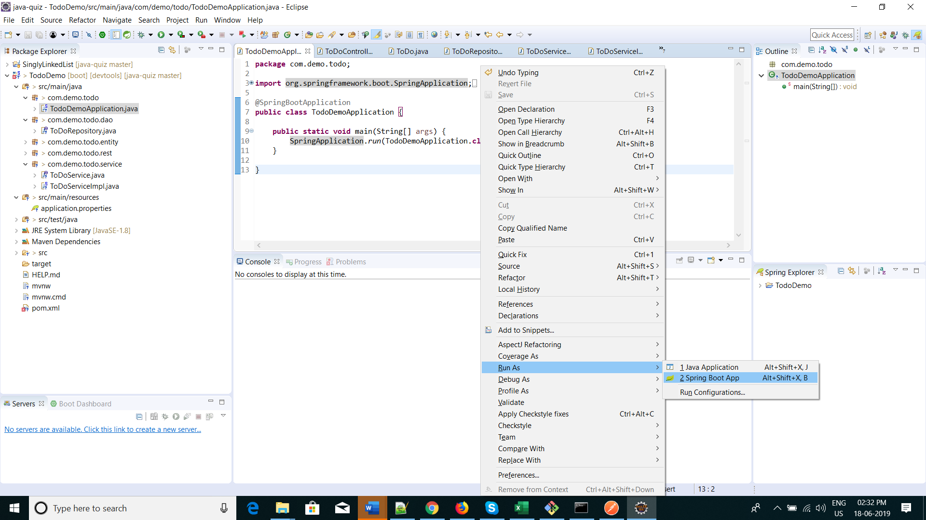

1. How to use ToDo REST API’s ?

* 1. Import ‘java-quiz/demo-todo.postman_collection.json’ in POSTMAN(<https://www.getpostman.com/>)
  2. Add new todo

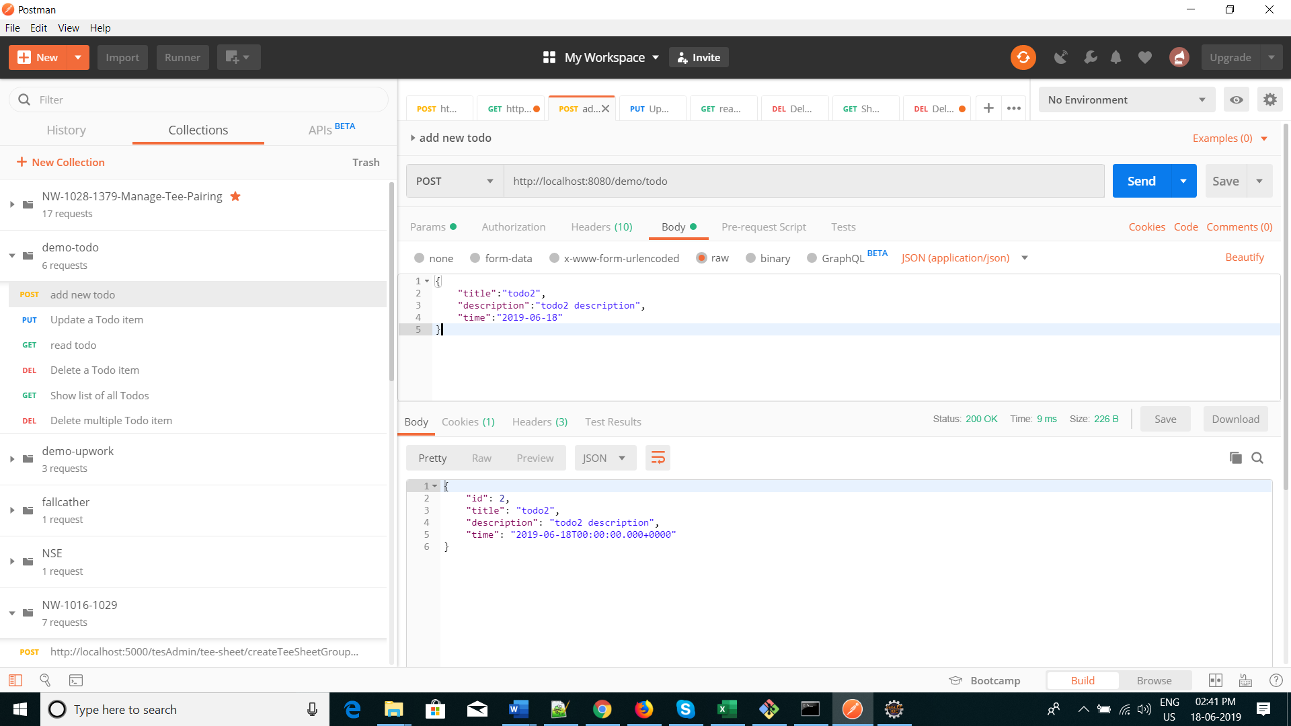

* 1. Update a Todo item

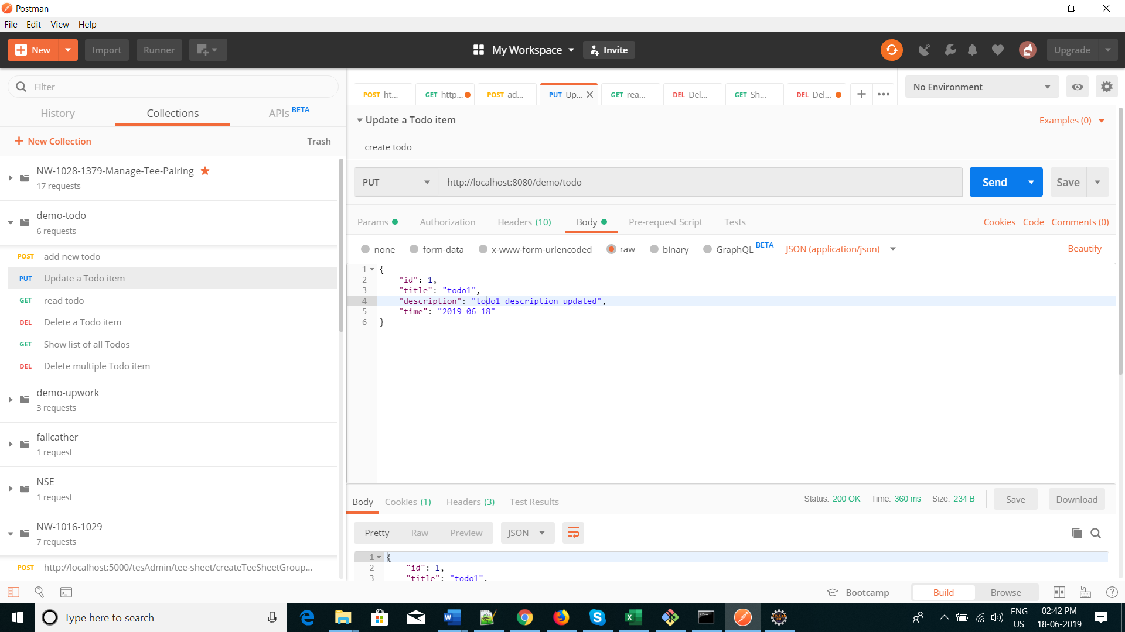

* 1. Delete a Todo item

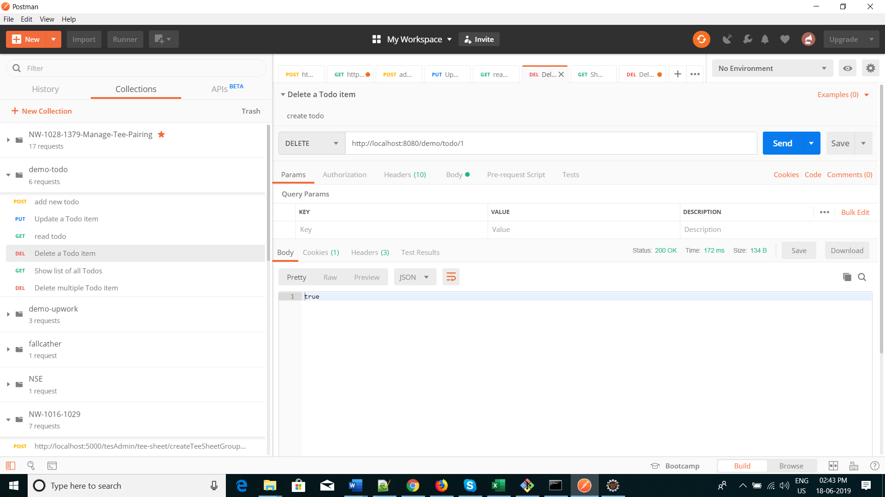

* 1. Show list of all Todos

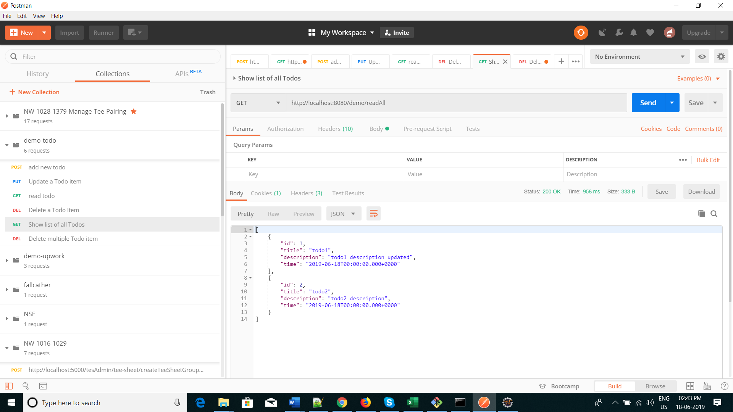

* 1. Delete multiple Todo item

