Exploratory Data Analysis
Smartphone RGB Turmeric Adulteration Screening
Prisha Goswami · Non-Trivial Fellowship · EDA gate report
This report is the EDA gate: before investing in models, we test whether a low-cost smartphone RGB pipeline carries any class signal for turmeric adulteration (pure vs yellow-dye adulterated), and we document how the dataset flows through the pipeline. Three methodology guards apply throughout:
- The test set is never used here. All signal-detection analyses (colour-vs-ratio, PCA) use the train + val split only; peeking at test-set structure to choose a modelling approach would bias the final evaluation.
- Lighting confound handled. Raw mean RGB is dominated by the SVI screen colour, not the powder, so colour-vs-ratio and the class-separation PCA are computed on the ambient subset. Colored-light shots are analysed separately to quantify the diversity they add.
- Masked features. Colour/texture features are measured over the segmented sample region only, so background never contaminates the statistics.

1. Dataset summary
Counts for the active dataset (pure + yellow-dye), split into images and videos, with the number of distinct illumination conditions each ratio was shot under. A starch-adulterated set (81 images / 31 videos across 8 ratios) is held in reserve and excluded here, as are the two quarantined segmentation failures.
ratio | type | images | videos | lightings
pure | pure | 42 | 10 | 6
97.5/2.5 | yellow_dye | 29 | 7 | 6
95/5 | yellow_dye | 20 | 6 | 6
90/10 | yellow_dye | 18 | 6 | 6
85/15 | yellow_dye | 21 | 4 | 6
80/20 | yellow_dye | 21 | 6 | 6
75/25 | yellow_dye | 21 | 6 | 6
70/30 | yellow_dye | 21 | 6 | 6
60/40 | yellow_dye | 21 | 6 | 6
50/50 | yellow_dye | 24 | 6 | 6

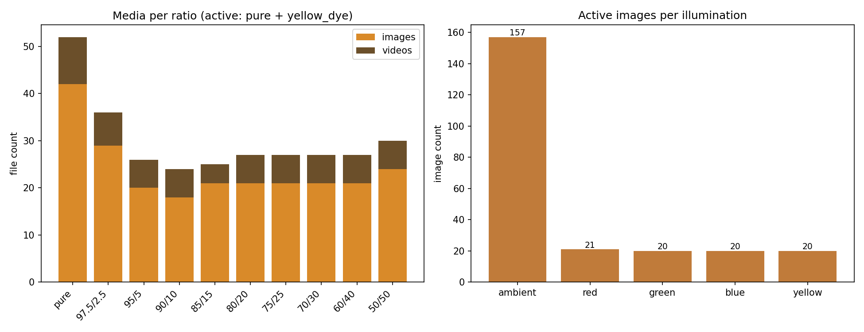
Figure 1. Media per ratio (left) and images per illumination condition (right), active dataset.
Read. All nine yellow-dye ratios are covered from 97.5/2.5 (near-pure) to 50/50, plus pure. Crucially, ambient shots are sparse for several ratios — most adulterated samples were captured under colored SVI light — which shapes the colour analysis in Section 3.

2. Segmentation statistics
Headline result. Automatic, illumination-independent segmentation isolated the turmeric sample in 100% of images (0 fallbacks) across all 238 reviewed images; 99.2% (236/238) remained usable after quarantining two objectively failed ROIs. Median ROI area is 4.12% of the frame.
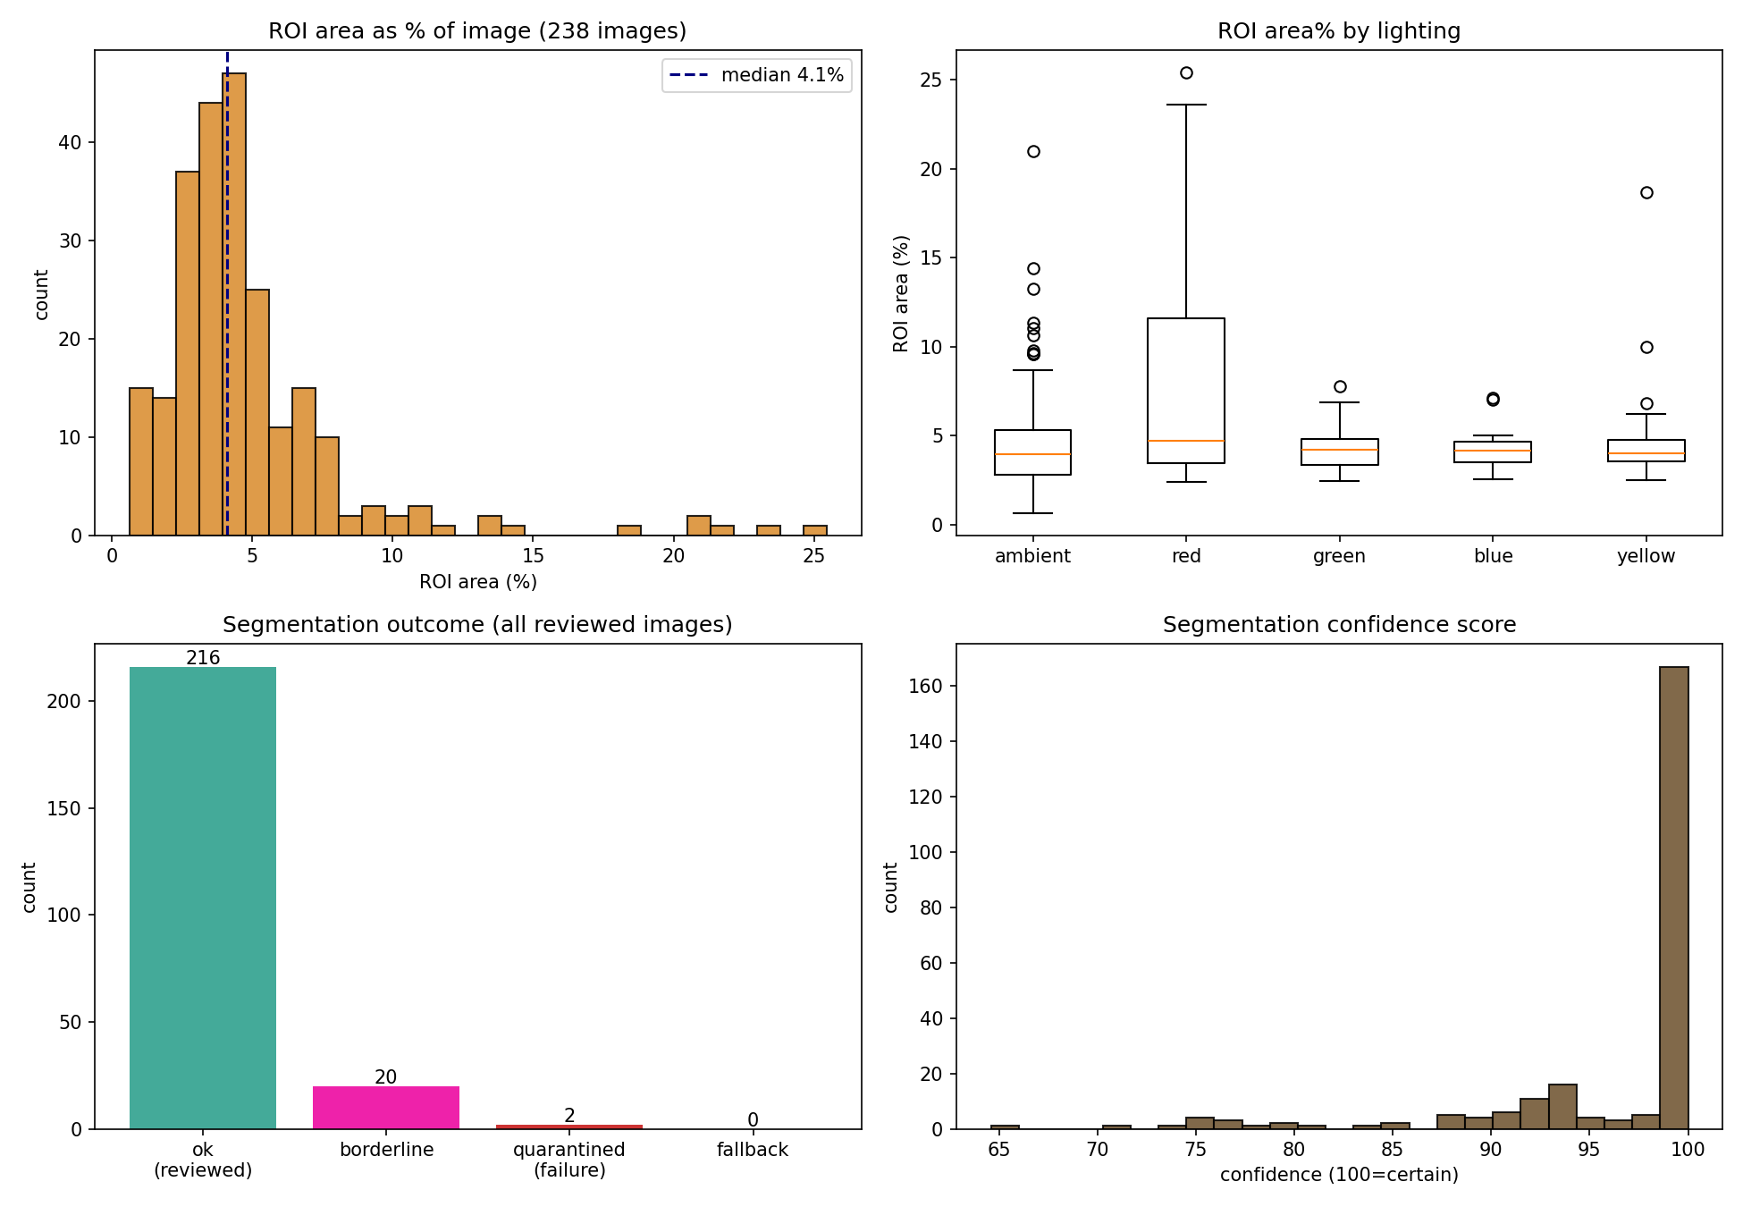
Figure 2. ROI area distribution, ROI area by lighting, segmentation outcomes, and confidence scores.
Read. The 20 borderline-flagged images are dominated by 'tiny mask' cases (small/far mounds) that are conservative but correctly on-target; only two crops were objectively unusable and were quarantined. Segmentation quality is consistent across every lighting condition, including colored light — the property the classical colour-threshold approach lacked.

3. Colour vs adulteration ratio (ambient only)
Does the sample's colour shift with dye fraction? Measured on ambient images so colour reflects the powder rather than the screen. Caveat: ambient n per ratio is uneven and small for several ratios, so intermediate points are noisy.
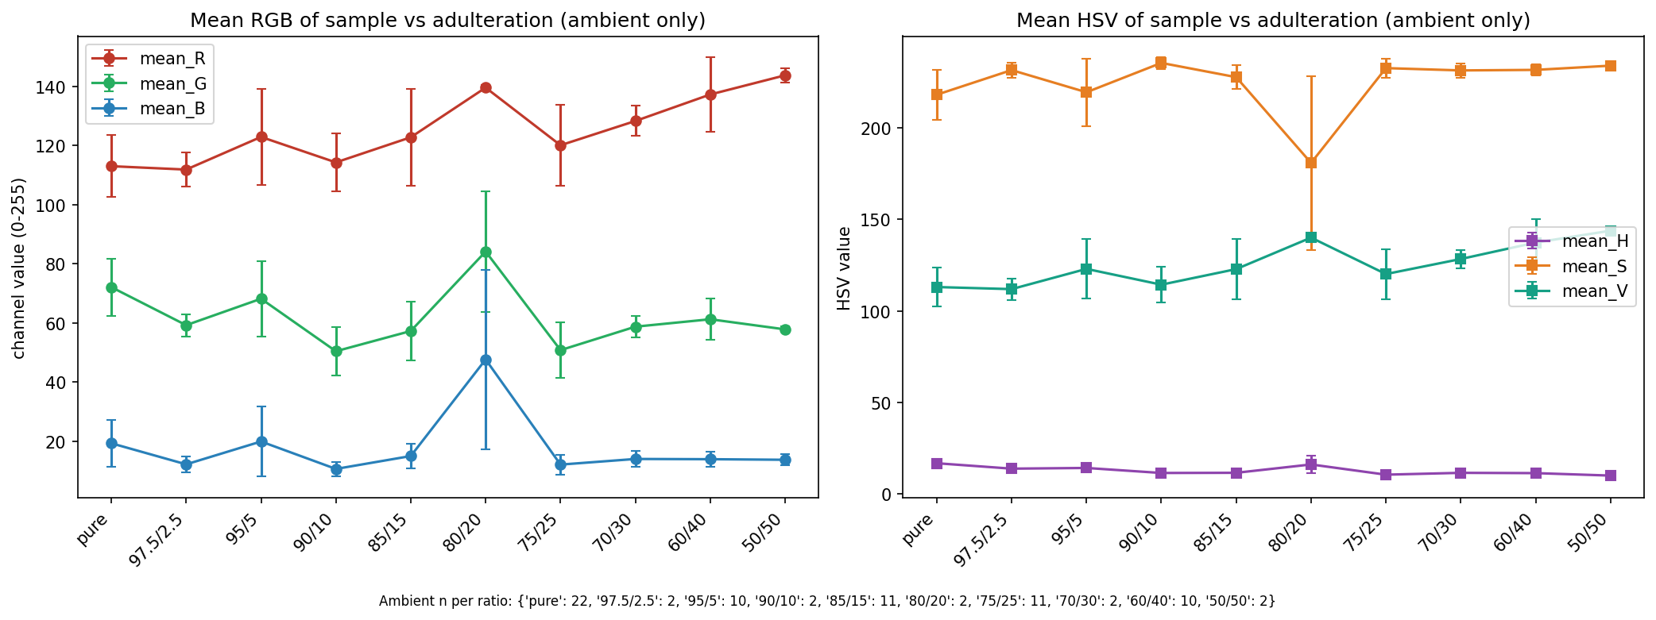
Figure 3. Mean RGB (left) and HSV (right) of the segmented sample vs adulteration ratio, ambient only. Error bars are ±1 SD.
Read. Mean red and saturation trend upward as dye fraction increases (pure R≈113 → 50/50 R≈144; S≈218 → ≈232), consistent with yellow dye brightening and saturating the powder. The trend is suggestive rather than clean — the 80/20 spike is an n=2 artifact — but it points in a physically sensible direction.

4. PCA — the signal gate
If pure and adulterated separate without using labels, that is encouraging. Left: all train+val coloured by lighting. Right: ambient only, coloured by class — the actual gate.
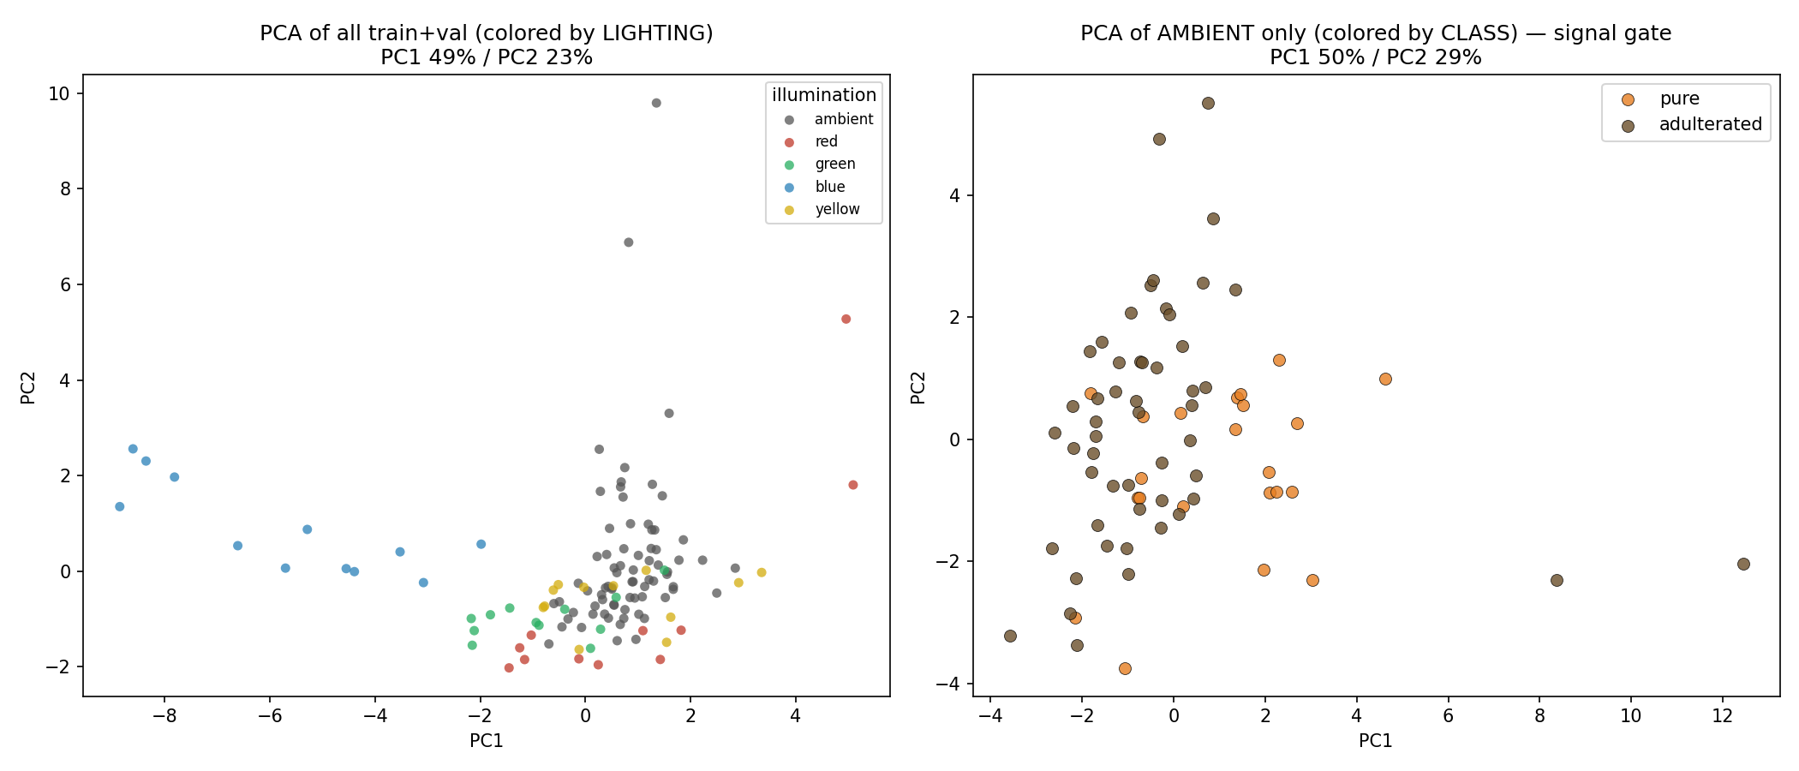
Figure 4. PCA of the 11 masked features. Left coloured by illumination (PC1 49% / PC2 23%); right, ambient only, coloured by class (n=74).
Read. Lighting is the dominant axis of variation overall (blue-lit shots split off entirely) — which is why the robustness study matters. On the ambient subset, pure and adulterated show partial separation (pure concentrates toward positive PC1, adulterated spreads wider) with real overlap. Unsupervised structure is weak-but-present: enough to justify supervised baselines, not so clean that the problem is trivial.

5. Lighting analysis — did colored light add diversity?
The SVI colored-light protocol was intended to expand real-world variability. We compare the feature spread of ambient vs colored shots.
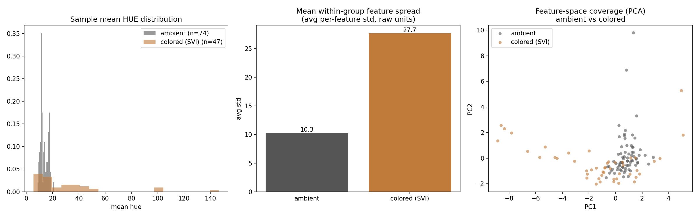
Figure 5. Sample hue distribution, mean per-feature spread, and PCA-space coverage: ambient vs colored (SVI).
Read. Colored-light shots cover about 2.7× the feature spread of ambient shots (avg per-feature SD 27.71 vs 10.28) and occupy regions of PCA space ambient never reaches. The colored-illumination protocol demonstrably expanded diversity — the basis for the degradation/robustness study, and the reason segmentation had to be illumination-independent.

6. Class balance through the pipeline
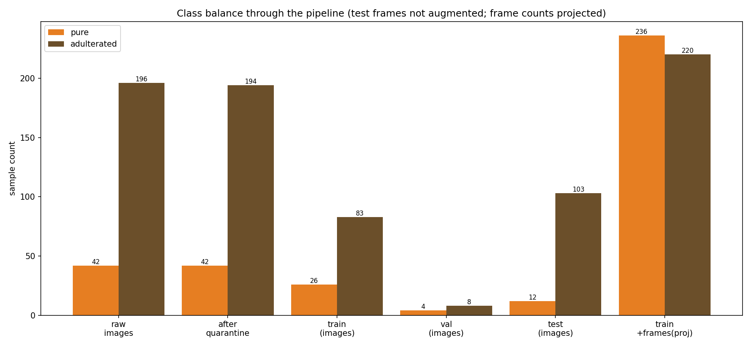
Figure 6. Class counts at each stage. Frame counts for the final stage are projected from video length at the planned sampling rates; test frames are not augmented.
Read. Raw images are imbalanced (42 pure : 194 adulterated after quarantine). The planned asymmetric frame sampling (pure videos every 15 frames, adulterated every 60) lifts the training set to ≈236 pure : 220 adulterated — near balance — without touching val/test. Because video frames are temporally correlated and pure diversity is still only 5 physical piles, class_weight='balanced' and pile-aware reporting remain necessary.

Signal-gate verdict
PASS — proceed to baselines.
- Segmentation is reliable (99.2% usable), so the colour features downstream are trustworthy.
- Colour statistics show a physically sensible trend (red and saturation rise with dye fraction).
- Unsupervised PCA on the ambient subset shows partial pure/adulterated separation — signal is present but not trivial.
- Lighting is the dominant variance axis (≈2.7× spread), confirming the colored-light protocol added the real-world diversity the robustness study depends on.
There is enough class signal to justify the Tier-1→3 models. The honest framing for the report is that the easy signal is entangled with illumination — precisely the phenomenon the degradation study is designed to characterise. No need to stop and re-scope.
All analyses above use train + val only; the test set remains sealed for final reporting.

