Line Search

Wenping Guo

基本原理
线搜索是在搜索方向确定的前提下, 将梯度向量 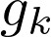 投影到搜索方向 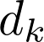 上, 进行一维搜索, 用于确定合理的步长 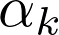.
位置坐标迭代公式:
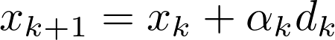
其中 为搜索方向矢量(search direction).
定义如下一维函数:
对应的:
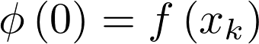, 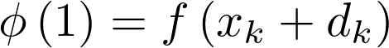
将function gradient 投影到搜索方向矢量 上, 即得到线搜索的梯度, 其它为标量.
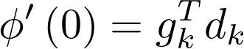
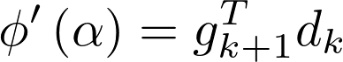
使用二分法, 黄金分割法, 可以确定较为精确的step size, 但计算量较大, 通常也没有必要. 在实际计算中, 应用的较多是近似搜索(inexact line search, approximate line search). line search要控制步长别太大, 同时也不能太小. 一维搜索应返回较优的 , 使得 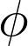 和 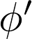 满足线搜索收敛性条件, 比如Wolfe condition等.
- 条件1: The Sufficient Decrease Condition, 也称为Armijo condition 确保能量降低足够大.
或写为:
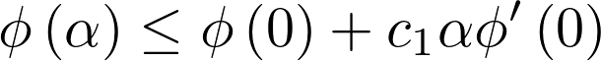
- 条件2: The Curvature Condition, 确保斜率变化足够大.
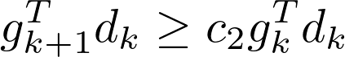
也可写为:
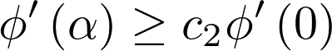
- 条件3: strong wolfe condition on curvature
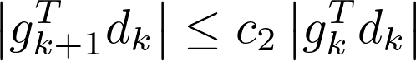
或:
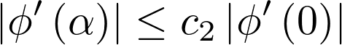
满足条件1和条件2, 称为 Wolfe conditions; 满足条件1和条件3, 称为Strong Wolfe conditions.
其中参数要求:
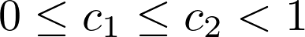
wikipedia中提及, 通常情况下, c1 = 0.1, c2 = 0.4
几种重要的线搜索算法:
- Backtracking: 进退法, 最简单. 仅需要函数值.
- MoreThuente算法, 需要计算梯度, 满足strong wolfe conditions ¹ 原 LBFGS使用的就是这个算法. 以二次和三次插值为基础.
- HagerZhang ²

调用接口
使用builder自定义搜索参数, 使用find函数来优化步长. find函数需要定义回调函数, 用于计算单变量函数 的函数值 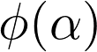 及梯度 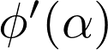 .
Listing 1:
Line search, also called one-dimensional search, refers to an optimization
procedure for univariable functions.

# Available algorithms

* MoreThuente
* BackTracking
* BackTrackingArmijo
* BackTrackingWolfe
* BackTrackingStrongWolfe

# References

* Sun, W.; Yuan, Y. Optimization Theory and Methods: Nonlinear Programming, 1st
ed.; Springer, 2006.
* Nocedal, J.; Wright, S. Numerical Optimization; Springer Science & Business
Media, 2006.
Listing 2:
use line::linesearch;

let mut step = 1.0;
let count = linesearch()
.with_max_iterations(5) // the default is 10
.with_initial_step(1.5) // the default is 1.0
.with_algorithm("BackTracking") // the default is MoreThuente
.find(|a: f64| {
// restore position
x.veccpy(&x_k);
// update position with step along d
x.vecadd(&d_k, a);
// update value and gradient
let phi_a = f(x, &mut gx)?;
// update line search gradient
let dphi = gx.vecdot(d);
// update optimal step size
step = a;
// return the value and the gradient in tuple
(phi_a, dphi)
})?;

References
- Line search - Wikipedia
- Wolfe conditions - Wikipedia
- Backtracking line search - Wikipedia
- climin/linesearch.py at master · BRML/climin
- pysisyphus/BacktrackingOptimizer.py at dev · eljost/pysisyphus
- JuliaNLSolvers/LineSearches.jl: Line search methods for optimization and root-finding

(1) Moré, J. J.; Thuente, D. J. Line Search Algorithms with Guaranteed Sufficient Decrease. ACM Trans. Math. Softw. TOMS 1994, 20 (3), 286–307.
(2) Hager, W. W.; Zhang, H. Algorithm 851: CG_DESCENT, a Conjugate Gradient Method with Guaranteed Descent. ACM Trans. Math. Softw. TOMS 2006, 32 (1), 113–137.

