Image processing | Task No. 3
Task variant: group I
Day and time Tuesday, 10:30  Academic year: 2023/2024 | Full name: Małgorzata Komorowska  Full name: Filip Andrzejewski
Description of the implementation of the basic morphological operations
- Description of the basic morphological operations:
In each function we transform the image to an array. Thanks to this approach, we can easily swap and try different
elements for performing the morphological operations.

The values stored in those arrays is the following:
1 represents black spot
0 represents white spot
2 represents inactive points, that should be skipped and not considered in the function performing the operation.

- Dilation:
The function iterates through each pixel of the input image, and for each pixel, it examines its neighborhood in a given structural element. If any white pixel (pixel value of 1) is found in the neighborhood, the corresponding pixel in the result image is set to white (1).
We repeat the process for all pixels in the image.
This is often done to highlight or emphasize certain features in the image.
The mathematical representation of the dilation:
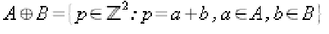

- Erosion:
Erosion is an operations, which resulting in shrinking or thinning the boundaries of the foreground object in a binary image. It iterates through each pixel in the input image, and for each pixel, it examines its neighborhood in a given structural element.. If all the pixels in the neighborhood are white (pixel value of 1), the corresponding pixel in the result image is set to white; otherwise, it is set to black (0).
The mathematical representation of the erosion:

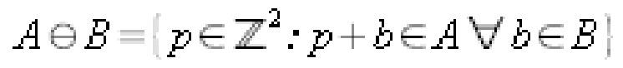

- Opening:
The opening operation is calculated by first dilation and then erosion.
The mathematical representation of the opening:

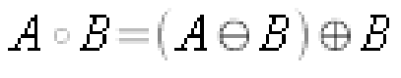

- Closing:
The closing operation first applies the erosion function and then the dilation function to the input image.
The mathematical representation of the closing:
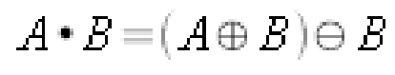

- Hit-or-miss transformation:
This transformation is used for detecting specific patterns in binary images. It works similar as previous operations, for each pixel we set the structuring element so that the origin of the structuring element coincides with the input pixel coordinates, and then compare the structuring element with the image pixels.
We have chosen 4 structuring elements to perform the HMT:
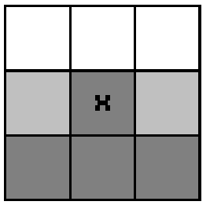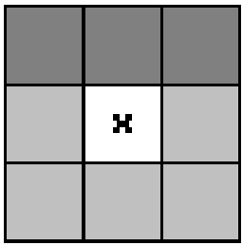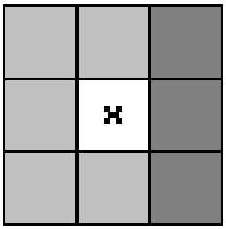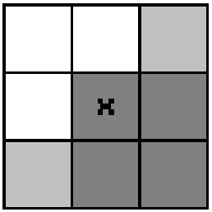
Where the white color represents the white pixels, the dark grey color represents black pixels, the light grey color represents inactive pixels, which means that we don’t use them in the operation.
In the report we will analyze the obtained results after applying these structure elements on the binary image.
The mathematical representation of the HMT:
Where:
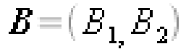

In this section the description of the implementation of the basic morphological operations: dylation, erosion, opening, closing and HMT should be presented. Special attention should be paid to the description of optimization of these methods (they may be implemented more efficiently than it appears from their definitions, provided that their operation is thoroughly understood).
Analysis of the results of the basic morphological operations
- Dilation
Original image/ structuring element | 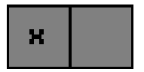 |  | 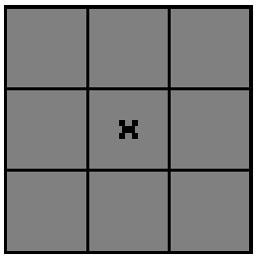 | 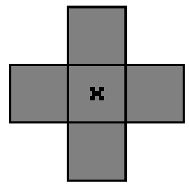
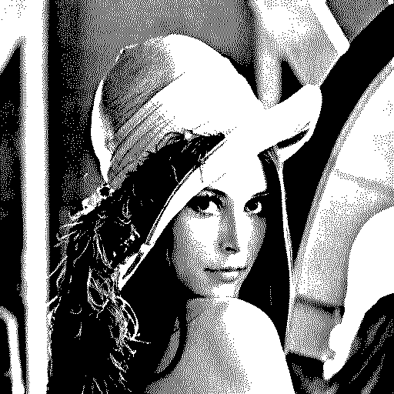 | 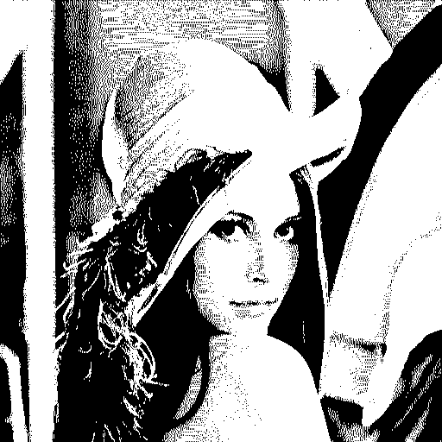 | 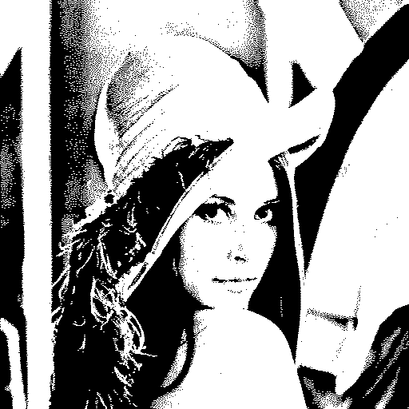 | 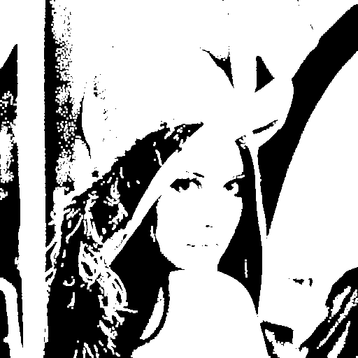 | 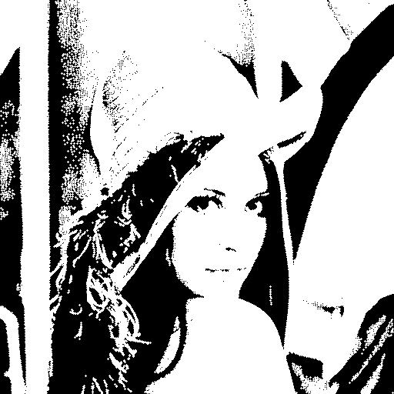
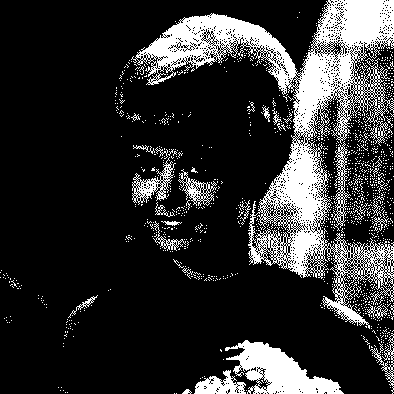 | 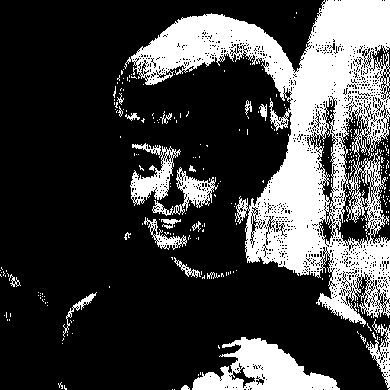 | 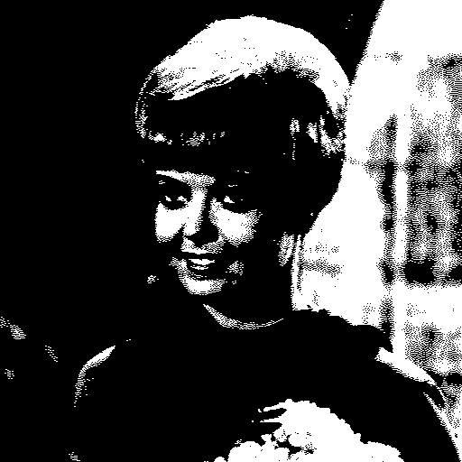 | 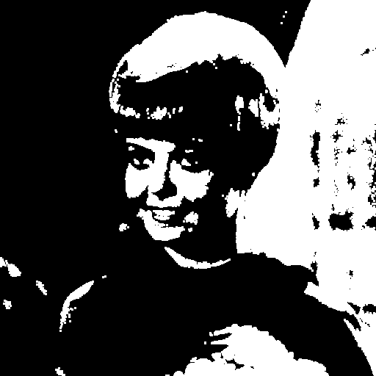 | 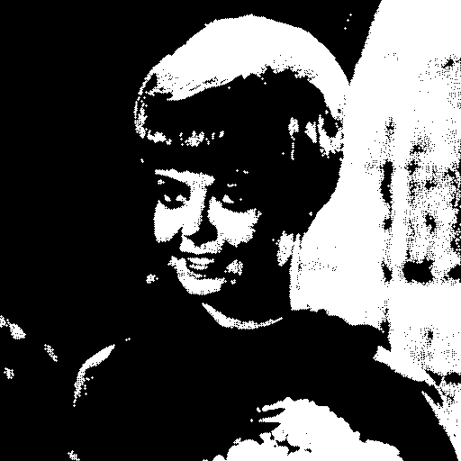
The result is slightly different in case each of the structuring elements, for example the third is more aggressive, it remove more details from the image.

- Erosion
Original image/ structuring element
 | 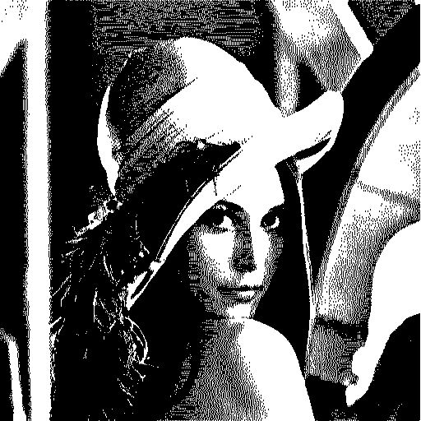 | 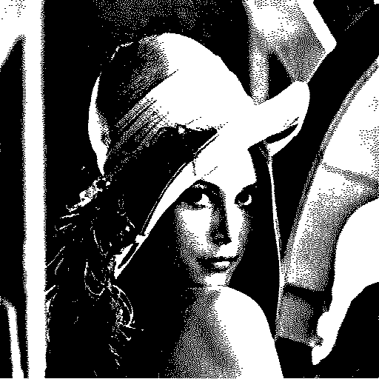 | 
 | 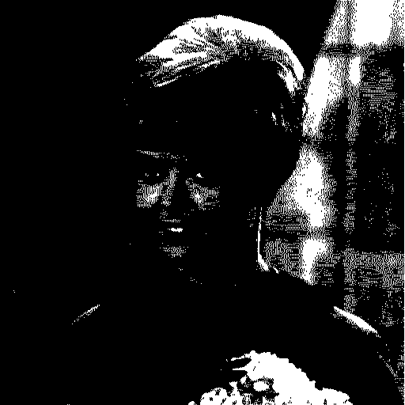 | 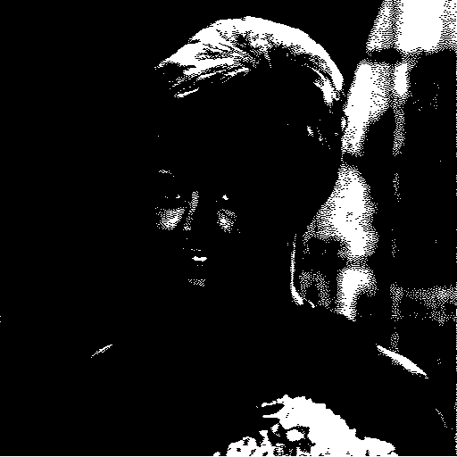 | 
Erosion is often used to remove small details from highlights of the image. We can see that each structuring element produces slightly different results. First and second structuring elements produce more delicate effects, removing only the smallest highlights of the image. On the other hand, the third and fourth create strong distinction between foreground and background of the image. As we can see in the second example when applying the third and fourth mask, the image is hardly visible, beacuease of the number of black pixels in the image.

- Opening:
The opening operation works by first eroding, later dilating the image using a structural mask. The results are easier to analyze, providing more information on the overall shape of the image. This operation is good for closing fills in small holes and gaps without changing the shape and size of bigger objects in the image. As in the erosion and dilation we have lost some information, especially applying the third and the fourth structuring elements.
Original image/ structuring element
 | 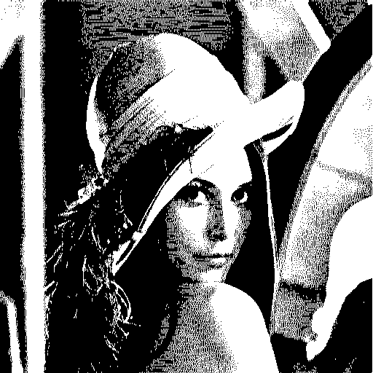 | 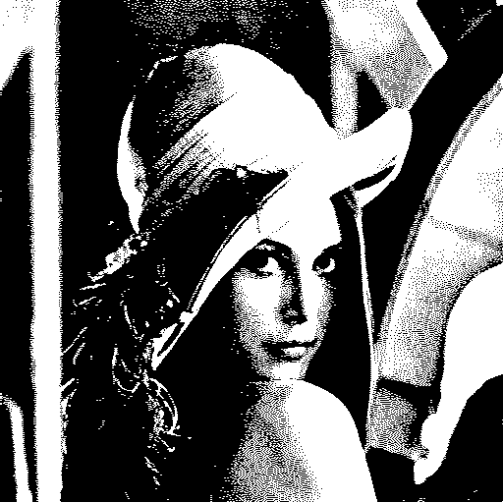 |  | 
 | 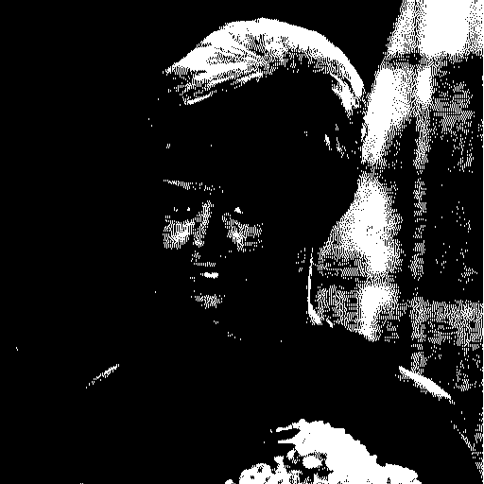 | 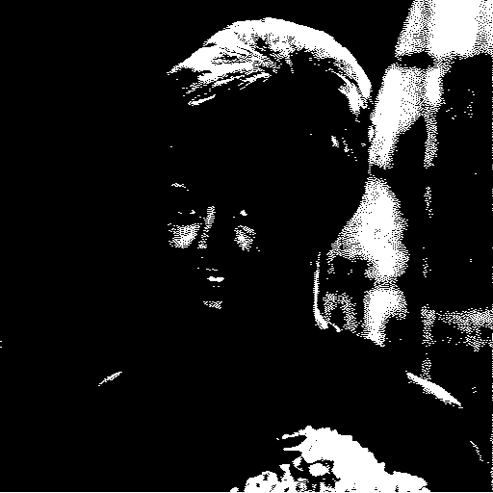 |  | 

- Closing:
Original image/ structuring element
 |  | 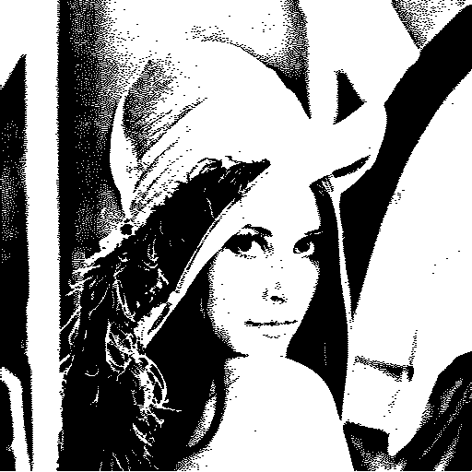 | 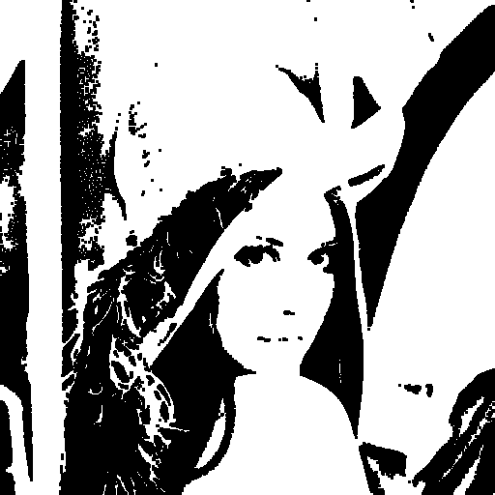 | 
 | 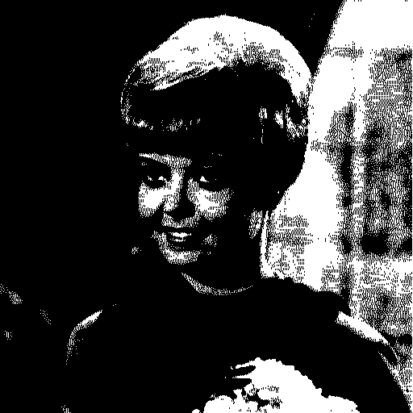 | 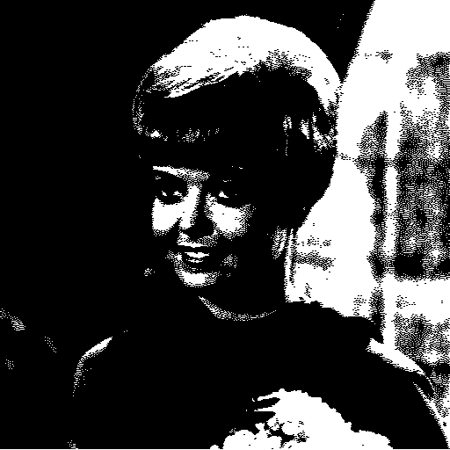 | 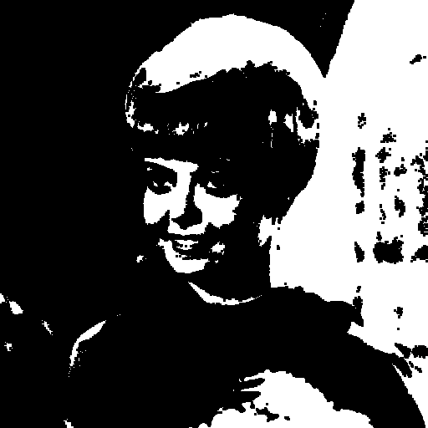 | 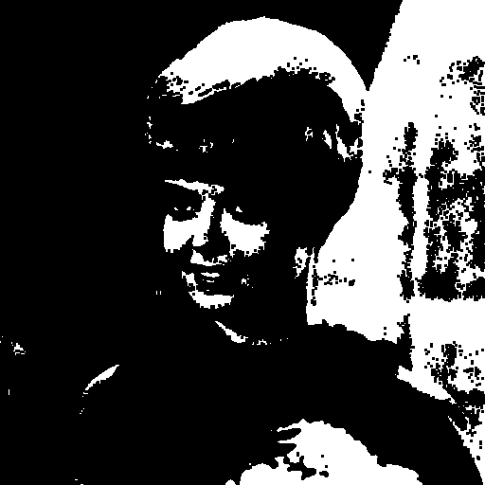
The closing operation works by first dilating, later erosing. The different order of transformation in closing and opening operations resulted in a much different results. Closing operation removes small holes and breaks in the foreground and smoothing out the edges of objects. It can be useful for removing small objects and lines from an image without changing the shape and size of bigger objects in the image.

- Hit-or-miss transformation
Original image/ structuring element
 |  |  | 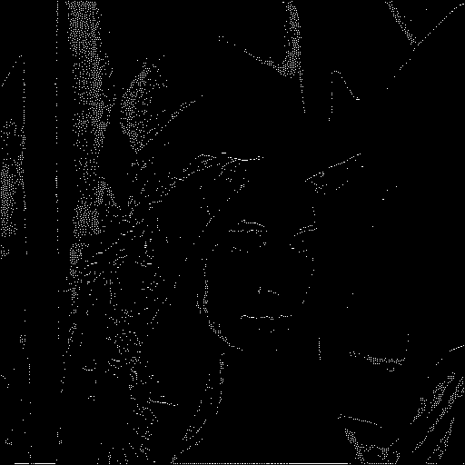 | 
 |  | 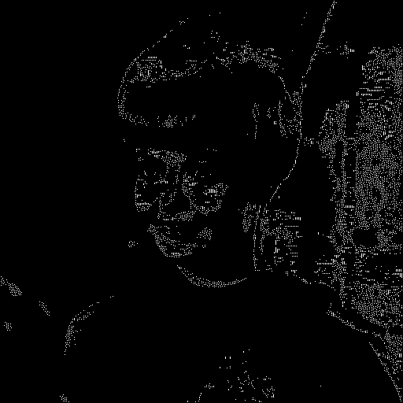 |  | 
This transformation is used to identify and extract specific features or objects of an object. It detects a given pattern in a binary image. As we can see, selected structuring elements generate completely different results. This shows where the pattern has been matched in the picture.

Here, the analysis of the results of the basic morphological operations application: dylation, erosion, opening, closing and HMT should be included. It should be observed how they behave for images of different types and how the choice of the structuring element influences it. Please, include all conclusions!
Description of the implementation of the assigned variant of morphological algorithm
Our assigned variant of the morphological algorithm is M3, the mathematical formula:
Where p is a point chosen by the user, B is the structuring element chosen by the user, A is the input image
Dilation with actual iterating area and the given structural element:
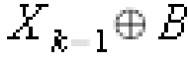
Intersection of the calculated dilation and the input image:
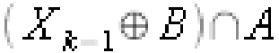

The description of the implementation of the assigned variant of morphological algorithm should be placed here. Special attention should be paid to the description of the data structures (memory usage) and the optimization methods applied (processing time)!
Analysis of the results of the assigned variant of morphological algorithm
In this place, the analysis of the results of the assigned variant of morphological algorithm should be included. The analysis should be based on experiments with images of different types. It is also valuable to try to modify the method itself (e.g. via changing the structuring elements). Please, include all conclusions!
Description of the implementation of the assigned segmentation variant
The assigned segmentation variant is region growing. It is a technique for segmenting an image into regions or segments based on the similarity of pixel intensities within a defined neighborhood. The idea behind region growing is to start with a seed point, or a set of seed points, in the image and then expand the region based on the pixel intensities of the surrounding pixels. The region is expanded until it meets a predetermined criterion, such as a certain intensity threshold or the presence of a boundary.
We implemented two functions for this variant.
First one is region_growing_static, in this function we take the value of the pixel chosen by the user and then we calculate the minimum and maximum value based on the threshold specified by the user.
The function initializes a region with the chosen pixel and iteratively adds new pixels to the region based on their intensity similarity to the initially chosen pixel. The region is expanded by examining the neighborhood of each pixel in the current region and adding pixels that satisfy the intensity homogeneity criterion. The process continues until no new pixels can be added to the region.
Second one is region_growing_contagious, in this function we don’t calculate the maximum and minimum value at the beginning but we calculate them new each time for each new pixel. Consequently, each pixel in its neighborhood will be compared to the min and max values calculated from the pixel in the middle of that neighborhood.
The whole operation is done in a while loop.
Here, the description of the implementation of the assigned segmentation variant should be placed. The attention should be paid to the description of the data structures, parameter specification, the possibility of applying new homogeneity criteria, etc. Naturally, all the possible optimization factors should be also described.
Analysis of the results of the assigned segmentation variant
The analysis of the results of the assigned segmentation variant should be presented here. At least 3 different homogeneity criteria should be included. The experiments and the presentation of their results must be based on images of different types. Please, include all conclusions!
Description of other changes which took place in the application
In this place, the description of any other changes which have taken place in the application since the last report should be presented. Please, boast about everything :-)
Teacher's remarks

This is a section for teacher's remarks for the laboratory group (please leave some free place).

