Image processing | Task No. 2
Task variant: group 1
Day and time: Tuesday, 10h30  Academic year: 2023/2024 | Full name: Małgorzata Komorowska  Full name: Filip Andrzejewski
Description of the implementation of the histogram-based image enhancement method
The method of histogram-based image enhancement selected for this report was histogram uniform final probability density function, to improve the quality of the original image. It is described by the following equation:
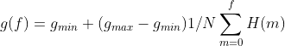
Where:
g_{min} - output minimum brightness in the output image (specified by the user)
g_{max} - output maximum brightness in the output image (specified by the user)
N- amount of the pixels in the image (width * height)
H(m) - histogram value for a level m
The histograms were obtained using a separate method, which iterated over each pixel of an image and counted how many times
each brightness level occurred. Obtained histograms were created for each channel of the image, and the enhancement equation above was applied to each level of the histogram, calculating the new brightness.

Originate image | Output image
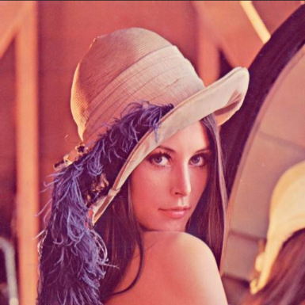 | 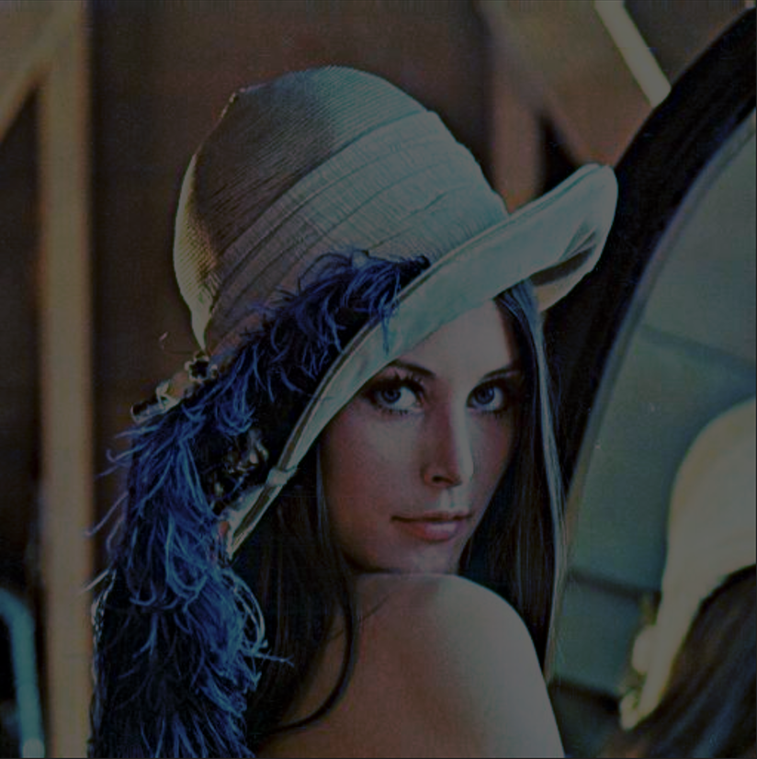
Result of the filter for parameters g_{min} = 0 and g_{max} = 100.

The description of the implementation of the histogram-based image enhancement method should be placed here. Special attention should be paid to parameters specification (if there are any), to exceptions and non-typical situations handling and to the issues resulting from color images processing (note that independent processing of the separate channels may not yield best results).
Image analysis on the basis of the histogram
Analysis:
• 24- bit image:
24-bit original image
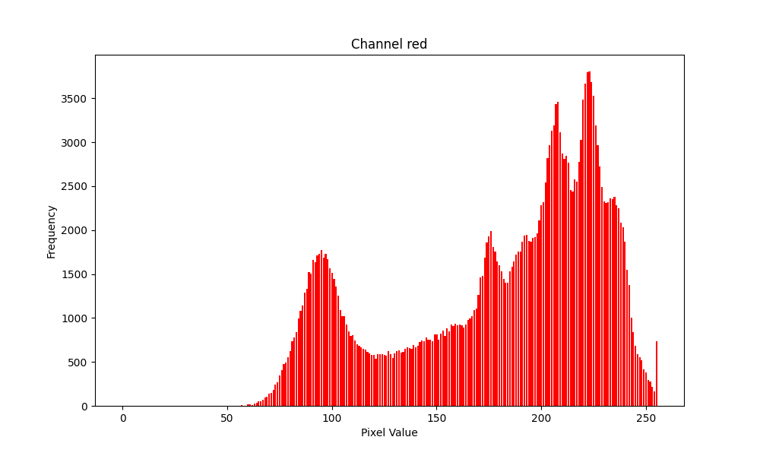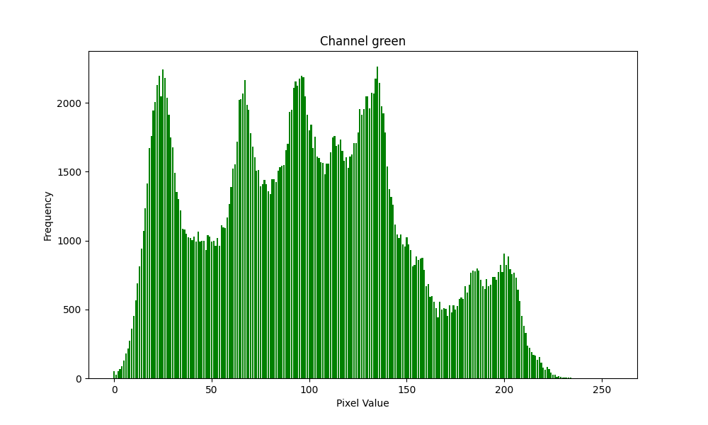
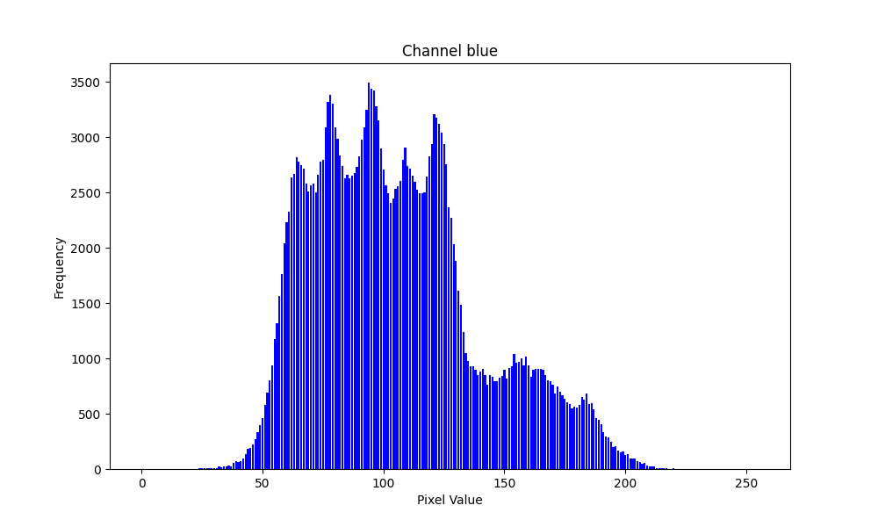
Obtained histograms from red, green, blue channels.

 | Mean | Variance | Standard deviation | Variation coefficient I | Asymmetry coefficient | Flattening coefficient | Variation  coefficient II | Information source  entropy
Red | 180.15 | 2428.88 | 49.28 | 0.27 | -0.69 | -0.79 | 0.008 | 7.27
Green | 99.04 | 2747.88 | 52.42 | 0.53 | 0.22 | -0.74 | 0.006 | 7.59
Blue | 105.45 | 1171.86 | 34.23 | 0.32 | 0.62 | -0.17 | 0.009 | 7.01
Table of image characteristics for 24-bit image

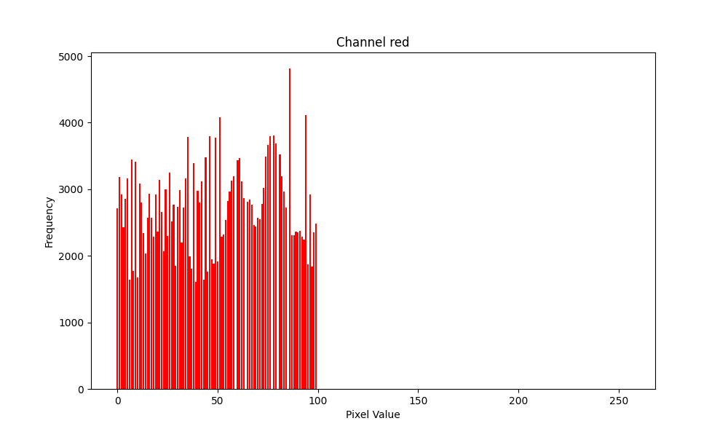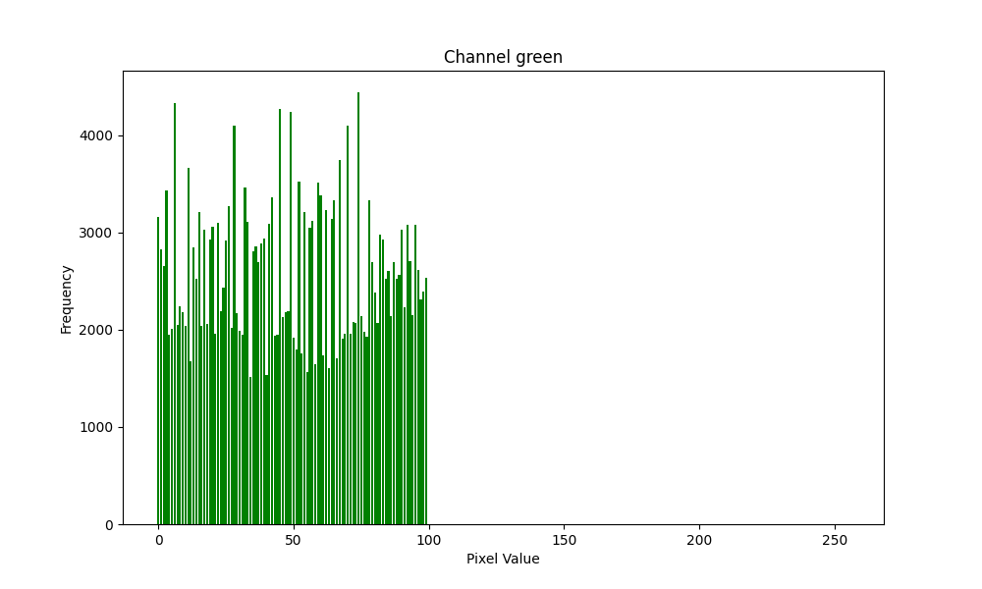
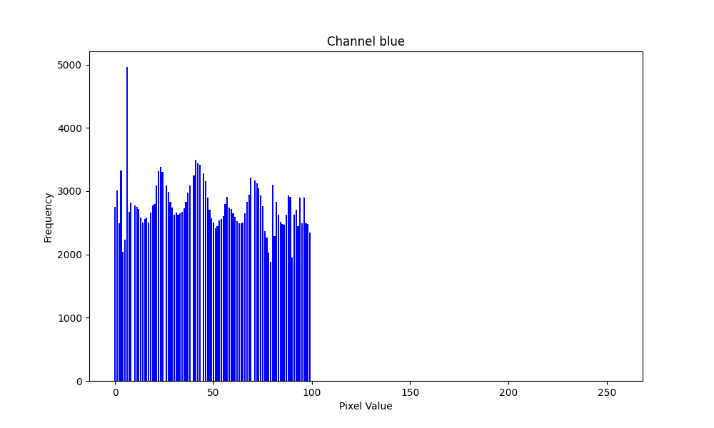

 | Mean | Variance | Standard deviation | Variation coefficient I | Asymmetry coefficient | Flattening coefficient | Variation  coefficient II | Information source  entropy
Red | 49.13 | 827.02 | 28.76 | 0.59 | 0.002 | -1.19 | 0.01 | 6.53
Green | 49.22 | 834.18 | 28.88 | 0.59 | 0.005 | -1.19 | 0.01 | 6.59
Blue | 49.01 | 833.99 | 28.88 | 0.59 | 0.02 | -1.19 | 0.01 | 6.56

• 8-bit image :
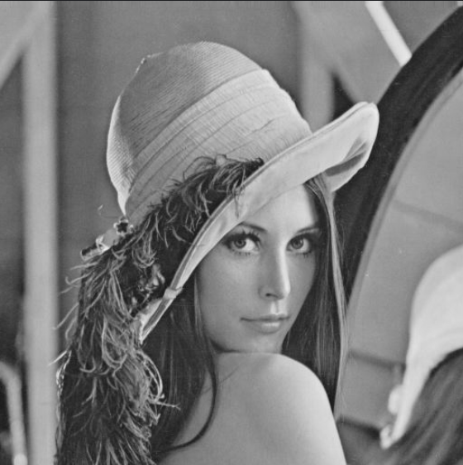
Original image
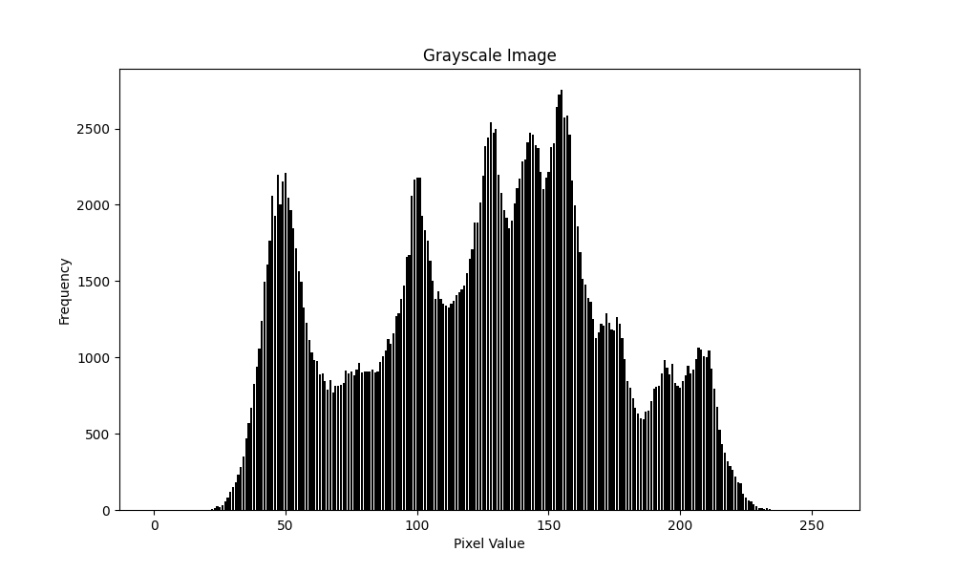
Obtained histogram
Mean | Variance | Standard deviation | Variation coefficient I | Asymmetry coefficient | Flattening coefficient | Variation  coefficient II | Information source  entropy
123.62 | 2298.56 | 47.94 | 0.39 | -0.09 | -3 | 0.006 | 7.45

The analysis of the correlation between the type of the image, its histogram shape and features computed from the histogram should be placed here. Also in this section, the analysis of the results of the image enhancement method should be included along with the presentation of its effects on the histogram shape and color distribution. Finally, conclusions concerning the types of images most suitable in the case of this particular method application should be formulated.
Description of the linear filter implementation (general formulation)
The description of the linear filter implementation in a general formulation, i.e. for arbitrary filter mask, should be placed in this section. For the masks specified in the assigned task variant describe and give reasons and solutions for the effects encountered at the image borders and in the case of exceeding the range of possible pixel values.
Description of the linear filter implementation (with optimization)
The description of the optimized linear filter implementation, for one mask chosen from those assigned in the task variant should be included here. It should be indicated how the optimization was obtained (e.g. via reduction of the number of arithmetic operations) and the results of comparisons of the processing times w. r. t. the non-optimized version should be presented.
Analysis of the filtering results (linear filter)
In this section the analysis of the results of the linear filter application should be placed for all of the assigned masks, along with observations about: the way the filter modifies an image, what can it be applied for, what influences its operation, etc.
Description of the non-linear filter implementation

Here, the description of the non-linear filter implementation should be placed, with special attention paid to methods of its potential optimization and solving some possible unusual situations.
Analysis of the filtering results (non-linear filter)
In this section the analysis of the results of the non-linear filter application should be placed for different image types, along with observations about: the way the filter modifies an image, what can it be applied for, what influences its operation, etc.
Description of other changes which took place in the application
In this place, the description of any other changes which have taken place in the application since the last report should be presented. Please, boast about everything :-)
Teacher's remarks

This is a section for teacher's remarks for the laboratory group (please leave some free place).

