实验1 图像分类

学号 202018526 姓名 高树林 专业 人工智能
【实验目的】
1、掌握svm模型损失函数求取方法
2、掌握绘制svm模型损失函数变化图像
3、掌握利用svm模型进行训练集和测试集上准确率预测
【实验步骤】
步骤1：数据预处理。先给每一张图像打好标签，并用matplotlib工具包做可视化。其代码具体如下所示。
- # Visualize some examples from the dataset.
- # We show a few examples of training images from each class.
- classes = ['plane', 'car', 'bird', 'cat', 'deer', 'dog', 'frog', 'horse', 'ship', 'truck']
- num_classes = len(classes)
- samples_per_class = 7
- for y, cls in enumerate(classes):
- idxs = np.flatnonzero(y_train == y)
- idxs = np.random.choice(idxs, samples_per_class, replace=False)
- for i, idx in enumerate(idxs):
- plt_idx = i * num_classes + y + 1
- plt.subplot(samples_per_class, num_classes, plt_idx)
- plt.imshow(X_train[idx].astype('uint8'))
- plt.axis('off')
- if i == 0:
- plt.title(cls)
- plt.show()
在上述代码中，首先定义了类别列表——classes，其中有10个元素，分别对应数据集中的10个不同类型的图像。之后用enumerate函数使该列表成为一个可迭代对象，其作用就是用于取下标的操作，方便后来对图像位置的定义。之后分别在每一类中取7张图像进行展示。
步骤2：分割数据集。数据预处理之后就需要分割数据集，本实验分为训练集、测试集以及验证集三个数据集。训练集用于训练模型，其数据占比一般是最多的；测试集用于测试训练出的模型的泛化能力，通常数据体量较小；验证集用于调整参数，通常数据体量较小；在一般情况下，测试集和验证集一般取相同大小。其具体代码如下所示。
- # Split the data into train, val, and test sets. In addition we will
- # create a small development set as a subset of the training data;
- # we can use this for development so our code runs faster.
- num_training = 49000
- num_validation = 1000
- num_test = 1000
- num_dev = 500

- # Our validation set will be num_validation points from the original
- # training set.
- mask = range(num_training, num_training + num_validation)
- X_val = X_train[mask]
- y_val = y_train[mask]

- # Our training set will be the first num_train points from the original
- # training set.
- mask = range(num_training)
- X_train = X_train[mask]
- y_train = y_train[mask]

- # We will also make a development set, which is a small subset of
- # the training set.
- mask = np.random.choice(num_training, num_dev, replace=False)
- X_dev = X_train[mask]
- y_dev = y_train[mask]

- # We use the first num_test points of the original test set as our
- # test set.
- mask = range(num_test)
- X_test = X_test[mask]
- y_test = y_test[mask]

- print('Train data shape: ', X_train.shape)
- print('Train labels shape: ', y_train.shape)
- print('Validation data shape: ', X_val.shape)
- print('Validation labels shape: ', y_val.shape)
- print('Test data shape: ', X_test.shape)
- print('Test labels shape: ', y_test.shape)
在上述代码中，首先定义了训练集数据量为49000条，验证集和测试集分别为1000条，符合正常的机器学习数据分配特征。在本实验中。取训练集中49000到50000之间的1000条数据作为验证集的数据，其标签页一一对应；取训练集中0到49000之间的数据为训练集的数据，其标签也一一对应；取测试集中前1000条数据作为测试集的数据。至此，数据集分割结束。最后打印各类数据集的大小，看分割数据集的结果是否出现错误。
步骤3：图像数据化处理。在步骤2中得到的数据分别拉伸，这里用到的是reshape函数，就是将原来32*32*3这个三维数据拉伸至一维数据，也可以用fatten方法实现该功能。这样做的好处是便于计算机识别和计算。其代码如下所示。
- # Preprocessing: reshape the image data into rows
- X_train = np.reshape(X_train, (X_train.shape[0], -1))
- X_val = np.reshape(X_val, (X_val.shape[0], -1))
- X_test = np.reshape(X_test, (X_test.shape[0], -1))
- X_dev = np.reshape(X_dev, (X_dev.shape[0], -1))

- # As a sanity check, print out the shapes of the data
- print('Training data shape: ', X_train.shape)
- print('Validation data shape: ', X_val.shape)
- print('Test data shape: ', X_test.shape)
- print('dev data shape: ', X_dev.shape)
在上述代码中，用numpy库中的reshape函数将图像数据拉伸至一维，之后再用shape方法检验是否拉伸成功。如果拉伸成功，那么图像的大小应该是32*32*3=3072。
步骤4：给每一类的图像取平均值，之后用每个图像的像素值减去对应的像素平均值，在这之后在每个图像的末尾加上一个偏差列，使其变成3073维的向量。其具体代码如下所示。
- # Preprocessing: subtract the mean image
- # first: compute the image mean based on the training data
- mean_image = np.mean(X_train, axis=0)
- print(mean_image[:10]) # print a few of the elements
- plt.figure(figsize=(4,4))
- plt.imshow(mean_image.reshape((32,32,3)).astype('uint8')) # visualize the mean image
- plt.show()

- # second: subtract the mean image from train and test data
- X_train -= mean_image
- X_val -= mean_image
- X_test -= mean_image
- X_dev -= mean_image

- # third: append the bias dimension of ones (i.e. bias trick) so that our SVM
- # only has to worry about optimizing a single weight matrix W.
- X_train = np.hstack([X_train, np.ones((X_train.shape[0], 1))])
- X_val = np.hstack([X_val, np.ones((X_val.shape[0], 1))])
- X_test = np.hstack([X_test, np.ones((X_test.shape[0], 1))])
- X_dev = np.hstack([X_dev, np.ones((X_dev.shape[0], 1))])

- print(X_train.shape, X_val.shape, X_test.shape, X_dev.shape)
步骤5：处理完数据之后，接着就要生成小数的随机 SVM 权重矩阵，并且重新计算梯度、进行梯度检查、然后计算损失并实现梯度。这些步骤的代码如下所示。
生成小数的随机 SVM 权重矩阵代码
- # Evaluate the naive implementation of the loss we provided for you:
- from cs231n.classifiers.linear_svm import svm_loss_naive
- import time

- # generate a random SVM weight matrix of small numbers
- W = np.random.randn(3073, 10) * 0.0001

- loss, grad = svm_loss_naive(W, X_dev, y_dev, 0.000005)
- print('loss: %f' % (loss, ))
重新计算梯度、进行梯度检查代码
- # Once you've implemented the gradient, recompute it with the code below
- # and gradient check it with the function we provided for you

- # Compute the loss and its gradient at W.
- loss, grad = svm_loss_naive(W, X_dev, y_dev, 0.0)

- # Numerically compute the gradient along several randomly chosen dimensions, and
- # compare them with your analytically computed gradient. The numbers should match
- # almost exactly along all dimensions.
- from cs231n.gradient_check import grad_check_sparse
- f = lambda w: svm_loss_naive(w, X_dev, y_dev, 0.0)[0]
- grad_numerical = grad_check_sparse(f, W, grad)

- # do the gradient check once again with regularization turned on
- # you didn't forget the regularization gradient did you?
- loss, grad = svm_loss_naive(W, X_dev, y_dev, 5e1)
- f = lambda w: svm_loss_naive(w, X_dev, y_dev, 5e1)[0]
- grad_numerical = grad_check_sparse(f, W, grad)
计算损失值代码
- # Next implement the function svm_loss_vectorized; for now only compute the loss;
- # we will implement the gradient in a moment.
- tic = time.time()
- loss_naive, grad_naive = svm_loss_naive(W, X_dev, y_dev, 0.000005)
- toc = time.time()
- print('Naive loss: %e computed in %fs' % (loss_naive, toc - tic))

- from cs231n.classifiers.linear_svm import svm_loss_vectorized
- tic = time.time()
- loss_vectorized, _ = svm_loss_vectorized(W, X_dev, y_dev, 0.000005)
- toc = time.time()
- print('Vectorized loss: %e computed in %fs' % (loss_vectorized, toc - tic))

- # The losses should match but your vectorized implementation should be much faster.
- print('difference: %f' % (loss_naive - loss_vectorized))
实现梯度代码代码
- # Complete the implementation of svm_loss_vectorized, and compute the gradient
- # of the loss function in a vectorized way.

- # The naive implementation and the vectorized implementation should match, but
- # the vectorized version should still be much faster.
- tic = time.time()
- _, grad_naive = svm_loss_naive(W, X_dev, y_dev, 0.000005)
- toc = time.time()
- print('Naive loss and gradient: computed in %fs' % (toc - tic))

- tic = time.time()
- _, grad_vectorized = svm_loss_vectorized(W, X_dev, y_dev, 0.000005)
- toc = time.time()
- print('Vectorized loss and gradient: computed in %fs' % (toc - tic))

- # The loss is a single number, so it is easy to compare the values computed
- # by the two implementations. The gradient on the other hand is a matrix, so
- # we use the Frobenius norm to compare them.
- difference = np.linalg.norm(grad_naive - grad_vectorized, ord='fro')
- print('difference: %f' % difference)
步骤6：训练模型。在本实验中，我们调用了cs231n.classifiers中的LinearSVM模型，用这个模型来加载参数。训练模型的代码如下所示。
- # In the file linear_classifier.py, implement SGD in the function
- # LinearClassifier.train() and then run it with the code below.
- from cs231n.classifiers import LinearSVM
- svm = LinearSVM()
- tic = time.time()
- loss_hist = svm.train(X_train, y_train, learning_rate=1e-7, reg=2.5e4,
- num_iters=1500, verbose=True)
- toc = time.time()
- print('That took %fs' % (toc - tic))
在上述代码中，首先定义了线性SVM分类器，之后修改线性SVM分类器的参数，如学习率为10^-7，reg=2.5*10^4,num_items为1500，verbose为True。
步骤7：训练过程损失值可视化的代码如下所示。
- # A useful debugging strategy is to plot the loss as a function of
- # iteration number:
- plt.plot(loss_hist)
- plt.xlabel('Iteration number')
- plt.ylabel('Loss value')
- plt.show(
在上述代码中，首先把loss值的折线图通过plt.plot函数画出来，之后再在图像上标记好横纵坐标的标记，之后显示出图像。
步骤8：得出模型以及模型训练时的loss曲线，从曲线可以看出，当前的参数并不是最佳参数，因此要利用验证集来调参。利用交叉验证调整超参数的代码如下所示。
- # Use the validation set to tune hyperparameters (regularization strength and
- # learning rate). You should experiment with different ranges for the learning
- # rates and regularization strengths; if you are careful you should be able to
- # get a classification accuracy of about 0.4 on the validation set.
- learning_rates = [1e-7, 5e-5]
- regularization_strengths = [5e4, 1e5]

- # results is dictionary mapping tuples of the form
- # (learning_rate, regularization_strength) to tuples of the form
- # (training_accuracy, validation_accuracy). The accuracy is simply the fraction
- # of data points that are correctly classified.
- results = {}
- best_val = -1 # The highest validation accuracy that we have seen so far.
- best_svm = None # The LinearSVM object that achieved the highest validation rate.

- ################################################################################
- # TODO: #
- # Write code that chooses the best hyperparameters by tuning on the validation #
- # set. For each combination of hyperparameters, train a linear SVM on the #
- # training set, compute its accuracy on the training and validation sets, and #
- # store these numbers in the results dictionary. In addition, store the best #
- # validation accuracy in best_val and the LinearSVM object that achieves this #
- # accuracy in best_svm. #
- # #
- # Hint: You should use a small value for num_iters as you develop your #
- # validation code so that the SVMs don't take much time to train; once you are #
- # confident that your validation code works, you should rerun the validation #
- # code with a larger value for num_iters. #
- ################################################################################
- iters = 2000 #100
- for lr in learning_rates:
- for rs in regularization_strengths:
- svm = LinearSVM()
- svm.train(X_train, y_train, learning_rate=lr, reg=rs, num_iters=iters)

- y_train_pred = svm.predict(X_train)
- acc_train = np.mean(y_train == y_train_pred)
- y_val_pred = svm.predict(X_val)
- acc_val = np.mean(y_val == y_val_pred)

- results[(lr, rs)] = (acc_train, acc_val)

- if best_val < acc_val:
- best_val = acc_val
- best_svm = svm
- ################################################################################
- # END OF YOUR CODE #
- ################################################################################

- # Print out results.
- for lr, reg in sorted(results):
- train_accuracy, val_accuracy = results[(lr, reg)]
- print ('lr %e reg %e train accuracy: %f val accuracy: %f' % (
- lr, reg, train_accuracy, val_accuracy))

- print ('best validation accuracy achieved during cross-validation: %f' % best_val)
在上述代码中，分别给出了学习率和reg参数的值，用for循环遍历2*2=4次，就能找到最优的参数组合，这是因为训练四次模型，分别在验证集上测试。在这之后取效果最好的那个模型，之后反求出参数即为最佳组合。
步骤9：将步骤8中的结果可视化出来的代码如下所示。
- # Visualize the cross-validation results
- import math
- x_scatter = [math.log10(x[0]) for x in results]
- y_scatter = [math.log10(x[1]) for x in results]

- # plot training accuracy
- marker_size = 100
- colors = [results[x][0] for x in results]
- plt.subplot(2, 1, 1)
- plt.scatter(x_scatter, y_scatter, marker_size, c=colors)
- plt.colorbar()
- plt.xlabel('log learning rate')
- plt.ylabel('log regularization strength')
- plt.title('CIFAR-10 training accuracy')

- # plot validation accuracy
- colors = [results[x][1] for x in results] # default size of markers is 20
- plt.subplot(2, 1, 2)
- plt.scatter(x_scatter, y_scatter, marker_size, c=colors)
- plt.colorbar()
- plt.xlabel('log learning rate')
- plt.ylabel('log regularization strength')
- plt.title('CIFAR-10 validation accuracy')
- plt.show()
在上述代码中，定义了两个版面的图，第一个图体现了训练集上的对数正则化强度随对数学习率的变化，第二个图体现了验证集上的对数正则化强度随对数学习率的变化。
步骤10：在测试集上进行测试的代码如下所示。
- # Evaluate the best svm on test set
- y_test_pred = best_svm.predict(X_test)
- test_accuracy = np.mean(y_test == y_test_pred)
- print('linear SVM on raw pixels final test set accuracy: %f' % test_accuracy)
在上述代码中，首先用训练出的最佳svm模型预测测试集的结果，之后和真实的数据进行对比求出准确率test_accurary。
步骤11：可视化每个类的学习权重的代码如下所示。
- # Visualize the learned weights for each class.
- # Depending on your choice of learning rate and regularization strength, these may
- # or may not be nice to look at.
- w = best_svm.W[:-1,:] # strip out the bias
- w = w.reshape(32, 32, 3, 10)
- w_min, w_max = np.min(w), np.max(w)
- classes = ['plane', 'car', 'bird', 'cat', 'deer', 'dog', 'frog', 'horse', 'ship', 'truck']
- for i in range(10):
- plt.subplot(2, 5, i + 1)

- # Rescale the weights to be between 0 and 255
- wimg = 255.0 * (w[:, :, :, i].squeeze() - w_min) / (w_max - w_min)
- plt.imshow(wimg.astype('uint8'))
- plt.axis('off')
- plt.title(classes[i])
在上述代码中，将权重重新缩放为 0 到 255 之间，并将这些权重按照uint8的格式重构，并可视化出来。
【实验结果】
结果1：数据处理中，给每个图像打好标签并用matplotlib可视化出来的结果如下图1所示。
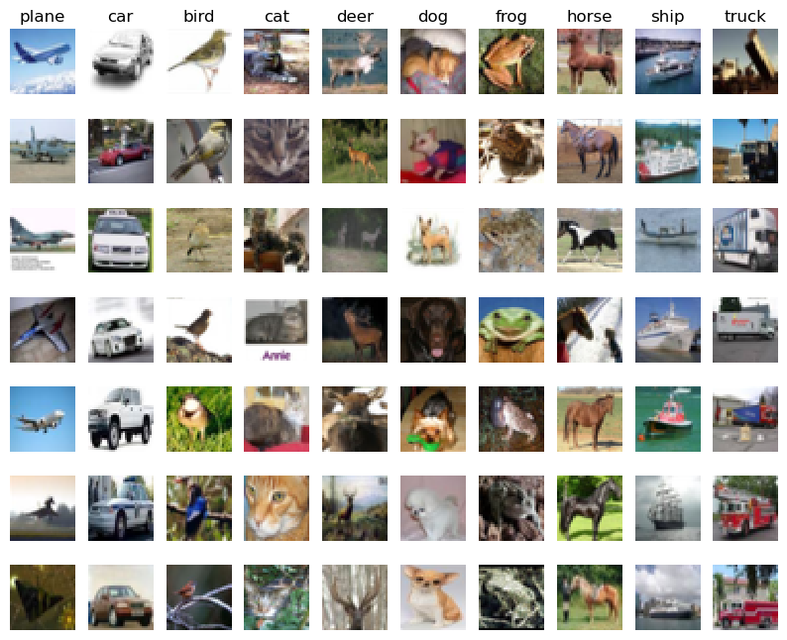
图1 数据处理结果的展示
结果2：分割数据集的结果如下图2所示。其结果是一个四元组，各个部分的含义为（图像数量，长像素，宽像素，通道数）。
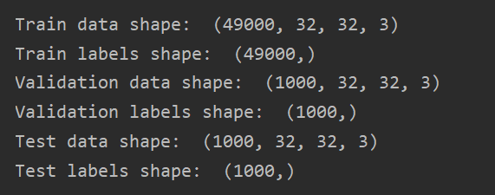
图2 分割数据集的结果
结果3：将图像拉伸至一维的结果如下图3所示。同结果2一样，该结果是元组类型的，哥哥部分的含义为（图像数量，图像长度）。
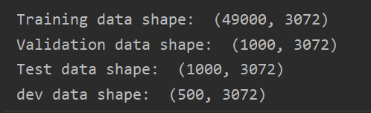
图3 图像拉伸结果
结果4：用cs231n训练模型的结果如下图4所示。
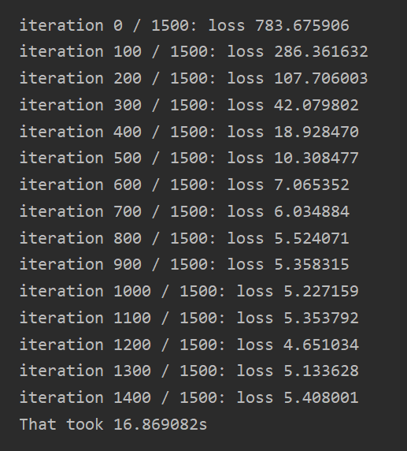
图4 模型训练结果
结果5：画出的loss折线图如下图5所示。
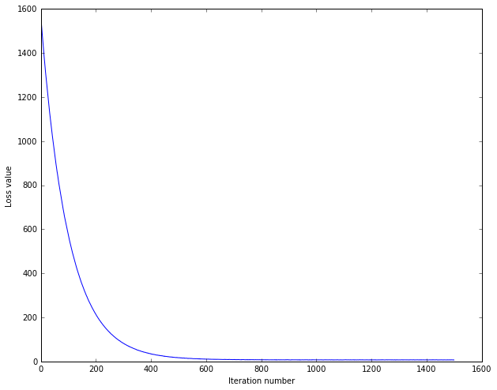
图5 训练过程中的loss值变化曲线
结果6：交叉验证调整超参数的结果如下图6所示，最终选取的是lr=1e-7,reg=5e4为最佳参数，此时他的准确率为37.9%。
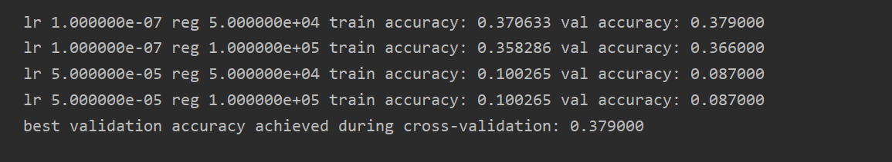
图6 交叉验证调整超参数的结果图
结果7：验证机调参的可视化结果如下图7所示。
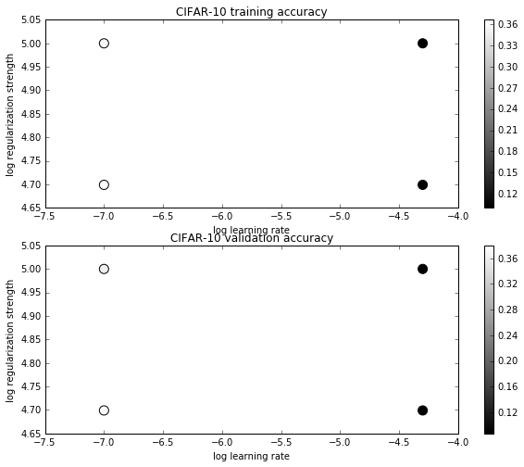
图7 验证集调参结果
结果8：模型在测试集上的测试结果如下图8所示。
图8 模型在测试集上的测试结果
结果9：可视化每个类的学习权重的结果如下图9所示。
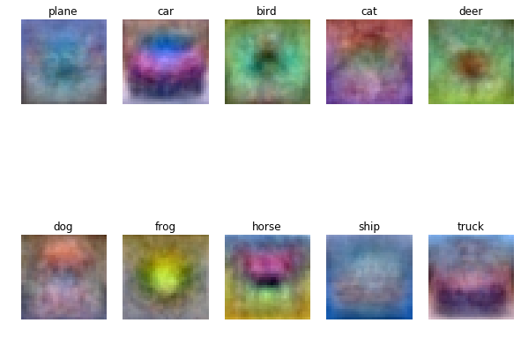
图9 每个类学习的权重图
【实验心得】
通过本次实验，我对机器学习的常用算法——SVM算法有了更深刻的认识。在原先上课的时候，我以为SVM只能做二分类模型，但是通过本次实验，我明白了，SVM不知可以做二分类，还可以做多分类，像本实验中的十分类一样能做。所谓支持向量机分类，在本实验的数据集——CIFAR-10中，它的图片转化成一个向量（后，就是一个高维度问题，而一个向量可以看作是3072维空间中的一个点，而线性分类器就是在高维度空间中的一个超平面，将各个空间点分开。这也让我更加深刻的认识到SVM的实质就是寻找一个W和一个b,使得这个超平面能很好的区分各个类。寻找方法就是不停的改变w和b的值，即不停的旋转平移，直到它使分类的偏差较小。
本次实验并不能算是很圆满的实验，因为它在测试集上的准确率才达到37%，可能是因为维度太高，包含有其他的干扰信息太多，像这种情况可以采用PCA降维算法。此外，我在机器学习课程设计中有尝试过把图片再缩小，一般缩小到24*24*3大小，这样压缩图像的方法在粗粒度图像识别中有着很高的准准确率，事实上在机器学习课程设计中，我尝试这个方法，能将二分类的准确率从50%左右提升至80%以上。时候我联系老师并自己做了分析，总结如下：图像压缩的实质就是保留全局特征，忽略掉细节特征，这样的压缩处理有利于放大全局特征，而全局特征在图像的粗粒度识别中是非常重要的。本实验我也采用这种算法，最后得出的准确率达到了惊人的77%，结果如下图10所示。较原先的37%提升了108%。由此证明这种算法在粗粒度图像分类中实际是可行的。
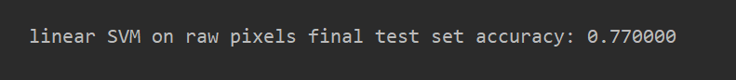
图10 调整后的准确率

