PyCharme SSH Setup

- Open project in PyCharme. Go to File→ Settings. Set up the project Interpreter

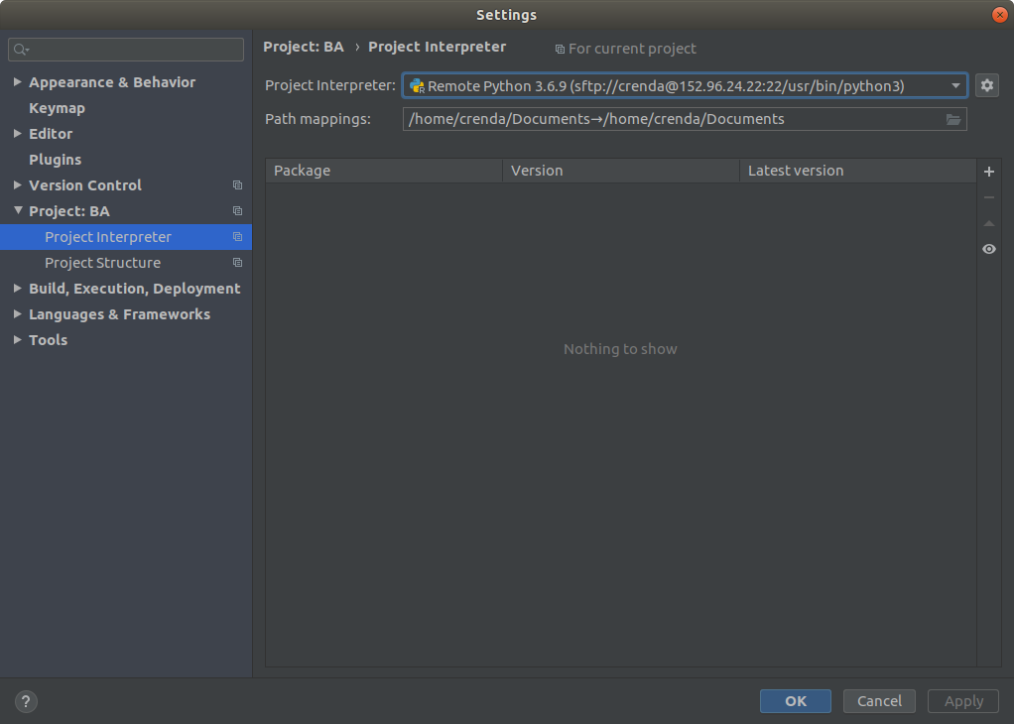
Select the drop down menu of the Project Interpreter and add a SSH Interpreter.
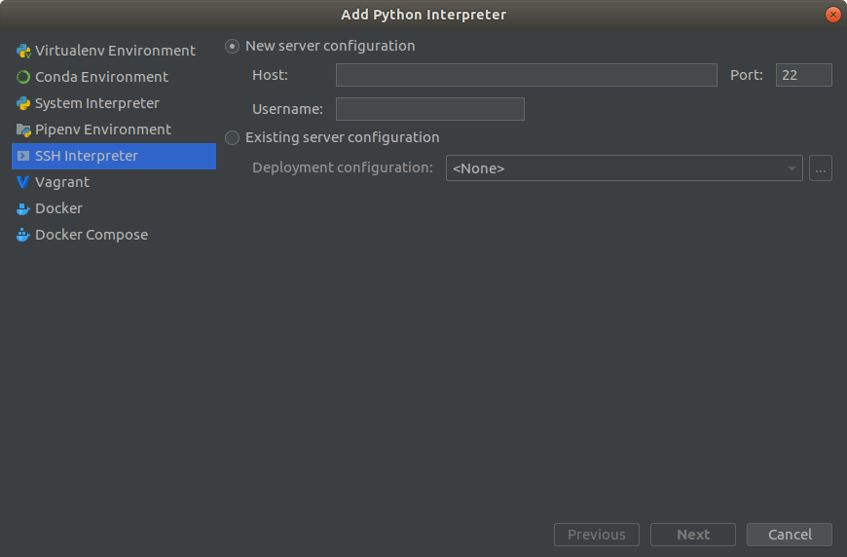

In the SSH Interpreter set Python3 as the standard interpreter.

After connecting with the interpreter open Tools→Deployment→Configuration... And fill in the Host IP again to set up the Jetson nano as an remote host server.
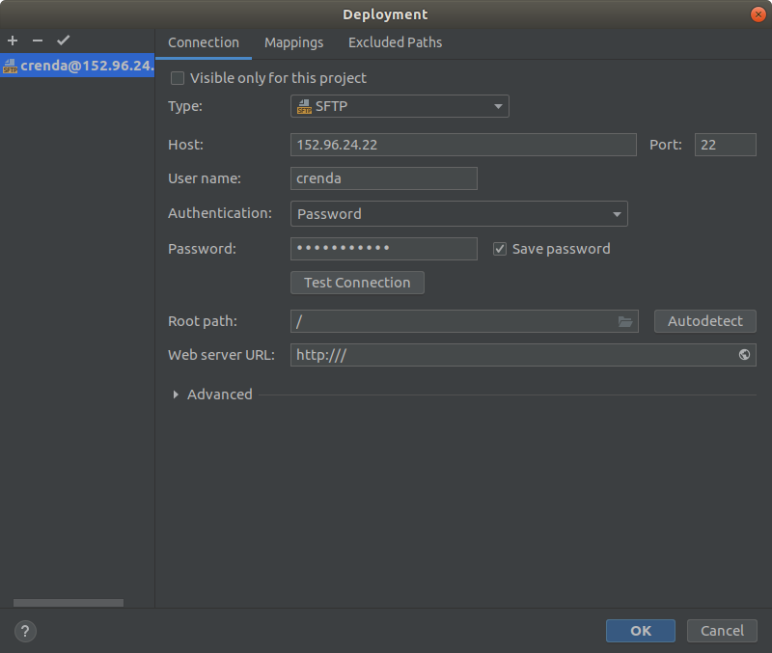
To ensure the right project files get written to the right place on the Jetson nano enter the mapping menu.
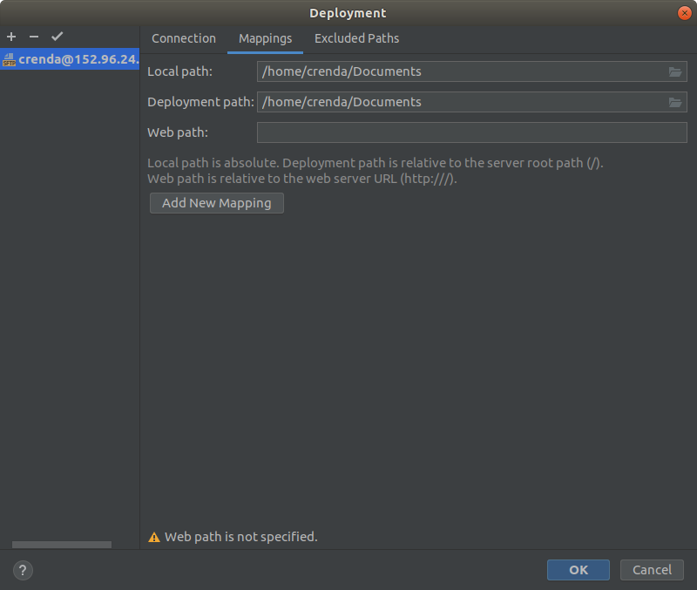

After the the configuration an SSH connection can be established under Tools→ Start SSH session… . Here the already set up host server can be choosen. Or the SSH session can be established with pressing Edit credentials. The SSH session configurations window opens and all the used IP adresses and Host user name & Password are asked in the next 3 windows.
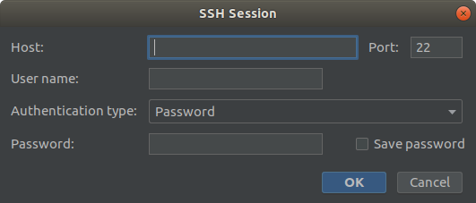
From now on all files written in pycharm can be updated to the Jetson Nano via the Tools→ Deployment→ Upload to (yout jetson name). Or simply run und the Run menu and directly run on your host platform.
If a new Window is opened by the python Skript there is an error since the SSH can’t open the new window on the client side and the X11 SSH option is not available under PyCharm.

