Makeathon / Girls Make / Makeathons branding:

-be simple but versatile (think H from hillary clinton campaign)

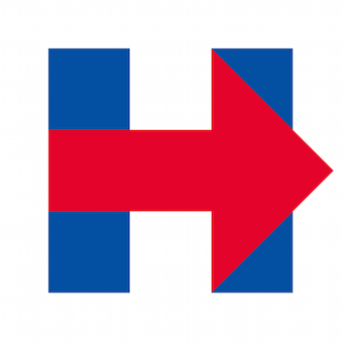

- “The style can be unique for both parts but there should be some underlying connection between the two.” — bstanfield (think house of highlights and bleacher report)