Douglas Goss

CMPS-394 Advisor Log Application

September 2019

**Part 1**

1. **Purpose**

The purpose of this part is to allow a user to enter information as either a student or as an advisor.

1. **Implementation**
2. Storage- no files are stored
3. File description-

***student_view.html***- page from which students upload their thesis

***advisor_view***.html- page from which advisors provide feedback to students

1. Usage Overview

This is the view a student is presented upon loading ***student_view.html***.

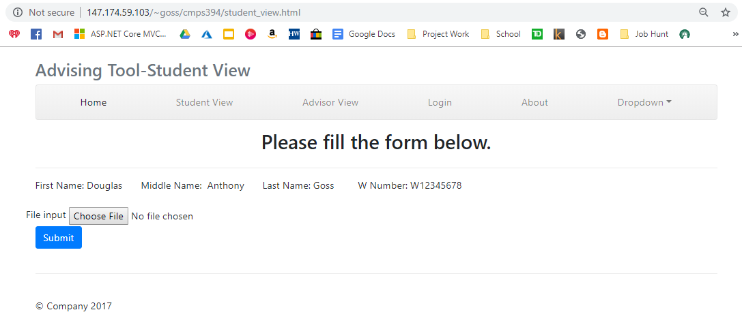

**Choose File-** allows for the selection of a file to upload to the server.

1. Walkthrough of typical usage
2. **Student View-** Select the file to be uploaded.

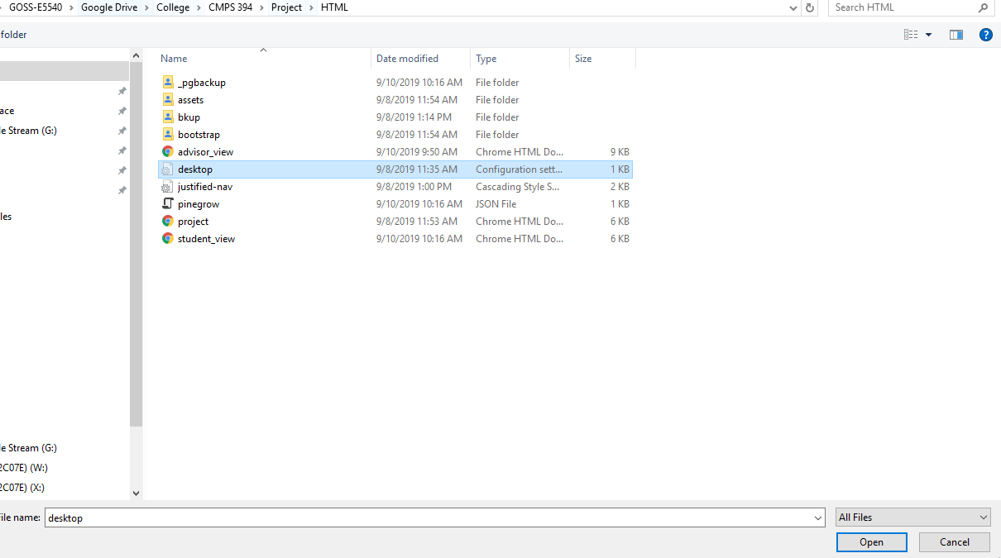

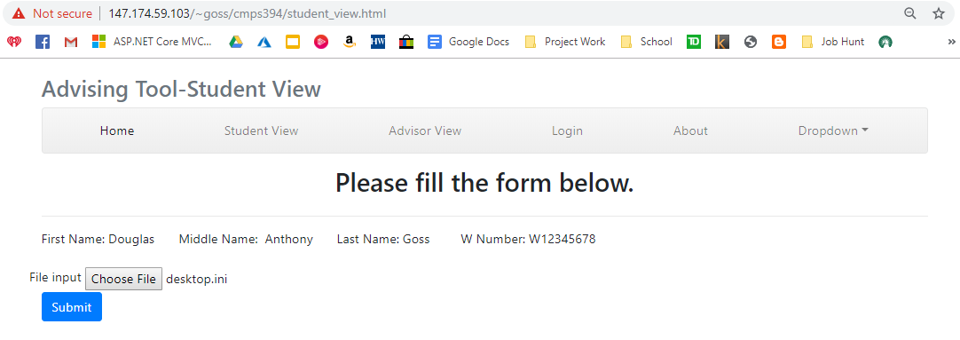

1. **Advisor View-** Select the student from the dropdown box, enter remarks and select the feedback from the dropdown box.

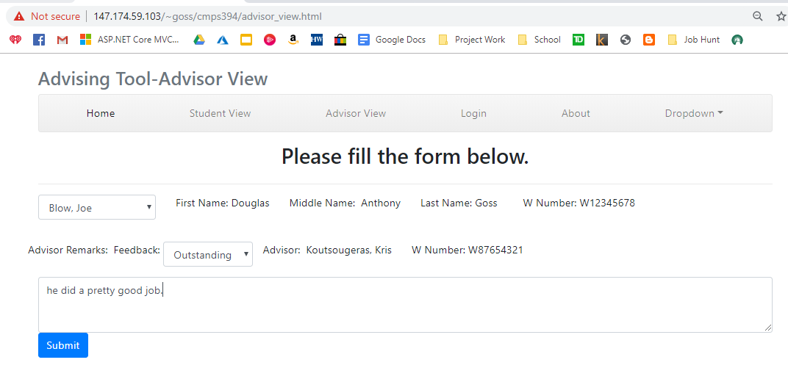

1. Code
2. **advisor_view.html**

<!DOCTYPE html>

<html lang="en">

<head>

<meta charset="utf-8">

<meta http-equiv="X-UA-Compatible" content="IE=edge">

<meta name="viewport" content="width=device-width, initial-scale=1, shrink-to-fit=no">

<meta name="description" content="">

<meta name="author" content="">

<title>Advising Tool</title>

<!-- Bootstrap core CSS -->

<link href="bootstrap/css/bootstrap.css" rel="stylesheet">

<!-- Custom styles for this template -->

<link href="justified-nav.css" rel="stylesheet">

</head>

<body>

<div class="container">

<div class="masthead">

<h3 class="text-muted">Advising Tool-Advisor View</h3>

<nav class="navbar navbar-expand-md navbar-light bg-light rounded mb-3">

<button class="navbar-toggler" type="button" data-toggle="collapse" data-target="#navbarCollapse" aria-controls="navbarCollapse" aria-expanded="false" aria-label="Toggle navigation">

<span class="navbar-toggler-icon"></span>

</button>

<div class="collapse navbar-collapse" id="navbarCollapse">

<ul class="navbar-nav text-md-center nav-justified w-100">

<li class="nav-item active">

<a class="nav-link" href="#">Home <span class="sr-only">(current)</span></a>

</li>

<li class="nav-item">

<a class="nav-link" href="student_view.html">Student View</a>

</li>

<li class="nav-item">

<a class="nav-link" href="advisor_view.html">Advisor View</a>

</li>

<li class="nav-item">

<a class="nav-link" href="#">Login</a>

</li>

<li class="nav-item">

<a class="nav-link" href="#">About</a>

</li>

<li class="nav-item dropdown">

<a class="nav-link dropdown-toggle" href="http://example.com" id="dropdown01" data-toggle="dropdown" aria-haspopup="true" aria-expanded="false">Dropdown</a>

<div class="dropdown-menu" aria-labelledby="dropdown01">

<a class="dropdown-item" href="#">Action</a>

<a class="dropdown-item" href="#">Another action</a>

<a class="dropdown-item" href="#">Something else here</a>

</div>

</li>

</ul>

</div>

</nav>

<h2 class="align-middle text-center">Please fill the form below.</h2>

</div>

<!-- Jumbotron -->

<!-- Example row of columns -->

<div class="row">

<div class="col-md-12">

<form role="form">

<div class="form-group">

<div class="row">

<div class="col-md-auto label_container">

<select id="formInput78" class="form-control">

<option>Select Student</option>

<option>Blow, Joe</option>

<option>Castor, Mike</option>

<option>Donaldson, Nicole</option>

<option>Evans, Will</option>

<option>Franklin, Max</option>

</select>

</div>

<div class="col-md-auto label_container">

<label for="exampleInputEmail1">First Name:</label>

<label for="exampleInputEmail1">Douglas</label>

</div>

<div class="col-md-auto label_container">

<label for="exampleInputEmail1">Middle Name:&nbsp;</label>

<label for="exampleInputEmail1">Anthony</label>

</div>

<div class="col-md-auto label_container">

<label for="exampleInputEmail1">Last Name:</label>

<label for="exampleInputEmail1">Goss</label> &nbsp;

</div>

<div class="col-md-auto label_container">

<label for="exampleInputEmail1">W Number:</label>

<label for="exampleInputEmail1">W12345678</label> &nbsp;

</div>

</div>

</div>

<div class="row">

<div class="form-group">

<label for="exampleInputFile">Advisor Remarks:&nbsp;</label>

<label for="formInput78">Grade:&nbsp</label>

</div>

<div class="form-group">

<select id="formInput78" class="form-control">

<option>SELECT</option>

<option>Outstanding</option>

<option>Great</option>

<option>OK</option>

<option>D</option>

<option>F</option>

</select>

</div>

<div class="col-md-auto label_container">

<label for="exampleInputEmail1">Advisor:&nbsp;</label>

<label for="exampleInputEmail1">Koutsougeras, Kris</label>

</div>

<div class="col-md-auto label_container">

<label for="exampleInputEmail1">W Number:</label>

<label for="exampleInputEmail1">W87654321</label> &nbsp;

</div>

<div class="form-group">

</div>

</div>

<textarea class="form-control" rows="3"></textarea>

<button type="submit" class="btn btn-primary">Submit</button>

</form>

</div>

</div>

<!-- Site footer -->

<footer class="footer">

<p>© Company 2017</p>

</footer>

</div>

<!-- /container -->

<!-- Bootstrap core JavaScript

================================================== -->

<!-- Placed at the end of the document so the pages load faster -->

<script src="assets/js/jquery.min.js"></script>

<script src="assets/js/popper.js"></script>

<script src="bootstrap/js/bootstrap.min.js"></script>

</body>

</html>

1. **student_view.html**

<!DOCTYPE html>

<html lang="en">

<head>

<meta charset="utf-8">

<meta http-equiv="X-UA-Compatible" content="IE=edge">

<meta name="viewport" content="width=device-width, initial-scale=1, shrink-to-fit=no">

<meta name="description" content="">

<meta name="author" content="">

<title>Advising Tool</title>

<!-- Bootstrap core CSS -->

<link href="bootstrap/css/bootstrap.css" rel="stylesheet">

<!-- Custom styles for this template -->

<link href="justified-nav.css" rel="stylesheet">

</head>

<body>

<div class="container">

<div class="masthead">

<h3 class="text-muted">Advising Tool-Student View</h3>

<nav class="navbar navbar-expand-md navbar-light bg-light rounded mb-3">

<button class="navbar-toggler" type="button" data-toggle="collapse" data-target="#navbarCollapse" aria-controls="navbarCollapse" aria-expanded="false" aria-label="Toggle navigation">

<span class="navbar-toggler-icon"></span>

</button>

<div class="collapse navbar-collapse" id="navbarCollapse">

<ul class="navbar-nav text-md-center nav-justified w-100">

<li class="nav-item active">

<a class="nav-link" href="#">Home <span class="sr-only">(current)</span></a>

</li>

<li class="nav-item">

<a class="nav-link" href="student_view.html">Student View</a>

</li>

<li class="nav-item">

<a class="nav-link" href="advisor_view.html">Advisor View</a>

</li>

<li class="nav-item">

<a class="nav-link" href="#">Login</a>

</li>

<li class="nav-item">

<a class="nav-link" href="#">About</a>

</li>

<li class="nav-item dropdown">

<a class="nav-link dropdown-toggle" href="http://example.com" id="dropdown01" data-toggle="dropdown" aria-haspopup="true" aria-expanded="false">Dropdown</a>

<div class="dropdown-menu" aria-labelledby="dropdown01">

<a class="dropdown-item" href="#">Action</a>

<a class="dropdown-item" href="#">Another action</a>

<a class="dropdown-item" href="#">Something else here</a>

</div>

</li>

</ul>

</div>

</nav>

<h2 class="align-middle text-center">Please fill the form below.</h2>

</div>

<!-- Jumbotron -->

<!-- Example row of columns -->

<div class="row">

<div class="col-md-12">

<form role="form">

<hr>

<div class="form-group">

<div class="row">

<div class="col-md-auto">

<label for="exampleInputEmail1">First Name:</label>

<label for="exampleInputEmail1">Douglas</label>

</div>

<div class="col-md-auto">

<label for="exampleInputEmail1">Middle Name:&nbsp;</label>

<label for="exampleInputEmail1">Anthony</label>

</div>

<div class="col-md-auto">

<label for="exampleInputEmail1">Last Name:</label>

<label for="exampleInputEmail1">Goss</label> &nbsp;

</div>

<div class="col-md-auto">

<label for="exampleInputEmail1">W Number:</label>

<label for="exampleInputEmail1">W12345678</label> &nbsp;

</div>

</div>

</div>

<div class="row">

<label for="exampleInputFile">File input&nbsp</label>

<input type="file" id="exampleInputFile">

</div>

<button type="submit" class="btn btn-primary">Submit</button>

</form>

</div>

</div>

<!-- Site footer -->

<footer class="footer">

<p>© Company 2017</p>

</footer>

</div>

<!-- /container -->

<!-- Bootstrap core JavaScript

================================================== -->

<!-- Placed at the end of the document so the pages load faster -->

<script src="assets/js/jquery.min.js"></script>

<script src="assets/js/popper.js"></script>

<script src="bootstrap/js/bootstrap.min.js"></script>

</body>

</html>

1. File/Aid links

<http://147.174.59.103/~goss/cmps394/student_view.html>