**DDL Query #1- Create TBL_COMMON_MTRL**

CREATE TABLE [dbo].[TBL_COMMON_MTRL](

[id] [int] IDENTITY(1,1) NOT NULL,

[type] [nvarchar](25) NOT NULL,

[subtype] [nvarchar](25) NOT NULL,

CONSTRAINT [PK_TBL_COMMON_MTRL] PRIMARY KEY CLUSTERED

([type] ASC,[subtype] ASC)

) 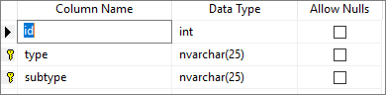

**DDL Query #2- Create TBL_DEPENDENT**

CREATE TABLE [dbo].[TBL_DEPENDENT](

[id] [int] IDENTITY(1,1) NOT NULL,

[emp_id] [smallint] NOT NULL,

[fname] [nvarchar](20) NOT NULL,

[gender] [char](1) NOT NULL,

[b_date] [date] NOT NULL,

[relationship] [nvarchar](20) NOT NULL,

CONSTRAINT [PK_TBL_DEPENDENT] PRIMARY KEY CLUSTERED

([emp_id] ASC,[fname] ASC))

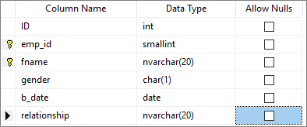

**DDL Query #3- Create TBL_EMP_INSURANCE**

CREATE TABLE [dbo].[TBL_EMP_INSURANCE](

[id] [int] IDENTITY(1,1) NOT NULL,

[plan_code] [nvarchar](15) NOT NULL,

[provider] [nvarchar](20) NOT NULL,

[tier] [nvarchar](20) NOT NULL

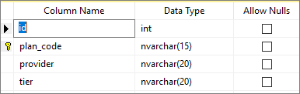

**DDL Query #4- Create TBL_EMPLOYEE**

CREATE TABLE [dbo].[TBL_EMPLOYEE](

[id] [int] IDENTITY(1,1) NOT NULL,

[emp_id] [smallint] NOT NULL,

[fname] [nvarchar](20) NOT NULL,

[lname] [nvarchar](20) NOT NULL,

[email] [nvarchar](20) NOT NULL,

[address] [nvarchar](25) NOT NULL,

[state] [char](2) NOT NULL,

[zip] [nvarchar](15) NOT NULL,

[phone] [nvarchar](15) NULL,

[hlth_ins_plan] [nvarchar](15) NOT NULL,

CONSTRAINT [PK_TBL_EMPLOYEE] PRIMARY KEY CLUSTERED

([emp_id] ASC))

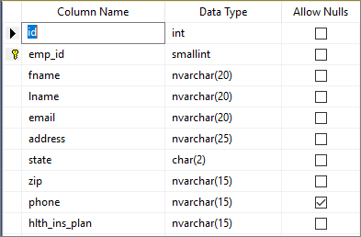

**DDL Query #5- Create TBL_EXPENSE**

CREATE TABLE [dbo].[TBL_EXPENSE](

[id] [int] IDENTITY(1,1) NOT NULL,

[type] [nvarchar](25) NOT NULL,

[subtype] [nvarchar](25) NOT NULL,

[dscptn] [nvarchar](25) NOT NULL,

[date_purchased] [date] NOT NULL,

[price] [decimal](18, 2) NOT NULL,

[quantity] [int] NOT NULL,

CONSTRAINT [PK_TBL_EXPENSE_1] PRIMARY KEY CLUSTERED

([type] ASC,[subtype] ASC,[dscptn] ASC,[date_purchased] ASC))

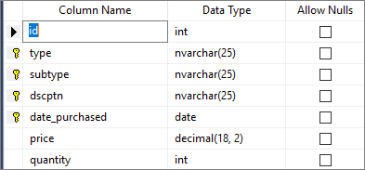

**DDL Query #6- Create TBL_INVOICE**

CREATE TABLE [dbo].[TBL_INVOICE](

[id] [int] IDENTITY(1,1) NOT NULL,

[prdct_code] [nvarchar](50) NOT NULL,

[shop_code] [nvarchar](50) NOT NULL,

[inv_date] [date] NOT NULL,

[quantity] [int] NOT NULL,

CONSTRAINT [PK_TBL_SALES] PRIMARY KEY CLUSTERED

([prdct_code] ASC,[shop_code] ASC,[inv_date] ASC))

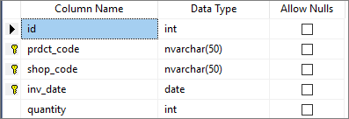

**DDL Query #7- Create TBL_PRDCT_TYPE**

CREATE TABLE [dbo].[TBL_PRDCT_TYPE](

[type] [nvarchar](20) NOT NULL,

[ID] [int] IDENTITY(1,1) NOT NULL,

CONSTRAINT [PK_TBL_PRDCT_TYPE] PRIMARY KEY CLUSTERED

([type] ASC))

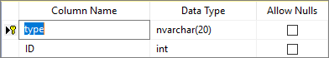

**DDL Query #8- Create TBL_PRICE**

CREATE TABLE [dbo].[TBL_PRICE](

[id] [int] IDENTITY(1,1) NOT NULL,

[prdct_code] [nvarchar](50) NOT NULL,

[shop_code] [nvarchar](50) NOT NULL,

[shelf_price] [decimal](18, 2) NOT NULL,

CONSTRAINT [PK_TBL_PRICE] PRIMARY KEY CLUSTERED

([prdct_code] ASC,[shop_code] ASC))

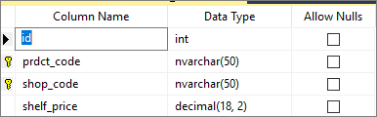

**DDL Query #9- Create TBL_PRODUCT**

CREATE TABLE [dbo].[TBL_PRODUCT](

[id] [int] IDENTITY(1,1) NOT NULL,

[prdct_code] [nvarchar](30) NOT NULL,

[prdct_type] [nvarchar](30) NOT NULL,

[description] [nvarchar](30) NOT NULL,

[size] [nvarchar](30) NOT NULL,

[accent_1] [nvarchar](30) NOT NULL,

[accent_1_sub] [nvarchar](30) NOT NULL,

[framed] [bit] NOT NULL,

CONSTRAINT [PK_TBL_PRODUCT] PRIMARY KEY CLUSTERED

([prdct_code] ASC))

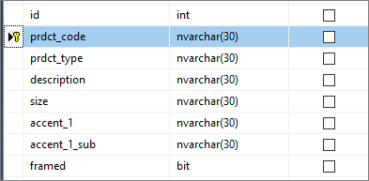

**DDL Query #10- Create TBL_SHOP**

CREATE TABLE [dbo].[TBL_SHOP](

[id] [int] IDENTITY(1,1) NOT NULL,

[shop_name] [nvarchar](50) NOT NULL,

[shop_code] [nvarchar](50) NOT NULL,

[address] [nvarchar](25) NOT NULL,

[city] [nvarchar](15) NOT NULL,

[state] [nvarchar](50) NOT NULL,

[zip] [nvarchar](50) NOT NULL,

[phone] [nvarchar](50) NOT NULL,

[email] [nvarchar](50) NULL,

[acct_rep] [smallint] NULL,

CONSTRAINT [PK_TBL_SHOP] PRIMARY KEY CLUSTERED

([shop_code] ASC))

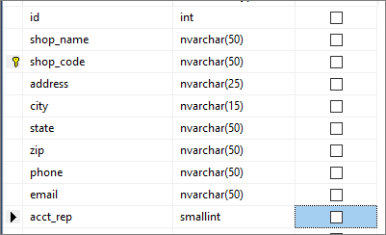

**DDL Query #11- Foreign key on TBL_EXPENSE to reference TBL_COMMON_MTRLS**

ALTER TABLE [dbo].[TBL_EXPENSE] WITH CHECK ADD CONSTRAINT [FK_TBL_EXPENSE_TBL_COMMON_MTRL] FOREIGN KEY([type], [desc1], [desc2])

REFERENCES [dbo].[TBL_COMMON_MTRL] ([type], [desc1], [desc2])

ON UPDATE CASCADE

**DDL Query #12- Foreign key on TBL_DEPENDENT to reference TBL_EMPLOYEE**

ALTER TABLE [dbo].[TBL_DEPENDENT] WITH CHECK ADD CONSTRAINT [FK_TBL_DEPENDENT_TBL_EMPLOYEE] FOREIGN KEY([emp_id])

REFERENCES [dbo].[TBL_EMPLOYEE] ([emp_id])

ON UPDATE CASCADE

**DDL Query #13- Foreign key on TBL_SHOP to reference TBL_EMPLOYEE**

ALTER TABLE [dbo].[TBL_SHOP] WITH CHECK ADD CONSTRAINT [FK_tbl_shop_tbl_employee] FOREIGN KEY([acct_rep])

REFERENCES [dbo].[TBL_EMPLOYEE] ([emp_id])

ON UPDATE CASCADE

**DDL Query #14- Foreign key on TBL_INVOICE to reference TBL_PRODUCT**

ALTER TABLE [dbo].[TBL_INVOICE] WITH CHECK ADD CONSTRAINT [FK_TBL_INVOICE_TBL_PRODUCT] FOREIGN KEY([prdct_code])

REFERENCES [dbo].[TBL_PRODUCT] ([prdct_code])

ON UPDATE CASCADE

**DDL Query #15- Foreign key on TBL_INVOICE to reference TBL_SHOP**

ALTER TABLE [dbo].[TBL_INVOICE] WITH CHECK ADD CONSTRAINT [FK_TBL_INVOICE_TBL_SHOP] FOREIGN KEY([shop_code])

REFERENCES [dbo].[TBL_SHOP] ([shop_code])

ON UPDATE CASCADE

**DDL Query #16- Foreign key on TBL_PRICE to reference TBL_PRODUCT**

ALTER TABLE [dbo].[TBL_INVOICE] WITH CHECK ADD CONSTRAINT [FK_TBL_INVOICE_TBL_PRODUCT] FOREIGN KEY([prdct_code])

REFERENCES [dbo].[TBL_PRODUCT] ([prdct_code])

ON UPDATE CASCADE

**DDL Query #17- Foreign key on TBL_PRICE to reference TBL_SHOP**

ALTER TABLE [dbo].[TBL_PRICE] WITH CHECK ADD CONSTRAINT [FK_tbl_price_tbl_shop] FOREIGN KEY([shop_code])

REFERENCES [dbo].[TBL_SHOP] ([shop_code])

ON UPDATE CASCADE

**DDL Query #18- Drop Foreign key on TBL_PRODUCT to reference TBL_PRDCT_TYPE, re-assert and add** ON UPDATE CASCADE

ALTER TABLE [dbo].[TBL_PRODUCT]

DROP CONSTRAINT [FK_TBL_PRODUCT_TBL_PRDCT_TYPE];

ALTER TABLE [dbo].[TBL_PRODUCT] WITH CHECK ADD CONSTRAINT [FK_TBL_PRODUCT_TBL_PRDCT_TYPE] FOREIGN KEY([prdct_type])

REFERENCES [dbo].[TBL_PRDCT_TYPE] ([type])

ON UPDATE CASCADE

**DDL Query #19- Check gender on TBL_DEPENDENT to equal “M” or “F”**

ALTER TABLE [dbo].[TBL_DEPENDENT]

ADD CONSTRAINT CHK_DpndtGender CHECK (gender='M' OR gender='F');

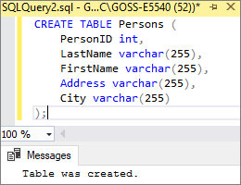**DDL Query #20- create trigger to show that a new table has been created.**

CREATE TRIGGER table_created

ON DATABASE

FOR CREATE_TABLE

AS

PRINT 'Table was created.';

--TEAM NAME:

--TEAM MEMBERS' NAME:

--~~~~~~~~~~~~~~~~~~~~~~~~~~~~~~~~~~~~~~~~~~~~~~~~~~~~~~~~~~~

--DDL QUERIES (THERE MUST BE 10 DDL QUERIES; GIVE A NUMBER "#" TO EACH QUERY)

--Q#: CREATE TABLE ...

--Q#: ALTER TABLE ...

AIM: .....................

--Q#: CHECK QUERY:

AIM: .....................

--Q#: ADD CONSTRAINT(S) TO THE TABLE ...

AIM: .....................

--Q#: ADD TRIGGER TO CHECK ...

AIM: .....................

**ALTER TABLE TBL_COMMON_MTRL**

**ADD PRIMARY KEY (type, subtype);**