**10 DMLs required.**

**DML Query 1, TYPE 5: Display all fields of the SHOP table along with the first name, last name and phone number of the account representative for that shop from the EMPLOYEE table. Attribute headings are to be aliased for formatting.**

SELECT TBL_SHOP.shop_name as "Shop", TBL_SHOP.shop_code as "Shop Code", TBL_SHOP.address as "Address",

TBL_SHOP.city as "City", TBL_SHOP.state as "State", TBL_SHOP.zip as "ZIP", TBL_SHOP.phone as "Phone",

TBL_SHOP.email as "E-mail", TBL_EMPLOYEE.fname as "Acct Rep F Name" ,

TBL_EMPLOYEE.lname as "Acct Rep L Name", TBL_EMPLOYEE.phone as "Acct Rep Phone"

FROM TBL_SHOP INNER JOIN

TBL_EMPLOYEE ON TBL_SHOP.acct_rep = TBL_EMPLOYEE.emp_id

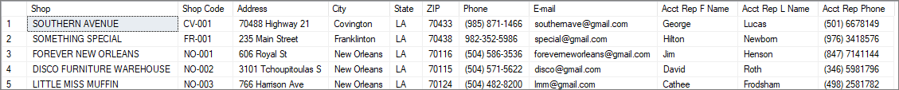

**DML Query 2, TYPE 3: UPDATE the lname field for emp_id 4 in the EMPLOYEE table to Goss. The change will be reflected in this table as well as be cascaded to the foreign key of the SHOP table.**

UPDATE TBL_EMPLOYEE

SET lname='Goss'

WHERE fname='Cathee' AND lname='Frodsham';

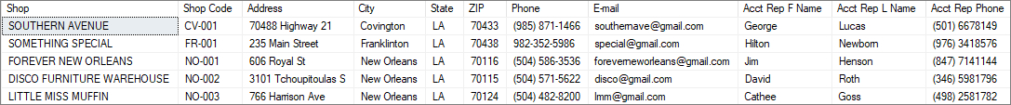

**DML Query 3, TYPE 2: INSERT a new employee record into the EMPLOYEE table.**

INSERT INTO TBL_EMPLOYEE (emp_id,fname,lname,email, address, state, ZIP, phone, hlth_ins_plan)

VALUES (6,'Anna', 'Lee', 'anna_lee@gmail.com', '123 Bell', 'LA', '70503', '(985) 235-5623', 'BC-2-A') ;

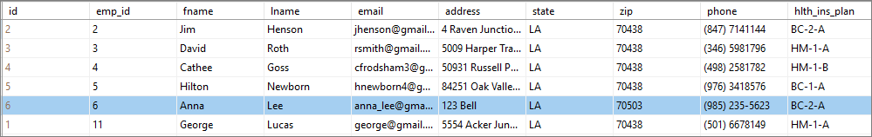

**DML Query 4, TYPE 4: DELETE this employee record from the EMPLOYEE table.**

DELETE FROM TBL_EMPLOYEE

WHERE fname='Anna' AND lname='Lee';

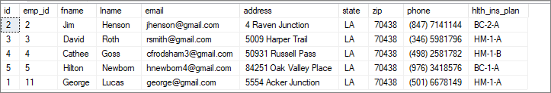

**DML Query 5, TYPE 11: Display the first and last name of an employee along with the first name, gender, birth date and relationship to the employee. Order by the last name of the employee. Attribute headings are to be aliased for formatting.**

SELECT TBL_EMPLOYEE.lname AS [Emp F Name], TBL_EMPLOYEE.fname AS [Emp L Name], TBL_DEPENDENT.fname AS [First name] , TBL_DEPENDENT.gender AS [Gender] , TBL_DEPENDENT.b_date AS [Birth Date] , TBL_DEPENDENT.relationship AS [Relationship]

FROM TBL_EMPLOYEE INNER JOIN

TBL_DEPENDENT ON TBL_EMPLOYEE.emp_id = TBL_DEPENDENT.emp_id

ORDER BY TBL_EMPLOYEE.lname;

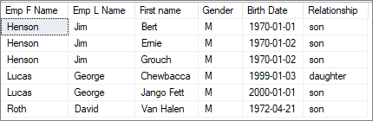

**DML Query 6, TYPE 15: Display the product code and quantities for products that have been invoiced to each of the shops during the year of 2015 more than 15 times. Order by the shop name. Attribute headings are to be aliased for formatting.**

SELECT TBL_SHOP.shop_name AS [Shop Name], TBL_INVOICE.prdct_code AS [Product Code], sum(TBL_INVOICE.quantity) AS Quantity

FROM TBL_INVOICE JOIN TBL_SHOP ON TBL_SHOP.shop_code=TBL_INVOICE.shop_code

WHERE TBL_INVOICE.inv_date>='2015-01-01' AND TBL_INVOICE.inv_date<='2015-12-31'

GROUP BY TBL_INVOICE.prdct_code, TBL_SHOP.shop_name

HAVING SUM((TBL_INVOICE.quantity))>15

ORDER BY TBL_SHOP.shop_name;

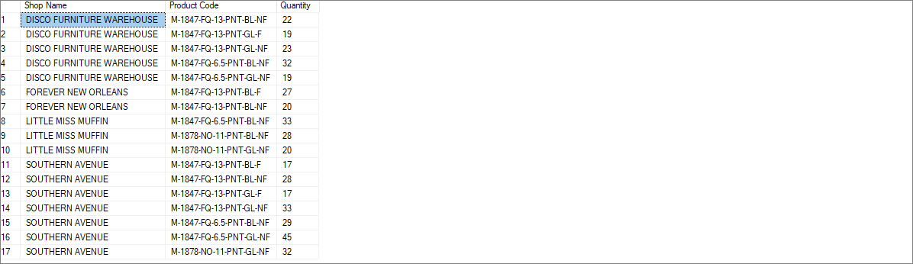

**DML Query 7, TYPE 16: Display the product code and quantities for French Quarter products that have been invoiced to each of the shops during the year of 2015. Order by the shop name. Attribute headings are to be aliased for formatting.**

SELECT TBL_SHOP.shop_name AS [Shop Name], TBL_INVOICE.prdct_code AS [Product Code], sum(TBL_INVOICE.quantity) AS Quantity

FROM TBL_INVOICE JOIN TBL_SHOP ON TBL_SHOP.shop_code=TBL_INVOICE.shop_code

WHERE

TBL_INVOICE.inv_date>='2015-01-01' AND TBL_INVOICE.inv_date<='2015-12-31'

AND TBL_INVOICE.prdct_code IN

(SELECT TBL_INVOICE.prdct_code

FROM TBL_INVOICE

WHERE TBL_INVOICE.prdct_code LIKE '%FQ%')

GROUP BY TBL_INVOICE.prdct_code, TBL_SHOP.shop_name

ORDER BY TBL_SHOP.shop_name;

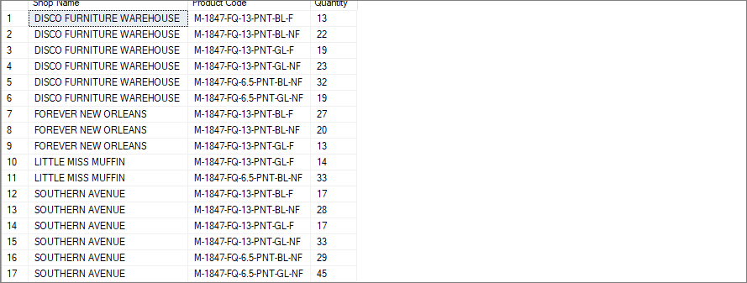

**DML Query 8, TYPE 1: Create a trigger that will increment the total number of map types in TBL_PRDCT_TYPE by 1 when a new map is added to TBL_PRODUCT.**

CREATE TRIGGER [dbo].[ttl_map_prdcts_increment] ON [dbo].[TBL_PRODUCT]

FOR INSERT

AS BEGIN

UPDATE TBL_PRDCT_TYPE

SET dbo.TBL_PRDCT_TYPE.quantity=TBL_PRDCT_TYPE.quantity+1

WHERE TBL_PRDCT_TYPE.TYPE='MAP'

END

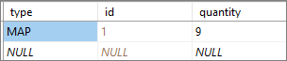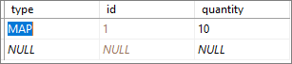

**DML Query 9, TYPE 1: Create a trigger that will decrement the total number of map types in TBL_PRDCT_TYPE by 1 when a map is deleted from TBL_PRODUCT.**

CREATE TRIGGER [dbo].[ttl_map_prdcts_decrement] ON [dbo].[TBL_PRODUCT]

FOR DELETE

AS BEGIN

UPDATE TBL_PRDCT_TYPE

SET dbo.TBL_PRDCT_TYPE.quantity=TBL_PRDCT_TYPE.quantity-1

WHERE TBL_PRDCT_TYPE.TYPE='MAP'

END

GO



**DML Query 10, TYPE 15: Display the item type, sub type, total cost and total quantity of the materials purchased in 2015 from the EXPENSE table to determine where most material expenditures are made. Attribute headings are to be aliased for formatting.**

SELECT TBL_EXPENSE.type AS [Item Type], TBL_EXPENSE.subtype AS [Sub-Type],

sum(TBL_EXPENSE.price*TBL_EXPENSE.quantity) AS [Total Cost], sum(TBL_EXPENSE.quantity) AS [Total Quantity]

FROM TBL_EXPENSE

WHERE TBL_EXPENSE.date_purchased>='2015-01-01' AND TBL_EXPENSE.date_purchased<='2015-12-31'

GROUP BY TBL_EXPENSE.type, TBL_EXPENSE.subtype

ORDER BY TBL_EXPENSE.type;

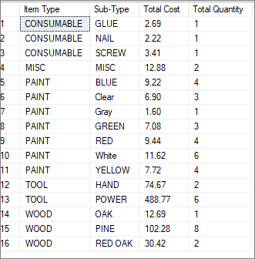

**DML Query 11, TYPE 5: Display shop, shop code, product code, shelf price, description, size, accents and framing of items sold at Southern Avenue from the PRICE, SHOP and PRODUCT tables. Attribute headings are to be aliased for formatting.**

SELECT TBL_SHOP.shop_name AS Shop, TBL_SHOP.shop_code AS [Shop Code], TBL_PRICE.prdct_code AS [Product Code], TBL_PRICE.shelf_price AS [Shelf Price], TBL_PRODUCT.description AS Description, TBL_PRODUCT.size AS [Size], TBL_PRODUCT.accent_1 AS Accent_1, TBL_PRODUCT.accent_1_sub AS Accent_2, TBL_PRODUCT.framed AS Framed

FROM TBL_SHOP, TBL_PRICE, TBL_PRODUCT

WHERE TBL_PRICE.shop_code=TBL_SHOP.shop_code AND

TBL_PRICE.prdct_code=TBL_PRODUCT.prdct_code AND

TBL_SHOP.shop_code='CV-001'

ORDER BY TBL_SHOP.shop_name;

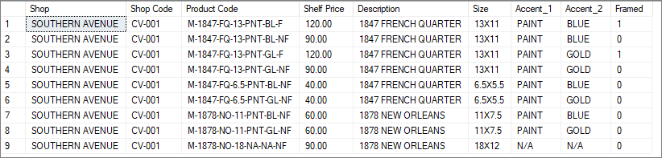

**DML Query 12, TYPE 6: Display the first name and last name of employees from the EMPLOYEE table which has a dependent with the same first name. Attribute headings are to be aliased for formatting.**

SELECT TBL_EMPLOYEE.fname as [First Name], TBL_EMPLOYEE.lname as [Last Name]

FROM TBL_EMPLOYEE

WHERE TBL_EMPLOYEE.emp_id IN (SELECT emp_id

FROM TBL_DEPENDENT

WHERE TBL_EMPLOYEE.fname=TBL_DEPENDENT.fname);



**In work**

SELECT TBL_INVOICE.shop_code AS [Shop Code], TBL_INVOICE.prdct_code AS [Product Code], SUM(TBL_INVOICE.quantity) AS Quantity

FROM TBL_INVOICE

WHERE

TBL_INVOICE.inv_date>='2016-01-01' AND TBL_INVOICE.inv_date<='2016-12-31'

AND TBL_INVOICE.shop_code='CV-001'

GROUP BY TBL_INVOICE.shop_code, TBL_INVOICE.prdct_code

ORDER BY TBL_INVOICE.prdct_code

|  |  |  |
| --- | --- | --- |
| **Q TYPE 1: TRIGGER TEST QUERY** | **Q TYPE 2:INSERT DATA** | **Q TYPE 3: UPDATE DATA** |
| **Q TYPE 4: DELETE DATA** | **Q TYPE 5: QUERY DATA** | **Q TYPE 6: QUERY DATA WITH SUB-QUERY IN WHERE CLAUSE** |
| **Q TYPE 7: QUERY DATA WITH SUB-QUERY IN FROM CLAUSE** | **Q TYPE 8: QUERY DATA WITH SUB-QUERY IN SELECT CLAUSE** | **Q TYPE 9: QUERY DATA WITH EXCEPT** |
| **Q TYPE 10: QUERY DATA WITH ANY/SOME/ALL** | **Q TYPE 11: INNER-JOIN-QUERY** | **Q TYPE 12: FULL-OUTER-JOIN-QUERY** |
| **Q TYPE 13: LEFT-OUTER-JOIN-QUERY** | **Q TYPE 14: RIGHT-OUTER-JOIN-QUERY** | **Q TYPE 15: AGGREGATION-JOIN-QUERY WITH GROUP BY & HAVING** |
| **Q TYPE 16: AGGREGATION-JOIN-QUERY WITH SUB-QUERY** | **Q TYPE 17: WITH-QUERY** |  |

SELECT TBL_INVOICE.shop_code AS [Shop Code], TBL_INVOICE.prdct_code AS [Product Code], SUM(TBL_INVOICE.quantity*TBL_PRICE.shelf_price)

FROM TBL_INVOICE, TBL_PRICE

WHERE TBL_INVOICE.shop_code=TBL_PRICE.shop_code

AND TBL_INVOICE.inv_date>='2016-01-01' AND TBL_INVOICE.inv_date<='2016-12-31'

AND TBL_INVOICE.shop_code='CV-001'

GROUP BY TBL_INVOICE.shop_code, TBL_INVOICE.prdct_code

ORDER BY TBL_INVOICE.prdct_code;

SELECT TBL_INVOICE.shop_code AS [Shop Code], TBL_INVOICE.prdct_code AS [Product Code], SUM(TBL_INVOICE.quantity), SUM(TBL_PRICE.shelf_price)

FROM TBL_INVOICE, TBL_PRICE

WHERE TBL_INVOICE.shop_code=TBL_PRICE.shop_code

AND TBL_INVOICE.inv_date>='2016-01-01' AND TBL_INVOICE.inv_date<='2016-12-31'

AND TBL_INVOICE.shop_code='CV-001'

GROUP BY TBL_INVOICE.shop_code, TBL_INVOICE.prdct_code

ORDER BY TBL_INVOICE.prdct_code;