The connection string.

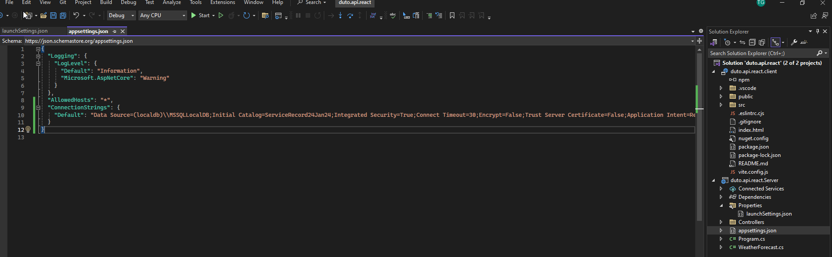

I need to set up a database with migrations enabled.