STAT-515-002
Final Project Report
GLOBAL TEMPRATURE CHANGE 1850-2016 (model)
Group-9
Navy Merianda
Garima Oswal
Ahmed Mahfouz
Vivian Gnan Sagar Pakalapati

Purpose:
In this project, we will be able to explore a large dataset of global climate change causes by consolidating our dataset from the redesign project i.e. HadCRUT4: a dataset of Global historical surface temperature anomalies with another dataset from NASA for the climate forcing which includes both natural and industrial factors (since 1880 to 2014) such as Human, Natural, Anthropogenic tropospheric aerosol, Greenhouse gases, Land use, Orbital changes, Ozone, Solar, Volcanic, contribute to global warming, based on NASA’s Goddard Institute for Space Studies . In this project we are planning to build a model aiming to see which one of these forcings ends up being the most significant variable that plays a major role in the Climate Temperature increase and we will anticipate the temperature increase in 2030. [1] [2] [3]

Dataset Overview
For this project we are combining the previous dataset HadCRUT4 and the new dataset NASA: Forcings in GISS Climate Models Dataset.
About the Previous Dataset:
HadCRUT4:
HadCRUT4 is a dataset of Global historical surface temperature anomalies relative to a 1961-1990 reference period, which is gridded. In this, for each month since January 1850, on a 5-degree grid is available. This dataset is collected as a combined product of the Met Office Hadley Centre and the Climatic Research Unit at the University of East Anglia.
This gridded dataset is the combination of the CRUTEM4 land-surface air temperature dataset and HadSST3 sea-surface temperature (SST) dataset. The more detailed information is as follows:
- CRUTEM4:
The gridded data depend on a file of a month to month mean temperature given by more than 5500 climate stations conveyed the world over.
- Hadley Centre SST data set (HadSST3):
HadSST3 is a month to month worldwide field of SST on a 5° scope by 5° longitude framework from 1850 to date.
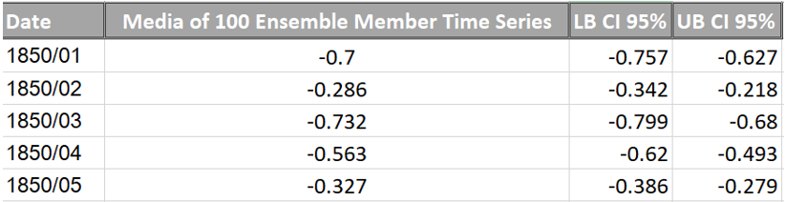

Redesign project dataset and visuals recap:
Redesigning the original graph and transforming it into two new scatter plots. In the first scatter plot, it provides an easier way to visualize the trend in global temperatures since the late 90s and how the trend has been high for the past decades. The second scatter plot, groups the temperatures changes from 1850 through 2016 monthly helps the user to look at the data from a different perspective and see the changes across the months and across the seasons and observe how consistent it’s with just slight changes.
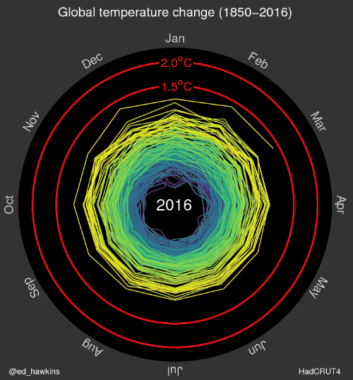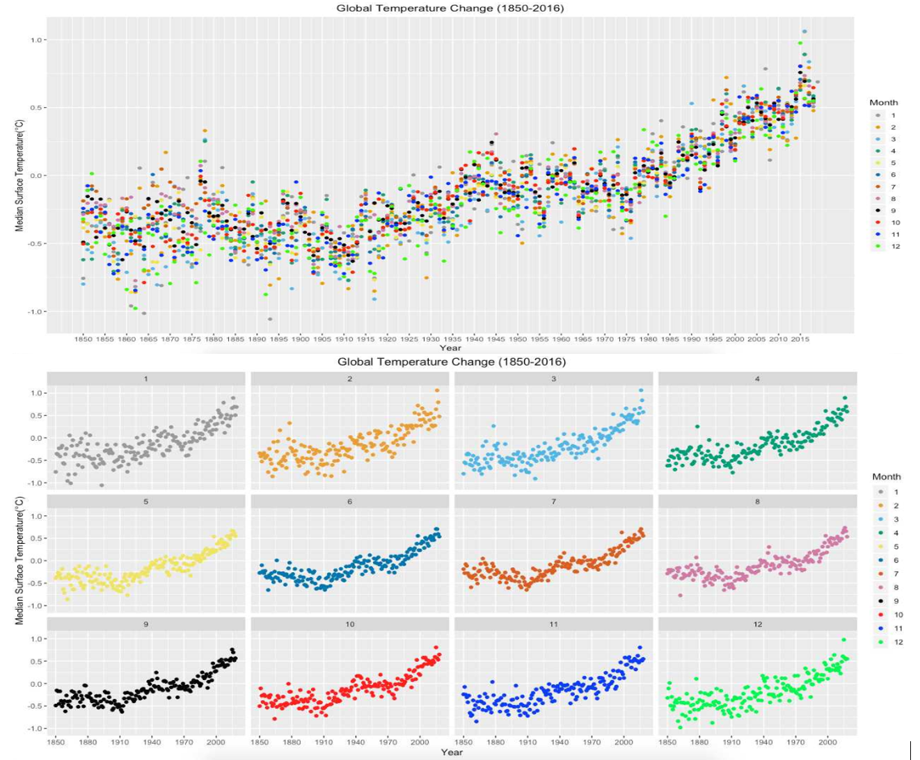
About the New Dataset:
NASA: Forcings in GISS Climate Models Dataset:
Dataset Description
- Who (company, agency, organization) collected the data, who they are, why did they collect this data?
NASA Goddard Institute for Space Studies collected the data since 1850 to 2012. NASA Goddard Institute for Space Studies (GISS) underscores a broad study of global change, which addresses the natural and man-made changes in the environment that happen on different time scales that includes one-time forcings such as volcanic explosions, seasonal and annual effects that influence the habitability of our planet. [2]

Forcings in GISS Climate Models
Forcings can be specified in a number of different ways. Traditionally, forcings have been categorized based on specific components in the radiative transfer calculation (concentrations of greenhouse gases, aerosols, surface albedo changes, solar irradiance, etc.). More recently, attribution of forcings have been made via specific emissions (which may have impacts on multiple atmospheric components) or by processes (such as deforestation) that impact multiple terms at once (e.g., Shindell et al., 2009).

CMIP5 GISS-E2 Global Radiative Forcings (Fi) Miller et al (2014)
Overall, this dataset is the summary of forcing datasets that has been used in GISS global climate models over the years. In this dataset the forcings can be categorized based on different components in the radiative transfer calculation such as surface albedo changes, concentrations of greenhouse gases, aerosols, solar irradiance. In addition to that, specific emissions that has impacts on multiple atmospheric components, some processes such as deforestation etc. The objective of the Coupled Model Intercomparison Project (CMIP) is to better understand past, present and future climate changes arising from natural, unforced variability or in response to changes in radiative forcing in a multi-model context. [2]
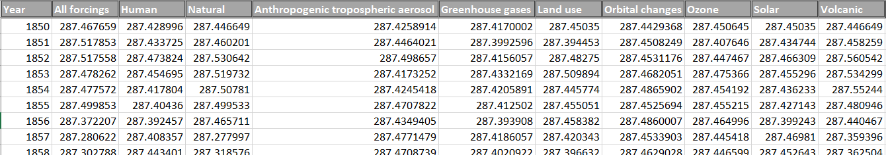
Combing Hadcrut4 and NASA datasets
We have combined the data from the CMIP5 and HadCRUT4 and produced one single gridded data that we used for building our model and aggregated visualizations. 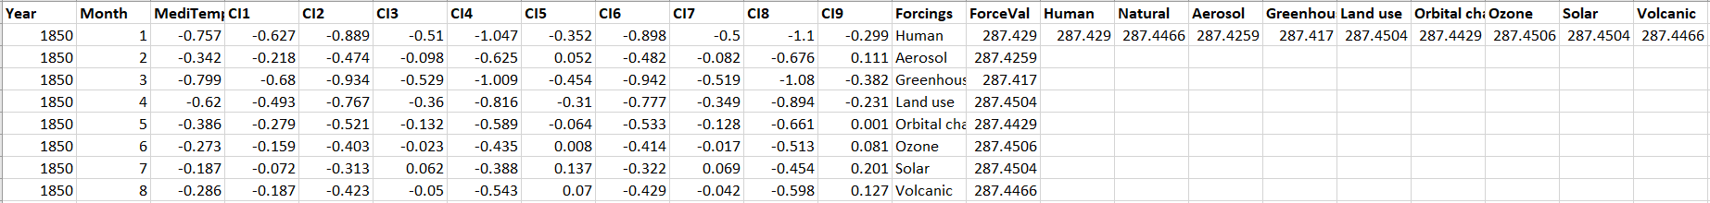

Data Analysis:
For the final project, a model has been created to evaluate which one of these forcings, is the most significant variable contributing towards Global temperature increase. In addition, the future temperature increase prediction, for the year 2030 has also been calculated.

At first, we introduced the factors that have influenced the temperature changes for the past years by a line plot which shows the increase in values of various forcings through the years and individual plots for each of the forcings through the years, indicating, Greenhouse gases is the most influential factor amongst them.
To get a clearer view on how each forcing value changes over the years, we break down plots separately. By doing so, we can compare the changes in value for each forcing more efficiently. Line plots for each forcing is given below. From the plotted graphs, we can confirm that greenhouse gases do indeed have the most significant increase as shown below in the graph:
The graph above is a line plot which showcases how the value for each forcing, changes over the years. We can understand from the graph that greenhouse gases have the most significant increase in value for the years that have gone by.
Next, to get the overview of temperature changes as well as forcings, Scatter plot for the temperature change over the years, which has been plotted for the redesign project and the current line plots for change in forcing value over the years have been combined. Both the graphs are given below. This can give us a quick overview of how the temperature change and forcing value varies over the years.

Questions we aim to answer with our regression model:
- Is there any relationship between the different forcings and the climate temperature increase?

Multiple Regression Model and Variable Selection process:
A linear regression model is used to model and study the relationship between two variables.

The figure below showcases the diagnostic plots of the linear model with the dependent variable being median temperature and independent variables being various forcings. To predict the major forcing which is contributing to temperature increase, we try to build a multiple linear regression model as shown below which shows that the data has a linear relationship.

Moreover, Residuals vs Fitted plot checks for linear relationships. Since the red line is horizontal and coincides with zero residual values, it is a good indication of a linear relationship Normal Q-Q plot contains points which are seen forming a straight line and these points coincide along the dotted line which indicate that they are normally distributed. Scale Location plot shows if residuals are spread equally along the ranges of predictors. The more equally spread the points are, the more horizontal the red line which means the better its homoscedasticity. In the Residuals vs Leverage plot, all points are within the Cook’s distance lines and there are no outliers.

- Which forcing has a strong relationship and is an important variable to predict the Climate Temperature increase?
Regsubset
To aid our model selection process which would help us in identifying the key forcing for our model, the regsubset function was used.
Each row in this plotted graph represents a model. The shaded rectangles in the columns indicate the variables included in the given model. The darkness of the shading simply represents the ordering of the BIC values, the BIC (Bayesian Information Criterion) has a minimum at 1 variable. The BIC is often chosen the preferred model selection criterion. From the figure above, we can depict that the best model has greenhouses gases (and the intercept) with the lowest BIC value of -110 and conclude the key forcing is greenhouse gases.

- How accurate our estimated model for prediction?
To build the perfect model to predict the temperature based on forcing changes for the future years, backward selection process has been applied. In this case, our dependent variable which we took for this would be the median temperature and the independent variables would be all the forcings. Here’s the summary.
Forcings were removed individually at each step which had the highest Pr values in summary until the most significant ones were found. The most significant Forcing was found to be greenhouse gases.
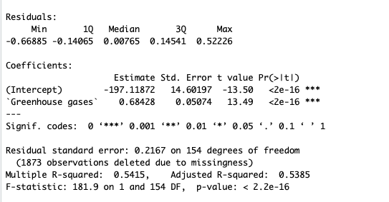

Removed Human forcing:

Removed Land Use:

Removed Volcanic:

Removed Ozone:

Removed Orbital Changes:

Removed Aerosol:

Removed Solar:

After the backwards selection, diagnostic plot has been plotted again and a stronger linear relationship is found. There is also a difference in the Scale Location plot. Residuals are spread more evenly with equal variance after backward selection and the red line is more horizontal which refers to better homoscedasticity.

Linear Regression – Best Fit Line Plots:
Linear regression consists of finding the best-fitting straight line through the data points. The best-fitting line is called a regression line. The diagonal line in the figure below is the regression line and consists of the predicted score on Y (Temperature) for each possible value of X (Forcings).
Graph below shows a linear regression plot for temperature vs greenhouse gases which clearly depicts the strong positive linear relationship between them.
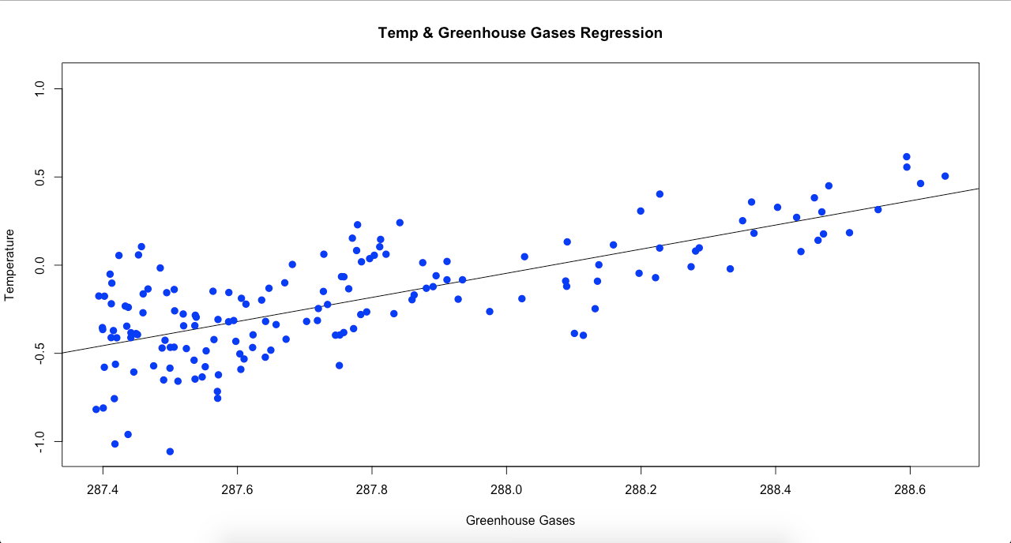
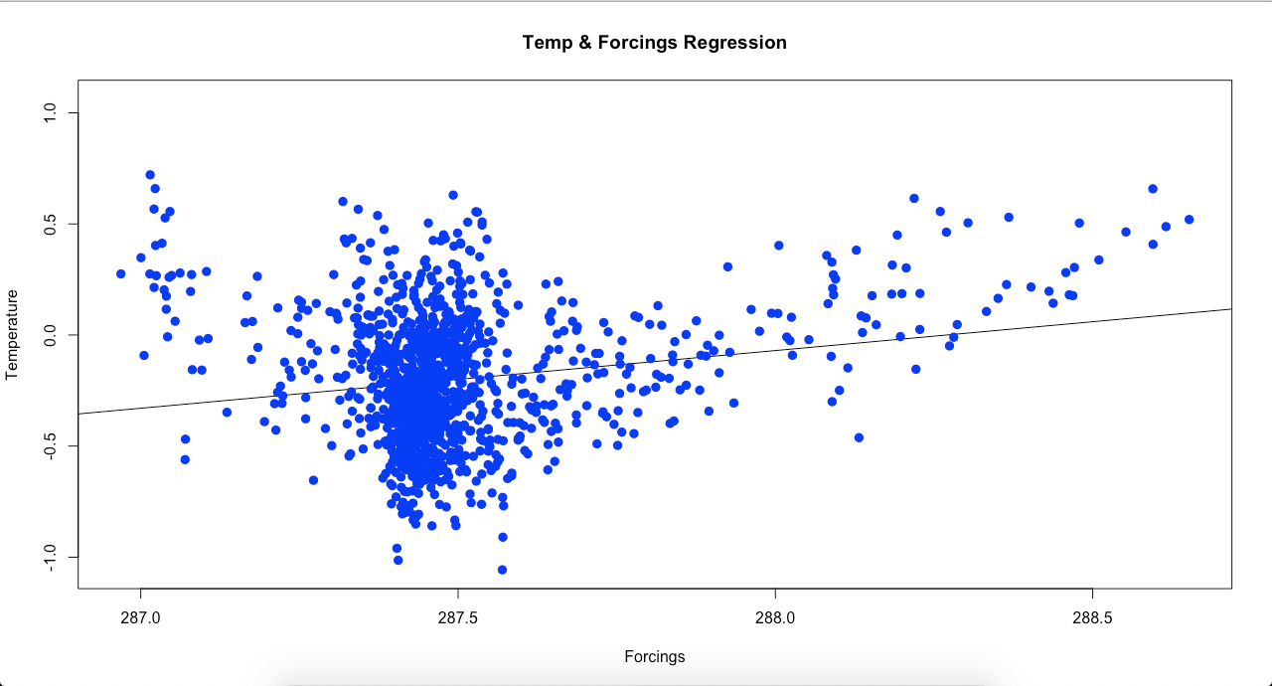

Conclusion:
With the help of our regression model, we can predict that there is 1.5° Climate Temperature increase in the coming year by 2030 which is a very fast approaching. Also, the current WMO report shows with this current rate of emissions, the world will reach at around 1.5° warming by between 2030 and 2052.
Also, by building the right data visualization plots, it helped us in understanding and examining the data visually with better insights before constructing the model.
With the help of linear model diagnostics plot we’ve examined the relationship between the climate forcings and the temperature which concluded that there is a linear relationship.
Moreover, by using variable selection which is a key element for building an efficient model helped us focus on the right predictors, which thereby aided in solidifying our model for predicting temperatures.

References

[1] | E. R. a. B. Migliozzi, "bloomberg.com," 25 June 2015. [Online]. Available: https://www.bloomberg.com/graphics/2015-whats-warming-the-world/.
[2] | D. M. S. a. D. G. Schmidt, "National Aeronautics and Space Administration," 26 June 2018. [Online]. Available: https://data.giss.nasa.gov/modelforce/.
[3] | C. Morice, "Met Office Hadley Center," 15 September 2016. [Online]. Available: https://www.metoffice.gov.uk/hadobs/hadcrut4/.

Appendix:
Plot & Code updates for phase 2:
• plot2 <- ggplot(data = tempDataSet, mapping = aes(x = Year, y = ForceVal, color =
Forcings)) +geom_line() +
scale_x_continuous(breaks=seq(1850,2005,10)) +
theme(plot.title = element_text(hjust = 0.5)) +
labs(title = "Global Forcings Change (1850-2005)", y = "Value") +
scale_color_manual(breaks = c("Human", "Land use","Aerosol","Greenhouse
gases","Orbital changes", "Ozone", "Solar", "Volcanic"),
values=c("#999999", "#E69F00", "#009E73", "red", "#0072B2", "#D55E00",
"#CC79A7", "#000000"))
• tempDataSet %>%
drop_na(Forcings) %>%
ggplot(mapping = aes(x = Year, y = ForceVal, color = Forcings)) +
geom_line() +
scale_x_continuous(breaks=seq(1850,2005,10)) +
theme(plot.title = element_text(hjust = 0.5)) +
labs(title = "Global Forcings Change (1850-2005)", y = "Value") +
facet_wrap("Forcings", ncol=2) +
scale_color_manual(breaks = c("Human", "Land use","Aerosol","Greenhouse
gases","Orbital changes", "Ozone", "Solar", "Volcanic"),
values=c("#999999", "#E69F00", "#009E73", "red", "#0072B2",
"#D55E00", "#CC79A7", "#000000"))
• plot1 <- tempDataSet %>%
group_by(Month) %>%
ggplot(mapping = aes(x = Year, y = MediTemp, group = Month, color = Month)) +
geom_point() +
scale_x_continuous(breaks=seq(1850,2016,10)) +
labs(title = "Global Temperature Change (1850-2016)", y = "Median Surface
Temperature(°C)") +
theme(plot.title = element_text(hjust = 0.5)) +
scale_color_manual(breaks = c("1", "2", "3","4","5","6", "7", "8", "9", "10", "11", "12"),
values=c("#999999", "#E69F00", "#56B4E9", "#009E73", "#F0E442",
"#0072B2", "#D55E00", "#CC79A7", "#000000", "red", "blue", "green"))
plot2 <- ggplot(data = tempDataSet, mapping = aes(x = Year, y = ForceVal, color =
Forcings)) +
geom_line() +
scale_x_continuous(breaks=seq(1850,2005,10)) +
theme(plot.title = element_text(hjust = 0.5)) +
labs(title = "Global Forcings Change (1850-2005)", y = "Value") +
scale_color_manual(breaks = c("Human", "Land use","Aerosol","Greenhouse
gases","Orbital changes", "Ozone", "Solar", "Volcanic"),
values=c("#999999", "#E69F00", "#009E73", "red", "#0072B2",
"#D55E00", "#CC79A7", "#000000"))
grid.arrange(plot1, plot2, nrow=2, ncol=1)
tempModel <- lm(MediTemp~Human+Aerosol+`Greenhouse gases`+`Land use`+`Orbital
changes`+Ozone+Solar+Volcanic, data = tempDataSet, na.action=na.omit)
summary(tempModel)
plot(tempModel)
subsets <- regsubsets(MediTemp~Human+Aerosol+`Greenhouse gases`+`Land
use`+`Orbital changes`+Ozone+Solar+Volcanic, data = tempDataSet,
na.action=na.exclude)
plot(subsets)
• Final diagnostic plots after backward selection:
tempModel <- lm(MediTemp~Human+Aerosol+`Greenhouse gases`+`Land use`+`Orbital
changes`+Ozone+Solar+Volcanic, data = tempDataSet, na.action=na.omit)
summary(tempModel)
tempModel <- lm(MediTemp~Aerosol+`Greenhouse gases`+`Land use`+`Orbital
changes`+Ozone+Solar+Volcanic, data = tempDataSet, na.action=na.omit)
summary(tempModel)
tempModel <- lm(MediTemp~Aerosol+`Greenhouse gases`+`Orbital
changes`+Ozone+Solar+Volcanic, data = tempDataSet, na.action=na.omit)
summary(tempModel)
tempModel <- lm(MediTemp~Aerosol+`Greenhouse gases`+`Orbital
changes`+Ozone+Solar, data = tempDataSet, na.action=na.omit)
summary(tempModel)
tempModel <- lm(MediTemp~`Greenhouse gases`, data = tempDataSet,
na.action=na.omit)
summary(tempModel)
plot(tempModel)

