AWS VPC PEERING
AND EC2 CONNECTIVITY
Project Report
Submitted by
Aalap Goswami
B.Tech Computer Science and Engineering
Date: 30/10/26
Submitted to :- EWB Courses
Amazon Web Services (AWS) • Amazon VPC • Amazon EC2 • MobaXterm

Abstract
This project demonstrates the configuration of two Amazon Virtual Private Clouds (VPCs) and private network communication between EC2 instances using VPC Peering. The implementation covers VPC CIDR planning, subnet configuration, route tables, an Internet Gateway, security group rules, SSH access through MobaXterm, and ICMP connectivity tests. Screenshots should be added to the designated evidence placeholders after verifying the final AWS configuration.

1. Objectives
- Create two logically separate VPC network environments with non-overlapping IPv4 CIDR blocks.
- Configure public and private subnets for network organization.
- Configure route tables and Internet Gateway connectivity where required.
- Establish VPC Peering between VPC A and VPC B.
- Configure security group rules for SSH and ICMP testing.
- Connect to EC2 instances using MobaXterm and verify cross-VPC connectivity.

2. Tools and Services
- Amazon Web Services (AWS) Management Console
- Amazon VPC, subnets, route tables, Internet Gateway, and VPC Peering
- Amazon EC2 with Amazon Linux 2023
- EC2 security groups
- MobaXterm SSH client
- ping utility for ICMP connectivity tests

3. Network Design
The project uses two VPC address spaces. Confirm the final values in the AWS console before submission.
Resource | Name / CIDR | Purpose
VPC A | ewb-vpc-a — 10.10.0.0/16 | Network A
VPC A public subnet | 10.10.1.0/24 | Public-facing resources, if configured
VPC A private subnet | 10.10.2.0/24 | Private resources, if configured
VPC B | ewb-vpc-b — 10.20.0.0/16 | Network B
VPC B public subnet | 10.20.1.0/24 | Public-facing resources, if configured
VPC B private subnet | 10.20.2.0/24 | Private resources, if configured
Note: An additional VPC B subnet (10.20.3.0/24) appeared during configuration. Include it only if it is intentionally part of the final design. Confirm all subnet CIDRs and associations before submitting.

4. Implementation Steps

4.1 Create VPCs
Create VPC A and VPC B with separate, non-overlapping IPv4 CIDR blocks. Verify the VPC names, CIDRs, and state in the VPC console.

4.2 Create subnets
Create the required public and private subnets in their intended VPCs and Availability Zones. Confirm the CIDR blocks and VPC associations.

4.3 Configure Internet Gateway
Attach an Internet Gateway to the VPC that requires internet access. An Internet Gateway alone does not make a subnet public; the subnet also needs an appropriate route and suitable security configuration.

4.4 Configure route tables
Each VPC route table should include its local route. For VPC-to-VPC communication, add a route to the other VPC's CIDR with the VPC Peering connection as the target, and ensure the relevant subnet is associated with that route table.

4.5 Configure VPC Peering
Create a peering connection between the correct VPC A and VPC B IDs and accept it if required. Verify that its state is Active. An Active peering connection still requires correct routes and security group rules to pass traffic.

4.6 Configure security groups
Allow only the traffic required for the project. SSH (TCP port 22) should be restricted to the appropriate trusted source. ICMP rules should allow the relevant peer VPC CIDR for ping testing.

4.7 Connect with MobaXterm
Create an SSH session in MobaXterm using the intended EC2 instance's reachable address, the correct login username (for example, ec2-user on Amazon Linux), port 22, and the matching private key. For a private instance, use an approved access path such as a bastion host or another configured private connectivity method.

5. Connectivity Testing
The following commands were shown in the terminal screenshots. The recorded successful results indicate ICMP connectivity between the two private IP addresses at the time of testing.
ping -c 4 10.20.2.138
ping -c 4 10.10.1.162
Observed results: 4 packets transmitted, 4 received, and 0% packet loss for each shown test. Verify the IP addresses and source server labels in the final screenshots before submission.

6. Screenshot Evidence
Insert the corresponding AWS console or terminal screenshot under each placeholder. Use captions and ensure that resource IDs, statuses, routes, and IP addresses are readable.
Figure 1. VPC list and CIDR blocks
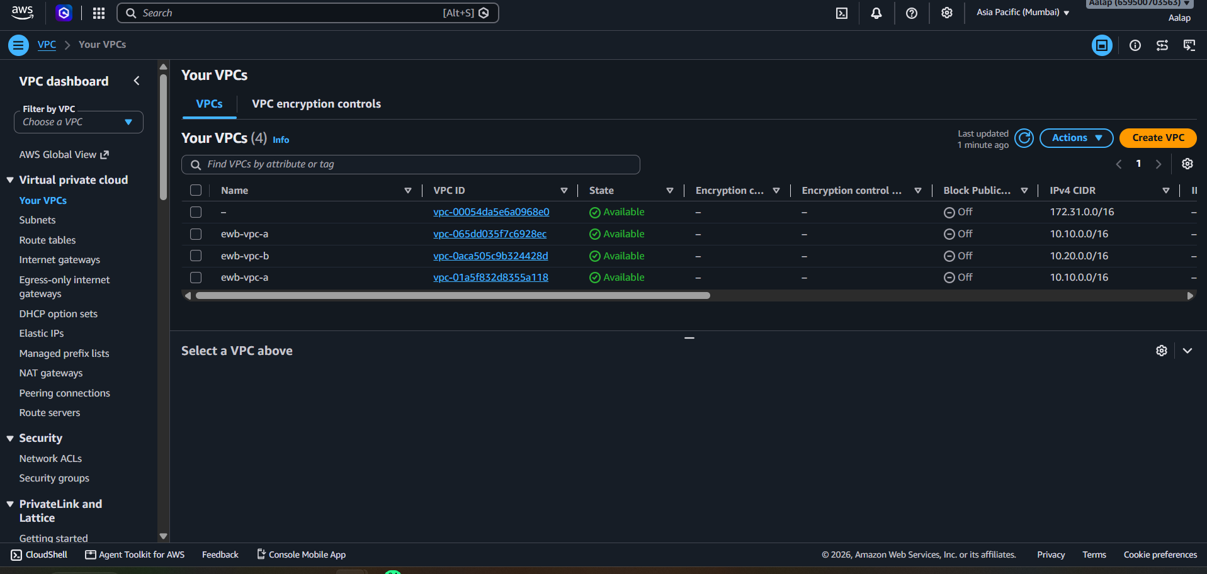
Figure 2. Subnets in VPC A and VPC B
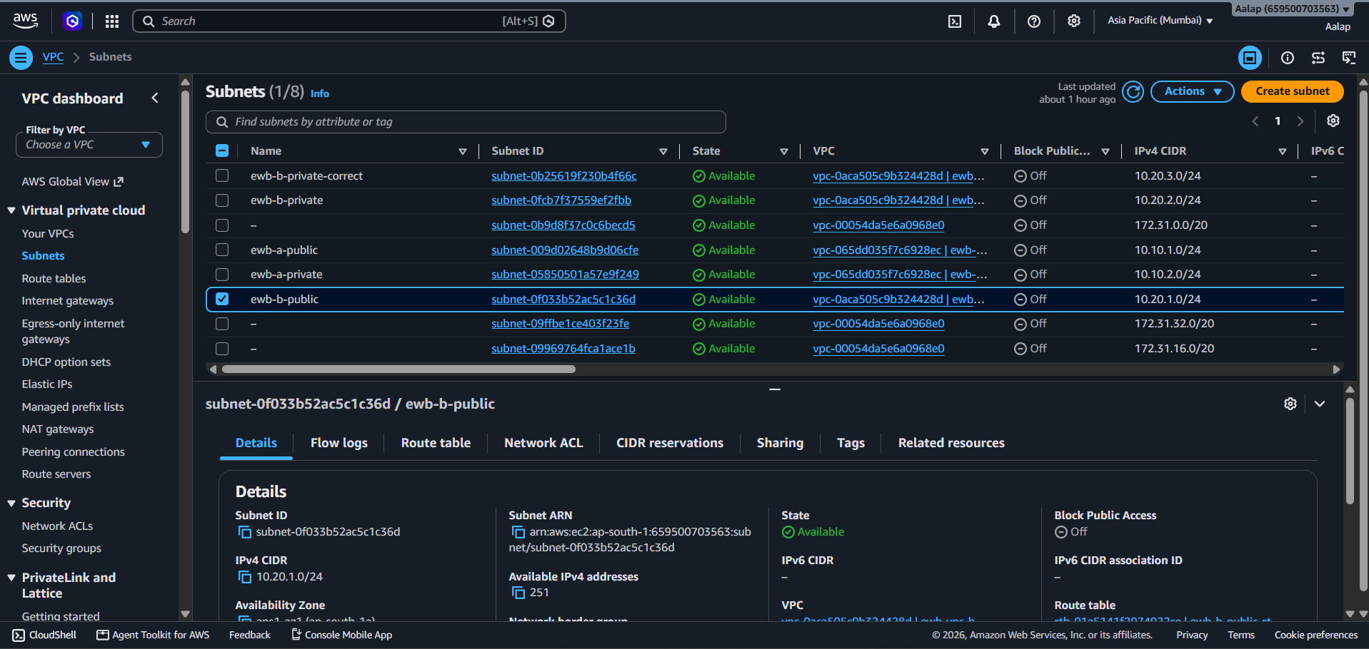
Figure 3. Internet Gateway attachment
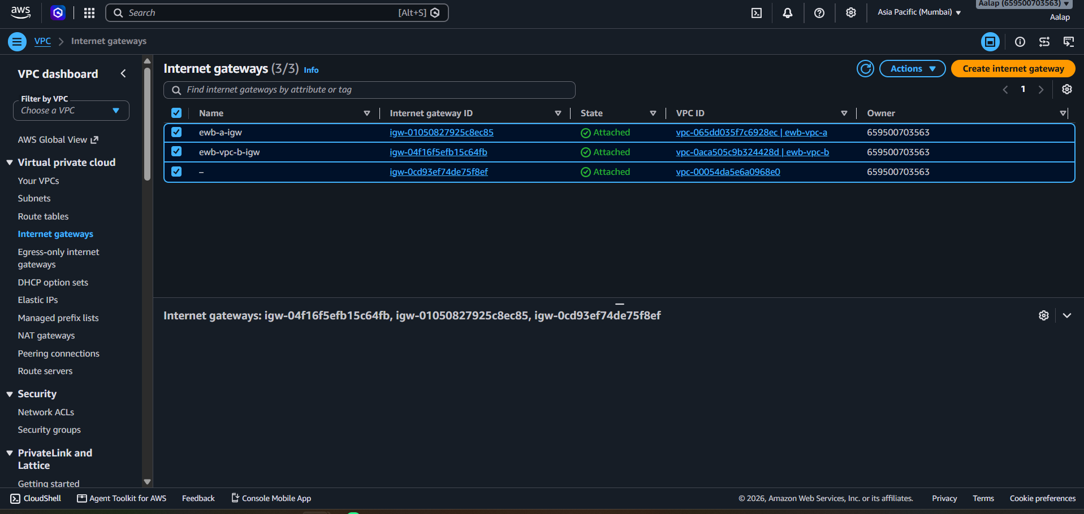
Figure 4. VPC Peering status
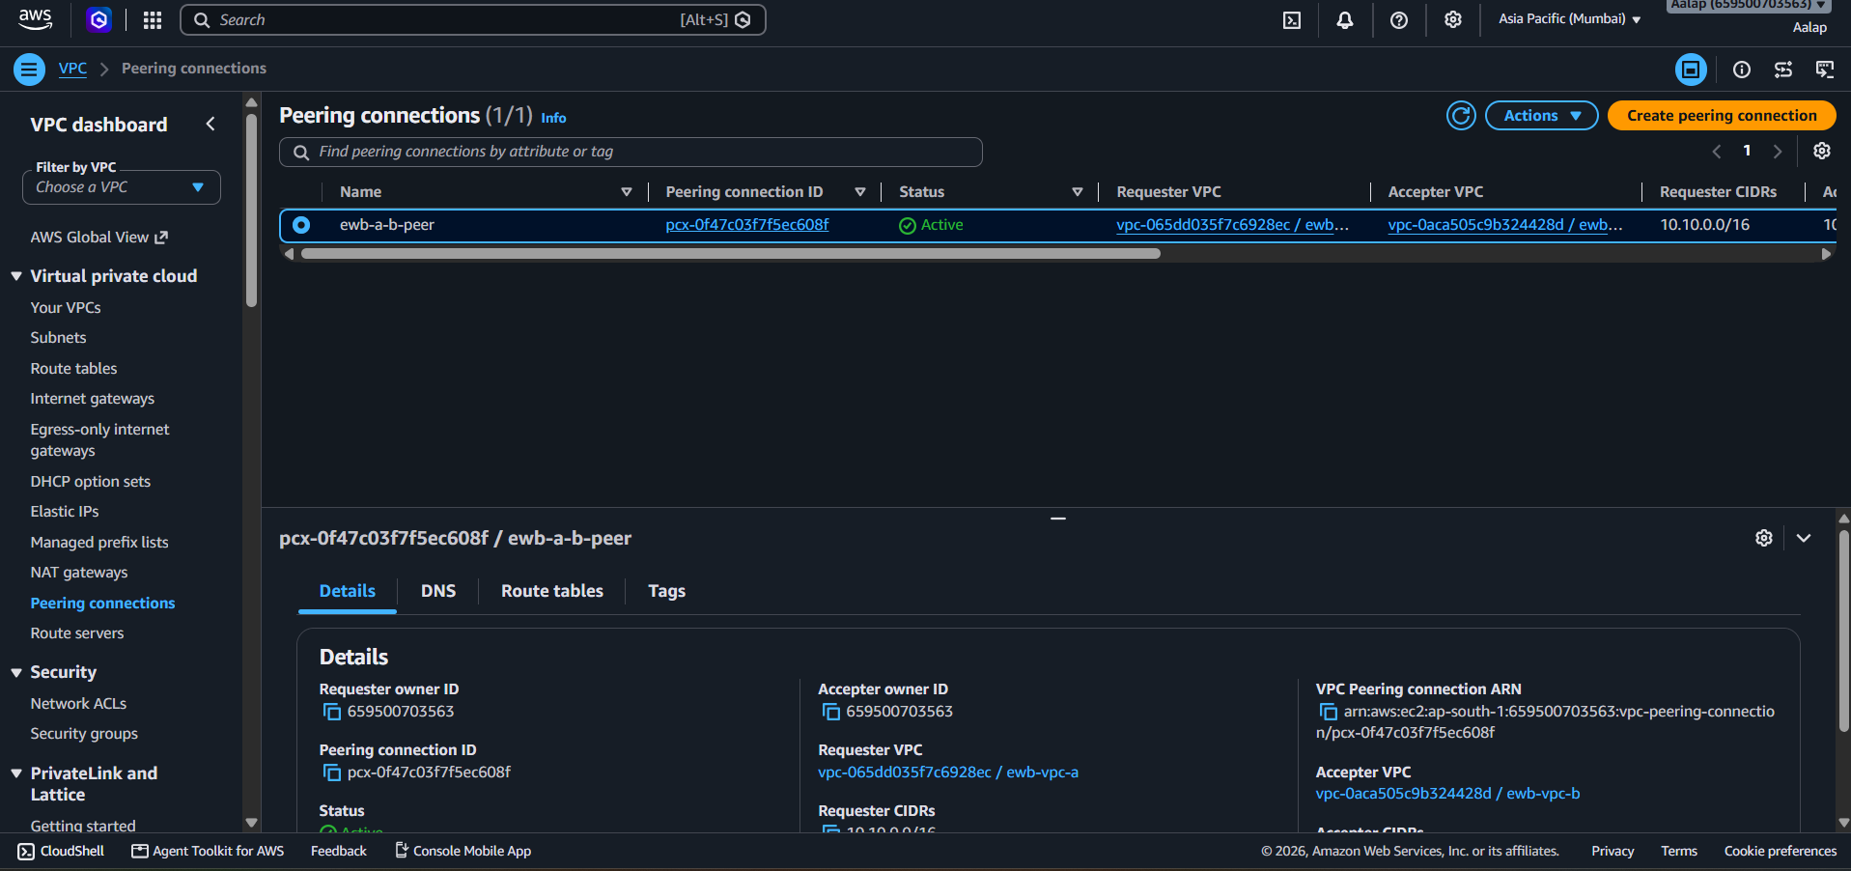
Figure 5. EC2 instance details
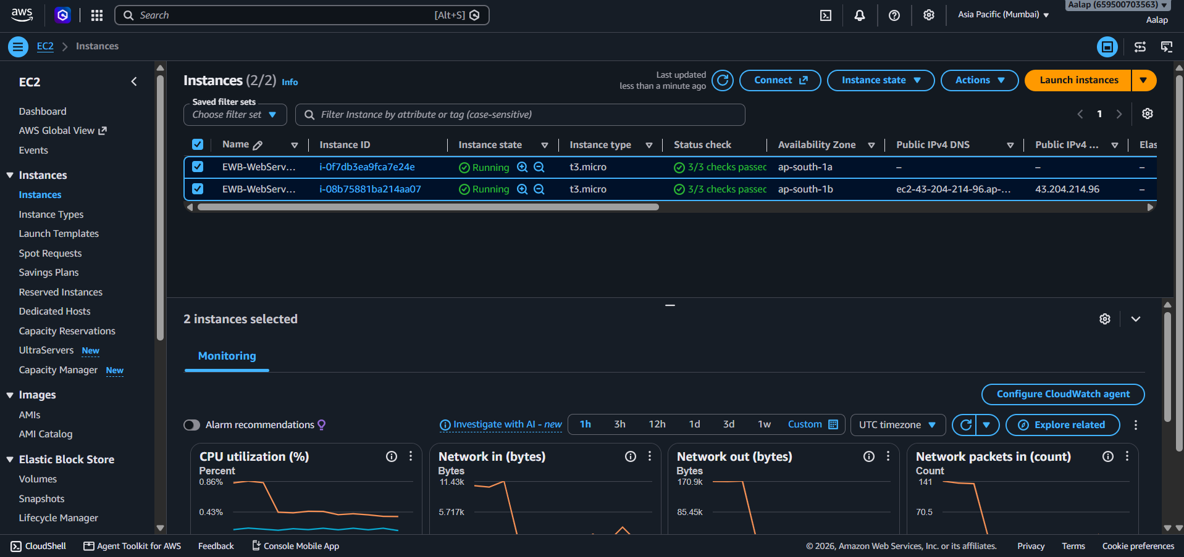
Figure 6. Security group inbound rules
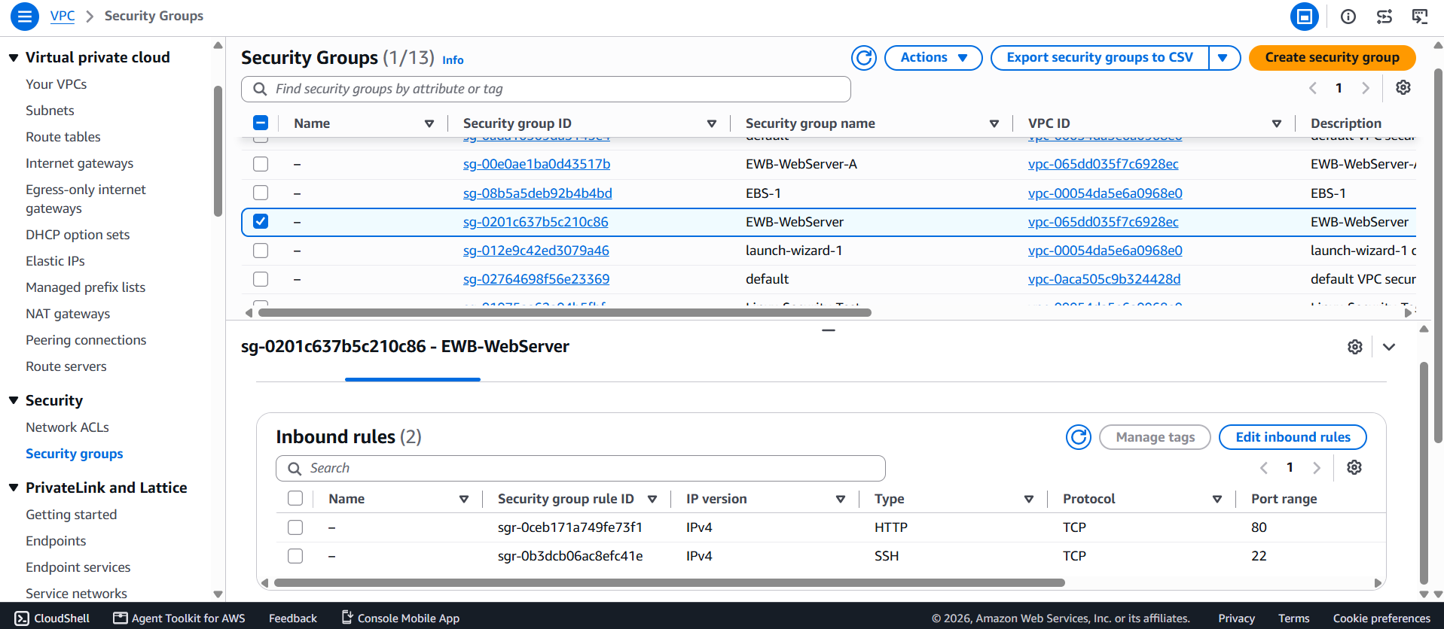
Figure 7. Route table for VPC A
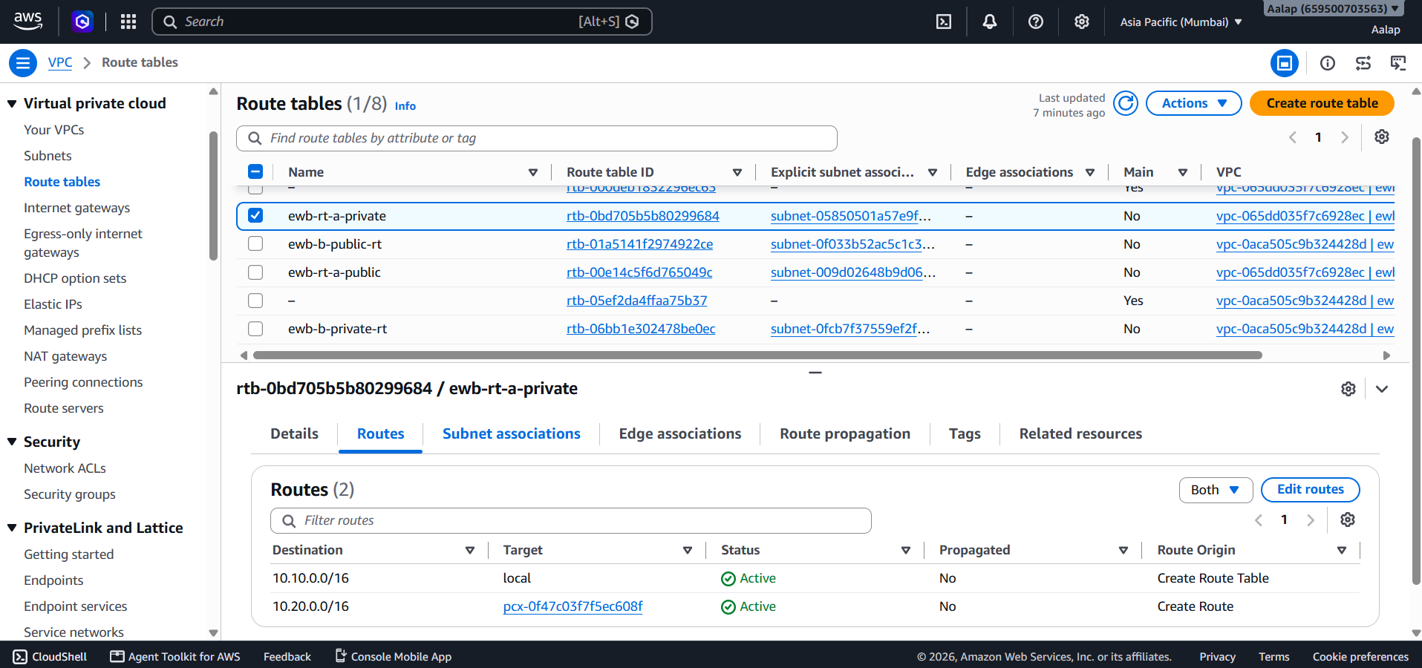
Figure 8. Route table for VPC B
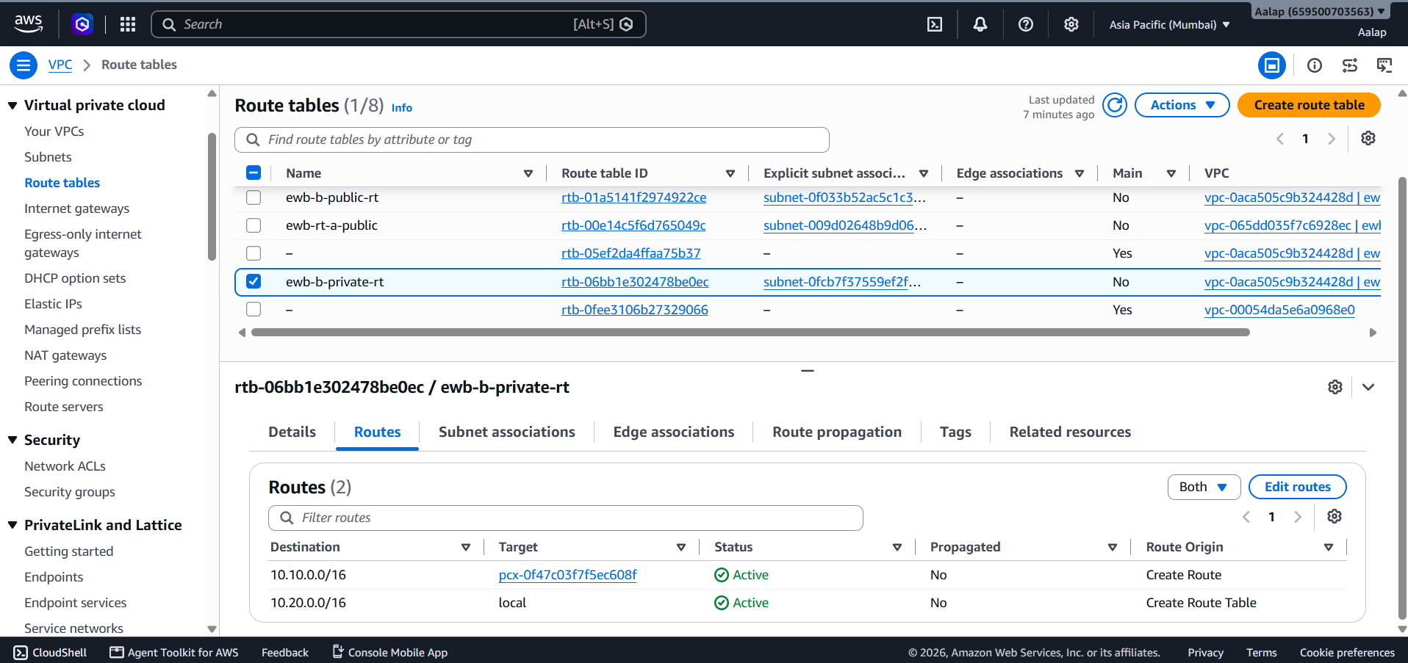
Figure 9. Ping from Server A to Server B
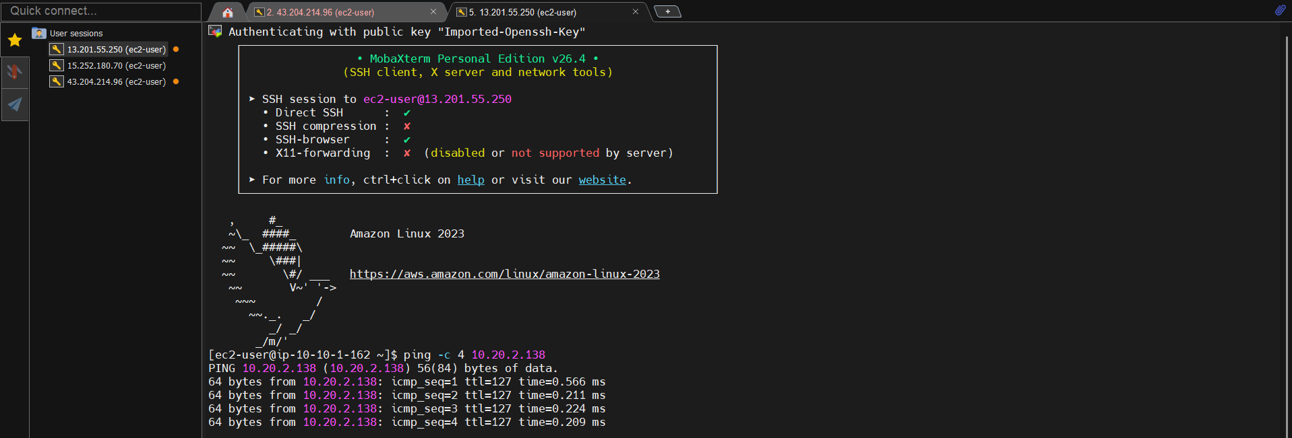
Figure 10. Ping from Server B to Server A
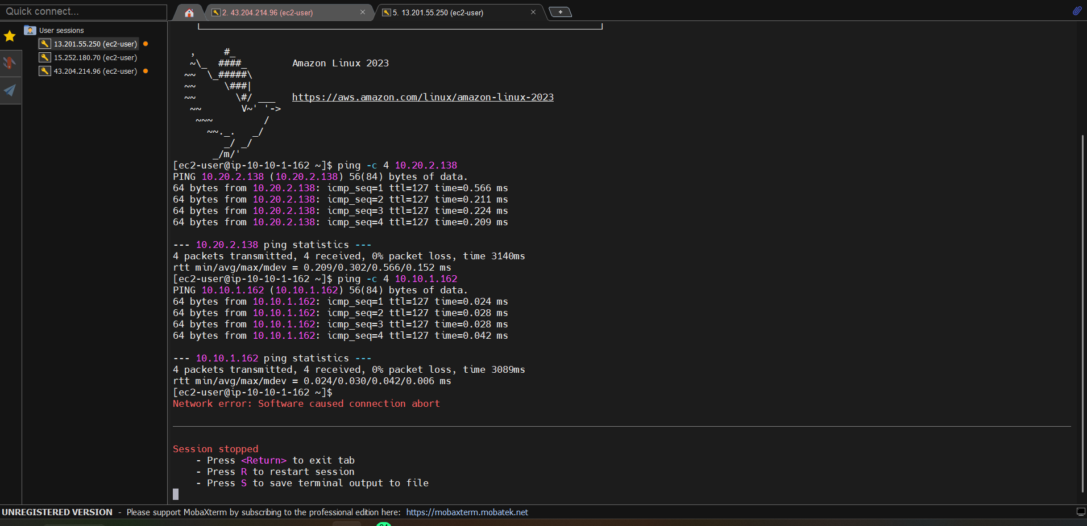

7. Security Considerations
- Use least-privilege security group rules and avoid opening SSH to all IPv4 addresses.
- Do not include private keys, passwords, access tokens, or other secrets in the report or GitHub repository.
- Use private IP addresses for cross-VPC tests when validating private connectivity.
- Verify route table associations and peering routes in both directions.

8. Conclusion
This project provided practical experience with AWS network isolation, subnet design, routing, VPC Peering, security groups, EC2 administration, and remote access through MobaXterm. The recorded ping tests showed successful bidirectional ICMP connectivity between the tested private IP addresses. The final report should include the screenshots that substantiate each configuration and test result.

9. Repository
GitHub repository: https://github.com/goswamiaalap-svg/aws-vpc-peering-project

