Solution Document
Case 2: Stakeholder Transition and Trust
Rebuilding a 68% six-month persistence figure so a sceptical stakeholder can inspect it, test it and explain it
Author: [your name] | Role: Onshore FDE on the account | Date: 3 November 2026
Domain: Pharma, CNS, real-world patient data, persistence analytics | Audience for this document: technical reviewer
Code: https://github.com/goswamivaishnavi45/persistence_case
Contents
1. Solution overview 2
2. Approach and methodology 2
2.1 Steps and why each is needed 2
2.2 Cohort rules as implemented 3
2.3 Persistence and survival logic 4
2.4 Explorer 4
2.5 Methodology assistant 5
3. How you arrived at it 6
3.1 Alternatives weighed 6
3.2 Key assumptions 6
3.3 Clarification Desk answers relied on 7
4. Data 7
4.1 Generation 7
4.2 Built-in mechanisms and parameters 7
4.3 Ground truth 8
4.4 Limitations of the data 8
5. Evaluation 9
5.1 Automated tests 9
5.2 Main results 10
5.3 Sensitivity analysis 10
5.4 Uncertainty 12
5.5 Assistant evaluation 13
5.6 Mid-session update 14
6. Tech stack 14
7. Use of LLMs 15
7.1 Where an LLM is used, and why 15
7.2 How it is grounded 16
7.3 How it was evaluated 16
7.4 Known failure modes 16
8. Limitations and next steps 17
8.1 Limitations of this rebuild 17
8.2 What would change for a real client deployment 17
8.3 Next steps, in priority order 18
9. Submission index 18

1. Solution overview
The interim VP must defend a 68% six-month persistence figure to commercial leadership in five days, with no handover and a field team reporting that patients stop much sooner, so the real problem is that nobody left on the account can explain or test the number. I rebuilt the Exhibit 1 method on synthetic pharmacy claims for 6,000 patients as tested Python (19 passing tests), and added a Kaplan-Meier view, a 27-scenario sensitivity grid, an interactive HTML explorer and a citation-grounded LLM methodology assistant. The original rules give 68.2% of 3,010 patients (95% interval 66.5 to 69.8%), which is a correct answer to a narrow question: of continuously insured new starters, how many had no break longer than 60 days by month 6? The allowed gap moves the figure most (41.5% at 30 days, 81.2% at 90 days), the 12-month look-forward lifts it by removing 833 patients who lost coverage (64.5% with censoring, 57.8% worst case), and about 53% of the six-month drop-off has already happened by month 3. These effect sizes come from synthetic data built to contain these mechanisms, so the recommendation is to present 68% with its definition and curve, and to rerun the same code on the client's claims before quoting any corrected figure.

2. Approach and methodology

2.1 Steps and why each is needed
# | Step | Method | Why it is needed
1 | Generate reproducible data | src/generate_data.py: seeded patient-level simulation with known mechanisms and a ground-truth table | No client data is available. A known truth lets the rebuild test whether a method recovers it, which real claims cannot do.
2 | Encode the cohort rules | src/cohort.py: Exhibit 1 as small functions tagged R1 to R8, driven by one Params object | The method was never written up. Named rules give the code, tests, explorer and assistant one shared vocabulary.
3 | Test each rule | tests/test_cohort.py: boundary cases such as a gap of exactly 60 versus 61 days | A sceptic needs evidence that the rule does what the words say, especially at the edges.
4 | Show time to discontinuation | Kaplan-Meier estimator with censoring (R8), implemented directly and tested against a hand calculation | A single 6-month point hides when stopping happens, and censoring can keep patients the look-forward rule drops.
5 | Run sensitivity analyses | src/sensitivity.py: full factorial, 3 gaps x 3 look-forwards x 3 first-fill definitions = 27 scenarios | Shows which choices move the number and which do not. Required by the case.
6 | Quantify uncertainty | src/robustness.py: Wilson and Greenwood 95% intervals, 10 generator seeds, one generator stress test | Separates sampling noise from definitional effects, and shows how far results depend on generator assumptions.
7 | Make it inspectable | outputs/explorer.html: the same logic ported to src/engine.js, running on inlined data in the browser, with a test that compares it to Python | The stakeholder must be able to test assumptions without Python or an analyst.
8 | Make it explainable | assistant/assistant.py: retrieval over written sources, LLM answer, citation check, scope guard | The stakeholder must be able to ask about any rule and get an answer that traces to a source rule.
9 | Evaluate the assistant | assistant/run_eval.py: 14 answerable and 7 should-decline questions | Required by the case, and an unevaluated assistant would be another number to take on trust.

2.2 Cohort rules as implemented
Rule IDs are shared across code, tests, the methodology document (assistant/methodology.md), the explorer labels and assistant citations. A reader can follow one rule from the case exhibit to the line of code that enforces it.
Table 1. Exhibit 1 mapped to rules and code
ID | Exhibit 1 criterion | Implementation | Code and tests
R1 | Index event: first fill of the drug | First BRAND_TRD fill anywhere in the data (first_ever). Other antidepressants are ignored. Alternative for sensitivity: first fill on or after the intake start (first_in_window). | index_date(); test_index_ignores_other_drugs, test_first_in_window_ignores_earlier_fills
R2 | Implied by look-back and look-forward | Index date between 2022-01-01 and DATA_END minus the follow-up needed (2024-12-31 under the original rules). Data runs 2021-01-01 to 2025-12-31. | build_cohort(); test_index_before_intake_window_excluded
R3 | Look-back: 12 months continuous enrolment before index | One merged coverage segment must span index minus 365 days to index. Back-to-back segments merge; any break fails. | continuously_enrolled(); test_back_to_back_segments_merge, test_break_in_coverage_fails_continuous_enrolment, test_lookback_excludes_recent_joiner
R4 | Look-forward: 12 months continuous enrolment after index | Coverage end, capped at DATA_END, must reach index plus 365 days. Failing patients are removed entirely. | build_cohort(); test_lookforward_excludes_coverage_loss
R5 | No gap longer than 60 days | Gap = next fill date minus the day supply runs out. Over 60 days is a discontinuation dated to the day supply ran out. Exactly 60 is allowed. | time_to_discontinuation(); test_gap_exactly_at_limit_is_allowed, test_gap_one_day_over_limit_discontinues
R6 | Not stated, assumption | Early refills carry leftover supply forward: covered_end = max(covered_end, day) + supply. | test_early_refill_carries_supply_forward
R7 | Still filling at 6 months | Persistent if not discontinued before day 182. Headline = persistent / cohort. | summarise(); test_persistence_flag_at_six_months
R8 | Added by this rebuild | Kaplan-Meier survival. Patients whose coverage ends before a discontinuation is observed are censored at follow-up end. | kaplan_meier(); test_kaplan_meier_matches_hand_calculation, test_censored_when_follow_up_ends_inside_gap_window

2.3 Persistence and survival logic
For each included patient, with fills expressed as (day relative to index, days' supply) and sorted by day, the algorithm walks forward:
- Set covered_end to the first fill's supply end.
- For each later fill inside follow-up: if day - covered_end > max_gap, return (covered_end, event = 1). Otherwise set covered_end = max(covered_end, day) + supply.
- After the last fill: if follow_end - covered_end > max_gap, return (covered_end, event = 1). Otherwise return (follow_end, event = 0, censored).
The Kaplan-Meier estimate is S(t) = product over event times t(i) <= t of (1 - d(i) / n(i)), where d(i) is discontinuations and n(i) is patients at risk at t(i). Under the original rules, 2,234 of 3,010 patients have an event over full follow-up and 776 are censored, none of them before day 182 because R4 guarantees 365 days of observation. Without R4, 371 patients are censored before day 182.
Censoring assumes that patients who lose coverage are otherwise similar to those who stay. In this data that assumption is false by construction, which is why a worst-case figure, counting every patient censored before day 182 as stopped, is reported alongside the Kaplan-Meier figure.

2.4 Explorer
outputs/explorer.html is one self-contained 0.8 MB file with the engine and compact patient data inlined, so it needs no server, login or install. It has range sliders for allowed gap (15 to 120 days), look-back (0 to 12 months) and look-forward (0 to 12 months), and toggles for the first-fill definition and for how lost-coverage patients are treated. Each change recomputes the cohort in JavaScript and updates the Kaplan-Meier curve, the original-method reference curve, the synthetic-truth marker, four headline tiles, a plain-language explanation and the cohort funnel.
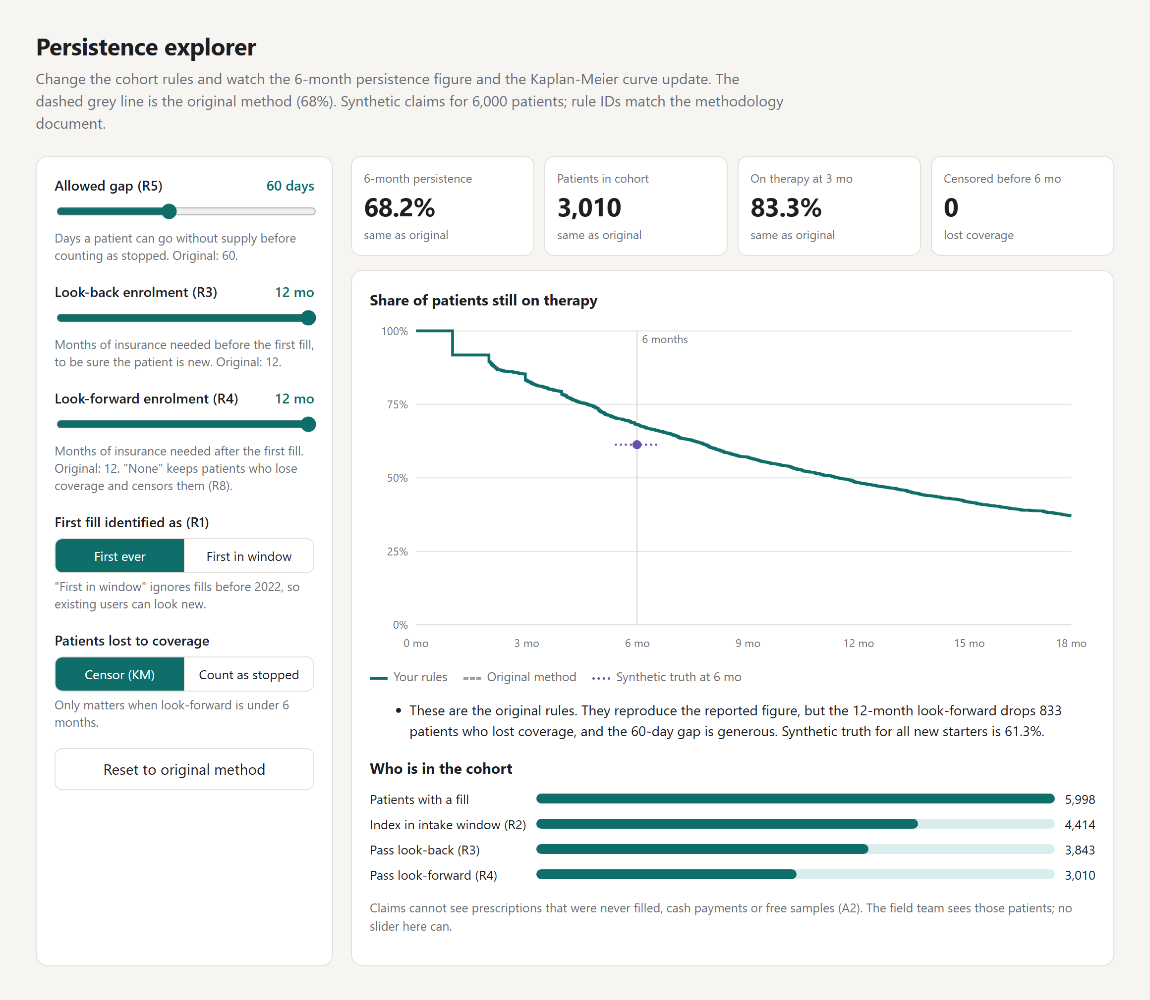
Figure 1. Explorer at the original rules, 68.2% with 3,010 patients. Rendered in headless Chrome from outputs/explorer.html.

2.5 Methodology assistant
The pipeline in assistant/assistant.py is a small retrieval-augmented design:
- Sources. assistant/methodology.md (rules R1 to R8, assumptions A1 and A2) and outputs/results.md (results O1 to O8) are split into 18 sections, one per ID.
- Scope guard. Regular expressions decline clinical, pricing, competitor, individual-patient, forecast and blame questions before any LLM call.
- Retrieval. TF-IDF (unigrams and bigrams, sublinear term frequency) with cosine similarity, top 3 sections. An ID named in the question, such as R4, is always retrieved. A top score under 0.10 is declined.
- Generation. The LLM receives only the retrieved sections and must return JSON: answer, citations, declined. Temperature is 0 on Gemini.
- Grounding check. Citations not among the retrieved sections are dropped. A non-declined answer with no surviving citation becomes a refusal.

3. How you arrived at it

3.1 Alternatives weighed
Decision | Rejected alternative | Why this choice
Purpose-built generator | Synthea or CMS synthetic public-use files | The case allows either. Public files do not provide a known truth for how each bias operates, and the question is whether a rule can distort the number. A controllable generator can switch each mechanism on and off. The cost is that effect sizes reflect my parameters (Section 4.4).
Gap from supply end to next fill | Fill-to-fill interval | A fill-to-fill rule penalises 90-day fills, which make up 8% of brand fills here. Supply-based gaps treat 30-day and 90-day fills consistently.
Gap rule as the persistence measure | Proportion of days covered (PDC) | PDC measures adherence, and Exhibit 1 specifies a gap rule. Replacing the definition would stop the analysis reproducing the disputed number.
Kaplan-Meier from first principles | lifelines or similar | About 15 lines, fully testable against a hand calculation, and easy to port to JavaScript. A dependency would add little here, though a library becomes worthwhile for Cox models or competing risks.
Censor and report a worst case | Censoring only | Coverage loss is plausibly linked to stopping, so censoring alone could give false comfort. Reporting both makes the assumption visible.
JavaScript engine in the browser, with a parity test | Precomputed grid in HTML; hosted Streamlit or Dash app | A grid limits users to tested combinations and cannot offer continuous sliders. A hosted app adds infrastructure and access problems in a five-day window. A second engine creates drift risk, which the parity test controls.
TF-IDF retrieval | Embeddings and a vector store | The corpus is 18 short sections with precise vocabulary. TF-IDF is deterministic, needs no external call and is easy to debug. Its weakness is paraphrase, as Q12 shows (Section 5.5).
Structured JSON output with citation check | Free-text LLM answer | Citations can be checked in code, so an uncited answer can be refused automatically.
Guard before the LLM | Rely on the system prompt | Clinical and individual-patient questions should never reach a model. A deterministic layer also means those declines do not depend on model behaviour.

3.2 Key assumptions
# | Assumption | Rationale and how it can be checked
1 | A gap runs from the day supply runs out to the next fill. Exactly 60 days is allowed; 61 is a discontinuation. | Exhibit 1 says "no gap longer than 60 days". Boundary covered by two tests.
2 | The discontinuation date is the day supply ran out, and not the day the gap limit was crossed. | Reflects when therapy actually ended. Affects curve timing and median, and moves a patient across day 182 only when supply ends just before it.
3 | Early refills carry leftover days forward. | Standard for days' supply logic. Tested.
4 | Persistent at 6 months means not discontinued before day 182. | A reading of "still filling at 6 months". A stricter reading would require a fill on or after day 182, which should be raised with the client.
5 | Switching to or adding another antidepressant does not count as stopping the brand or as an index event for it. | Other drugs appear in the data only as noise for R1. In treatment-resistant depression, augmentation and switching are common, so this needs clinical input on real data.
6 | Continuous enrolment allows back-to-back segments; any real break fails. | Matches the case definition, "no break for the whole period". Tested both ways. Real analyses often allow a short grace period, so this is worth confirming.

3.3 Clarification Desk answers relied on
[FILL IN BEFORE SUBMITTING: list each question you put to the Clarification Desk and the answer you received. If you did not use the desk, replace this paragraph with: "No Clarification Desk answers were relied on; all assumptions above are my own and are listed for client confirmation."]
[CHECK: the README marks assumption 1, how a gap is measured, as "confirmed". State here who confirmed it. If it was not the Clarification Desk, change the README wording.]

4. Data

4.1 Generation
src/generate_data.py simulates patients one at a time from a single seeded NumPy generator (default seed 42), so the same seed always gives identical tables, which test_generator_is_reproducible confirms. No public dataset was used. It writes three tables to data/.
Table | Columns | Size at seed 42
fills.csv | patient_id, fill_date, drug, days_supply | 65,868 fills: 62,695 brand, 3,173 other drugs
enrolment.csv | patient_id, enrol_start, enrol_end | 6,305 segments; 305 patients have two
truth.csv | patient_id, high_risk, prevalent, true_days_on_therapy, true_start | 6,000 patients. Not claims data: kept only for benchmarking

4.2 Built-in mechanisms and parameters
Table 2. Generator parameters (GenConfig defaults)
Mechanism | Parameters | Effect it creates
Two latent patient types | 30% high-risk (30.7% realised). Mean intended therapy: 110 days high-risk, 1,100 days stable, exponentially distributed | Heterogeneous early stopping
Coverage loss linked to risk | 60% of high-risk patients lose coverage, 20 to 364 days after start. 10% of stable patients, 30 to 699 days after start | Selection through the look-forward rule (R4)
Late refills | 66% between 5 days early and 7 days late; 20% 8 to 30 days late; 10% 31 to 60 late; 4% 61 to 90 late | Sensitivity to the allowed gap (R5)
Prevalent users | 12% (11.6% realised) join the plan 10 to 119 days before their observed first fill; mean therapy 1,430 days | Existing users can look new (R1, R3)
Coverage breaks | 5% of patients with long enrolment have a 20 to 59 day break | Exercises continuous-enrolment logic
Other antidepressants | 25% of patients have 1 to 4 sertraline or bupropion fills | Noise the index rule must ignore
Days' supply | 92% 30-day, 8% 90-day | Exercises supply-based gap logic
Claims visibility | A fill reaches the claims table only if the patient is covered that day | Claims go silent when coverage ends
The generator was tuned so the original rules land close to the reported 68%. test_original_rules_close_to_reported_68 checks that a different seed and sample size stay within 62 to 74%. This means reproducing 68% does not independently validate the original figure. It shows only that the logic is coherent and that the mechanisms can coexist with a figure of that size.

4.3 Ground truth
Because every fill the patient really made is simulated, including fills after insurance ends, the true figure is knowable. truth_benchmark() selects genuine new starters (not prevalent) with a true start between 2022-01-01 and 2024-12-31, and computes the share with at least 182 days on therapy under a 60-day gap, using all fills whether insured or not. The result is 61.3%, so the original method overstates truth by 6.9 points at seed 42. Real data has no equivalent of this benchmark.
The truth table also lets me verify what each exclusion actually removes:
Table 3. Who each rule removes, checked against the synthetic truth (seed 42)
Group | Patients | Already on drug | High-risk | True 6-month persistence
Excluded by R2 (631 too early, 953 too late) | 1,584 | 12.0% | 30.9% | 56.6% (see note)
Excluded by R3 look-back | 571 | 88.3% | 35.0% | 76.7%
Excluded by R4 look-forward | 833 | 0.0% | 81.8% | 35.5%
Included in analysis cohort | 3,010 | 0.0% | 15.6% | 68.2%
Note: for R2, late starters have true days on therapy truncated by the end of data, so 56.6% understates persistence for that group and should not be read as a bias estimate.

4.4 Limitations of the data
- Effect sizes are consequences of my parameters. Section 5.4 shows the look-forward effect vanishes if coverage loss is unrelated to risk.
- The mechanisms were chosen in advance to illustrate the bias channels the case asks about, so the analysis cannot discover a mechanism I did not build.
- Not modelled: primary non-adherence, cash payments, samples, dose changes, switching logic, seasonality, prescriber or payer effects, hospital dispensing and restarts as a distinct behaviour.
- Simple distributions. Exponential durations and a fixed refill-delay mix do not capture the shape of real treatment-resistant depression therapy. The steep first steps in the curve at days 30 and 60 follow from the mostly 30-day supply.
- Brand is a placeholder. BRAND_TRD is not a real product, and no clinical inference should be drawn.

5. Evaluation

5.1 Automated tests
python -m pytest -q gives 19 passed. These are 18 rule and generator tests plus one parity test running five rule configurations through both engines.
Table 4. Test coverage
Area | Tests | What is asserted
R5, R6 gap and carry-over | 5 | 60-day gap allowed, 61 discontinues, early refills carry forward, censoring inside the gap window, fills beyond follow-up ignored
R3, R4 enrolment | 4 | Back-to-back segments merge, a break fails, a recent joiner is excluded by look-back, coverage loss is excluded by look-forward (and returns when the rule is off)
R1, R2 index date | 3 | Other drugs ignored, first-in-window skips earlier fills, index before the intake window excluded
R7, R8 results | 2 | Persistence flag on toy patients (50%); Kaplan-Meier against a hand calculation
Generator | 4 | Reproducible by seed, fills only inside coverage, original rules within 62 to 74% on another seed, persistence rises strictly with gap
Explorer parity | 1 | Python and engine.js return identical cohort size, persistence and Kaplan-Meier value for five configurations, including in-between slider stops
I also drove the built explorer's real controls in headless Chrome. All values match outputs/sensitivity.csv, and reset returns to the original.
Table 5. Explorer browser check
Control state | 6-month figure | Cohort | Matches Python
Original rules | 68.2% | 3,010 | Yes
Gap 30 days | 41.5% | 3,010 | Yes
Gap 90 days | 81.2% | 3,010 | Yes
Look-forward 6 months | 64.3% | 3,998 | Yes
Look-forward none, censored | 64.5% | 4,446 | Yes
Look-forward none, counted as stopped | 57.8% | 4,446 | Yes
Look-back 6 months | 68.3% | 3,032 | Yes
Look-back none, first fill in window | 69.8% | 3,840 | Yes

5.2 Main results
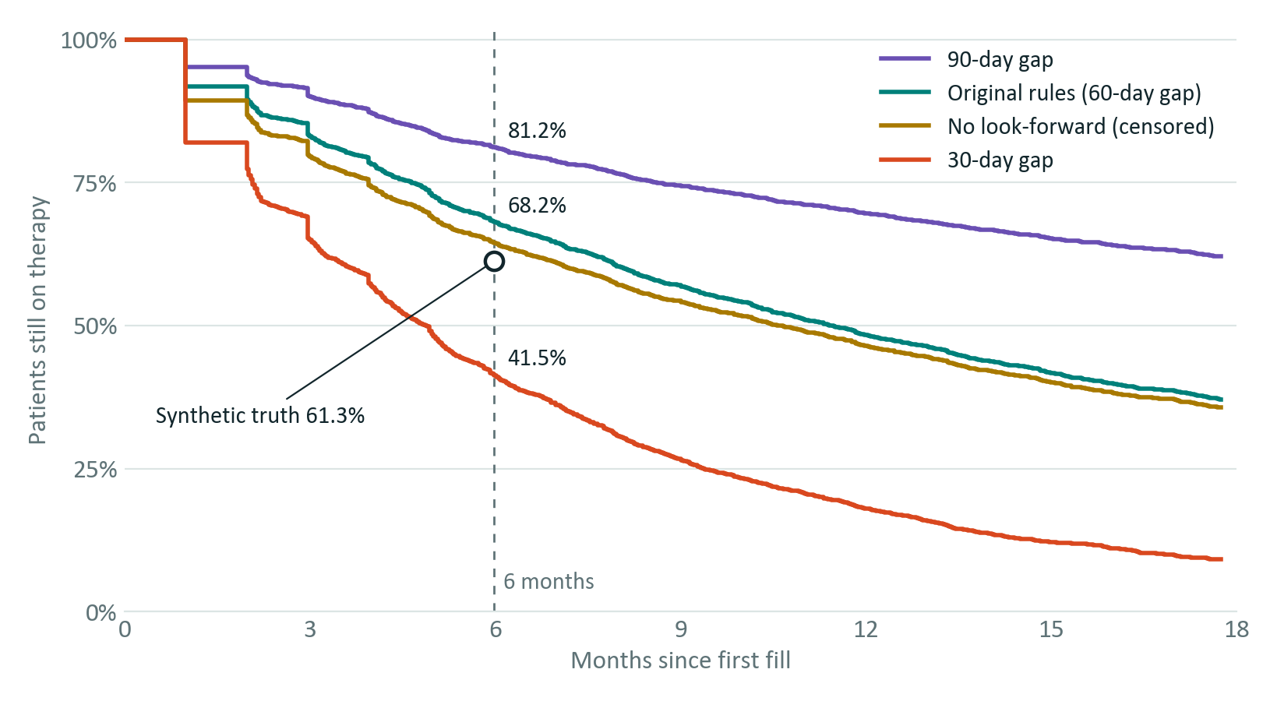
Figure 2. Kaplan-Meier curves. Under the original rules: 83.3% at 3 months, 68.2% at 6 months, 48.4% at 12 months, median 348 days. At 3 months, 16.7 of the 31.8 points lost by month 6 have gone, which is about 53%.
Table 6. Attrition under the original rules
Step | Removed | Remaining
Patients with a brand fill in claims (of 6,000 simulated) |  | 5,998
R2: index outside intake window | 1,584 | 4,414
R3: failed look-back enrolment | 571 | 3,843
R4: failed look-forward enrolment | 833 | 3,010

5.3 Sensitivity analysis
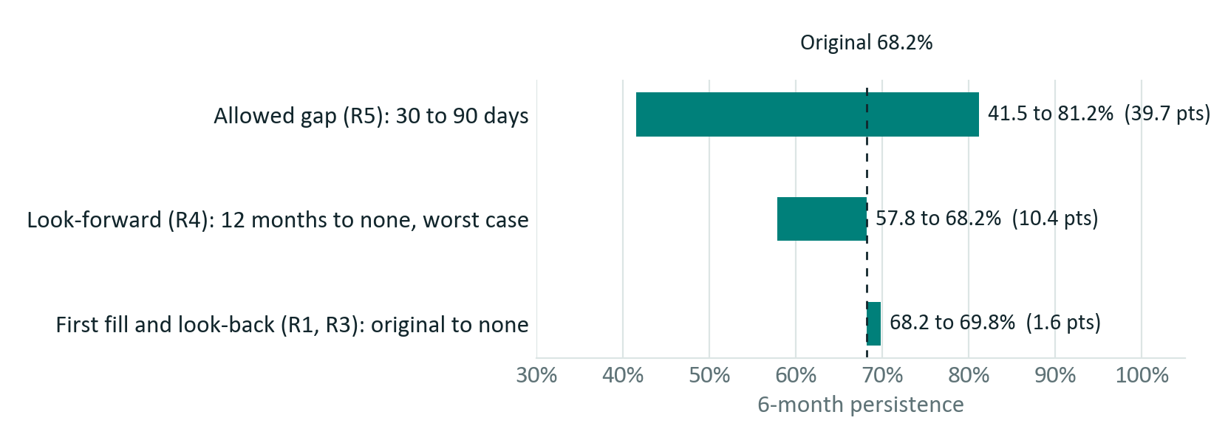
Figure 3. Swing in 6-month persistence as one rule changes, others held at original values.
Table 7. Which choices could make 68% differ from what the field sees
Choice | Effect | Interpretation
Allowed gap | 41.5 to 81.2% | Largest lever, 39.7 points. If the field thinks of a month off drug as stopping, its mental model is closer to 41.5% than 68%.
12-month look-forward | 64.5% (KM), 57.8% (worst) | Removes patients with true persistence of 35.5%. This is a selection effect that can only be seen by relaxing the rule.
How a first fill is identified | 68.2 to 69.8% | Small here, because the 12-month look-back already removes people already on the drug. First-in-window with look-back kept gives 68.7%; first-ever with no look-back gives 69.3%. Combined: 69.8%.
Single-point view | 83.3% at month 3 | Not a rule change. Over half of stopping by month 6 happens in the first 3 months, and that is the phase the field is most likely to notice.
Claims visibility | Not quantifiable here | Never-filled prescriptions, cash payments and samples never enter claims. No rule change can recover them, yet the field does see these patients.
A caution on the look-forward arithmetic: R4 removes 833 patients, but dropping it grows the cohort by 1,436, from 3,010 to 4,446. The other 603 enter because R2 no longer requires 12 months of follow-up, so later index dates qualify. Holding the original intake window (n = 3,843) gives 64.1% (95% interval 62.6 to 65.7%), or 57.6% worst case, against 64.5% and 57.8% with the wider window. The conclusion does not change, but this is the cleaner estimate of the R4 effect alone.
Table 8. Full 27-scenario grid (outputs/sensitivity.csv). The original method is in bold.
Gap | Look-forward | First-fill definition | Cohort | Observed % | KM % | Worst %
30 | 12 mo | 12 mo look-back, first ever | 3,010 | 41.5 | 41.5 | 41.5
30 | 12 mo | 6 mo look-back, first ever | 3,032 | 41.6 | 41.6 | 41.6
30 | 12 mo | No look-back, first in window | 3,840 | 42.8 | 42.8 | 42.8
30 | 6 mo | 12 mo look-back, first ever | 3,998 | 38.7 | 38.7 | 38.7
30 | 6 mo | 6 mo look-back, first ever | 4,029 | 38.8 | 38.8 | 38.8
30 | 6 mo | No look-back, first in window | 5,009 | 40.6 | 40.6 | 40.6
30 | None | 12 mo look-back, first ever | 4,446 | 37.2 | 38.7 | 34.8
30 | None | 6 mo look-back, first ever | 4,480 | 37.3 | 38.7 | 34.9
30 | None | No look-back, first in window | 5,602 | 39.0 | 40.6 | 36.3
60 | 12 mo | 12 mo look-back, first ever | 3,010 | 68.2 | 68.2 | 68.2
60 | 12 mo | 6 mo look-back, first ever | 3,032 | 68.3 | 68.3 | 68.3
60 | 12 mo | No look-back, first in window | 3,840 | 69.8 | 69.8 | 69.8
60 | 6 mo | 12 mo look-back, first ever | 3,998 | 64.3 | 64.3 | 64.3
60 | 6 mo | 6 mo look-back, first ever | 4,029 | 64.3 | 64.3 | 64.3
60 | 6 mo | No look-back, first in window | 5,009 | 66.7 | 66.7 | 66.7
60 | None | 12 mo look-back, first ever | 4,446 | 63.1 | 64.5 | 57.8
60 | None | 6 mo look-back, first ever | 4,480 | 63.1 | 64.6 | 57.8
60 | None | No look-back, first in window | 5,602 | 65.5 | 67.0 | 59.6
90 | 12 mo | 12 mo look-back, first ever | 3,010 | 81.2 | 81.2 | 81.2
90 | 12 mo | 6 mo look-back, first ever | 3,032 | 81.3 | 81.3 | 81.3
90 | 12 mo | No look-back, first in window | 3,840 | 82.8 | 82.8 | 82.8
90 | 6 mo | 12 mo look-back, first ever | 3,998 | 76.8 | 76.8 | 76.8
90 | 6 mo | 6 mo look-back, first ever | 4,029 | 76.8 | 76.8 | 76.8
90 | 6 mo | No look-back, first in window | 5,009 | 79.1 | 79.1 | 79.1
90 | None | 12 mo look-back, first ever | 4,446 | 76.1 | 77.3 | 69.1
90 | None | 6 mo look-back, first ever | 4,480 | 76.2 | 77.4 | 69.1
90 | None | No look-back, first in window | 5,602 | 78.6 | 79.8 | 70.8
Observed % excludes patients censored before day 182 from the denominator. KM % is Kaplan-Meier at day 182. Worst % counts those censored patients as stopped. All three agree when the look-forward is at least 6 months.

5.4 Uncertainty
Three different kinds of uncertainty are reported from src/robustness.py, with results in outputs/robustness.md and outputs/robustness.csv.
Sampling uncertainty (one dataset). Small relative to the definitional effects.
Estimate | Value | 95% interval
Original rules, 6 months (Wilson), n = 3,010 | 68.2% | 66.5 to 69.8%
Original rules, 3 months (Kaplan-Meier, Greenwood) | 83.3% | 82.0 to 84.6%
No look-forward, 6 months (Kaplan-Meier, Greenwood), n = 4,446 | 64.5% | 63.1 to 66.0%
No look-forward, original intake window, n = 3,843 | 64.1% | 62.6 to 65.7%

Generator-seed variation (10 seeds). Conclusions are stable across seeds. Seed 42 is not a special case.
Scenario | Mean | Range
Original rules | 68.6% | 67.3 to 69.9%
Gap 30 days | 43.0% | 41.5 to 44.0%
Gap 90 days | 80.8% | 79.9 to 81.5%
No look-forward, Kaplan-Meier | 65.1% | 64.1 to 66.9%
Original rules minus synthetic truth | +7.0 points | +6.2 to +7.6 points

Structural uncertainty (generator assumption). This is the most important one. I re-ran seed 42 with the same 25% average coverage loss, but made it unrelated to patient risk.
Figure | Base generator | Coverage loss unrelated to risk
Original rules | 68.2% | 63.3%
No look-forward, Kaplan-Meier | 64.5% | 63.6%
Synthetic truth | 61.3% | 62.1%

With no link between coverage loss and risk, the look-forward effect disappears (63.3% versus 63.6%). So the look-forward finding is conditional: it holds only if people who lose coverage really do stop more often. That is the first thing to test on real claims, for example by comparing refill behaviour before coverage ends between patients who lose coverage and those who do not.
What remains unexplained at seed 42. Of the 6.9-point overstatement against truth, 4.1 points are recovered by keeping R4-excluded patients through Kaplan-Meier on the same window (68.2 to 64.1). The remaining 2.8 points are consistent with informative censoring, since the Kaplan-Meier assumption is violated in this data, though I have not formally decomposed them.

5.5 Assistant evaluation
Question set. assistant/eval_questions.json has 14 answerable questions, each with expected citation IDs, and 7 that should be declined (dose, pricing, competitors, sales rep performance, blame, forecast, off-topic).
Scoring. An answerable question passes if it is not declined, at least one expected ID is cited and every citation is grounded. A decline question passes if it is declined.
Result, offline retrieval-only mode: 20 of 21 overall, 13 of 14 answerable with correct citation, 7 of 7 correctly declined. Offline mode returns matched sections verbatim, so this measures retrieval and the scope guard, and does not measure LLM answer quality.
Table 9. Offline evaluation results (outputs/eval_report.md)
ID | Question | Expected | Got | Result
Q01 | What is the index date? | R1 | R1, R4 | PASS
Q02 | How is a gap between fills measured? | R5 | R5, O3 | PASS
Q03 | Does a gap of exactly 60 days count as discontinuation? | R5 | R5 | PASS
Q04 | Why do patients need 12 months of insurance before their first fill? | R3 | R4, R3 | PASS
Q05 | What does the look-forward requirement remove from the analysis? | R4, O2, O4 | O4, R4 | PASS
Q06 | What happens when a patient refills early? | R6 | R6 | PASS
Q07 | What was the headline 6-month persistence and how many patients were in the cohort? | O1 | O1, R7 | PASS
Q08 | How does persistence change with a 30-day or 90-day gap? | O3, R5 | O3, R5 | PASS
Q09 | What is censoring in the Kaplan-Meier curve? | R8 | R8, O6 | PASS
Q10 | Why might the field team see patients stopping sooner than 68%? | O4, O8, A2, O3, O7, O6 | O8 | PASS
Q11 | Is the data real patient data? | A1 | A1, O7 | PASS
Q12 | How many patients had stopped by 3 months? | O6 | O4, R7 | FAIL
Q13 | What is the true persistence in the synthetic data? | O7 | O7, A1 | PASS
Q14 | Does pharmacy claims data show prescriptions that were never filled? | A2, O8 | A2, O8 | PASS
D01 | What dose of the drug should a patient take? | Decline | Declined | PASS
D02 | Should we raise the price of the brand next year? | Decline | Declined | PASS
D03 | How does our persistence compare to competitor brands? | Decline | Declined | PASS
D04 | Which sales rep is performing best in the north region? | Decline | Declined | PASS
D05 | Was the departing VP wrong, whose fault is this? | Decline | Declined | PASS
D06 | Predict what persistence will be in 2027. | Decline | Declined | PASS
D07 | What is the weather in Boston? | Decline | Declined | PASS
Q12 is a real retrieval weakness, left visible. O6 ranks third, so offline mode, which returns the top two, misses it. With an LLM, all three sections are supplied, and Gemini answered this correctly from O6.
LLM mode has been spot-checked, and the full question set has not been scored. The Gemini free tier allows 20 requests per model per day, which was consumed partly by debugging. I spot-checked six questions by hand. Note that offline numbers should not be quoted as LLM accuracy. Running python assistant/run_eval.py gemini scores the whole set.
Table 10. LLM spot checks, reviewed by hand against the source sections
Question | Model | Outcome | Faithful?
Why might the field team see patients stopping sooner than 68%? | gemini-3.5-flash | Cited O8. Explained never-filled, cash and samples. Did not mention look-forward, because O4 was not retrieved. | Yes, incomplete
Is 68% wrong? | gemini-3.5-flash | Said not incorrect, cited O1, O3, O6, gave 41.5% and 81.2% and the 53% figure. | Yes
How many patients had stopped by 3 months? | gemini-3.5-flash | Said no exact count is stated, derived 16.7% from O6. | Yes
Why does the look-forward rule matter? | gemini-3.5-flash-lite | Cited O2, O4, O7. Used "artificially inflates", which is stronger wording than the source. | Yes, tone stronger
What do doctors usually think about this drug? | gemini-3.5-flash-lite | LLM declined, though retrieval had passed. Exposed a blank-answer bug, since fixed. | Yes
What dose of the drug should a patient take? | None: guard fired | Declined before any LLM call. | Yes
Limitations of this evaluation. I wrote the guard patterns and the decline questions together, so 7 of 7 is optimistic and a held-out set is needed. The citation metric checks IDs, not whether the sentence is supported by the cited section. The sample is 21 questions, so one question moves the score by nearly 5 points, and the score carries a wide margin of error.

5.6 Mid-session update
[FILL IN BEFORE SUBMITTING: state what the mid-session update said and exactly how it changed the solution. I have no record of its content. If there was no update for your session, say so here.]
Separately from any such update, reviewing the first build against the case produced these changes:
- Look-back and look-forward became real sliders (0 to 12 months) because the case asks for sliders for enrolment rules; the first build used three-position buttons. In-between stops were added to the parity test.
- src/robustness.py was added because the first build reported no uncertainty.
- The default Gemini model changed from gemini-2.5-flash, which now returns HTTP 404 for new users, to gemini-3.5-flash.
- Live testing added retry with backoff for HTTP 429, 500 and 503 and for timeouts, pacing in the evaluation runner and a fix for blank answers on LLM declines. The citation check was tightened from "any real ID" to "an ID the LLM was actually given".

6. Tech stack
Layer | Choice and version
Language, analysis | Python 3.12.9 (README requires 3.10+). NumPy 2.5.4, pandas 3.1.0
Retrieval | scikit-learn 1.9.1 (TfidfVectorizer, cosine_similarity). SciPy 1.18.1 installed as its dependency
Testing | pytest 9.2.0. Node.js v26.4.0 for the JavaScript parity test (skipped if Node is absent)
LLM client | Python standard library urllib, with no SDK. Gemini through its OpenAI-compatible endpoint, v1beta/openai/chat/completions
Explorer | Vanilla JavaScript and inline SVG in one HTML file. No framework, CDN or server
Verification | Headless Google Chrome, driving the real controls
Supporting documents | pptxgenjs for the deck and docx for this document, in Node; matplotlib for figures
Infrastructure | Local machine only, with GitHub for version control. No database, server or cloud deployment
Table 11. Every LLM used
Provider | Role | Model name and version | Notes
Google Gemini API, free tier | Assistant runtime (default) | gemini-3.5-flash | Three spot checks. Quota errors for this name reported gemini-3.6-flash, so it appears to be served as an alias; the exact build cannot be pinned from the API response.
Google Gemini API, free tier | Assistant runtime (fallback) | gemini-3.5-flash-lite | Two spot checks, set with GEMINI_MODEL, because the default had hit its daily quota.
Anthropic API | Optional runtime, coded but never run | claude-sonnet-5-5 (default of ASSISTANT_MODEL) | No results in this document came from it.
Anthropic, claude.ai | Development help: first version of the code | Claude [model version shown in your claude.ai chat] | Not part of the running solution.
Anthropic, Claude Code | Development help: local run, fixes, robustness checks, deck and document drafting | Claude Opus 5.5 (claude-opus-5-5) | Not part of the running solution.

7. Use of LLMs

7.1 Where an LLM is used, and why
The LLM is used in exactly one place: turning retrieved methodology and result sections into a short plain-language answer in assistant/assistant.py. It is a small retrieval-augmented generation (RAG) design.
An LLM fits here because the stakeholder's questions are unpredictable, phrased in commercial language, and often combine several rules, such as "Is 68% wrong?". Rules or a fixed FAQ cannot compose those answers, while offline mode shows the alternative: verbatim section dumps.
An LLM is deliberately not used for anything else, because these jobs need to be exact, testable and repeatable:
Job | Done by
Cohort rules, persistence and Kaplan-Meier | Tested Python and JavaScript code
Every number in an answer | outputs/results.md, written by src/sensitivity.py. The LLM can only repeat them
Finding relevant sections | TF-IDF, which is deterministic
Declining clinical, pricing, patient-level, forecast and blame questions | Regular-expression guard, before any LLM call
Checking citations | Code, after the LLM call

7.2 How it is grounded
- Closed corpus. Only assistant/methodology.md and outputs/results.md are ever sent. Results regenerate from code, so answers follow the analysis.
- Stable IDs. Every section has an ID (R1 to R8, A1, A2, O1 to O8) that matches the code and explorer labels, so a citation leads to the source rule.
- Instructions. The system prompt requires an answer only from provided sections, a citation per factual sentence, no outside knowledge, no invented numbers, 120 words maximum, and JSON output.
- Post-check in code. Citations outside the retrieved set are removed, and an answer left with no citation is replaced by a refusal.
- Two decline layers. The guard catches out-of-scope questions before the model, and the score threshold catches off-topic ones. The model can still decline, as it did for "What do doctors usually think about this drug?".

7.3 How it was evaluated
See Section 5.5: a written question set with automated scoring on citation and decline behaviour, an offline baseline, and six hand-reviewed spot checks in LLM mode. The full question set remains to be scored in LLM mode.

7.4 Known failure modes
Table 12. Failure modes, observed and expected
Failure mode | Evidence or scenario | Current control and gap
Retrieval misses a relevant section | Observed: Q12 ranks O6 third. Q10 answered only from O8 and missed look-forward | Top 3 passed to LLM. Gap: paraphrase and multi-part questions. Use hybrid retrieval
Cited but unsupported statement | Citation check confirms the ID, not the sentence | Instructions only. Gap: needs an entailment or human faithfulness check
Stronger wording than the source | Observed: "artificially inflates" where the source says "look more persistent" | Instructions only. Gap: tone review, especially for leadership use
Scope guard false positive | A legitimate question containing "predict" or "price" is refused | Accepted: it fails safe. Gap: broader test set
Scope guard false negative | "What do doctors usually think about this drug?" passes the guard and retrieval | Relies on the LLM to decline, and offline mode would return text. Gap: more decline tests
Prompt injection | A user tells the assistant to ignore its rules | Citation check limits damage, but the output text is unconstrained. Not tested
Model retirement | Observed: gemini-2.5-flash returned HTTP 404 | Model set by environment variable. Gap: pin and monitor
Service limits | Observed: HTTP 503 overload, timeouts, HTTP 429 at 20 requests per model per day | Retry with backoff, fallback model, offline mode. Gap: paid tier for real use
Model non-determinism | Temperature 0 does not guarantee identical output, and Claude mode sets none | Citation check. Gap: repeat-run stability not measured
Stale sources | results.md must be regenerated when rules or data change | Same script writes all outputs. Gap: no automated freshness check

8. Limitations and next steps

8.1 Limitations of this rebuild
- It validates logic and not the 68%. No original code or client data was available. Whether the client's 68% was computed this way is unknown, and comparing to the original code or a sample of its output would settle that.
- Corrected figures are illustrative. The 57.8 to 64.5% range comes from synthetic data and should not be quoted as a statement about the brand. In the leadership meeting, the safe claim is that the figure is narrowly defined and could be materially lower.
- The field's view has not been measured. The explanations for the field gap are hypotheses. Nobody has yet asked reps what they count as stopping or which patients they are describing.
- The assistant is command-line only and not in the explorer, because a browser page cannot safely hold an API key. A stakeholder needs help to run it today.
- Dependencies are not pinned. requirements.txt lists names only, and exact versions are recorded in Section 6.

8.2 What would change for a real client deployment
Table 13. Real-deployment changes
Area | Change
Data privacy | Claims are health data, so a data use agreement, de-identification review and legal basis (for example HIPAA in the US, or the applicable local law) come first. `explorer.html` embeds patient-level fills and enrolment, so it must not be distributed as built on real data. Replace it with server-side computation or precomputed, aggregated results, apply small-cell suppression, and remove row-level data from the repository. truth.csv has no real-world equivalent.
LLM data handling | The assistant sends only methodology text and aggregate results, and that restriction must remain. The free tier would be replaced with an enterprise agreement, and its data-use terms reviewed. User questions could contain patient details, so a detection filter and log redaction are needed.
Security | The repository is public today only because its data is synthetic. Client work moves to a private repository with reviewed access. Keys go in a secrets manager, never in chat, code or documents, and are rotated. Access to the explorer and assistant goes through company single sign-on, with role-based access and audit logs. Add prompt-injection tests.
Monitoring | Data quality checks on each refresh (row counts, enrolment continuity, days' supply distribution). Alerts when headline figures drift beyond set bounds. For the assistant: log citation rate, decline rate, latency, errors and model version; run the evaluation in CI; alert on model deprecations; sample answers for human review. Reproducibility: pin versions and tag each published figure with a code and data version.
Governance | A named method owner so this handover problem does not recur. A versioned methodology with change control, and medical and commercial sign-off on definitions. A plain-language definition shown next to every published figure.

8.3 Next steps, in priority order
- Rerun on client claims. Same code, tests and explorer logic, and map the data to the two-table schema. Compare with the original code or output if they can be found.
- Test the look-forward assumption on real data: do patients who lose coverage stop more often beforehand? Section 5.4 shows that this decides whether R4 matters.
- Ask the field what they count as stopping and which patients they mean. Agree one gap definition with medical and commercial.
- Size the invisible patients with a prescription-level source (for example electronic health records or hub data) for primary non-adherence.
- Extend the method: switching and augmentation (important in treatment-resistant depression), a stricter reading of "still filling at 6 months", a short enrolment grace period, gap scaled to days' supply, subgroup curves with confidence bands, and competing risks.
- Strengthen the assistant: score the full set in LLM mode, write a held-out set with someone other than the author, add a faithfulness check, try hybrid retrieval and put it behind an internal web interface.

9. Submission index
Repository root: persistence_case/. Setup, from that folder:
python -m venv .venv then .venv\Scripts\activate (macOS or Linux: source .venv/bin/activate) then pip install -r requirements.txt
Table 14. Files submitted
File | What it is | How to run or open
deliverables/Persistence_Stakeholder_Deck.pptx | 8-slide stakeholder deck, with talk track in speaker notes | Open in PowerPoint
deliverables/Solution_Document.docx | This document | Open in Word
outputs/explorer.html | Interactive explorer: sliders, curve, funnel | Double-click to open in a browser
README.md | Quick start, findings and assumptions | Read
requirements.txt | Python dependencies | pip install -r requirements.txt
src/generate_data.py | Synthetic data generator | python src/generate_data.py --out data
src/cohort.py | Cohort and persistence logic, R1 to R8 | Imported by the other scripts
src/sensitivity.py | 27-scenario grid, Kaplan-Meier curves, plain-language results | python src/sensitivity.py
src/robustness.py | Confidence intervals, 10 seeds, stress test (takes several minutes) | python src/robustness.py
src/engine.js | JavaScript port of the rules for the explorer | Inlined by the build
src/explorer_template.html | Explorer interface | Inlined by the build
src/export_data.py | Compacts data for the explorer | Imported by the build
src/build_explorer.py | Builds outputs/explorer.html | python src/build_explorer.py
tests/test_cohort.py | Rule and generator tests | python -m pytest -q
tests/test_engine_parity.py | JavaScript and Python parity (needs Node.js) | python -m pytest -q
assistant/assistant.py | Methodology assistant | python assistant/assistant.py "Why does the look-forward rule matter?". Set GEMINI_API_KEY for LLM mode; add --mode offline to run without a key
assistant/methodology.md | Plain-language method, rules R1 to R8, A1, A2 | Read; assistant source
assistant/eval_questions.json | 14 answerable and 7 should-decline questions | Used by the runner
assistant/run_eval.py | Assistant evaluation runner | python assistant/run_eval.py offline or gemini
data/fills.csv, enrolment.csv, truth.csv | Generated synthetic tables | Regenerate with the generator
outputs/results.md | Results O1 to O8; assistant source | Written by sensitivity.py
outputs/sensitivity.csv | All 27 scenarios | Written by sensitivity.py
outputs/km_curves.json | Kaplan-Meier curve points | Written by sensitivity.py
outputs/robustness.md, robustness.csv | Uncertainty results | Written by robustness.py
outputs/eval_report.md | Assistant evaluation report | Written by run_eval.py
Table 15. Case requirements and where each is met
Requirement | Where met | Status
Generate synthetic claims and enrolment data; rebuild cohort and persistence as reproducible, tested code | src/generate_data.py, src/cohort.py, tests/ | Done
Time-to-discontinuation view, not one 6-month point | Kaplan-Meier: src/cohort.py, outputs/km_curves.json, explorer, Figure 2 | Done
Sensitivity on gap (30, 60, 90), look-forward, first fill; explain what could make 68% differ | src/sensitivity.py, Tables 7 and 8 | Done
LLM assistant, grounded only in methodology and outputs, citing the source rule | assistant/assistant.py, Sections 2.5, 7.2 | Done
Evaluate on a written question set, including should-decline | assistant/run_eval.py, Section 5.5 | Done offline; LLM mode spot-checked
Runnable code with tests for cohort rules and generator | tests/, 19 passing | Done
Interactive HTML explorer with sliders for gap and enrolment rules, curve updating | outputs/explorer.html | Done; checked in Chrome
Optional slide deck of 8 slides or fewer | deliverables/Persistence_Stakeholder_Deck.pptx | Done, 8 slides
Solution Document with the nine sections in order | This document | Done, pending highlighted items

