

Ergonomic recommendations
6 – Error prevention
Author: the Studio
Date: 29/09/2006
Reference: KAWWA_Usability_Guidelines_6_ErrorPrevention
Content of this document
The recommendations set out in this document concern the methods that must be implemented to prevent user errors as much as possible.
Criticality of recommendations
The recommendations set out in this document include a degree of criticality rated from 1 to 3 which indicates how important implementing said recommendations is:
The recommendation improves the usability of the application but implementing it is not mandatory.
The recommendation vastly improves the usability of the application. It is strongly recommended to implement it.
The recommendation is critical. Not implementing it causes an unacceptable usability issue. Implementation is mandatory.
Who should you contact if you have questions, criticisms...?
If you have observations, questions or criticisms about the recommendations given in this document, please feel free to contact us. This document is not set in stone and we would be happy to get feedback from you so we can keep on improving and enriching it.
Angela Ricci – Web designer: Angela.Ricci@atosorigin.com
Jérôme Simans – Ergonomist: Jerome.Simans@atosorigin.com
Jean-Luc Macke – Studio Manager: Jean-Luc.Macke@atosorigin.com
Table of contents
6.1. Form fields should accept uppercase and lowercase characters without any distinction 4
6.2. Measurement units that apply to the values entered into form fields must be specified by the application, not by the user 5
6.3. A form field must always be able to display the value that must be inserted into it in its entirety 6
6.4. Recommendations for form fields that only accept a maximum number of characters 8
6.5. Menu section names must be mutually exclusive, and their destinations must be explicit 9
6.6. Alert windows must be displayed when the user is about to execute an action that can modify part of the system's data (addition, modification, deletion) 10
6.7. If possible, form fields must provide default values 11
6.8. When the user must make a selection, they should be provided only with the options that they can select so they cannot choose any unauthorised option 12
6.9. Data should not be browsed in a page in “form” mode 14
6.10. In a tabular list, do not highlight lines when the mouse moves over them, and do not transform the cursor into a “hand” 15
6.11. If a form contains a lot of a data or is filled in in several steps, a summary page should be displayed before the form is validated 16

Form fields should accept uppercase and lowercase characters without any distinction

Criticality

Description of the recommendation
The user must not be forced to enter values using uppercase or lowercase characters. The checks performed on the entered values must take this fact into account and therefore be case-insensitive. Forcing the user to make a difference between uppercase and lowercase characters during data entry is a useless constraint.

Risk incurred if the recommendation is not implemented
It can be tedious for the user to enter both uppercase and lowercase characters into the same area. Forcing them to enter data in either format (or both) can also be a waste of time and prove frustrating.

How to implement the recommendation
Do not take the case into account when checking form fields. Possibly, if you want certain information to be displayed later in uppercase or lowercase characters, you can reprocess the user's input and transform the text according to your needs.

Tolerated exceptions
Of course, certain form fields have to make the distinction between uppercase and lowercase characters for well-defined reasons (security for instance), and in such cases, this property must not be suppressed if the reason for differentiating between uppercase and lowercase characters is justified (e.g. entering a password).

Illustration
No illustration required here.

Measurement units that apply to the values entered into form fields must be specified by the application, not by the user

Criticality

Description of the recommendation
Form fields must only ask for values, not values plus units.

Risk incurred if the recommendation is not implemented
Having the application specify measurement units automatically makes it possible to avoid oversights and mistakes.

How to implement the recommendation
Write the measurement unit directly, before or after the form field, and leave the field empty so the value can be entered.

Tolerated exceptions
It is so easy to specify the measurement unit for the value to enter into a field, whether it is after the field or in brackets after the label of the field, that no exception can be tolerated, even though this is not a critical issue that would prevent the user from filling in the form.

Illustration
Here are two ways of automatically integrating units into a form:
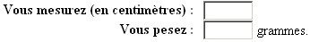
- Integration of the measurement unit into the form
There is a third solution, which would consist in pre-filling the text field, with the measurement unit already inserted. However, if the user deletes it inadvertently, they can forget it or make a mistake when entering it themselves. This is not the case if the unit is placed outside of the field, which is what we advise you to do.

A form field must always be able to display the value that must be inserted into it in its entirety

Criticality

Description of the recommendation
It is very uncomfortable for the user to have to enter information into a field that is too small to display the text entered in its entirety; this prevents the user from seeing most of the information. Therefore, a text field must always be long enough to receive all the text that must be entered into it. As far as they are concerned, option lists must be able to display the entire text of the longest available option.

Risk incurred if the recommendation is not implemented
If the user cannot read the entire content of a text field or list option, they will have to select the item and highlight its content to read the entire text. This causes an obvious waste of time and efficiency.

How to implement the recommendation
Just test the component during development:
- Check that lists are wide enough to display the text of the widest option;
- Enter the biggest possible value into the text fields.
If, in either case, the whole value is not displayed, then its size will have to be increased.

Here is how to define the length of a text field in the CSS stylesheet:
#identifiantDuChamp {
width : 50px ;
}
This is done as follows in the XHTML code:
<input type="text" id="identifiantDuChamp" />

Here is how you define the width of a dropdown list in the CSS stylesheet:
#identifiantDeVotreListe {
width : 50px ;
}
This is done as follows in the XHTML code:
<select id="identifiantDuChamp">
<option>…</option>
<option>…</option>
</select>

Tolerated exceptions
This recommendation should be implemented without any exception, even though not doing so would not prevent the user from filling in the form. On the other hand, this will make the form very difficult to proofread.

Illustration
Below is an example of a text field that is too short to contain the whole value to enter.
- Text field that is too short and does not make it possible to read the entire value
A field like the one shown below should have been used as all characters can be displayed in it.
- Text field that is long enough and makes it possible to read the entire value
The same applies to lists.
Here is an example of a list that is too short and therefore does not allow the user to view the whole text of the selected option.
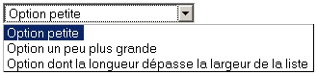 →
- Dropdown list that is too small to show the longest value in its entirety
A list like the one shown below should have been used as all characters can be displayed in it
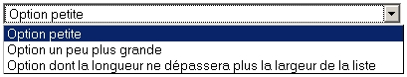 →
- Dropdown list that can show the longest value in its entirety

Recommendations for form fields that only accept a maximum number of characters

Criticality

Description of the recommendation
If a maximum length is set for an element to enter, the user must be informed of that and be able to check directly whether the text that they typed is not too long.

Risk incurred if the recommendation is not implemented
If the user is not informed of the maximum authorised length, an error may occur during form validation because the value entered will be longer than the maximum authorised value. The user will thus have to fill in the form again, which causes an obvious waste of time and efficiency. Besides, the user will feel frustrated because they should have been warned that the value entered was too long before form validation.

How to implement the recommendation
Two solutions can be implemented:
- Insert a label next to the field which specifies the maximum number of characters authorised. However, do not block the input if the user enters more characters than expected.
- If you use a textarea-type component, insert next to it the number of characters that have already been entered; this will save the user from counting them themselves. You can also modify the colour of the text that has been entered to produce even more visible feedback for the user when the number of characters entered exceeds the authorised maximum number.

Tolerated exceptions
It is strongly advised to implement this recommendation, even though it is not mandatory.

Illustration
Below is an example of a textarea with a maximum number of characters authorised and immediate feedback produced by both the display of the number of characters already entered and the different colour of the text if the maximum authorised length is exceeded.
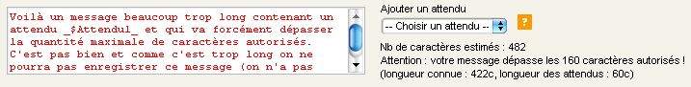
- Textarea in which the text entered exceeds the maximum length authorised

Menu section names must be mutually exclusive, and their destinations must be explicit

Criticality

Description of the recommendation
Navigation in a site or application must be as intuitive as possible so the user focuses entirely on their task and not on figuring out where they are in the site or application.

Risk incurred if the recommendation is not implemented
If the user does not know where they will go when reading section titles, or if they hesitate between several sections because their names are too similar, not only do they waste time and efficiency, but they are also disoriented and do not know how to access the function that they are looking for, which is a more serious issue. Thus, they will have to make more mental efforts to find it and may focus less on their task.

How to implement the recommendation
First, all sections must be named using a vocabulary that the user knows well and uses every day as part of their activity.
Second, you must make sure that the titles given to sections are clear enough i.e. that the terms used are not confusing by being semantically too close to one another.

Tolerated exceptions
There should not be any exception.

Illustration
No illustration required here.

Alert windows must be displayed when the user is about to execute an action that can modify part of the system's data (addition, modification, deletion)

Criticality

Description of the recommendation
If a user's action is going to modify the system's data (adding/modifying/deleting an item, validating a form), the system must warn the user before executing the command because there is always a risk that the user might have made a mistake or not paid attention to what they were doing.

Risk incurred if the recommendation is not implemented
If the user is not warned of the fact that their action is potentially impossible to cancel, or at least informed of its consequences, they might be very surprised by the result, which they did not necessarily expect. If case of a user error, the user will be very annoyed by the fact that they were not warned of the consequences, and will be all the more reluctant to use the application in the future. Besides, having modified the system's data without necessarily wanting it will force the user to get the data back as they were before their action modified them, which represents a significant waste of time.

How to implement the recommendation
Before any action that has consequences on the system's data is executed, a dialogue box must be displayed to inform the user about the consequences of their action and ask for a confirmation.

Tolerated exceptions
None.

Illustration
The screenshot below shows a confirmation request displayed when the user wants to delete an e-mail account:
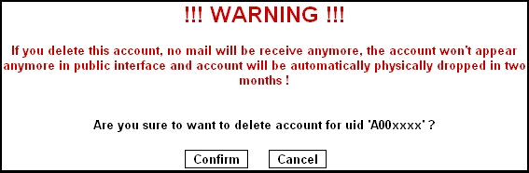
- Alert message asking the user for a confirmation

If possible, form fields must provide default values

Criticality

Description of the recommendation
When possible, and when a default choice can be provided to fill in texts, dropdown lists, etc., said choice must be automatically inserted into the form:
- first, it gives an indication about the expected input format and type of value;
- second, it makes it possible to fill in the form more quickly if the value provided corresponds to the one most frequently entered; this saves the user from entering it.

Risk incurred if the recommendation is not implemented
Not providing a default value does not cause any real risk; however, it allows the user to fill in the form more quickly (especially if they must fill in the form many times during the day).

How to implement the recommendation
To know which values are most frequently entered, you can ask your users (in case of a business application for instance), and if you cannot do so (case of a web site), you can analyse their behaviour (by analysing log files for instance).

Tolerated exceptions
As specified previously, the idea is more to help the user work more quickly than to solve an actual critical problem that would prevent them from filling in a form completely.

Illustrations
The screenshot below shows the use of default values in a form.
The start date is automatically set to the current day's date, the value displayed in the list is the one that is selected the most often, and a text is already entered into the appropriate field to make the user's work easier.
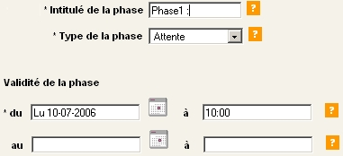
- Form with default values

When the user must make a selection, they should be provided only with the options that they can select so they cannot choose any unauthorised option

Criticality

Description of the recommendation
Making a selection means choosing between different options. Some of these options may be unauthorised for the user when they make this choice. Therefore, it is necessary to correctly specify which options they can choose, so they do not select an option that might cause an error during form validation.

Risk incurred if the recommendation is not implemented
An option that is unauthorised but not identified as such can be selected by the user, which might cause an error during form validation and force the user to make a selection again, which is a waste of time and efficiency.
Besides, the user who has made a mistake due to a lack of information from the system will distrust it and will be less inclined to use it.

How to implement the recommendation
When an option must not be selected, either it should not be displayed (and therefore only authorised options should be displayed in the pages), or the item that the user must not select must be greyed out (button, checkbox, dropdown list...).
To do so, you must use the “disabled” attribute in the HTML code, which applies to all form tags.
Example for an option list:
<select disabled="disabled">
<option>Option 1</option>
<option>Option 2</option>
</select>
To deactivate the item, the value of the “disabled” attribute must be “disabled”.

Tolerated exceptions
None.

Illustration
No illustration required here.

Data should not be browsed in a page in “form” mode

Criticality

Description of the recommendation
When the user browses data, the latter must not be displayed like in a creation or modification form, with text fields and option fields. The data must be “hardcoded”.

Risk incurred if the recommendation is not implemented
If the data are displayed in a page in “form” mode, the user may believe that they can modify them. They may be bothered by this fact, notably for fear that they might modify the data when they only wanted to browse them.

How to implement the recommendation
For data consultation pages, “hardcode” the data into the page, and not in form fields.

Tolerated exceptions
No use case justifying an exception has been encountered yet.

Illustration
The following screenshot shows a page for browsing data in which the latter are displayed in “form” mode, which leads the user to think that they can modify them.
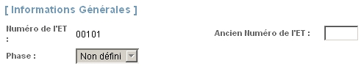
- Page for browsing data which simultaneously provides greyed-out fields, accessible fields and “hardcoded” text

In a tabular list, do not highlight lines when the mouse moves over them, and do not transform the cursor into a “hand”

Criticality

Description of the recommendation
Since tabular lists contain a lot of data, it may be tempting to highlight the line over which the mouse is moving, in order to distinguish it from the others. However, this behaviour must be avoided absolutely.

Risk incurred if the recommendation is not implemented
Rows in tabular lists sometimes contain several links (in the form of text or pictograms) that can lead to different pages (since they trigger different functionalities such as viewing or editing). Now, if the row which the mouse is moving over is highlighted, the user will no longer know which link will be activated if they click, even more so if the mouse cursor turns into a hand because they will feel that they are moving the mouse over a link (the entire row), which will make the situation even more confusing.

How to implement the recommendation
Do not highlight rows when the mouse moves over them.

Tolerated exceptions
No use case justifying an exception has been encountered yet.

Illustration
The image below shows what happens if a row is highlighted when the mouse moves over it. The user does not know which functionality they will activate if they click (viewing, editing, deletion?).
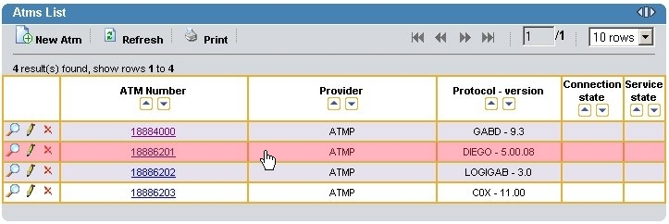
- Counter-example: row highlighted when the mouse moves over it

If a form contains a lot of a data or is filled in in several steps, a summary page should be displayed before the form is validated

Criticality

Description of the recommendation
When the user has filled in a form in several steps, or when the form contains a large number of fields to fill in, it is reassuring to provide a page that summarises all the data that the user has entered. This allows them to check all the data entered and prevents errors. It also reassures the user because they can go back before validating the data.

Risk incurred if the recommendation is not implemented
Entering a large number of data will require a lot of concentration from the user, and they will most probably have difficulty remembering all the information that they have entered once they reach the end of the form. The same thing happens when the input process includes several steps: at step 5, the user will not necessarily remember what they entered during step 1.

How to implement the recommendation
When many fields must be filled in in a form, or the input process is done in several steps, you can display a page that lists all the information entered by the user so they can check it before validating it.

Tolerated exceptions
Not implementing this recommendation will not prevent the user from working, but it will make data entry more secure and increase the user’s satisfaction with the application.

Illustration
No illustration required here
List of illustrations
Fig. 1 : Integration of the measurement unit into the form 5
Fig. 2 : Text field that is too short and does not make it possible to read the entire value 7
Fig. 3 : Text field that is long enough and makes it possible to read the entire value 7
Fig. 4 : Dropdown list that is too small to show the longest value in its entirety 7
Fig. 5 : Dropdown list that can show the longest value in its entirety 7
Fig. 6 : Textarea in which the text entered exceeds the maximum length authorised 8
Fig. 7 : Alert message asking the user for a confirmation 10
Fig. 8 : Form with default values 11
Fig. 9 : Page for browsing data which simultaneously provides greyed-out fields, accessible fields and “hardcoded” text 14
6.11. Counter-example: row highlighted when the mouse moves over it 15

