

Ergonomic recommendations
8 – Feedback
Author: the Studio
Date: 29/09/2006
Reference: KAWWA_Usability_Guidelines_8_Feedback
Content of this document
The recommendations set out in this document concern the methods that must be implemented to allow the user to always know which item is selected, if an action that they have triggered has been executed correctly, how much time is required to complete a task…
Criticality of recommendations
The recommendations set out in this document include a degree of criticality rated from 1 to 3 which indicates how important implementing said recommendations is:
The recommendation improves the usability of the application but implementing it is not mandatory.
The recommendation vastly improves the usability of the application. It is strongly recommended to implement it.
The recommendation is critical. Not implementing it causes an unacceptable usability issue. Implementation is mandatory.
Who should you contact if you have questions, criticisms...?
If you have observations, questions or criticisms about the recommendations given in this document, please feel free to contact us. This document is not set in stone and we would be happy to get feedback from you so we can keep on improving and enriching it.
Angela Ricci – Web designer: Angela.Ricci@atosorigin.com
Jérôme Simans – Ergonomist: Jerome.Simans@atosorigin.com
Jean-Luc Macke – Studio Manager: Jean-Luc.Macke@atosorigin.com
Table of contents
8.1. A selected item, regardless of what it is (link, menu section, icon…), must be easy to distinguish from other, non-selected items 4
8.2. Messages to the user (notably warning and error messages) should always be displayed at the same place on the screen 5
8.3. A feedback message must be displayed after each data-altering user action (creation, modification, deletion) 6
8.4. If keyboard shortcuts can be used, a feedback message should be displayed to confirm that the user’s action has been taken into account 7
8.5. If response time is required during a user action, the user must be warned by a message that can specify the time remaining before processing finishes 8
8.6. Recommendations on the page displayed after a user action (addition, modification, deletion, form validation) has been validated 9

A selected item, regardless of what it is (link, menu section, icon…), must be easy to distinguish from other, non-selected items

Criticality

Description of the recommendation
Differentiating the item that the user has just selected from other items gives them feedback about their task and thus allows them to confirm (or not) that their action has been taken into account and that it works as they wanted to.

RISK INCURRED IF THE RECOMMENDATION IS NOT COMPLIED WITH
If the user cannot differentiate a selected item from other, non-selected items, they have no way of determining whether the action that they have performed (by selecting the item) has worked correctly, and whether they have performed the right action. Therefore, they will most likely be disoriented, in addition to the fact that they have wasted time verifying that their action was correct.

How to implement the recommendation
Give a different look to a selected item (different from the look that it had before being selected). The change of colour remains the easiest solution.
Remove underlining for links, which should be underlined when not selected.

Tolerated exceptions
None.

Illustration
The screen below shows how to differentiate a selected section from others (highlighting), and a selected link from others (different colour and lack of underlining).
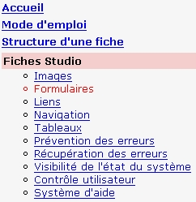
- Differentiation between selected and non-selected items

Messages to the user (notably warning and error messages) should always be displayed at the same place on the screen

Criticality

Description of the recommendation
The system must constantly give feedback to the user regarding the correct (or incorrect) execution of their actions. These messages must be located at the same place on the screen, regardless of the page where the user is. If alert windows are used to display these messages, they must always appear in the foreground and at the same place.

RISK INCURRED IF THE RECOMMENDATION IS NOT COMPLIED WITH
If the messages sent to the user are not always located at the same place, they will most probably miss some of them. Indeed, the user will have got used to reading the messages sent to them at a certain location in the page, and if other messages are displayed elsewhere, they are very likely not to see them and thus not read them. Therefore, they will feel that the application does not inform them about whether their actions have been executed correctly

How to implement the recommendation
As of the model design phase, create a dedicated area which the messages to the user will be inserted into.
For errors occurring during form validation, you can obtain further information in recommendation 7.7).

Tolerated exceptions
None.

Illustration
In the screenshot below, you can see an application model containing an area that displays error messages (of course, this area does not appear on the screen when there is no error message to display):
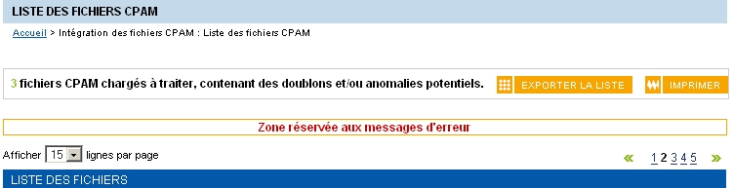
- Area dedicated to displaying error messages

A feedback message must be displayed after each data-altering user action (creation, modification, deletion)

Criticality

Description of the recommendation
When the user performs actions on data, they must receive feedback telling them that their action has been executed correctly or, on the contrary, that a problem has occurred.

RISK INCURRED IF THE RECOMMENDATION IS NOT COMPLIED WITH
If no information is given to the user when they perform an action, they can wonder first, whether it has been taken into account and second, whether it has been executed correctly. They can also try to perform the action again, and, for instance, create the same new item again, which can result in a mistake. Their trust in the application will be reduced.

How to implement the recommendation
As explained in recommendation 8.2, as of the model design phase, an area must be dedicated to displaying the messages that confirm that the user's actions have been taken into account.

Tolerated exceptions
None.

Illustration
In the screenshot below, a confirmation message is displayed to tell the user that the creation of a new item (here a campaign to invite people to a cancer screening) was successful. Highlighting the new row in the list that contains all campaign also provides feedback.
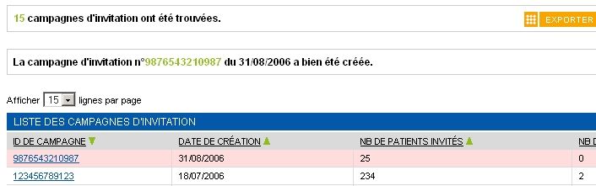
- Displaying a message that provides feedback about a user action

If keyboard shortcuts can be used, a feedback message should be displayed to confirm that the user’s action has been taken into account

Criticality

Description of the recommendation
As has already been explained in the previous recommendations, the user needs to be reassured and to know that the system has correctly taken their actions into account. Keyboard shortcuts are no exceptions to this rule. Even though they are features intended for expert users, it can only be beneficial to provide a message confirming that they have been taken into account.

RISK INCURRED IF THE RECOMMENDATION IS NOT COMPLIED WITH
Usually, keyboard shortcuts are only used by experts. The latter are thus supposed to know the application and the consequences of their actions. There is no real risk for these users in terms of application usability.
On the other hand, if novice users activate a keyboard shortcut accidentally or by mistake, it would be useful to tell them which action they have triggered and what consequences it may have.

How to implement the recommendation
As explained in recommendation 8.2, a special area for displaying messages to the user should be created as of the interface design phase.

Tolerated exceptions
This recommendation does not apply if feedback is immediate, as when the “display help page” shortcut (Alt + H) is used.

Illustration
See the illustration of recommendation 8.2 about the area used to display messages to the user.

If response time is required during a user action, the user must be warned by a message that can specify the time remaining before processing finishes

Criticality

Description of the recommendation
The system may need some time to process an operation triggered by the user (e.g. execution of a request in a database). The user must be informed of that fact either before they trigger the action or while the action is in progress; for instance, the time remaining before the end of the operation should be displayed.

RISK INCURRED IF THE RECOMMENDATION IS NOT COMPLIED WITH
If the user is not informed when the system needs time to complete an operation, they may wonder whether the system is blocked or whether the operation has failed. They might be tempted to cancel the operation in progress (by closing the application, pressing the ESC key...) although it is being executed correctly, because they have not been informed of the time required before completion.

How to implement the recommendation
Several solutions are available to warn a user that time is required to complete an operation:
- Displaying a warning message before the operation starts;
- Displaying a progress bar or indicator that shows the proportion of the operation that has been completed (x% done or 345 Kb downloaded out of 810)
Both solutions are not mutually exclusive.

Tolerated exceptions
None.

Illustration
The screenshot below shows a progress bar that visually indicates the time elapsed and the time remaining until the operation is complete. This bar is completed with a percentage and the remaining time in a textual form. Therefore, the user is perfectly informed about the progress of the operation
- Displaying a progress bar

Recommendations on the page displayed after a user action (addition, modification, deletion, form validation) has been validated

Criticality

Description of the recommendation
This recommendation defines what should be displayed to indicate that a user's action has been validated.

RISK INCURRED IF THE RECOMMENDATION IS NOT COMPLIED WITH
If this recommendation is not implemented in your application, users will reach a “dead end” page after validating an action i.e. they will reach a page confirming that the validation has worked (this is the least you can do) and will then have to use the menu to go back to the page on which they triggered the action. This waste of time can be avoided by implementing the recommendation.

How to implement the recommendation
- Once the user's action has been validated, a page that summarises the data added, modified or deleted must be displayed. This page must also contain a link to return to the page on which the user performed the action (the page that was displayed when they decided to add, modify or delete data).
- When the user browses a data list and triggers an action that requires a confirmation (creating a new item, editing or deleting an existing item), you can also choose, once the action has been validated, to take the user back to the list page, provided you remind them in the appropriate notification area that the validation has worked.

Tolerated exceptions
No use case justifying an exception has been encountered so far.

Illustration
The image below shows a confirmation given to the user after an element has been added into a list. A message is displayed at the top of the page and the added row can be highlighted for better visibility.
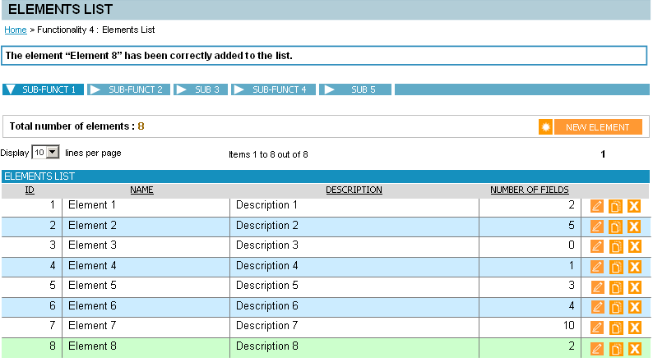
- Example of a confirmation that an element has been added into a list
List of illustrations
Fig. 1 : Differentiation between selected and non-selected items 4
Fig. 2 : Area dedicated to displaying error messages 5
Fig. 3 : Displaying a message that provides feedback about a user action 6
Fig. 4 : Displaying a progress bar 8
Fig. 5 : Example of a confirmation that an element has been added into a list 10

