

Ergonomic recommendations
2 - Forms
Author(s): the Studio
Date: 29/09/2006
Reference: KAWWA_Usability_Guidelines_2_Forms
Content of this document
The recommendations set out in this document concern the data input forms that your application can contain.
They will define the presentation order, object alignment...
Criticality of recommendations
The recommendations set out in this document include a degree of criticality rated from 1 to 3 which indicates how important implementing said recommendations is:
The recommendation improves the usability of the application but implementing it is not mandatory.
The recommendation vastly improves the usability of the application. It is strongly recommended to implement it.
The recommendation is critical. Not implementing it causes an unacceptable usability issue. Implementation is mandatory.
Who should you contact if you have questions, criticisms...?
If you have observations, questions or criticisms about the recommendations given in this document, please feel free to contact us. This document is not set in stone and we would be happy to get feedback from you so we can keep on improving and enriching it.
Angela Ricci – Web designer: Angela.Ricci@atosorigin.com
Jérôme Simans – Ergonomist: Jerome.Simans@atosorigin.com
Jean-Luc Macke – Studio Manager: Jean-Luc.Macke@atosorigin.com
Table of contents
2.1. Each form field must be preceded by a clear explicit description 4
2.2. field descriptions must be close enough to fields 6
2.3. Field values must be aligned to the left 8
2.4. Form fields must be presented in a logical ORDER THAT follows the logic according to which the user fills in the form 9
2.5. mandatory fields must be clearly identifiable 11
2.6. The cursor should automatically position itself on the first field to fill in 12
2.7. tabulations should follow the order in which the form is read 13
2.8. Long fields must be partitioned when possible 15
2.9. the data to enter must be grouped into logical categories 16
2.10. Recommendations on the positioning of radio buttons and checkboxes 17

Each form field must be preceded by a clear explicit description

Criticality

Description of the recommendation
Each form field must be introduced by a description that must perfectly inform the user about the expected content.

Risk incurred if the recommendation is not implemented
If a field has no description, or a vague one, the user may not understand it correctly and may fill it in incorrectly, which might cause form processing errors.

How to implement the recommendation
To make the description clear enough, use the language that the user is familiar with and uses constantly when they have to enter that type of information. Avoid using abbreviations as much as possible.

Tolerated exceptions
No exception can be tolerated.

Illustration
In the screenshot below, descriptions are either unclear or missing. This makes it very difficult for the user to correctly enter information into this form.
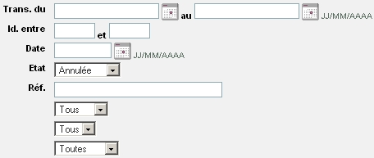
- Form with unclear or missing descriptions
The descriptions of the fields to fill in or the values contained in lists must be clear. Each form field must have a description. The screenshot below shows how the form should have been designed.
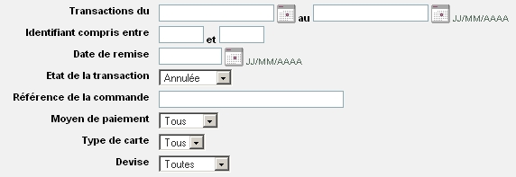
- Identical form but with an explicit description for each control

field descriptions must be close enough to fields

Criticality

Description of the recommendation
For better readability, the space between the end of a description and the form item that it refers to must be reduced.
The user will associate a description with the corresponding form field more easily if there is only a short distance between them.

Risk incurred if the recommendation is not implemented
It may be more difficult and time-consuming for the user to fill in the form because they must make the effort to mentally align descriptions with the fields which they refer to.

How to implement the recommendation
The descriptions are aligned to the left, under one another; form fields are also aligned under one another. The space between the shortest description and its form field cannot be too big, in order not to disrupt the user when they read and fill in the form.
Therefore, it can be considered that there must be a maximum space of 6 characters between the end of the shortest description and the end of the longest one.
If the space exceeds 6 characters, the descriptions, the length of which will be unequal, will be too far from the fields that correspond to them (at least for the shortest ones). In that case, it is preferable to align the descriptions to the right.

Tolerated exceptions
This recommendation cannot be considered as critical as not implementing it will not prevent the user from filling in the form. However, it is recommended to implement it for better efficiency and ease-of-use.

Illustration
In the first screenshot below, descriptions are aligned to the left, but the space between the end of the shortest description and the end of the longest one exceeds 6 characters. Therefore, the space between the descriptions and the corresponding form fields will be too big.
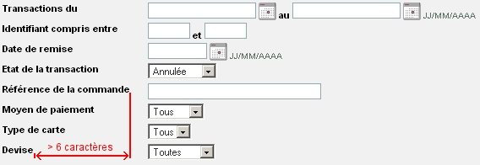
- Descriptions aligned to the left, far from the controls which they refer to
Since the space between the shortest description and the field that it describes becomes too big, the descriptions should be aligned to the right as shown below.
- Descriptions aligned to the right, right next to the controls which they refer to

Field values must be aligned to the left

Criticality

Description of the recommendation
Whether they are textual or numerical (except for numerical values that need to be compared with other values), field values must be aligned to the left so they are close to the description of the field into which they are entered (this is deduced from the previous recommendation).

Risk incurred if the recommendation is not implemented
It has been previously recommended to align descriptions to the right so they are close to the form fields; however, aligning the texts contained in these fields to the right produces the same unwanted effect i.e. a waste of time and lesser ease-of-use when entering the values.

How to implement the recommendation
Values are aligned to the left by default. If you have modified this property, with a CSS stylesheet for instance, re-align values to the left.

Tolerated exceptions
This does not make the form impossible to read for the user; however, this improves the ease-of-use and makes the input process easier; therefore, we advise you to implement this rule.

Illustration
In the screenshot below, the text entered into form fields is aligned to the right and thus, far from its description:
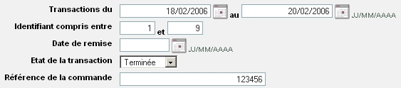
- The texts in the fields are aligned to the right, far from their descriptions
The values in the fields should have been aligned to the left, as shown on the following screenshot.
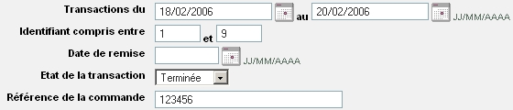
- The texts in the fields are aligned to the left, and therefore right next to their descriptions

Form fields must be presented in a logical ORDER THAT follows the logic according to which the user fills in the form

Criticality

Description of the recommendation
Users who must use a form to enter information expect the input fields to be displayed in a logical order in relation to their activity.

Risk incurred if the recommendation is not implemented
If the presentation of the form does not use the logical order expected by users, said users will become less efficient (obvious waste of time).

How to implement the recommendation
To know the most logical order in which users fill in forms depending on their activity, you must ask them the question when you are not dealing with standard cases (such as filling in a form containing postal data). An ergonomist can assist you in that task by analysing users' activity.

Tolerated exceptions
Even if users can fill in forms whose fields are displayed in an order that differs from what they expect, they will most certainly prefer filling in a form that follows the order that they have in mind; they will make fewer mistakes and waste less time filling in the form.

Illustration
Some information, such as a user's postal data, must be entered in a certain order and follow certain logic. To do so, you can use the standard which La Poste has defined for this purpose as a basis:
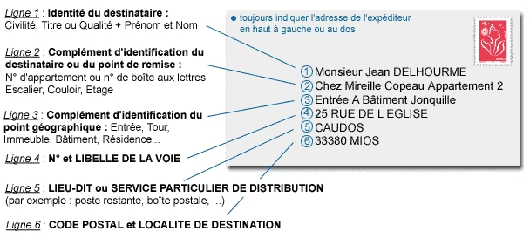
- Image illustrating the order in which fields are presented in a form used to enter postal data

mandatory fields must be clearly identifiable

Criticality

Description of the recommendation
When users fill in a form, it is imperative that they can differentiate between mandatory and optional fields

Risk incurred if the recommendation is not implemented
Properly marking mandatory fields prevents users from forgetting to fill in any of them, and thus prevents a waste of time and efficiency.

How to implement the recommendation
Each mandatory field description must be preceded by an asterisk (*). This description can possibly be written with bold formatting and/or its colour may be changed to provide an additional way of differentiating it from the others.
Besides, this indication must be placed BEFORE the mandatory fields if they are aligned to the right and AFTER them if they are aligned to the left.

Tolerated exceptions
No exception can be tolerated. Implementing this recommendation is mandatory.

Illustration
In the first screenshot below, it is impossible to determine which fields are mandatory; the uncertainty is dispelled in the second screenshot thanks to the differentiation between the descriptions of mandatory and optional fields.
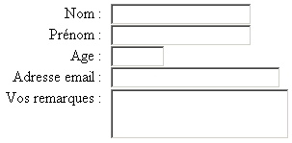
- Form with no distinction between mandatory and optional fields
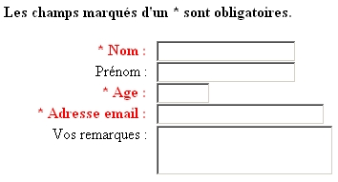
- Form where mandatory and optional fields are differentiated

The cursor should automatically position itself on the first field to fill in

Criticality

Description of the recommendation
To make the user’s work easier and reduce the time that they spend filling in a form, it might be a good thing to automatically give the focus to the control containing the first value to enter. Thus, the user can start filling in the form directly with the keyboard, without having to use the mouse to go to the correct location.

Risk incurred if the recommendation is not implemented
If the cursor is not positioned automatically on the first field to fill in, the user will waste time manually selecting the field. While this may seem unimportant, you have to keep in mind that the user will have to perform this operation dozens or hundreds of times during the day. In addition to being a waste of time and thus efficiency, this will quickly become frustrating and thus diminish ease of use.

How to implement the recommendation
You can use the focus() Javascript function to give the focus to an item of the form:
document.nomDuFormulaire.nomElement.focus() ;

Tolerated exceptions
This recommendation is not mandatory but aims to improve ease of use. Not implementing the recommendation will not prevent the user from working but will significantly reduce their efficiency.

Illustration
No illustration required

tabulations should follow the order in which the form is read

Criticality

Description of the recommendation
If a user wants to cycle through the different form fields using the “Tab” key, then the cursor must move from one field to another in the order in which fields are displayed in the form.

Risk incurred if the recommendation is not implemented
If the cursor moves from a field to another without following the order in which the form is read (the order in which fields are displayed on the screen), the user will become less efficient because the interest of tabulations in a form is precisely that they help the user fill in the form more quickly. Now, if the user has to position the cursor at the right place because it does not move logically, they lose the entire benefit of being able to cycle through fields using tabulations.

How to implement the recommendation
Assign a tabulation order to your form fields: the number of the first field will be 0, the number of the second field will be 1 etc.
Use the “tabindex” attribute in the XHTML code.
Example:
<input type= "text" tabindex= "0" />

Tolerated exceptions
This recommendation does not only make your application more usable, it also makes it more accessible. This is why we recommend implementing it without any exception.

Illustration
The following screenshot shows the order in which fields can be cycled through thanks to tabulations; this order is the same in which fields are displayed.
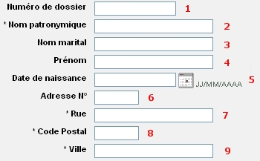
- Form field tabulation order

Long fields must be partitioned when possible

Criticality

Description of the recommendation
If a field must contain a long sequence of characters that can be split into several “pieces” (e.g. 3 digits, 4 letters then 3 digits), then the long fields must be split into several smaller ones in order to make input easier for the user and reduce the risk of error.

Risk incurred if the recommendation is not implemented
Input errors are easy to make when the expected value uses a complicated format. The user may have to enter the information again, which is a waste of time and efficiency.

How to implement the recommendation
For all fields whose content can be split into several parts (e.g. credit card number), do not provide the user with a single field to fill in; split it into several pieces which will be easier to fill in and, above all, easier to check.

Tolerated exceptions
Even if the recommendation is not mandatory, we strongly advise to implement it as it makes data input much easier and limits the risk of error.

Illustration
For a text field with 3 digits, then 4 letters, then 3 digits, then 3 letters:
Rather than having a field that looks like the one below:
- Unpartitioned long field whose format can cause errors
Use a field like this one:
- Long field that has been partitioned, thus reducing the risk of error

the data to enter must be grouped into logical categories

Criticality

Description of the recommendation
A logical category corresponds to a set of values to enter that have a common subject.
It will be easier for the user to understand and fill in a form whose fields have been grouped into logical categories rather than non-grouped fields which will make it more difficult for them to establish connections between the various form fields.

Risk incurred if the recommendation is not implemented
If the fields of a form are laid out without any interconnections, the user will spend more time filling in the form and thus be less efficient.

How to implement the recommendation
Form fields dealing with the same subject must be grouped in the same place.

Tolerated exceptions
No exception can be tolerated.

Illustration
Here is an example showing fields grouped into logical categories, which makes them easier to identify.
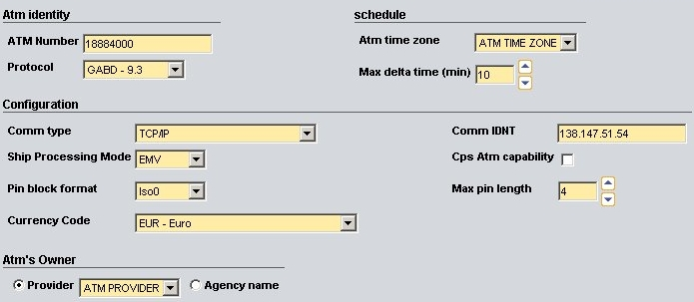
- Form showing the information sorted into logical groups

Recommendations on the positioning of radio buttons and checkboxes

Criticality

Description of the recommendation
To make forms more readable, it is preferable to align options (represented by radio buttons or checkboxes) under one another.
Labels must be placed to the right of checkboxes and radio buttons.

Risk incurred if the recommendation is not implemented
Besides reducing readability, this may cause confusion for the user, who might not know whether a checkbox or radio button concerns the label displayed before or after it.

HOW TO IMPLEMENT THE RECOMMENDATION
Refer to page 24 of the toolkit guide to know how to position boxes, buttons and labels.

TOLERATED EXCEPTIONS
If an application needs space to be saved as much as possible, then having several radio buttons or checkboxes on the same line will be acceptable.

Illustration
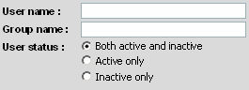
- Radio buttons aligned under one another
List of illustrations
Fig. 1 : Form with unclear or missing descriptions 5
Fig. 2 : Identical form but with an explicit description for each control 5
Fig. 3 : Descriptions aligned to the left, far from the controls which they refer to 7
Fig. 4 : Descriptions aligned to the right, right next to the controls which they refer to 7
Fig. 5 : The texts in the fields are aligned to the right, far from their descriptions 8
Fig. 6 : The texts in the fields are aligned to the left, and therefore right next to their descriptions 8
Fig. 7 : Image illustrating the order in which fields are presented in a form used to enter postal data 10
Fig. 8 : Form with no distinction between mandatory and optional fields 11
Fig. 9 : Form where mandatory and optional fields are differentiated 11
Fig. 10 : Form field tabulation order 14
Fig. 11 : Unpartitioned long field whose format can cause errors 15
Fig. 12 : Long field that has been partitioned, thus reducing the risk of error 15
Fig. 13 : Form showing the information sorted into logical groups 16
Fig. 14 : Radio buttons aligned under one another 17

