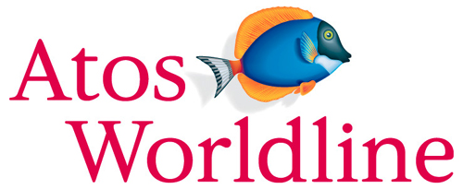

Ergonomic recommendations
3 - Links
Author: the Studio
Date: 29/09/2006
Reference: KAWWA_Usability_Guidelines_3_Links
Content of this document
The recommendations set out in this document concern the links that the user will use to move within the application.
To be efficient, links must be explicit, coherent and recognisable.
Criticality of recommendations
The recommendations set out in this document include a degree of criticality rated from 1 to 3 which indicates how important implementing said recommendations is:
The recommendation improves the usability of the application but implementing it is not mandatory.
The recommendation vastly improves the usability of the application. It is strongly recommended to implement it.
The recommendation is critical. Not implementing it causes an unacceptable usability issue. Implementation is mandatory.
Who should you contact if you have questions, criticisms...?
If you have observations, questions or criticisms about the recommendations given in this document, please feel free to contact us. This document is not set in stone and we would be happy to get feedback from you so we can keep on improving and enriching it.
Angela Ricci – Web designer: Angela.Ricci@atosorigin.com
Jérôme Simans – Ergonomist: Jerome.Simans@atosorigin.com
Jean-Luc Macke – Studio Manager: Jean-Luc.Macke@atosorigin.com
Table of contents
3.1. Links must be easy to distinguish from ordinary text 4
3.2. Simple text must be easy to distinguish 6
3.3. Active navigation links must be easy to distinguish from other links 7
3.4. Links must be presented consistently in the whole application 9
3.5. Link destinations must be explicit 10
3.6. Textual links should be used rather than image links 11
3.7. Image links must contain the “alt” and “title” attributes 12
3.8. The unity of a link must be easy to distinguish 14
3.9. In a list of (visually) similar links, only make the different text clickable 15
3.10. In a vertical list of links, do not place links too close to one another 16
3.11. The behaviour of links must be homogeneous in the whole application 18
3.12. The pages linked to must open in the same window 19
3.13. A link to a PDF or MS office document must open in a new window 20

Links must be easy to distinguish from ordinary text

Criticality

Description of the recommendation
A link must not be confused with normal text. Sufficient indications must be provided so the user does not have to wonder whether such or such element is a link or not.
Users must not have to move over the text with the mouse to determine whether the text is a link. Not only is this process hard to master for novice users, but it is tiring for everyone and hinders the user’s navigation, regardless of their level of expertise. “Visualisation” is much easier and quicker to spot links on a page.

Risk incurred if the recommendation is not implemented
If the user hesitates because they cannot distinguish a link from ordinary text, they will waste time and become less efficient.

How to implement the recommendation
To easily distinguish a link from normal text, we advise you to:
- Give all links the same colour;
- Underline all links.

Tolerated exceptions
No exception can be tolerated. Implementing this recommendation is mandatory. However, it is acceptable for links contained in menus, tabs (navigation links) or action buttons not to be underlined or of the same colour since their very position defines them as links.
Of course, all the links making up the menu must be presented consistently (all of them must have the same look i.e. colour, size, bold formatting, uppercase).

Illustration
The screenshot below shows that all links of the page, except those in the menu and tabs, are of the same colour and properly underlined, and that no other text in the page is of the same colour or underlined.
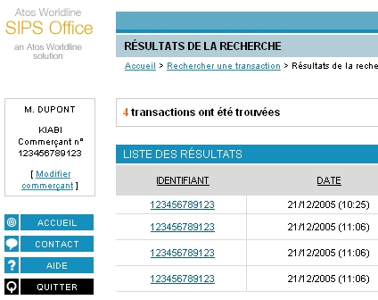
- Distinction between links and ordinary text

Simple text must be easy to distinguish

Criticality

Description of the recommendation
This recommendation is a corollary of the previous one.
Any text that is not a link must not be interpreted as being a link.

Risk incurred if the recommendation is not implemented
As specified in the previous recommendation, the user must not wonder whether such or such text is a link. For ordinary text, using a presentation format similar to that of the links is the surest way of confusing the user.

How to implement the recommendation
We advise you:
- not to underline text unless it is a link;
- not to use for ordinary text the same colour as that used for links.
To highlight text, use bold formatting, not underlining.

Tolerated exceptions
No exception can be tolerated.

Illustration
No illustration required.

Active navigation links must be easy to distinguish from other links

Criticality

Description of the recommendation
This recommendation only applies to navigation links i.e. links used in menus or tabs.
The user must be able to quickly distinguish the link on which they have clicked (the active link) and which has led them to the page that they are browsing, so they can easily know where they are in the application.

Risk incurred if the recommendation is not implemented
If the active link cannot be distinguished from the others, the user loses a way of knowing where they are in the application. They may click on the same link again, since they have no way of determining that it is the link that they have just activated.

How to implement the recommendation
We advise you:
- to make the active link unclickable (and therefore no longer a link) because clicking on it would only reload the page that is being browsed, which hinders the user's navigation (except for a tab that may be used to go back to the home page of the functionality);
- not to underline the active link (it is no longer a real link; therefore, it must not be underlined any more);
- to possibly use a different colour to emphasise the difference from other links.

Tolerated exceptions
This recommendation should be implemented without any exception.

Illustration
The first screenshot below shows the difference between the selected tab and the others. Thanks to this distinction, the user identifies the active functionality immediately.

- Distinction between active and inactive tabs
The second screenshot below shows the distinction between the active link (the one which has led to the page currently browsed) and the others; the active link is no longer underlined and its colour has changed.
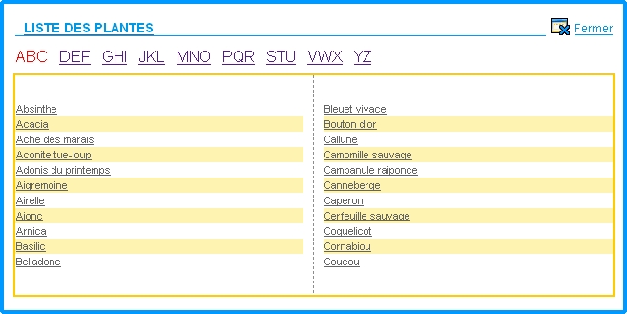
- Distinction between the active link and the others

Links must be presented consistently in the whole application

Criticality

Description of the recommendation
Link formatting must remain identical in the entire application.
Links must keep the same look (size, colour, underlining).

Risk incurred if the recommendation is not implemented
If link formatting changes from one page to another, the user will be unable to easily recognise a link, and therefore will waste time and become less efficient.

How to implement the recommendation
Keep the same formatting for all links in the whole application (same size, same colour, same case).

Tolerated exceptions
While navigation links (menus and tabs) or action buttons can use a different formatting from that of the links present in pages, these menus, tabs or action buttons must keep the same formatting in the whole application.

Illustration
No illustration required.

Link destinations must be explicit

Criticality

Description of the recommendation
It must be impossible for users to make navigation mistakes by clicking on a link and reaching a page or activating a functionality that they did not want to reach/activate.
The text of the link must be perfectly meaningful and inform the user sufficiently about the page which it leads to or the functionality that it activates.

Risk incurred if the recommendation is not implemented
If the user doubts when reading the title of a link and is unsure of where it leads to, either they will not click on it (for fear they might activate an unwanted functionality) or they will click on it and maybe make a mistake by going to the wrong page or not triggering the required functionality. The risk here is that the user might waste time, make a mistake and be disoriented.

How to implement the recommendation
A link must contain (at least partially) the title of the page which it leads to so the user can keep navigating in the application.
Generally, when a link is “taken out» of its context i.e. when one reads it without referring to the page in which it is displayed, its meaning must still be understandable. In other words, one must know which page will be displayed if the link is clicked on.
Thus, the use of “click here” must be banned.
Do not write:
If you want to read the help file, click here.
Rather, write:
You can read the help file

Tolerated exceptions
No exception can be tolerated.

Illustration
No illustration required.

Textual links should be used rather than image links

Criticality

Description of the recommendation
The use of images to represent text (the text is inserted into an image) must be forbidden.

Risk incurred if the recommendation is not implemented
Besides making maintenance and translation more difficult (to change the text, an image must be recreated, which takes a lot more time than only changing the text), the risk incurred here is an accessibility problem. Indeed, a user who cannot view images, or has trouble displaying them in their browser, will not be able to see the text written in an image if the textual alternative is missing or incorrectly specified.

How to implement the recommendation
To write text, use...text!

Tolerated exceptions
Of course, pictograms representing common functionalities can be accepted (such as viewing, editing or deleting items from a list for instance) but these pictograms will imperatively include the “title” attribute (in the <img> tag) so a tooltip is displayed when the mouse moves over them, as well as the “alt” attribute (in the <img> tag), to provide a textual alternative should the browser not display the image.

Illustration
The link shown below is an image representing text. To obtain the same formatting, CSS stylesheets can be used instead, thus avoiding the use of an image to represent a textual link.

- Textual link represented by an image

Image links must contain the “alt” and “title” attributes

Criticality

Description of the recommendation
In the <img> tag, the “title” attribute makes it possible to display a tooltip when the mouse moves over the image. The “alt” attribute makes it possible to display a textual alternative when the user's browser does not display images.
Images used as links, which are generally pictograms representing functionalities in lists, must also inform the user about their meanings (this is the role of the “title” attribute, which displays a tooltip) and a textual alternative if the image cannot be viewed by the user (this is the role of the “alt” attribute, which displays a text instead of the image).

Risk incurred if the recommendation is not implemented
If no indication (tooltip) is given to the user, they may hesitate to click on an image because they are unsure of what it means (certain pictograms representing complex functionalities are far from being intuitive).
Likewise, if an image cannot be viewed by a user (handicap, browser setting or malfunction) and no textual alternative is provided, the user will not be able to know what the image meant.

How to implement the recommendation
This is done as follows in the (X)HTML code:
<a …><img src="image_path" alt="textual alternative" title="tooltip_text" /></a>

Tolerated exceptions
None is tolerated. Implementing this recommendation is mandatory. It is easy to implement and thus must not be ignored.

Illustration
Here is what the user sees when an image cannot be displayed in the browser:

- Image that cannot be displayed and has no textual alternative
Here is what would have been displayed if a textual alternative had been provided:
- Image that cannot be displayed but has a textual alternative
When using pictograms as links to unclear functionalities, tooltips should be displayed when the mouse moves over the pictograms in order to help the user.
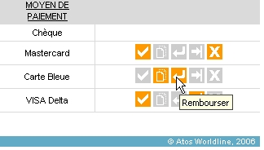
- Tooltip displayed when the mouse moves over an unclear pictogram

The unity of a link must be easy to distinguish

Criticality

Description of the recommendation
When a link is made up of several elements (word + pictogram, word + word), the clickable area must include all these elements i.e. there must not be any unclickable area between the elements.

Risk incurred if the recommendation is not implemented
The user may think that the links are different (i.e. leading to different pages) since they are not part of the same unique link.

How to implement the recommendation
Make the link contain all the elements (pictogram + text) instead of defining each element as a link.
For instance, do not use:
<a href="page.html"><img src="…" alt="pictogram" /></a> <a href="page.html">Link text</a>
But rather:
<a href="page.html"><img src="…" alt="pictogram" /> Link text</a>

Tolerated exceptions
No exception to this recommendation has been found yet. It is strongly advised to implement it.

Illustration
In the link shown below, there must not be any unclickable space between the pictogram and the link description.

Rapport de l’assemblée générale Atos Worldline France (doc)

In a list of (visually) similar links, only make the different text clickable

Criticality

Description of the recommendation
When a list of links is displayed, it is easier and more readable for the user to only distinguish between different texts rather than reading similar texts in which only a few words change.

Risk incurred if the recommendation is not implemented
If this recommendation is not implemented, the user will still be able to read the information contained in a page, and notably links, but the information will be harder to read.

How to implement the recommendation
Rather than:
- Résumé de la conférence de Seclin
- Résumé de la conférence de Paris
- Résumé de la conférence de Francfort

Use preferably:
- Résumé de la conférence de Seclin
- Résumé de la conférence de Paris
- Résumé de la conférence de Francfort

N.B: the “conférence de” text, although it is identical for the three links, is kept because, as explained in recommendation 3.5, link destinations must be explicit. Therefore, the user must be able to know where a link will lead them only by reading its title. The “Seclin”, “Paris” or “Francfort” elements alone would not allow it.

Tolerated exceptions
No exception to this recommendation has been found yet. It is strongly advised to implement it.

Illustration
No illustration required.

In a vertical list of links, do not place links too close to one another

Criticality

Description of the recommendation
For better readability, links must not be placed too close to one another so the user does not have to make any special effort to distinguish them and click on them. The spacing must be sufficient so the user can easily distinguish between links and click on the link of their choice.

Risk incurred if the recommendation is not implemented
It will be difficult for the easier to distinguish between links and/or click on them (they might click on the link located above or below).

How to implement the recommendation
You can define the minimum spacing between two items thanks to a CSS stylesheet. For instance, to define a space of 2 pixels above and 2 pixels below an item of the list, you can use:
li {
padding: 2px 0 ;
}
Here, li defines the tag that introduces a list item and a 2-px space must be used above and below it (0 on the left and right). Using padding-top and padding-bottom was also possible.

The exact same thing applies to a table containing links: the padding on top and bottom is increased, for the td item this time:
td {
padding: 2px 0 ;
}

Tolerated exceptions
No exception to this recommendation has been found yet. It is strongly advised to implement it.

Illustration
As shown on the following screenshot, sufficient spacing must be used to allow comfortable reading and error-free selection.
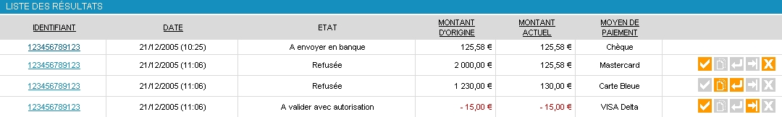
- Table showing the information with sufficient spacing between the data

The behaviour of links must be homogeneous in the whole application

Criticality

Description of the recommendation
The same link (link name) must always lead to the same page, and the same page must always be accessible from a link that has the same name. This helps the user know where they are in the application, and also makes learning and navigation easier.

Risk incurred if the recommendation is not implemented
If links with different names lead to the same page, or, conversely, if links with identical names lead to different pages, the user will lose confidence in the system used to navigate in the application. They will waste time and constantly hesitate before clicking on a link, because they will want to make sure that the link will lead them where they want to go.

How to implement the recommendation
Always use the same description for links or section titles for a given page or functionality.

Tolerated exceptions
No exception can be tolerated.

Illustration
No illustration required.

The pages linked to must open in the same window

Criticality

Description of the recommendation
To save the user having multiple open windows and not knowing any more which one contains the information that they need in order to perform their task, pages should not open in new browser windows.

Risk incurred if the recommendation is not implemented
If the application piles up several windows, it becomes difficult to navigate and the user may find it hard to know where they are, and notably to see which window contains the information that they need at this particular time.

How to implement the recommendation
Except for the exceptions listed below, always make links open in the same window.

Tolerated exceptions
There are four exceptions to this recommendation:
- the first one applies to links to MS Office or PDF documents; this will be detailed in the next recommendation.
- the second one applies to links to external sites. In that case, displaying the page in a new window can be tolerated but the user must be warned (explicit sentence next to the link, warning message in a dialogue box...).
- the third one applies to the help, which can be displayed in a new window when the user uses it.
- the last one applies to input aid “popup» windows, which are explained in detail in the document about the help system (recommendation 10.3, fig.7).
Links that open a new window must warn the user (e.g. this can be done by filling in the “title” attribute of the link).

Illustration
No illustration required

A link to a PDF or MS office document must open in a new window

Criticality

Explanation of the recommendation
When a link points to a document (pdf, doc, xls), said document must be opened in a new window in order to properly differentiate the page used by the application from the one used to browse the document.

Risk incurred if the recommendation is not implemented
If the recommendation is not implemented, the user is puzzled and feels that the document has been opened in the application when this is not the case; the browser has interpreted and opened the document. The user then tends to close the browser, believing that they have closed the application, and then loses their work.

How to implement the recommendation
Force these files to open in a new window/

Tolerated exceptions
This easy-to-implement recommendation greatly improves the usability of the application. Therefore, it is mandatory and no exception can be tolerated.

Illustration
The following screenshot shows a PDF document displayed in the browser's main window, and not in a new window. Viewing this document disrupts the navigation in the application, which is uncomfortable and makes it hard for the user to know where they are.
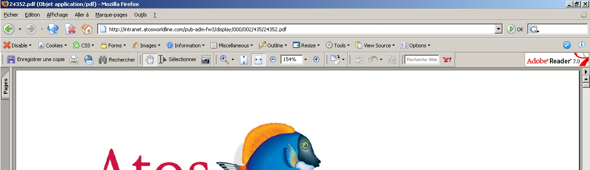
- PDF document opening in the main navigation window
List of illustrations
Fig. 1 : Distinction between links and ordinary text 5
Fig. 2 : Distinction between active and inactive tabs 8
Fig. 3 : Distinction between the active link and the others 8
Fig. 4 : Textual link represented by an image 11
Fig. 5 : Image that cannot be displayed and has no textual alternative 13
Fig. 6 : Image that cannot be displayed but has a textual alternative 13
Fig. 7 : Tooltip displayed when the mouse moves over an unclear pictogram 13
Fig. 8 : Table showing the information with sufficient spacing between the data 17
Fig. 9 : PDF document opening in the main navigation window 20

