

Ergonomic recommendations
5 - Tables
Author(s): le Studio
Date: 29/09/2006
Reference: KAWWA_Usability_Guidelines_5_Tables
Content of this document
The recommendations set out in this document concern everything related to the tables displayed in the pages of the application: column alignment, size…
Criticality of recommendations
The recommendations set out in this document include a degree of criticality rated from 1 to 3 which indicates how important implementing said recommendations is:
The recommendation improves the usability of the application but implementing it is not mandatory.
The recommendation vastly improves the usability of the application. It is strongly recommended to implement it.
The recommendation is critical. Not implementing it causes an unacceptable usability issue. Implementation is mandatory.
Who should you contact if you have questions, criticisms...?
If you have observations, questions or criticisms about the recommendations given in this document, please feel free to contact us. This document is not set in stone and we would be happy to get feedback from you so we can keep on improving and enriching it.
Angela Ricci – Web designer: Angela.Ricci@atosorigin.com
Jérôme Simans – Ergonomist: Jerome.Simans@atosorigin.com
Jean-Luc Macke – Studio Manager: Jean-Luc.Macke@atosorigin.com
Table of contents
5.1. Tables must not be used for layout purposes 4
5.2. Recommendations on the alignment of text in columns 5
5.3. There should be sufficient spacing between table rows 7
5.4. Table rows should use alternate colours 8
5.5. A table must not be too wide, so horizontal scrolling can be avoided 9
5.6. The item selection mode of a table must suit the required action (single or multiple selection) 10

Tables must not be used for layout purposes

Criticality

Description of the recommendation
For accessibility and maintenance purposes, the layout should be based on CSS stylesheets, not tables. Tables must be used only to display lists of data.

Risk incurred if the recommendation is not implemented
If the layout uses tables, the people who use special mechanisms to access the pages (screen reader, textual browser) will very likely not be able to read these tables correctly, as well as the information that they contain.

How to implement the recommendation
Use CSS stylesheets!

Tolerated exceptions
Tables must be used only to display values, not to lay out pages. No exception will be tolerated. Implementing this recommendation is mandatory.

Illustration
No illustration is required here (there is no visual difference between a page created with tables and one created with CSS stylesheets).

Recommendations on the alignment of text in columns

Criticality

Description of the recommendation
This recommendation aims to define the best possible alignment for data displayed in tabular lists, according to their type.
Aligning text blocks to the left ensures that, regardless of their length, they will start under one another at the same location, which guarantees better readability for the user.

Risk incurred if the recommendation is not implemented
If text blocks are centred or aligned to the right, they will never start at the same location (under one another) since they are very likely to have different lengths. Having to “look for” the beginning of the text every time the line changes is very tiring for the eyes.

How to implement the recommendation
- Short text blocks (the longest text block in the column being 20 characters at the most) with fairly similar lengths can be centred in the column. This implies that the longest text blocks will force the column to accept alignment to the left.
- Numerical or monetary data should be aligned to the right.
- Same-length data (same number of characters), such as ids, can be centred in a column.
- Functionality pictograms must be centred in the column that contains them.

Tolerated exceptions
We strongly advise you to implement these recommendations regarding alignment without any exceptions.

Illustration
The following screen shows the various possible types of alignment:
- All the text blocks in the “identifiant” and “date” columns have the same length. Therefore, they can be centred (the text blocks will always begin at the same location).
- The text blocks in the “moyen de paiement” column have fairly similar lengths. Centring them is acceptable even though it is still possible to align them to the left.
- Since the text blocks in the “état” column do not have the same length, they must be aligned to the left so that they are easier to read.
- The text blocks in the “montant d’origine” and “montant actuel” columns are aligned to the right because they are monetary values; aligning them to the right makes it possible to compare them.
- The pictograms in the last column are centred.
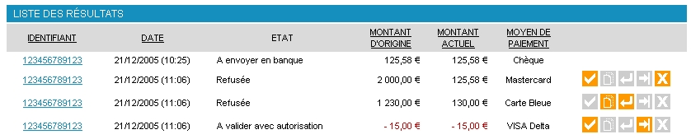
- Table showing the various possible types of alignment

There should be sufficient spacing between table rows

Criticality

Description of the recommendation
For better readability, there should be sufficient spacing between table rows.

Risk incurred if the recommendation is not implemented
Readability will be much less good if rows are too close to one another. The user will spend more time reading the data because they will be harder to read.

How to implement the recommendation
The spacing between table rows is sufficient in the templates provided by the studio (“KAWWA Toolkit”).
However, if you wish to increase this spacing, just increase the top and bottom padding of your cells in the dev.css stylesheet, as shown below:
td {
padding : 5px 0 ;
}
In this example, 5-pixel spacing is defined above and under each cell (and thus each row); no spacing is allocated to the right or left. padding-top and padding-bottom could also be used.

Tolerated exceptions
This recommendation aims to make tables easier to read for the user; it is not mandatory, but it is easy to implement, which is why we strongly advise you to implement it.

Illustration
No illustration required here.

Table rows should use alternate colours

Criticality

Description of the recommendation
To improve readability, the background colour can change every other line, thus producing a “pyjamas effect”. The rows and their content can be distinguished much better this way.

Risk incurred if the recommendation is not implemented
The distinction between rows can be less good when rows use identical background colours. The content is thus harder to read, which makes the search for information more difficult.

HOW TO IMPLEMENT THE RECOMMENDATION
In your CSS stylesheet, you can define a particular style for the cells whose colour will change:
tr.alternative td {
background : laCouleurDeFond ;
}

Tolerated exceptions
Implementing this recommendation is not mandatory but significantly improves the ease of use. As such, we strongly advise you to implement it.

Illustration
The following screenshot shows the use of two different colours for the rows of a data table.
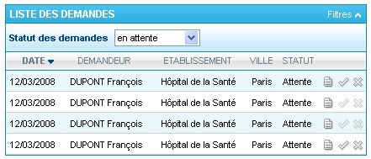
- “Pyjamas” effect: use of 2 different colours for the rows of a table

A table must not be too wide, so horizontal scrolling can be avoided

Criticality

Description of the recommendation
While vertical scrolling is perfectly accepted and acceptable, reading information on a page that is wider than the screen, and thus displays a scroll box, is much more annoying.
Reading is much difficult on such a page and the user's efficiency is reduced because they do not see all the data over the width of a standard page, they have to use their mouse to browse the rest of the information.

Risk incurred if the recommendation is not implemented
Horizontal scrolling greatly disrupts the reading and the search for information on a page.
The user may be bothered if they have to read pages that are too wide, all the more so since the information that seems important to them may be out of the page at first. Besides, if they have to display this page several dozen times during the day, they will quickly feel dissatisfied with the application.

How to implement the recommendation
Table width should be limited in order to avoid horizontal scrolling. Two conditions should be met for this purpose:
- First, do not increase the width defined in the CSS stylesheet provided with the templates. It is set to 100% by default, which means that the table will take up all the space allocated to it in the div block which it is inserted into. You can reduce this width if you wish but never increase it.
- Second, only display the most important values in the table. Indeed, you must not overload the table with all the data about an item (first, to avoid overwhelming the user, and second, because the table may then exceed the allocated width and impose the use of a horizontal scroll box). To do so, just display the most important information (which also keeps the details page relevant). Example: if the “item details” page contains 12 information fields, only the 4-5 most significant ones must be displayed.

Tolerated exceptions
No exception should be tolerated.

Illustration
No illustration required here.

The item selection mode of a table must suit the required action (single or multiple selection)

Criticality

Description of the recommendation
There are two ways of selecting items; here are our recommendations for both:
- if only one item can be selected at a time, the selection will be done by clicking on a link present in the row (usually, this will be the most representative value such as a terminal number, service name....)
- if multiple selection is allowed (it is possible to select multiple items at once before executing an action), then there must be a column on the far left of the table, which will contain checkboxes for specifying the items to select. Ideally, there should be two more links, above and under the table; one for selecting all items and one for unselecting them all.

Risk incurred if the recommendation is not implemented
Providing a checkbox-based selection is unnecessary if only one item can be selected at a time. It is easier and quicker for the user to click directly on the item (or row) which they are interested in.

How to implement the recommendation
For single selection, allow users to click on representative data (file number, service name...) and/or a pictogram.
For multiple selections, display a checkbox to the left of all rows to allow users to select the rows which they are interested in.

Tolerated exceptions
Not implementing this recommendation may result in significant usability problems. This is why we advise you to implement it systematically.

Illustration
The screen below shows the method for selecting one item at a time. To do so, one must click on the terminal number to access the details of the item.
- Selecting one item at a time
The screen below shows that it is possible to select several items at a time (in this example, in order to delete them) thanks to checkboxes on the far left of the table.
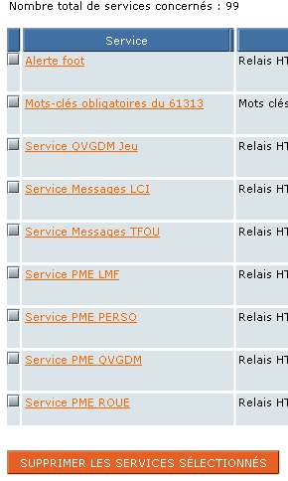
- Selecting multiple items at a time
List of illustrations
Fig. 1 : Table showing the various possible types of alignment 6
Fig. 2 : “Pyjamas” effect: use of 2 different colours for the rows of a table 8
Fig. 3 : Selecting one item at a time 11
Fig. 4 : Selecting multiple items at a time 11

