

Ergonomic recommendations
7 – Error recovery
Author: the Studio
Date: 29/09/2006
Reference: KAWWA_Usability_Guidelines_7_ErrorRecovery
Content of this document
The recommendations set out in this document concern the methods that must be implemented to allow the user to solve possible errors.
Criticality of recommendations
The recommendations set out in this document include a degree of criticality rated from 1 to 3 which indicates how important implementing said recommendations is:
The recommendation improves the usability of the application but implementing it is not mandatory.
The recommendation vastly improves the usability of the application. It is strongly recommended to implement it.
The recommendation is critical. Not implementing it causes an unacceptable usability issue. Implementation is mandatory.
Who should you contact if you have questions, criticisms...?
If you have observations, questions or criticisms about the recommendations given in this document, please feel free to contact us. This document is not set in stone and we would be happy to get feedback from you so we can keep on improving and enriching it.
Angela Ricci – Web designer: Angela.Ricci@atosorigin.com
Jérôme Simans – Ergonomist: Jerome.Simans@atosorigin.com
Jean-Luc Macke – Studio Manager: Jean-Luc.Macke@atosorigin.com
Table of contents
7.1. Error messages must inform the user of the nature of the error 4
7.2. Error messages should inform the user of the severity of the problem 5
7.3. Error messages must explain to the user the best way of solving the problem 7
7.4. Error messages must be written in a language that the user can understand, not in technical language 8
7.5. Error messages must blame the system, not the user 9
7.6. When an error occurs while a form is beiing filled in, the cursor should automatically positition itself in the field that causes the error 10
7.7. How to notify an error in a form 11

Error messages must inform the user of the nature of the error

Criticality

Description of the recommendation
To solve the problem, users must know precisely which error has occurred.

RISK INCURRED IF THE RECOMMENDATION IS NOT IMPLEMENTED
If the user does not understand the nature of the problem, they are even less likely to be able to solve it.

How to implement the recommendation
In the case of a form filled in incorrectly, specify which field contains an error and above all, the type of the error (mandatory field not filled in, wrong type of data entered...).
If the error has been triggered by a user's action, specify in the message which action has caused the error if possible (even going as far as to recreate what the user did).

Tolerated exceptions
This recommendation is not mandatory; however, it is strongly advised to implement it.

Illustration
The screenshot below shows a form filled in incorrectly. The field containing an error is highlighted (red frame, see recommendation 7.6), and the type of the error is explained to the user: the field cannot contain numerical values.
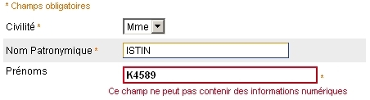
- Error message informing the user of the type of error

Error messages should inform the user of the severity of the problem

Criticality

Description of the recommendation
The more information the user has about the error that has occurred, the more chance they have to solve it. Indicating the severity of the problem can help the user adjust their action accordingly.

RISK INCURRED IF THE RECOMMENDATION IS NOT IMPLEMENTED
Informing the user of the severity of the error that has occurred does not pose any risk; it is additional information that can help them solve the problem by adjusting their behaviour.

How to implement the recommendation
Various methods can be used to display the level of severity of an error:
- You can simply write it in full, which remains the simplest and safest solution (in terms of readability and understanding of the information).
- You can also choose to assign a colour to the error message based on its severity. However, be careful not to use colour only to report an error since people with visual deficiencies such as colour-blindness may have problems discerning colours, and thus may not understand the information that you are giving to them.

Tolerated exceptions
This recommendation is not at all mandatory.

Illustration
In the two screenshots below, one can see a difference in the severity of the encountered problem thanks to a difference in the colour of the message that is likely to cause an error. The same thing can be envisioned for the error message (here, what is marked is the component that causes the error).
NB: colour is not the only way of conveying information about the severity of the error, since the text changes according to it and also gives information about it.
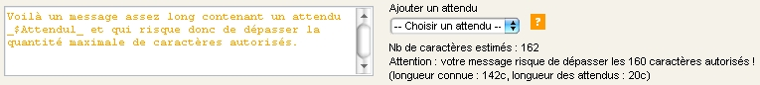
- Displaying the severity of the problem (medium severity)
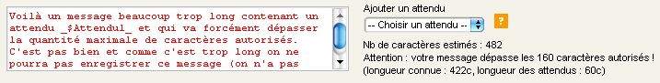
- Displaying the severity of the problem (high severity)

Error messages must explain to the user the best way of solving the problem

Criticality

Description of the recommendation
Displaying a message that explains to the user why an error has occurred is already a good thing as it helps the user understand why the error has occurred. However, this is not sufficient because what matters when a problem is detected is the ability to solve it. Therefore, the user must receive indications that will help them solve the error or, at worst, bypass the issue and continue working in spite of it.

RISK INCURRED IF THE RECOMMENDATION IS NOT IMPLEMENTED
If the user is not informed of the best way of solving a problem:
- either they will be blocked and therefore become less efficient
- or they will try to solve the issue themselves and might aggravate the situation, which is clearly not desirable.

How to implement the recommendation
The error message must include explicative text that allows the user to understand how to solve the issue, or give a link to the online help that contains said explanation.

Tolerated exceptions
This recommendation is mandatory because the user cannot work with the application any more if they cannot solve an error.

Illustration
The screenshot below shows an error message displayed after a form validation error. The message tells the user how to solve the issue: they must enter an integer.

- Error message specifying how to solve the problem

Error messages must be written in a language that the user can understand, not in technical language

Criticality

Description of the recommendation
An error message is meant to help the user understand the problem. Therefore, this message must be clear and understandable for the user, not a technician. Indeed, the person who has to solve the problem immediately is the application user, not a technician.

RISK INCURRED IF THE RECOMMENDATION IS NOT IMPLEMENTED
If the user does not understand the error message, they cannot solve the problem at all.

How to implement the recommendation
Avoid using technical language in your error messages. If you want technicians to have a trace of the problem, create a log file containing all the information that can help them but are useless for the user.

Tolerated exceptions
None.

Illustration
The screenshot below shows exactly what should not be done i.e. an error message that only contains technical terms that the user cannot understand.
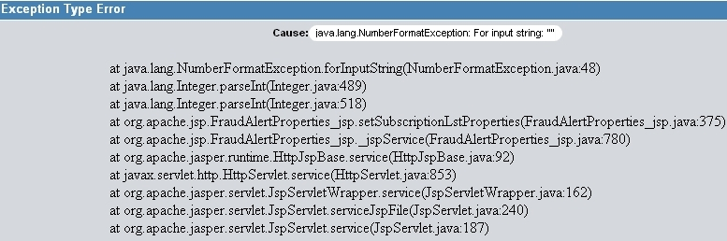
- Error message using a language that is impossible for the user to understand

Error messages must blame the system, not the user

Criticality

Description of the recommendation
When a problem occurs, the user will of course be annoyed. They may have made a mistake that has caused the problem; however they should not be reminded of the fact that they have done such or such thing incorrectly. Besides, the system itself may be the only element to blame. Therefore, the user should not be blamed in error messages, in order not to aggravate their frustration or disturbance.

RISK INCURRED IF THE RECOMMENDATION IS NOT IMPLEMENTED
If the error message blames the user directly, the latter will most probably feel frustrated when using the application; first, because the system did not warn them enough that they were about to make a mistake and second, because they are accused of making a mistake when the problem occurs.

How to implement the recommendation
Try to keep a neutral tone; do not blame the user's actions as the cause of the problem.

Tolerated exceptions
This recommendation is not mandatory; however, it is advised to implement it to keep the user’s level of satisfaction sufficient.

Illustration
No illustration required.

When an error occurs while a form is beiing filled in, the cursor should automatically positition itself in the field that causes the error

Criticality

Description of the recommendation
To shorten the time required to correct a mistake, the cursor should preferably position itself automatically in the field that the user has not filled in correctly. Besides, this saves the user from searching the page to find where the error has occurred.

RISK INCURRED IF THE RECOMMENDATION IS NOT IMPLEMENTED
The user will waste time trying to find where the field that has caused the error is located.

How to implement the recommendation
To correctly set the cursor in the right field, a unique id must be assigned to each form thanks to the “id” attribute.
e.g. For a text field: <input type="text" id="CodePostal" />.
Then, just give the focus to said field. For instance, in Javascript, you can use the, focus() function:
document.nomDuFormulaire.CodePostal.focus() ;

Tolerated exceptions
No use case justifying an exception has been encountered so far.

Illustration
No illustration required.

How to notify an error in a form

Criticality

Description of the recommendation
This recommendation will describe how one or more errors should be notified during form validation.

RISK INCURRED IF THE RECOMMENDATION IS NOT IMPLEMENTED
Not implementing this recommendation does not mean that the users who will fill in a form incorrectly will be unable to correct it. However, we advise you to implement this recommendation to maintain consistency in all Worldline applications.

How to implement the recommendation
Here are three suggestions in cases an error occurs during form validation:
- The first thing to do if the user has made a mistake is to inform them. The quickest and most efficient way of drawing their attention is to display an alert window at the centre of the screen; since it is modal, the user will have to confirm that they have read it by clicking on the “OK” button.
- Second, now that the user has been warned, all the errors that they have made in the form page must be summarised (since the alert window is no longer displayed, they still need to see the summary of the errors that they have made). In the templates provided by the Studio, an error message notification area exists in the XHTML pages. Therefore, errors must be listed in this area.
- The user must now fix their errors. Therefore, they are going to modify or complete the form. They must not be forced to go back to the top of the page in order to browse the list. Therefore, each field that has caused an error can be highlighted clearly, with a red border for instance, but above all, the type of error that has occurred (and possibly the best way of solving the problem, see recommendation 7.3) must we written next to the field (or below/above it, as the layout matters less than the fact of highlighting the field).
The message displayed in the alert window can be as follows:
- First, it can simply state that errors have occurred during form validation. This very short introduction text tells the user why this window is displayed.
- If a single error has occurred, the message can tell the user which field has caused the error and immediately specify the type of the error (field not filled in, field filled in incorrectly).
- If several errors of the same type have occurred (several fields not filled in or filled in incorrectly), the message can specify the type of the error and then list all the fields that have caused errors.
- If errors of different types have occurred, then the message might be too long for the alert box only. In that case, just tell the user that errors have occurred and ask them to refer to the error notification area of the page. Remember that the alert message aims to alert the user, not make a long list of the errors that have been encountered. The user must not waste time reading it and above all, remembering too much information.

Tolerated exceptions
We advise you to implement this recommendation without any exception

Illustration
The image below shows an error message displayed when a form is being filled in.
The message tells the user that the fields containing errors will be indicated by a pictogram, and then sums up all the ways of correcting the errors in said fields
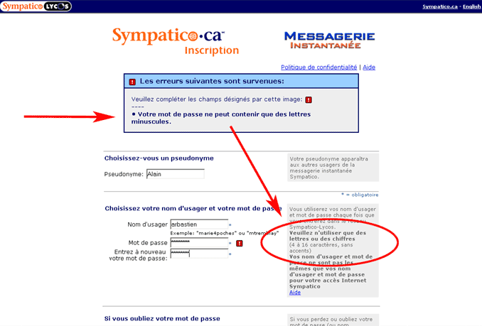
- Example of an error message for a form
List of illustrations
Fig. 1 : Error message informing the user of the type of error 4
Fig. 2 : Displaying the severity of the problem (medium severity) 6
Fig. 3 : Displaying the severity of the problem (high severity) 6
Fig. 4 : Error message specifying how to solve the problem 7
Fig. 5 : Error message using a language that is impossible for the user to understand 8
Fig. 6 : Example of an error message for a form 12

