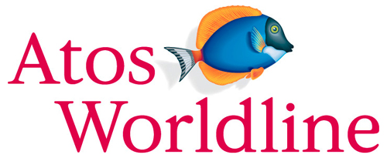

Ergonomic recommendations
1 - Images
Author(s): the Studio
Date: 29/09/2006
Reference: KAWWA_Usability_Guidelines_1_Images
Content of this document
The recommendations set out in this document refer to everything related to the images that your applications can contain.
They will remind you of the importance of textual alternatives and tooltips, define the use of text with images etc…
Criticality of recommendations
The recommendations set out in this document include a degree of criticality rated from 1 to 3 which indicates how important implementing said recommendations is:
The recommendation improves the usability of the application but implementing it is not mandatory.
The recommendation vastly improves the usability of the application. It is strongly recommended to implement it.
The recommendation is critical. Not implementing it causes an unacceptable usability issue. Implementation is mandatory.
Who should you contact if you have questions, criticisms...?
If you have observations, questions or criticisms about the recommendations given in this document, please feel free to contact us. This document is not set in stone and we would be happy to get feedback from you so we can keep on improving and enriching it.
Angela Ricci – Web designer: Angela.Ricci@atosorigin.com
Jérôme Simans – Ergonomist: Jerome.Simans@atosorigin.com
Jean-Luc Macke – Studio Manager: Jean-Luc.Macke@atosorigin.com
Table of contents
1.1. A textual alternative must be provided for each image 4
1.2. Text in images should be avoided 5
1.3. Clickable images must include descriptions 7
1.4. The use of reduced-size images should be preferred when real-size pictures are not necessary 8
1.5. Pictograms must include tooltips 9
1.6. pictograms must be used consistently in the whole application 10

A textual alternative must be provided for each image

criticality

Description of the recommendation
In case a user cannot see images (handicap or browser malfunction), it is imperative that a textual alternative be provided for all displayed images.

Risk incurred if the recommendation is not implemented
If an image cannot be viewed (display error in the browser or visual handicap of the user) and no textual alternative is provided, there is no way of knowing what the image was supposed to represent.

How to implement the recommendation
Systematically add the <alt> attribute into the <img> tag in the (X)HTML code.
Example: <img src="…" alt="here is the text that will be displayed instead of the image" />

Tolerated exceptions
No exception can be accepted

Illustration
Here is what the user sees when an image cannot be displayed in the browser:

- Image that cannot be displayed and has no textual alternative
Here is what would have been displayed if a textual alternative had been provided.
- Image that cannot be displayed but has a textual alternative

Text in images should be avoided

Criticality

Description of the recommendation
As a general rule, images must not be used to represent text. Usually, gif files (therefore images) contain the text and are used to create menus, buttons...Such use should be forbidden.

Risk incurred if the recommendation is not implemented
Using images to represent text makes the page heavier but above all, difficult to translate and maintain.

How to implement the recommendation
Thanks to a CSS stylesheet, a particular style can be defined to replace images with formatted text with a background image, in order to preserve the look.

In this example, we will use the images shown in the “Illustration” section below, which were taken from the Intranet.

Here is the style that could be applied to the “div” that makes up section titles:
div.monEntete {
color: #FFF; /* text colour */
background: #couleurDeFond url(../imgs/entete.gif) bottom right no-repeat;
/* background colour + background image */
padding-right: 20px ;
/* = width of the background image to the right of the text */
}

Here is the XHTML code that would be used:
<div class="monEntete">
<img src="…" alt=" " /> (the alt is empty but must appear in the page)
AW Intranet (section title)
</div>

Tolerated exceptions
No use case justifying an exception has been encountered so far.

Illustration
Here is an example of an image used to represent text.
It is possible (and imperative) to obtain these results by using CSS stylesheets.
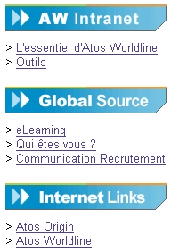
- Text represented by images

Clickable images must include descriptions

Criticality

Description of the recommendation
It is not always easy for users to determine whether images are clickable. Besides, since their meaning can be confusing, and since they are more difficult to interpret than text, they should include descriptions in order to help the user.

Risk incurred if the recommendation is not implemented
An image without any description that explains it is likely to confuse the user. Indeed, on the one hand, they may not manage to determine whether the image is clickable, and on the other hand, they may not understand what the image means, at least the first few times they use the application. While the symbol will be recognised more easily than the text once it has been understood, the latter remains essential during the first few uses of the application.

How to implement the recommendation
Add a text for each clickable image.

Tolerated exceptions
Two exceptions can be tolerated:
- The logo of the application, which does not need any additional explanation;
- Pictograms that represent possible actions in lists (create, modify, view, delete).
However, these images should include tooltips, as specified in recommendation 1.5.

Illustration
In the example below, images include descriptions that give the user information about the functions (hypertext links) and destinations of the images.
- Images with explanatory descriptions

The use of reduced-size images should be preferred when real-size pictures are not necessary

Criticality

Description of the recommendation
When viewing the real-size image is not of critical importance, one should make the page lighter by showing reduced-size images to the user, and allowing them to display the real-size images if they so wish.

Risk incurred if the recommendation is not implemented
The only risk incurred is that the page will be heavier.

How to implement the recommendation
Start by reducing the size of the image using appropriate software in order to insert a “real” reduced-size image into the page, and not the initial image resized only in the XHTML code (in that case, the weight of the image would be the same and implementing this recommendation would become pointless). This reduced-size image will have to become a link to a page containing the initial, real-size image.

Tolerated exceptions
Since the risk is not critical, we cannot make this recommendation mandatory; however, it is advised to implement it.

Illustration
The page below contains reduced-size images; if interested, the user can click on them to display them in real size.
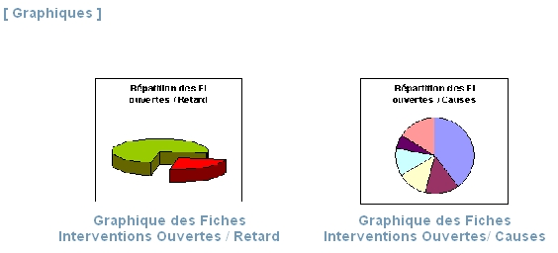
- Images inserted into a page in reduced size, not real size

Pictograms must include tooltips

Criticality

Description of the recommendation
Pictograms are small simple images that are usually used in lists and must represent their functionalities very intuitively.
However, some functionalities may be quite uncommon (refunding a transaction for instance) or may be represented by pictograms with unclear meanings. While users will no longer wonder what the pictogram means after they have used it a few times, they might be puzzled the first time they see it. Therefore, help must be provided to explain the functionality represented by the symbol. This is not done by adding a description (since the interest of pictograms is to save space, you do not want text to take up more space); rather, a tooltip must be displayed when the mouse cursor moves over the image.

Risk incurred if the recommendation is not implemented
The risk is here is vagueness; the user will not know what the pictogram means, notably the first few times they use the application. Therefore, they may either choose not to use it lest they make a mistake, or they may use it incorrectly and actually make a mistake. Either way, they will doubt, which will diminish their confidence and efficiency.

How to implement the recommendation
Technically, the “title” attribute must be inserted into the <img> tag of the XHTML code:
<img src="…" alt=" Functionality represented by the pictogram " title=" Functionality represented by the pictogram />

Tolerated exceptions
None since implementing this recommendation is very easy.

Illustration
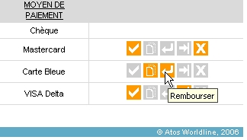
- Tooltip displayed when the mouse moves over a pictogram that is not very explicit

pictograms must be used consistently in the whole application

Criticality

Description of the recommendation
A pictogram used to define a functionality should be used for this functionality only. A functionality can only be defined by a single pictogram in the whole application in order to maintain consistency and allow users to instantly recognise a functionality in a page.

Risk incurred if the recommendation is not implemented
If identical pictograms are used to represent different functionalities (and conversely, if different pictograms identify the same functionality), users may no longer know which pictogram corresponds to which functionality (and conversely). Thus, they might waste time finding the right functionalities or worse, make mistakes if pictograms represent actions (e.g. deletion).

How to implement the recommendation
Just create one and only one pictogram per functionality. Thus, each functionality will be represented by a single pictogram, which will make it easier to locate and understand.

Tolerated exceptions
No exception is authorised.

Illustration
For instance, if a magnifying glass is used in a page to obtain the details of the components of a payment terminal, it can of course be used to obtain the details of a user profile because the functionality is the same (displaying the details of an item) but the magnifying glass cannot be used for the search function.

List of illustrations
Fig. 1 : Image that cannot be displayed and has no textual alternative 4
Fig. 2 : Image that cannot be displayed but has a textual alternative 4
Fig. 3 : Text represented by images 6
Fig. 4 : Images with explanatory descriptions 7
Fig. 5 : Images inserted into a page in reduced size, not real size 8
Fig. 6 : Tooltip displayed when the mouse moves over a pictogram that is not very explicit 9

