

Ergonomic recommendations
4 - Navigation
Author: the Studio
Date: 29/09/2006
Reference: KAWWA_Usability_Guidelines_4_Navigation
Content of this document
The recommendations set out in this document concern everything relating to the navigation in the application (i.e. the method used to find information and perform a task): presence of a breadcrumb trail, menu layout…

Criticality of recommendations
The recommendations set out in this document include a degree of criticality rated from 1 to 3 which indicates how important implementing said recommendations is:
The recommendation improves the usability of the application but implementing it is not mandatory.
The recommendation vastly improves the usability of the application. It is strongly recommended to implement it.
The recommendation is critical. Not implementing it causes an unacceptable usability issue. Implementation is mandatory.
Who should you contact if you have questions, criticisms...?
If you have observations, questions or criticisms about the recommendations given in this document, please feel free to contact us. This document is not set in stone and we would be happy to get feedback from you so we can keep on improving and enriching it.
Angela Ricci – Web designer: Angela.Ricci@atosorigin.com
Jérôme Simans – Ergonomist: Jerome.Simans@atosorigin.com
Jean-Luc Macke – Studio Manager: Jean-Luc.Macke@atosorigin.com

Table of contents
4.1. The navigation system must be autonomous (not based on a particular browser) 4
4.2. Each page must have a title that clearly explains its content 5
4.3. The title of a page must contain the title of the link which the user has clicked on, and must clarify it if need be 6
4.4. A breadcrumb trail should be provided 8
4.5. Long pages must contain links at the top to make navigation easier and avoid vertical scrolling 9
4.6. A link must be added at the bottom of long pages to allow the user to return to the top and avoid vertical scrolling 11
4.7. The navigation system must remain the same in the whole application 12
4.8. The navigation system must make it possible to use the browser's buttons wherever feasible 14
4.9. Navigation must not be based on dropdown menus 15
4.10. The Number of options provided in a menu must be reasonable 16
4.11. A link to the homepage must be present on all THE pages of the application 18
4.12. The tools menu must only contain non-specific links (links concerning the whole application and not a specific functionality) 19

The navigation system must be autonomous (not based on a particular browser)

Criticality

Description of the recommendation
The navigation in the application must not depend on the use of the browser's “Back” and “Next” buttons. Links must be provided to allow users to go from one page to another without having to use the browser's buttons.

Risk incurred if the recommendation is not implemented
There is no real risk, but to ensure the user's comfort, it is always better to provide links that make it possible to use the application without resorting to the browser's buttons. Besides, it is easier to control the application's behaviour by providing the right links rather than by relying on the browser's buttons.

HOW TO IMPLEMENT THE RECOMMENDATION
In your pages, provide links that make it possible to navigate (notably backwards) without resorting to the browser's buttons.

Tolerated exceptions
This rule is easy to implement. Therefore, we advise you to do so by providing the user with enough links to use the application without having to use their browser's buttons.

Illustration
In the page shown below, which displays the characteristics of an SMS service, a link at the bottom of the page allows the user to return to the previous page:
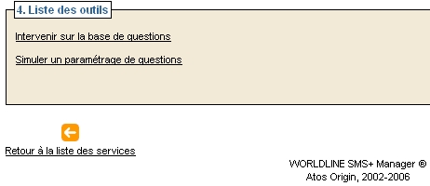
- Link for returning to a list without using the “back” button

Each page must have a title that clearly explains its content

Criticality

Description of the recommendation
Each page must have a title that allows the user to know whether the page will contain the information or functionality that they are looking for, without actually reading the content of this page.

Risk incurred if the recommendation is not implemented
If a page has no title, the user may wonder whether they are on the right page or clicked on the wrong link...The same goes if the page has a title that does not reveal anything about the expected content of the page.

HOW TO IMPLEMENT THE RECOMMENDATION
Always name your pages (by using the <title> tag in the XHTML code).
Beyond the XHTML code, consider creating an area in your interface that will always indicate the title of the page and tell the user where they are in the application.

Tolerated exceptions
No exception can be tolerated

Illustration
The page shown below does not have a title; therefore, it is impossible for the user to know what information the page contains before reading it:
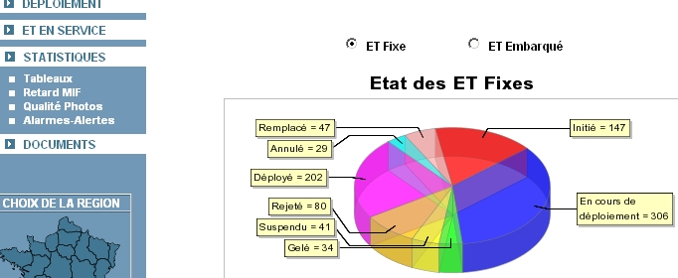
- Page without a title

The title of a page must contain the title of the link which the user has clicked on, and must clarify it if need be

Criticality

Description of the recommendation
Using all or part of the text of the link in the title of the page allows the user not to get lost in the application.
Besides, if the title can be clarified, this makes it even easier for the user to know where they are and understand the navigation system.

Risk incurred if the recommendation is not implemented
If the page that the user reaches after they have clicked on a link has a title that differs from the name of the link, the user will wonder whether they have clicked on the right link. They are very likely to feel disorientated.

HOW TO IMPLEMENT THE RECOMMENDATION
To name a page, reuse the word used in the link which the user has clicked on. This will ensure continuity and consistency when navigating the application.
Besides, and if possible, clarify this link: e.g. to display the details of a list item, the user can click on a link (or pictogram) called “See details”. The page then displayed can also be named not only “Details”, but also “Details of item 123”.

Tolerated exceptions
No exception will be tolerated, as this recommendation is easy to implement and makes it much easier for the user to know where they are in the application.

Illustration
In the screen below, we can see that the title of the page (“Liste des doublons d’un fichier”) also appears in the breadcrumb trail, which also clarifies the name of the file that is being browsed:

- Title of the page clarified by the breadcrumb trail
The page in question also provides a clearly visible title in the browser's bar:
- Title present in the browser’s title bar

A breadcrumb trail should be provided

Criticality

Description of the recommendation
A breadcrumb trail is inserted at the top of the page and contains the links to the pages that the user has read to reach the page that they are currently browsing.
It allows the user to:
- remember where they have been and which pages they have visited;
- easily come back to a visited page without having to find links in the menu.
Of course, the links contained in the breadcrumb trail must have the same names as the links which on the user has clicked to display the current page.
It must also be noted that the last item of the breadcrumb trail is not a link; it can be considered as identical to the title of the current page. Making this text a link would be illogical as it would simply reload the current page.

Risk incurred if the recommendation is not implemented
Not providing a breadcrumb trail prevents the user from immediately viewing the parts of the application that they have visited. Besides, to return to other pages, they will have to find the links using another method (menu, “back” button, “back” link...).

HOW TO IMPLEMENT THE RECOMMENDATION
The interface of the templates contains a small display area which this breadcrumb trail will be inserted into.
Always insert a link for returning to the home page before the breadcrumb trail (except if the page displayed is actually the home page); then, reuse the titles of the links which the user has clicked on to reach the page currently displayed.

Tolerated exceptions
None.

Illustration
The screen below shows a breadcrumb trail in an application:


- Breadcrumb trail

Long pages must contain links at the top to make navigation easier and avoid vertical scrolling

Criticality

Description of the recommendation
On pages containing a lot of information, the user must sometimes scroll down excessively to find what they are looking for. This can prove tedious with applications that must be used frequently. To make it easier for the user to search for information, links (“anchors”) must be provided early in the page and point to specific parts of said page; this will save the user from scrolling down and wasting time.

Risk incurred if the recommendation is not implemented
The user will waste time scrolling down on the page whereas anchors will allow them to reach the information that they are looking for much more quickly.

HOW TO IMPLEMENT THE RECOMMENDATION
To define an anchor in the XHTML code, you can assign an id to a <div> tag:
<div id="SectionDeTextePointée"><p>... text …</p></div>

Then, you can define a link at the top of the page that will point to this anchor and therefore this text section:
<a href="#SectionDeTextePointée" title="…">Name of the text section pointed to </a>

Tolerated exceptions
Implementing this recommendation is not mandatory, although it would vastly improve ease-of-use.

Illustration
Anchors can also be used as a summary on a page, as shown on the screen below:
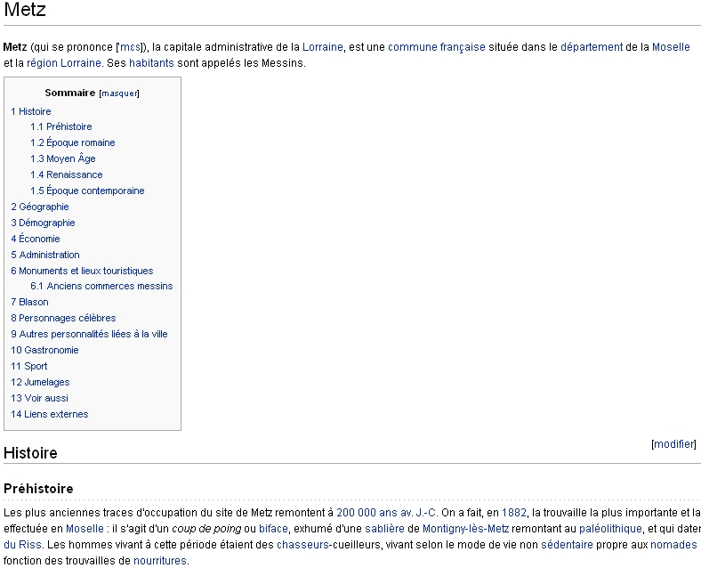
- Summary that uses anchors for page navigation

A link must be added at the bottom of long pages to allow the user to return to the top and avoid vertical scrolling

Criticality

Description of the recommendation
When a page contains a lot of information, and the user has to scroll down so much that the top of the page is no longer visible, a link must be provided so the user can return to the top of this page immediately and without scrolling.

Risk incurred if the recommendation is not implemented
The risk here is a waste of time for the user. The lesser ease-of-use caused by this can quickly become frustrating and greatly reduce the user's satisfaction with the application.

HOW TO IMPLEMENT THE RECOMMENDATION
To define an anchor in the XHTML code, you can define a link at the bottom of the page that will point to a div block located at the top of the page. In the provided templates, this is the div with the topwrap id.
<a href="#topwrap" title="…">Back to the top</a>

Tolerated exceptions
We strongly advise to implement this rule, as it is easy to do so and vastly improves ease-of-use.

Illustration
- Link for returning to the top of the page, located at the bottom of the page

The navigation system must remain the same in the whole application

Criticality

Description of the recommendation
Whether the system uses a menu or tabs, it is imperative that it do not change during navigation. No matter where the user is in the application, the menu must provide the same options in the same order.
If a section or link cannot be selected in a part of the application, they must be left in the menu, in order to keep the same navigation structure and help the user know where they are. On the other hand, it is possible to make these elements inactive so the user cannot select them. However, they must still appear in the menu.

Risk incurred if the recommendation is not implemented
If the options provided by the navigation system change from one page to another (different number of options, different presentation order...), the user will be completely lost and will also lose confidence in the navigation system.

HOW TO IMPLEMENT THE RECOMMENDATION
As an example, if a menu provides the following options:
Section 1
Link 11
Link 12
Link 13
Section 2
Link 21
Link 22
Link 23
Section 3
Link 31
Link 32
Link 33

These three sections must appear in all pages of the applications; so must the three links of each section, in the same order (link 13 must not appear before link 11 for instance).

Tolerated exceptions
One exception can be tolerated: if the application works with “profiles” i.e. if users access different options according to their profile, then of course, no “global” menu containing all possible sections and greying out those which the user cannot access will be created. However although the navigation options available change according to the profile, they must remain identical for each profile throughout the use of the application (as shown below).

Illustration
No illustration required.

The navigation system must make it possible to use the browser's buttons wherever feasible

Criticality

Description of the recommendation
Recommendation 4.1 specifies that all the necessary links should be provided so the user can navigate without using the browser's buttons.
On the other hand, these buttons must not be blocked in any way whatsoever as going back to the previous page using the browser's button is standard behaviour that is likely to be used frequently, or even preferred to the use of a link, to go back to the previous page.

Risk incurred if the recommendation is not implemented
Preventing the user from using basic functions such as going back to the previous page using the browser's button is a refusal to apply a fundamental principle of “web” ergonomics. Indeed, allowing the user to go back makes them feel secure, as they can always “cancel” their action and make a new choice.

HOW TO IMPLEMENT THE RECOMMENDATION
Do not block the access to the browser’s buttons
In certain cases, the use of the “back” button can obviously pose a problem.
This is the case whenever the user has had to confirm an action that was going to modify the data of the system e.g.
- Validating a form;
- Adding, modifying or deleting an element.
For this reason, you should:
- Warn the user before any action of this type so they know that they cannot cancel it by trying to go back;
- Implement a system for “backing up” the data entered into the forms so the user can go to the previous/next page without losing the data that has already been entered.

TOLERATED EXCEPTIONS
None.

Illustration
No illustration required.

Navigation must not be based on dropdown menus

Criticality

Description of the recommendation
Having to “drop down” menus to see their sections, and thus the functionalities that they provide, is not comfortable at all for users.
This is why the templates do not use dropdown menus at all; the navigation is done with tabs at the top of the page, and the action buttons are then used to execute the various functionalities.

Risk incurred if the recommendation is not implemented
Dropdown menus may prove difficult to master: in the case of “mouseover” navigation, the entire content of the menu might disappear if the user moves the mouse over it too quickly, or in case the mouse leaves the area used to expand the menu.

HOW TO IMPLEMENT THE RECOMMENDATION
Do not use dropdown menus in your applications; rather, use tab-based navigation as shown in the templates.

Tolerated exceptions
No use case justifying an exception has been found yet.

Illustration
None

The Number of options provided in a menu must be reasonable

Criticality

Description of the recommendation
The capacity of human memory makes it difficult to use a navigation system that provides too many options.
Usually, the architecture should be reworked if a menu provides too many options.
Options can be grouped into sections so they are easier to memorise; however, having 5 to 7 sections seems to be a maximum.
Besides, the number of subsections should be reduced as much as possible (a maximum number of 9-10 options seems reasonable), as shown in the example below.
When designing a navigation system, width (the number of level-1 sections) should take priority over the depth (maximum number of subsection levels).
However, width must not be excessive (9-10 sections are probably a maximum).

Risk incurred if the recommendation is not implemented
Providing too many options in a menu overloads the user's memory; they will quickly forget most of the options, which will not help them know where they are and navigate in the application.

HOW TO IMPLEMENT THE RECOMMENDATION
1st menu: 12 navigation options, with a tree depth of 4
Section 1
Subsection 11
Option 1
Option 2
Subsection 12
Subsection 121
Option 3
Option 4
Option 5
Subsection 122
Option 6
Option 7
Section 2
Subsection 21
Subsection 211
Option 8
Option 9
Subsection 212
Option 10
Option 11
Option 12

2nd menu: again, 12 navigation options with this time with a tree depth of 2
Section 1
Option 1
Option 2
Option 3
Section 2
Option 4
Option 5
Option 6
Section 3
Option 7
Option 8
Option 9
Section 4
Option 10
Option 11
Option 12

The 2nd menu must be preferred; since it is less deep, it is easier to understand and memorise for the user.
The templates provided by the Studio include two levels of navigation. This system corresponds to the 2nd example provided.

Tolerated exceptions
There should not be any exceptions. If your menu has too many options, then the architecture of functionalities should be reworked.

Illustration
No illustration required.

A link to the homepage must be present on all THE pages of the application

Criticality

Description of the recommendation
Returning to the homepage is a fundamental element of Web ergonomics. Thus, it is mandatory to allow the user to return to this page, wherever they are in the site, via a link in the page or a menu item.

Risk incurred if the recommendation is not implemented
Preventing the user from quickly returning to the site's homepage deprives them of a feature that makes the application easier to use and navigate. Besides, it may prove very difficult for them to return to the homepage (their browser's “Back” button may trigger unwanted actions performed in the visited pages, such as deletions, modifications…).

HOW TO IMPLEMENT THE RECOMMENDATION
Insert a link to return to the homepage, either as a menu item or as a permanent link (appearing at the same location on all the pages of your application).
Also, make the application logo a link that takes the user back to the homepage.

Tolerated exceptions
No exception will be accepted. Implementing the recommendation is mandatory.

Illustration
The link to the homepage can be located in the breadcrumb trail or in the menu as shown on the screen below.
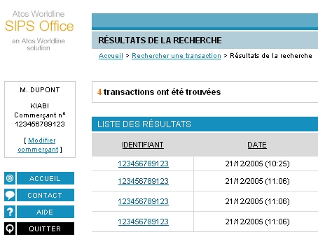
- Links for returning to the homepage

The tools menu must only contain non-specific links (links concerning the whole application and not a specific functionality)

Criticality

Description of the recommendation
This menu groups links that are useful regardless of the functionality being used or where the user is in the site. Therefore, they can only concern functionalities that must remain available all the time and must in no way whatsoever contain links to activate a particular functionality (such as printing a page or the search engine).

Risk incurred if the recommendation is not implemented
Including a link specific to a particular function into this tools menu conflicts with recommendation 4.7, which specifies that menus must be identical in the whole application. If the link only concerns a particular functionality instead of the whole application, it will no longer be displayed in the menu when the user browses another functionality. Therefore, to comply with recommendation 4.7, the link would have to always be present in the menu, even if the user browses a functionality that does not use this link. This inconsistency is unacceptable.

HOW TO IMPLEMENT THE RECOMMENDATION
The buttons that may be inserted into this tool menu are those provided in the templates:
- Return to the homepage;
- Online help (general help, common to the whole application);
- Contact (for asking the site manager for more specific help);
- Logout (for applications requiring users to log in).
The return to the homepage, help and logout items are mandatory in the tools menu.

Tolerated exceptions
No use case justifying an exception has been encountered so far.

Illustration
Here is the tools menu as shown in the templates; we advise you to keep it this way.
- Tools menu provided in the templates of the Studio
List of illustrations
Fig. 1 : Link for returning to a list without using the “back” button 4
Fig. 2 : Page without a title 5
Fig. 3 : Title of the page clarified by the breadcrumb trail 7
Fig. 4 : Title present in the browser’s title bar 7
Fig. 5 : Breadcrumb trail 8
Fig. 6 : Summary that uses anchors for page navigation 10
Fig. 7 : Link for returning to the top of the page, located at the bottom of the page 11
Fig. 8 : Links for returning to the homepage 18
Fig. 9 : Tools menu provided in the templates of the Studio 19

