

Ergonomic recommendations
10 – Help system
Author: le Studio
Date: 29/09/2006
Reference: KAWWA_Usability_Guidelines_10_HelpSystem
Content of this document
The recommendations set out in this document concern all the help features that will allow the user to find the information that they need and perform the task which they use the application for.
The help can be general (concerning all parts of the application and contained in a single help file), contextual (adjusting to the user’s issue) or procedural (describing how to use a functionality from start to finish).

Criticality of recommendations
The recommendations set out in this document include a degree of criticality rated from 1 to 3 which indicates how important implementing said recommendations is:
The recommendation improves the usability of the application but implementing it is not mandatory.
The recommendation vastly improves the usability of the application. It is strongly recommended to implement it.
The recommendation is critical. Not implementing it causes an unacceptable usability issue. Implementation is mandatory.
Who should you contact if you have questions, criticisms...?
If you have observations, questions or criticisms about the recommendations given in this document, please feel free to contact us. This document is not set in stone and we would be happy to get feedback from you so we can keep on improving and enriching it.
Angela Ricci – Web designer: Angela.Ricci@atosorigin.com
Jérôme Simans – Ergonomist: Jerome.Simans@atosorigin.com
Jean-Luc Macke – Studio Manager: Jean-Luc.Macke@atosorigin.com
Table of contents
10.1. The online help must not modify the user's work 6
10.2. Input aid must be provided wherever the requested information is not obvious 7
10.3. Procedural help should be provided to allow the user to solve the problems that they encounter step by step 11
10.4. The help system should take the user's expertise into account 13
10.5. It must be possible to deactivate “intrusive” help features 15

Criticality

Description of the recommendation
Regardless of the functionality they are using, or the page that they are browsing, the user must always be able to access the online help. This reinforces their trust in the application (because the user knows they can always be “helped out”).
This access can be materialised by a link provided in the menu, at the top or bottom of the page, which will open the index page of the help file.

RISK INCURRED IF THE RECOMMENDATION IS NOT IMPLEMENTED
If the user cannot access the online help constantly, they will have to stop working and go to the location where help is accessible if they encounter a problem. This is an obvious waste of time and efficiency as well as a lack of ease-of-use

How to implement the recommendation
Just include a link into all the pages of the application (the simplest solution is still to insert it into the menu).

Tolerated exceptions
No exception can be tolerated.

Illustration
The image below shows the existence of a link to the general help pages of an Atos Worldline application.
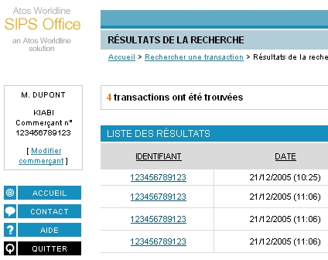
- Presence of a link to the general help of an application

The online help must not modify the user's work

Criticality

Description of the recommendation
Accessing the help does not mean leaving the task in progress. Therefore, once the user leaves the help, they must find the application in the state that it was in when they left it.
Therefore, the help page must open in a new browser window.

RISK INCURRED IF THE RECOMMENDATION IS NOT IMPLEMENTED
If the user needs to browse the help when they are performing an action and the state of the application has changed, they will be frustrated and wish they had not used the help. They will be frustrated because they will have to start their task all over again. Their satisfaction with the use of the application will be diminished.

HOW TO IMPLEMENT THE RECOMMENDATION
Do not open the online help in a working window: open a new browser window.

Tolerated exceptions
No exception can be tolerated.

Illustration
As can be seen on the screenshot below, the online help appears in a new window, the smaller size of which makes it possible to still see the application at the time when the user asked for help (the size of the window can be modified to take up the entire size of the screen if the user so wishes).
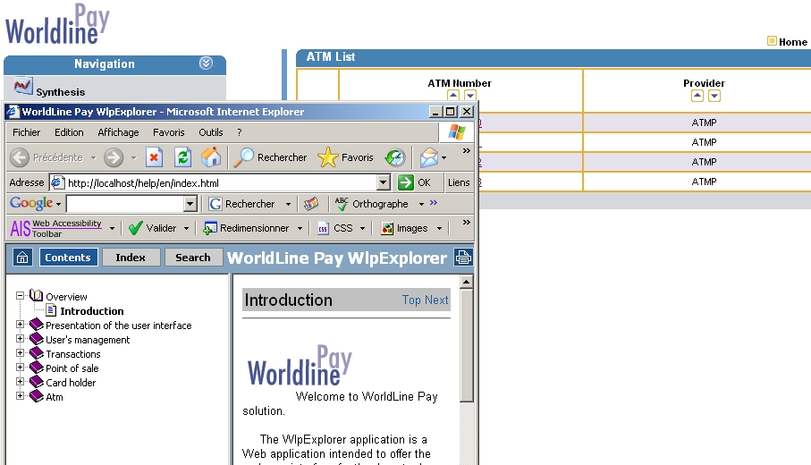
- Online help opening in a new window

Input aid must be provided wherever the requested information is not obvious

Criticality

Description of the recommendation
In page where the user is asked to enter information, input aid must be available for all the sections that may pose problems. This aid makes it possible to specify the nature of the information that the user must enter, the expected input format...all this without the user having to open the online help.

RISK INCURRED IF THE RECOMMENDATION IS NOT IMPLEMENTED
If a user does not know how to enter certain pieces of information, and no input aid is available, they will have to open the online help and waste time looking for the information that will allow them to solve their issue. If input aid had been available from the start, they could have solved the problem directly and resume working.

How to implement the recommendation
You can use four different types of input aids (calendar, tooltip, autocompletion, popup window). See the “illustration” part to know how to implement them.

Tolerated exceptions
It is not always easy to implement input aid features, although it is simpler than implementing contextual help. In the first two cases illustrated below, this should always be done. On the other hand, autocompletion and “popup” windows are more difficult to develop and therefore less simple to implement.
However, you should be aware that the better, more numerous input aid features are, the better the user will succeed in entering the information that they have to enter. Besides, they will be happy to use the application.

Illustration
4 types of input aids are going to be illustrated below:

- The first one is calendars, which makes it easy to enter a date without any error, and in the format expected by the application:
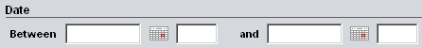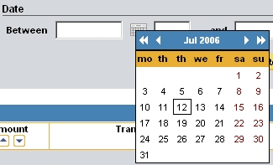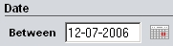
- Use of a calendar to enter a date
- The second type of input aid consists in displaying a small tooltip thanks to the use of a pictogram located next to the field that may pose a problem. For instance, this tooltip can inform the user about the type of information to enter.
Tooltips must be used when help texts are not too long (reading the text contained in the tooltip should not be tedious). Besides, tooltips must remain displayed on the screen as long as the user keeps their mouse over the help pictogram (tooltips must not disappear by themselves after a few seconds before the reader has finished reading them):
- Example of an input aid tooltip
- The third type of input aid is the autocompletion function. It consists in suggesting possible values to the user according to the text already entered, as shown in the screenshot below where only the word “win” has been entered.
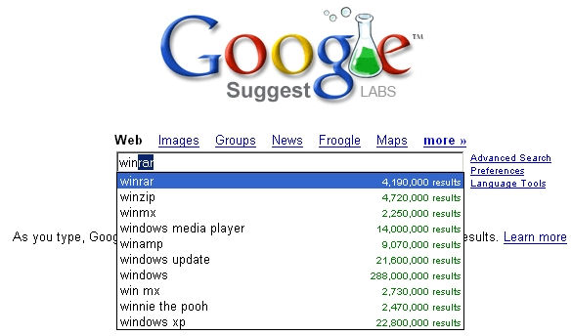
- Example of semiautomatic input
- The fourth and last type of input aid consists in opening a “popup» window to suggest values to enter into the form. This type of aid is particularly appropriate when many values can be entered, and the user has difficulty remembering all of them (this is especially true the first few times the application is used)
In the case of a “popup” window, as shown below:
- the window must be small, so it does not hide the main window and notably the form field for which help was required;
- the window must only be used to help the user enter information into a filed. It cannot be used like to use the application, like the main window (thus, it does not provide any functionality);
- the window must not be able to open another “popup” itself; this in order to avoid having too many windows on top of one another on the screen;
- the window must close by itself if possible once the user has clicked on the item they want to use in the field.
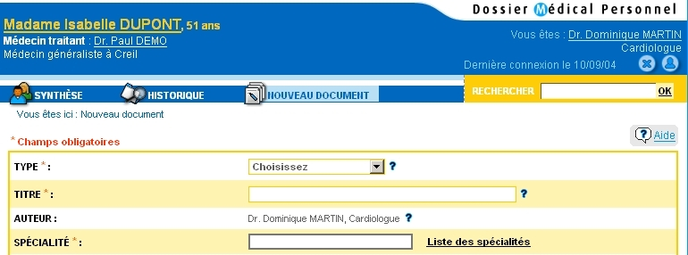
- The “Liste des spécialités” link opens the input aid window
On the screenshot above, the user must fill in a field named “SPECIALITE”, and they can use an input aid thanks to the “Liste des spécialités” link located next to the field.
When the user clicks on that link, a window is displayed; it contains the list of specialties.
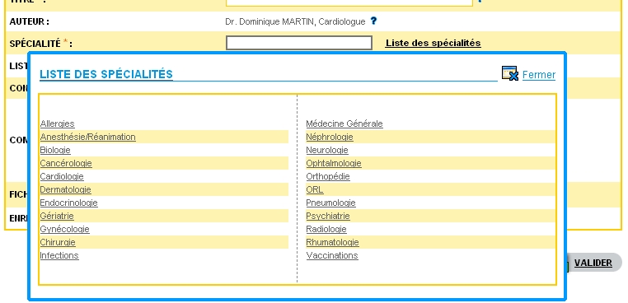
- Input aid “popup” window
This window, which must not mask the field about which the user asked for help, makes it easy to select a specialty with a single click on the one that corresponds to the user's choice.
Once the user has selected the value that must be inserted into the field (by clicking on it), the window closes automatically, and the field now contains the selected value.
- Inserting the selected value into the corresponding text field
If the list of items to display in the “popup” window is not too long, then all items can be displayed in the window.
On the other hand, if the list is too long, a classification will have to be implemented, using the alphabetical order for instance, to help the user easily find the required item as shown on the screenshot below.
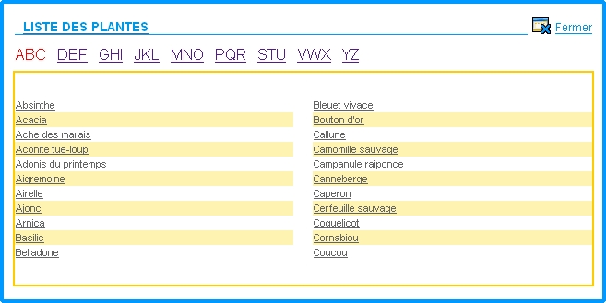
- Input aid “popup” window with alphabetical classification

Procedural help should be provided to allow the user to solve the problems that they encounter step by step

Criticality

Description of the recommendation
When the user cannot use a functionality, or makes a mistake while doing so, procedural help should be provided to guide them step by step in the problem solving process so they can finally use said functionality. Even though this cannot be implemented everywhere, it would be good thing for this help to be available for the most difficult functionalities to use.
Procedural help will list all the possible causes of a problem and provide a set of possible solutions according to the user's answers.
Procedural help can be called even when the user is not stuck, and when they wish to learn how to use a functionality. Then, it will use the same concept, asking the user what they want to do and offering them choices according to their answers.

RISK INCURRED IF THE RECOMMENDATION IS NOT IMPLEMENTED
If no procedural help is provided, the user will use the general help to find how to solve their problem. The risk here is that the user might waste time looking for the solution instead of directly having different appropriate solutions to their problem (since procedural help is contextual).

How to implement the recommendation
The procedural help must consist in a series of Q/As, starting from the most general cases and narrowing down to the particular case that interests the user. The first set of questions can deal with the topic (functionality) that the user wants to master thanks to the procedural help. The next sets of questions will depend on the different answers that the user will give, to finally deal with the process to implement to perform such or such action (and thus potentially solve a problem related to this action).

Tolerated exceptions
Setting up a procedural help system is not mandatory; however, it helps the user save time when they encounter a problem, by providing appropriate help rather than letting the user search a general help file.

Illustration
As an example, here is the procedural help provided by the Windows operating system when a printing problem is encountered.
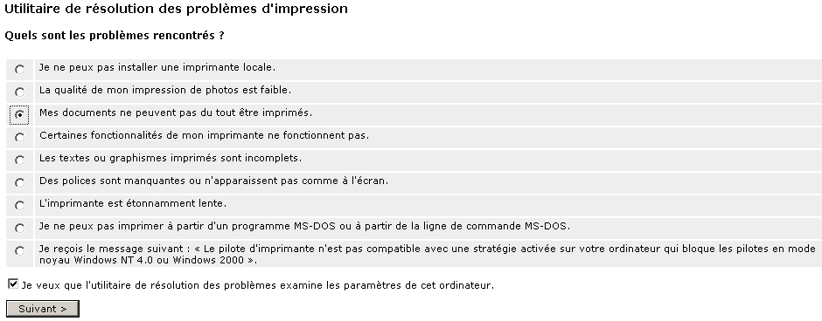
- Starting page of the Windows procedural help when a printing problem is encountered
First of all, the help shows a page that lists all the possible causes of the problem.
The user chooses the one that matches their case, and a new page will be displayed with practical information that will help the user solve their problem:
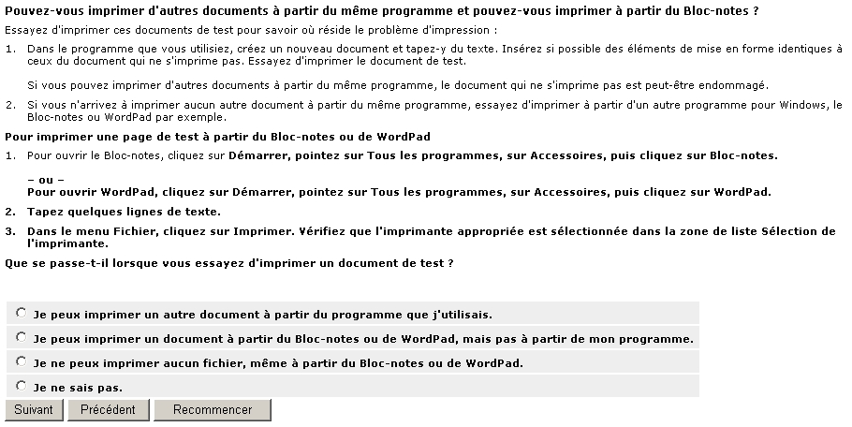
- Suggestions for solving the issue, with confirmation requests
The page thus displayed provides a method for solving the error/problem, and the system asks the user if the error/problem has been solved after the instructions have been followed. If so, the procedural help will stop there, and the user will close the help window; otherwise, it will continue until the problem no longer exists.
Above all, the “I don't know” option available on this page should be noted. This option can be useful for the users who are not familiar with the application and the “technical” methods used to solve the error, and it can allow them to solve the problem despite their lack of expertise. Taking into account the user’s expertise will be the subject of the next recommendation.

The help system should take the user's expertise into account

Criticality

Description of the recommendation
Novice users may need more explanations than more experienced users. This fact must be taken into account so several levels of guidance are provided when helping users.

RISK INCURRED IF THE RECOMMENDATION IS NOT IMPLEMENTED
If the help is too advanced, novice users may find it hard to obtain the basic information that they are looking for.
On the contrary, if the help is too simple, it will not be thorough enough for expert users, who are looking for information that is more precise and advanced.

How to implement the recommendation
The help could display all the explanations (even those considered as basic by experienced users) and thus allow users of all levels to understand them. But then, there should also exist a system that “hides” the basic explanations so expert users can go straight to the heart of the matter.
The opposite could also be done i.e. a help feature that only displays explanations for advanced users but also allows novice users, if they so wish, to request more details about the parts that are not explained because expert users already know them.

Tolerated exceptions
This recommendation is not mandatory. However it increases ease-of-use for users by providing them with several levels of guidance when solving a problem or learning how to use the application.

Illustration
The following screenshot shows two levels of help. The “novice” level is accessible for the users who need it and can then display additional information.
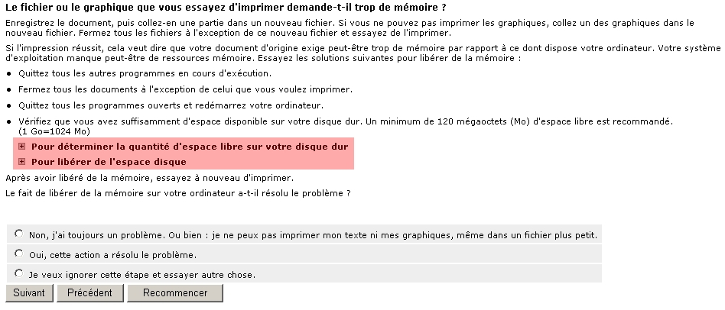
- Taking into account the user’s expertise; two levels of help are available

This screenshot shows:
- A help system for everyone (“Check that you have enough space…”);
- Twos additional help items for users who do not really know how to use the help provided.

It must be possible to deactivate “intrusive” help features

Criticality

Description of the rule
The user should always be able to deactivate “intrusive” help features, such as avatars, in the applications that use them.

RISK INCURRED IF THE RECOMMENDATION IS NOT IMPLEMENTED
There might come a time when this “intrusive” help will become more annoying than anything else, and will disrupt the user's work.

How to apply the recommendation
Always provide the user with an option for deactivating the intrusive help feature directly in it (as is the case for the “Office Companion”).
Also, provide a menu that makes it possible to deactivate or reactivate this intrusive help feature (of course, if a menu dedicated to help is provided, it will have to contain this option).

Tolerated exceptions
We strongly recommend you to apply this recommendation without any exception, even though not doing so does not prevent the user from doing their work.

Illustration
We can see in the screenshot below the option available directly in the intrusive help provided by the “Office Companion”.
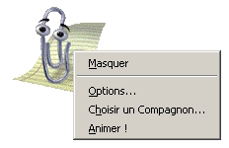
- Option for directly deactivating the intrusive help
In both of the screenshots below, you can see that an option of the help menu makes it possible to deactivate or reactivate the” Office Companion”.
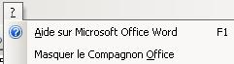
- Option for deactivating the intrusive help from the help menu

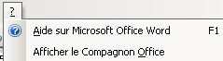
- Option for reactivating the intrusive help from the help menu
Table of illustrations
Fig. 1 : Presence of a link to the general help of an application 5
Fig. 2 : Online help opening in a new window 6
Fig. 3 : Use of a calendar to enter a date 8
Fig. 4 : Example of an input aid tooltip 8
Fig. 5 : Example of semiautomatic input 8
Fig. 6 : The “Liste des spécialités” link opens the input aid window 9
Fig. 7 : Input aid “popup” window 9
Fig. 8 : Inserting the selected value into the corresponding text field 10
Fig. 9 : Input aid “popup” window with alphabetical classification 10
Fig. 10 : Starting page of the Windows procedural help when a printing problem is encountered 12
Fig. 11 : Suggestions for solving the issue, with confirmation requests 12
Fig. 12 : Taking into account the user’s expertise; two levels of help are available 14
Fig. 13 : Option for directly deactivating the intrusive help 16
Fig. 14 : Option for deactivating the intrusive help from the help menu 16
Fig. 15 : 16
Fig. 16 : Option for reactivating the intrusive help from the help menu 16

