

Treeviews and usability
General guidelines
Author(s) : le Studio
Date : June 1st 2007
Référence :
Content of this document
The goal of this document is to answer the possible usability problems caused by treeviews. It will regroup some general guidelines on treeviews usages, in order to avoid some errors that may endanger the global usability of the application.
Who should you contact if you have questions, criticisms...?
If you have observations, questions or criticisms about the recommendations given in this document, please feel free to contact us. This document is not set in stone and we would be happy to get feedback from you so we can keep on improving and enriching it.
Angela Ricci – Web designer : Angela.Ricci@atosorigin.com
Jérôme Simans – Ergonomist : Jerome.Simans@atosorigin.com
Jean-Luc Macke – Manager Studio : Jean-Luc.Macke@atosorigin.com
Table of contents
General recommandations 4
The treeview should only represent real hierarchical structures 4
Nodes should not be automatically closed 5
Keep memory of the open nodes 6
The treeview should give information about the user’s position 7
The treeview should automatically be open 8
The treeview should not display the properties of a leaf 8
The treeview should only display objects of the same nature 9
The treeview must be optimised to maximise data readability for the user 10

General recommandations

The treeview should only represent real hierarchical structures
The arborescent structure is very well suited to represent data that are identically organized in the « real world », like a file system for example. Indeed, the user can quickly remember the « real » version and thus he can quickly understand the treeview functionnal mode.
On the other hand, treeviews are sometimes used only because it is easy, in a development way, to represent data in such a structure, and not because the data are really organized like this. Then the users will not understand why the data are organized in a treeview, and will probably spend a lot of time searching the desired items, and errors may occur by manipulation of these items. In conclusion, they will encounter big usability problems. This is the reason why you should always make sure sure that the data represented by a treeview can be organized in the same way in reality. If this is not the case, we can only use a search system to get the elements and lists to display them.
Moreover, the treeviews must not replace a « classical » navigational system. For example, with the KAWWA graphical chart, navigation is made with tabs, and not treeviews.

Nodes should not be automatically closed
When the user opens a node, other open nodes should not be automatically closed. The user may wish to compare some positions or items, and it could become fastidious for him to have to open a node, search for the interesting item, memorize the relevant information, close the node, open the other one, search for the other interesting information and compare them to the memorized ones.
A bad example in this case : the management of the bookmarks in Internet Explorer. When browsing this menu, we can access the bookmarks thanks to a treeview.

- Exploration of bookmarks in IE : level A
Unfortunately, it is impossible for the user to keep this level open, et to consult another one simultaneously, because IE automatically closes the open node as soon as the user opens a new one, as shown in the screenshot below :

- Exploration of bookmarks IE : level B
Thus, if a user wishes to consult many levels simultaneously, it is impossible with this system, which can become very frustrating, and efficiency costly.
We recommand to use a system as the one shown below :
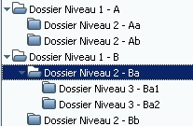
- Exploration of bookmarks in Opera
This system allows multiple nodes to be open at the same time, allowing the user to consult multiple folders, compare informations…

Keep memory of the open nodes
When a user closes a node A (father node) which had an open lower node Aa (son node), the system should keep memory of this state. Thus, if the user opens the father node again, the son node will automatically be open, and the user will have his treeview in the exact same state as it was before closing the father node.
For example, if we have a treeview open like this :
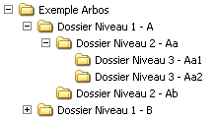
- Example of treeview with father (A) and son (Aa) nodes open
Here, if the user closes the father node (A), the treeview will be displayed like this :
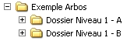
- Same example with the father node (A) closed
If the user chooses to open the father node (A) once again, he must find the same configuration as the one that existed before he closed the father node. In other words, all the son nodes that were open should now automatically open once more. This is shown in the example below :
- Same example of the treeview which has kept memory of open nodes
The treeview has the same configuration as before. Thus the user can quickly and simply remember his position, without having to manually open the nodes).
This behaviour is the one used in the Windows operating system, so the users are really accustomed to it. Therefore, this behaviour should be kept, allowing a better and quicker comprehension of the treeview’s working.

The treeview should give information about the user’s position
The knowledge of the position in a treeview can quickly become difficult if there is no reminder system of the user’s position in it. Indeed, navigating in a treeview demands a high amount of memory resources for the user. This amount is lower if the user is accustomed to this kind of structure, and lower again if there is a reminder system of his current location, as shown in the example below.
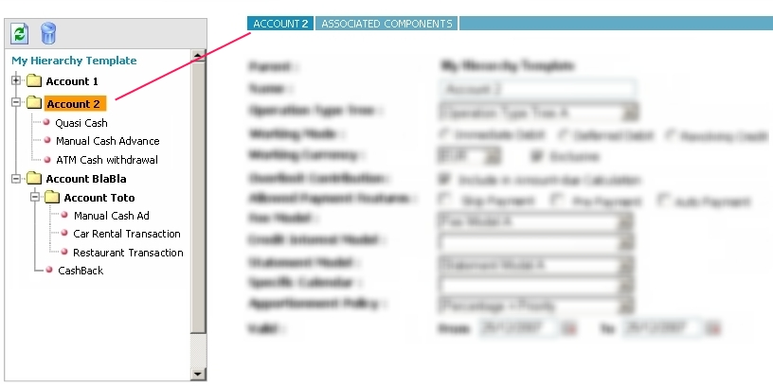
- Example of visual reminder of the user’s position in the treeview
In this example, two ways are used to alert the user about his position :
- The name of the currently visited node is highlighted in the treeview.
- The name of the currently visited node is reminded in the details part of the page, right to the treeview.
The same system is used in the Windows file explorer (we even have three reminders here) :
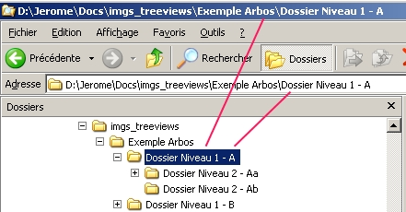
- Example of visual reminder in the Windows file explorer

The treeview should automatically be open
This means that the very first node of the treeview (the root node) should not be close when the treeview is displayed. It is useless, because it will generate a time loss, as the user will be forced to click on the root node to open it.

- Example of a treeview closed at the beginning

The treeview should not display the properties of a leaf
The properties or details of a leaf (or a node) should not be displayed in the tree, but in the main display zone of the page.
One bad example could be a treeview like the one shown below:
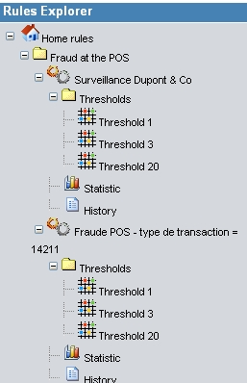
- Example of a treeview with some nodes properties displayed in the tree
Here, “Statistic” and “History” could probably be properties of the “Surveillance Dupont & Co” item which they are linked to. It should then be more correct to display them not as tree’s leafs, but as data displayed in the main content zone of the page (see fig. 12: “restrictions”).

The treeview should only display objects of the same nature
For example, the treeview should not display files and actions on the files. Indeed, this hybrid type of treeview confuses the user, as he has some difficulties to create a simple and coherent mental model (so he has to use more mental resources, making the task harder and the learning process longer). Thus, the treeview should only contain names, neither adjectives nor verbs. In other words, a treeview will only display elements, no actions.
The possible actions on an element (or on the whole tree, why not?) could be displayed above the treeview, as it is done for the treeviews used for SPOP applications, as shown below:

- Example of SPOP treeview

The treeview must be optimized to maximise data readability for the user
Displaying informations about elements in a treeview is very important, because the treeview is the way to select and consult items. The users should then see those elements in the best conditions. But it is important to note that the treeview is only the way to select the items, displaying the data details of an element will be done in the page main content area (see example below).
Thus, the treeview is not intended to be very tall, and even less large. If it is too deep (meaning that he has too many sub-levels), it will obviously need an horizontal slide bar, which is not very comfortable for the user, thus it is clearly recommended to avoid displaying one.
In order to limit the possibility to have an horizontal slide bar, we recommend to display no more than 3 levels in the treeview (the root node level, one first sub level and a second sub level, which can display its leaves).
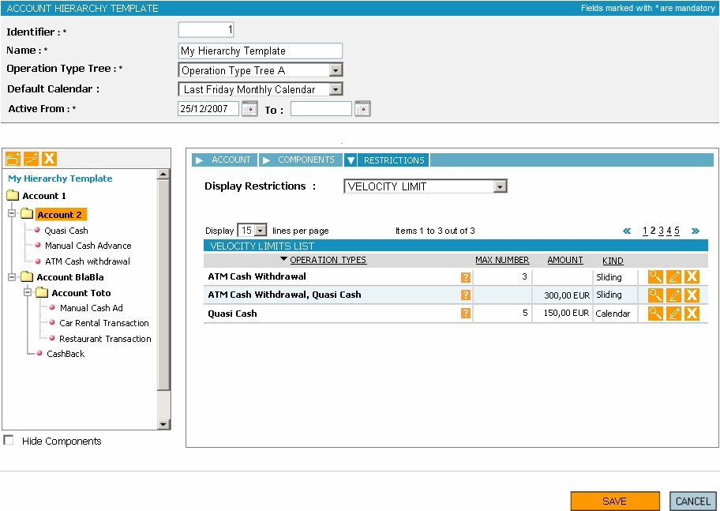
- Example of a page displaying details about an element selected in a treeview

Table des illustrations
Fig. 1 : Exploration of bookmarks in IE : level A 5
Fig. 2 : Exploration of bookmarks IE : level B 5
Fig. 3 : Exploration of bookmarks in Opera 5
Fig. 4 : Example of treeview with father (A) and son (Aa) nodes open 6
Fig. 5 : Same example with the father node (A) closed 6
Fig. 6 : Same example of the treeview which has kept memory of open nodes 6
Fig. 7 : Example of visual reminder of the user’s position in the treeview 7
Fig. 8 : Example of visual reminder in the Windows file explorer 7
Fig. 9 : Example of a treeview closed at the beginning 8
Fig. 10 : Example of a treeview with some nodes properties displayed in the tree 8
Fig. 11 : Example of SPOP treeview 9
Fig. 12 : Example of a page displaying details about an element selected in a treeview 10

