Climate Change Analysis and
Temperature Prediction Using Machine Learning

Gotam Kumar (23k-0860)
Course: Data Science
Instructor: Dr. Rabia Tabassum
Institution: FAST National University of Computer and Emerging Sciences (FAST-NUCES)
Date: May 2025

2. ABSTRACT
Climate change prediction has become a central problem in data science because rising temperature variability affects agriculture, water security, public health, and long-term urban planning. This study develops a reproducible machine learning pipeline for city-level temperature prediction using the Berkeley Earth Climate Change Dataset, specifically the GlobalLandTemperaturesByCity.csv file containing approximately 8.6 million records from 1750 to 2013. After cleaning and restricting the working analysis window to 1900 onward, the pipeline produced 4,788,080 usable observations and a stratified 75,000-row modeling sample. Five regression models were implemented: Linear Regression, Decision Tree, Random Forest, Gradient Boosting, and XGBoost. The study compared two validation strategies, namely a conventional random split and a time-aware chronological split, and computed MAE, MSE, RMSE, MAPE, and R2 for all models. Under the chronological split, Random Forest achieved the best held-out performance with RMSE = 1.372, MSE = 1.882, MAE = 0.927, MAPE = 48.649%, and R2 = 0.980. Cross-validation on 18,000 sampled rows produced the best average RMSE for XGBoost at 1.4029, followed by Random Forest at 1.4672. A decade-wise error analysis further showed increasing RMSE from the 1990s to the 2010s, indicating greater difficulty in modeling more recent climate conditions. The resulting workflow combines code-based reproducibility, comparative model evaluation, and interpretive diagnostics to support climate-oriented temperature forecasting.
Keywords: climate change, temperature prediction, machine learning, regression, Berkeley Earth, feature engineering, chronological validation, comparative analysis
3. INTRODUCTION
Climate change is no longer an abstract environmental concern; it is a measurable and accelerating transformation of the Earth system with direct consequences for food production, disaster risk, energy demand, migration patterns, and public health. Temperature is one of the most fundamental indicators of this transformation because it reflects both long-run warming and short-run climate variability. Reliable temperature prediction at city scale can therefore support adaptation planning, infrastructure design, and regional risk assessment, especially in densely populated and climate-sensitive regions.
Machine learning has increasingly been adopted in climate research because it can model nonlinear interactions, absorb large-scale historical records, and complement physically grounded forecasting systems. Recent studies have shown that modern learning algorithms can compete with or augment classical statistical approaches for temperature and rainfall estimation [2], while deep architectures have improved local and high-frequency environmental forecasting [4]. Yet the strongest model in one setting does not necessarily remain strongest in another, which makes comparative evaluation on large and diverse datasets especially important.
The Berkeley Earth Climate Change Dataset [1] is well suited to this task because it provides city-level monthly temperature records across centuries, multiple countries, and wide geographic coverage. The raw file used in this project, GlobalLandTemperaturesByCity.csv, contains roughly 8.6 million observations with timestamp, temperature, uncertainty, city, country, latitude, and longitude. This combination of temporal depth and geographic breadth supports both global pattern analysis and regional subset analysis, including a South Asia track that is particularly relevant for climate-vulnerable populations.
Despite the availability of the dataset, a clear gap remains in reproducible course-scale studies that combine leakage-aware feature engineering, direct comparison of multiple classical and ensemble regressors, chronological validation, and decade-wise error analysis on this exact city-level benchmark. Many applied studies still rely on random train-test splits, which can overstate model performance when future conditions indirectly influence training. Likewise, comparative work often stops at a single aggregate score and does not inspect how prediction error changes across recent decades.
This paper addresses that gap through a complete end-to-end pipeline implemented in Python and organized into reusable source files and notebooks. The study contributes a transparent preprocessing workflow, explicit feature engineering for temporal and geographic structure, a comparison of five machine learning regressors under random and chronological validation, cross-validation summaries, and decade-specific diagnostic analysis. The remainder of the paper reviews related literature, states the research problem, explains the methodology and experimental setup, presents the empirical findings, compares the models, and concludes with limitations and future directions.
4. LITERATURE REVIEW
4.1 Large-Scale Climate Forecasting Studies
Mishra et al. [2] and Ratnam et al. [5] both address climate forecasting at scales where temporal structure matters, but they approach the problem from different methodological traditions. Mishra et al. compare SARIMA, LSTM, and XGBoost for South Asian climate forecasting and show that hybrid statistical and machine learning approaches can exploit both long-term seasonal behavior and nonlinear relationships. Ratnam et al., by contrast, improve seasonal air-temperature forecasts through a genetic algorithm that optimizes the forecasting setup itself rather than relying on a direct comparison of standard regression learners. Both studies agree that climate prediction benefits from techniques capable of handling temporal dependence and nonstationary patterns. However, they differ in data granularity and evaluation emphasis: Mishra et al. focus on regional climate forecasting with explicit model competition, whereas Ratnam et al. focus more on forecast improvement strategy within seasonal prediction systems. The remaining gap is that neither study offers a broad city-level comparative regression framework on Berkeley Earth data with a straightforward, reproducible code pipeline and explicit decade-wise holdout diagnostics.
4.2 Local and High-Resolution Prediction Studies
Zanchi et al. [3], Khan and Al-Hajj [4], and Adeniran et al. [6] demonstrate the benefits of moving to finer spatial or temporal resolution. Zanchi et al. use deep learning to forecast local microclimate by leveraging global climate data, showing that high-resolution prediction can uncover local dynamics that are hidden in coarse global averages. Khan and Al-Hajj [4] push the resolution further with multi-output deep learning for high-frequency air and surface temperature prediction in Kuwait, while Adeniran et al. [6] develop an improved machine learning framework for diurnal and spatially continuous near-surface air temperature estimation. The common lesson across these studies is that richer local structure often improves predictive performance because models can learn place-specific thermal behavior. At the same time, this strength can become a limitation for generalizability: highly localized studies may optimize strongly for one geography, sensor network, or climate regime and therefore transfer poorly to multi-country historical datasets. The present study positions itself between local and global analysis by using a broad global dataset while still extracting city-specific historical patterns and a South Asia regional subset.
4.3 Machine Learning Model Comparison Studies
Comparative model evaluation is central to applied climate analytics, and studies by Abdelsattar et al. [7] and Elbeltagi et al. [8] reinforce the value of testing multiple algorithms under a shared experimental frame. Abdelsattar et al. compare nine machine learning models and report that XGBoost performs best in their setting, supporting the broader trend that boosted ensembles often outperform simpler baselines. Elbeltagi et al. reach a different conclusion, finding that the M5P model performs best for their Egyptian temperature estimation task. Together, these papers support two important claims. First, ensemble or tree-based methods frequently outperform strictly linear baselines because temperature behavior is shaped by nonlinear interactions, seasonality, and spatial heterogeneity. Second, no single model is universally dominant across datasets, geographies, feature sets, and evaluation protocols. This point is especially relevant to the current project, where Random Forest leads under chronological holdout while XGBoost leads under average cross-validation RMSE. The literature therefore motivates comparison, but it also shows why comparison must be grounded in a transparent validation design.
4.4 Evaluation Strategies and Limitations
A major methodological limitation in existing climate prediction work lies in evaluation strategy. Khan and Al-Hajj [4], Ratnam et al. [5], Abdelsattar et al. [7], Elbeltagi et al. [8], and Nirere et al. [9] all demonstrate useful predictive systems, yet the degree of time-aware validation varies considerably. Random train-test splitting is still common because it is simple and often yields stable aggregate metrics, but for historical climate data it can create temporal leakage by allowing model training to benefit indirectly from future conditions. This can make forecasting performance appear stronger than it would be in a real deployment scenario. The IoT-focused system in [9] also highlights an additional deployment issue: once predictive models are connected to live sensing or decision systems, evaluation errors become operational risks. The central gap, therefore, is not only algorithm choice but evaluation realism. The present study directly addresses this by contrasting random and chronological split strategies and by quantifying decade-wise error on the chronological test set.
5. PROBLEM STATEMENT
The core problem addressed in this study is the prediction of monthly city-level AverageTemperature as a continuous regression target using historical observations from the Berkeley Earth climate archive. Although temperature forecasting has been widely studied, many prior works rely on narrow regional datasets, sensor-specific environments, or evaluation designs that do not adequately separate past information from future observations. These limitations reduce the comparability and practical realism of reported results. In particular, the absence of chronological validation and decade-level diagnostic analysis makes it difficult to judge how robust a model remains under changing climate conditions. This study contributes five elements to that gap: the use of a very large historical source dataset, a leakage-aware chronological validation strategy, decade-wise error analysis on the holdout set, a South Asia regional analysis track derived from the same preprocessing pipeline, and a five-model comparison conducted under a single consistent framework.
Regression is the correct formulation for this problem because the target variable, AverageTemperature, is continuous rather than categorical. The aim is to predict real-valued monthly temperatures, not assign classes such as hot or cold. For that reason, the evaluation uses regression metrics, namely MAE, MSE, RMSE, MAPE, and R2, instead of classification measures such as accuracy, precision, recall, or F1-score.
The novelty of the study lies in combining city-level temperature prediction with leakage-aware historical features, chronology-aware validation, decade-wise error diagnostics, and a focused South Asia case study within one reproducible machine learning framework. This moves the work beyond a basic multi-model comparison and aligns it with the course requirement that the project demonstrate improved methods, meaningful comparisons, and real-world climate relevance.
Novelty of the Study
The novelty of this project lies in combining city-level temperature prediction with anomaly-based climate interpretation, time-aware validation, and a focused South Asia case study to improve both methodological realism and regional relevance. The project also compares random and chronological validation strategies, reports decade-wise error behavior, and interprets feature importance rather than presenting accuracy alone.
6. METHODOLOGY
6.1 Dataset Description
The raw dataset used in this project is the Berkeley Earth Climate Change Dataset obtained from Kaggle, specifically the file GlobalLandTemperaturesByCity.csv. It contains approximately 8.6 million monthly city-level observations spanning 1750 to 2013. Each record links a timestamp to observed average temperature, an uncertainty value, and geographic identifiers. The target variable for prediction is AverageTemperature, measured in degrees Celsius. Table 1 summarizes the original source columns used by the pipeline.
Table 1: Source Dataset Columns
Column | Description
dt | Date (YYYY-MM-DD)
AverageTemperature | Monthly average temperature in Celsius
AverageTemperatureUncertainty | 95% confidence interval / uncertainty estimate
City | City name
Country | Country name
Latitude | Geographic latitude string (for example 57.05N)
Longitude | Geographic longitude string (for example 10.33E)
6.2 Data Preprocessing
Data cleaning was implemented in src/preprocessing.py and documented in notebooks/01_data_cleaning.ipynb. The dt field was parsed to pandas datetime format, while AverageTemperature and AverageTemperatureUncertainty were cast to numeric values with coercion for malformed entries. Rows missing either dt or AverageTemperature were removed, and duplicate observations were dropped. The code then restricted the working analysis window to the year 1900 onward in order to focus the modeling task on the modern climate record. Coordinate strings were converted into signed floating-point values through a directional parser, so entries such as 57.05N became +57.05 and 10.33W became -10.33. In addition, the pipeline standardized several fields into compact numeric or categorical types for memory efficiency. This process produced a cleaned analytical dataset of 4,788,080 rows, while the missing-value summary recorded 364,130 missing temperature entries in the raw source before cleaning.
6.3 Feature Engineering
Feature engineering was performed primarily in src/preprocessing.py, with South Asia subset construction in src/feature_engineering.py. Temporal features included Year, Month, Quarter, YearsSince1900, and Decade. A categorical Season variable was derived using Winter for months 12, 1, and 2; Spring for 3, 4, and 5; Summer for 6, 7, and 8; and Autumn for 9, 10, and 11. Geographic transformation created LatitudeValue and LongitudeValue in floating-point form and a Hemisphere indicator based on the latitude sign. The cleaned dataset also tagged records as South Asia or Global using a code-defined set of Afghanistan, Bangladesh, Bhutan, India, Maldives, Nepal, Pakistan, and Sri Lanka. Leakage-aware historical features were then generated at city level, including Lag1Temperature, Lag12Temperature, and Rolling12MeanTemperature, where the rolling mean explicitly used shifted values so that current-month information did not leak into the predictor. HistoricalCityMonthMean was computed cumulatively for each city-month pair, and TemperatureAnomaly was calculated as the difference between current temperature and that historical mean. Additional engineered fields included CityYearMeanTemperature, DecadeMeanTemperature, and a composite ClimateRiskIndex formed from z-scored anomaly, uncertainty, and decade-level mean temperature. For practical training time, build_modeling_dataset created a stratified 75,000-row sample grouped by decade and region tag.
6.4 Exploratory Data Analysis
Exploratory analysis was performed in notebooks/02_eda.ipynb using the cleaned dataset and saved figures in outputs/figures. As shown in Figure 1, the global average temperature trend rises over the twentieth century, with more pronounced warming in later decades. Figure 2 summarizes missing values in the raw climate columns before cleaning, while Figure 3 shows the broad temperature distribution observed across cities and months. The seasonal structure of the data is evident in Figure 4, and the multivariate relationship among numerical variables is shown in Figure 5 through a correlation heatmap. Figure 6 compares global and South Asian yearly averages and indicates that the regional subset follows the broader warming direction while maintaining its own level and variability. Figure 7 visualizes anomaly behavior by decade, and Figure 8 compares estimated warming rates across South Asian countries with sufficient yearly coverage. Additional diagnostic plots such as country comparison, outlier boxplots, and Pakistan-focused trends were also produced in the repository and support the same overall interpretation.
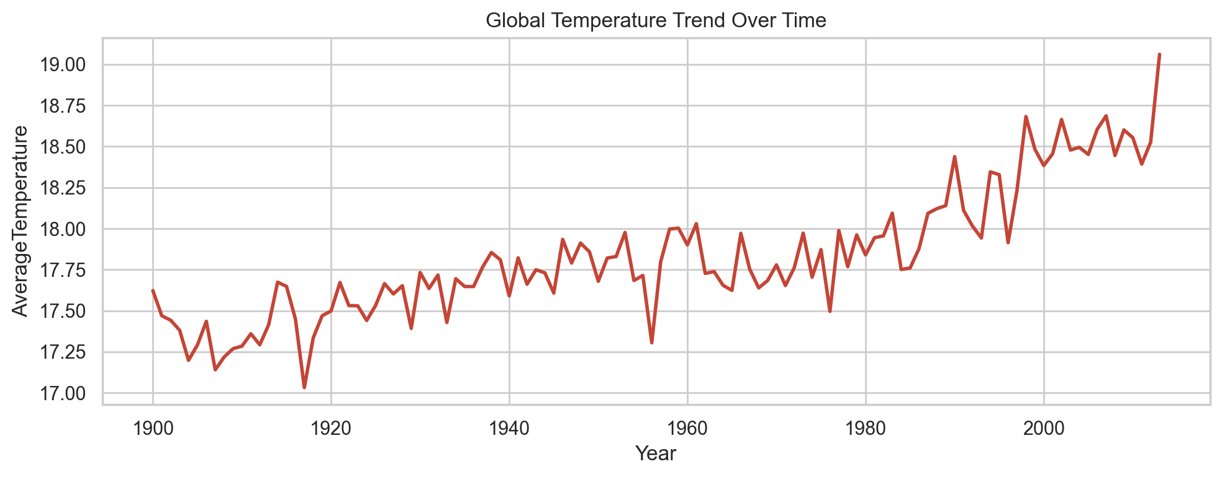
Figure 1: Global average temperature trend from the cleaned Berkeley Earth data.
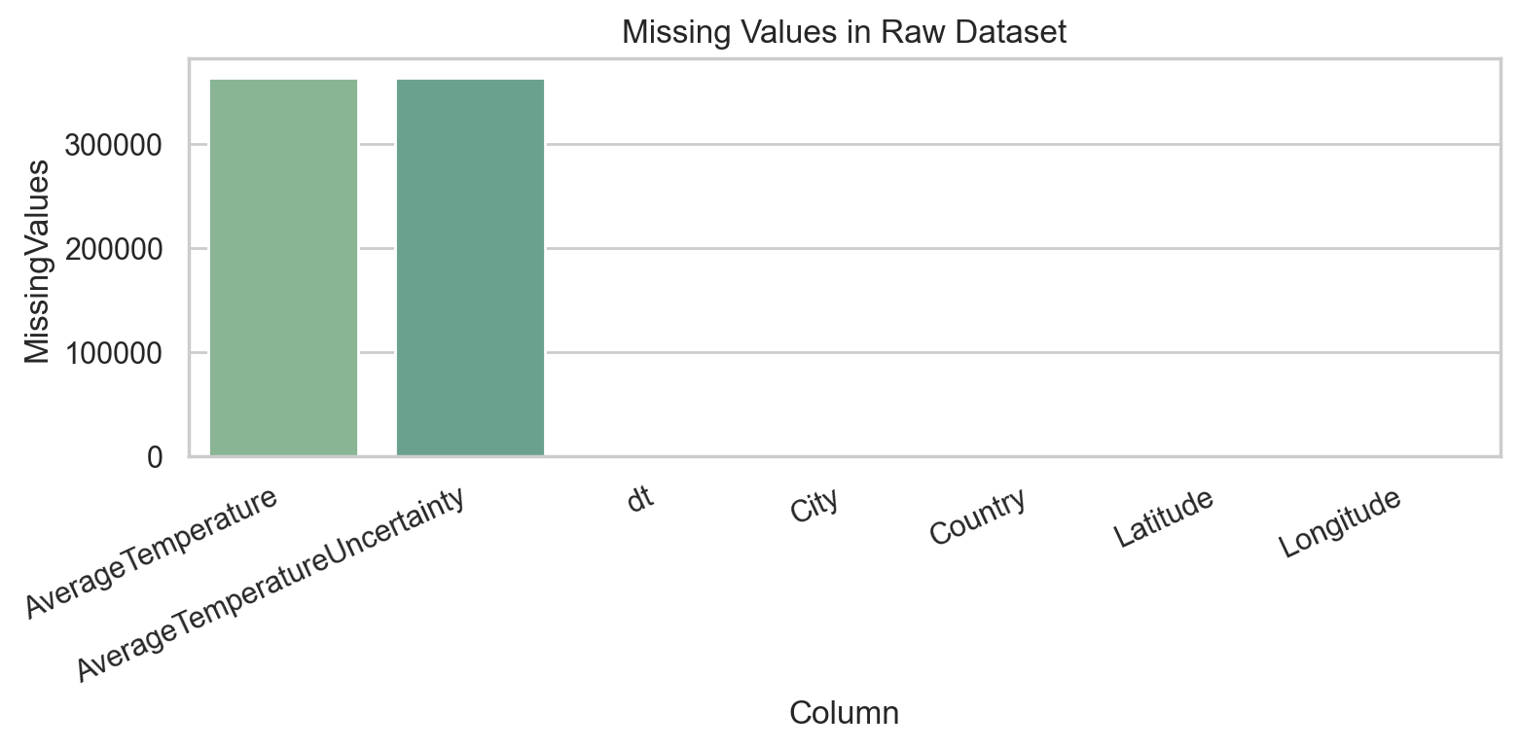
Figure 2: Missing-value counts in the main raw dataset columns before cleaning.
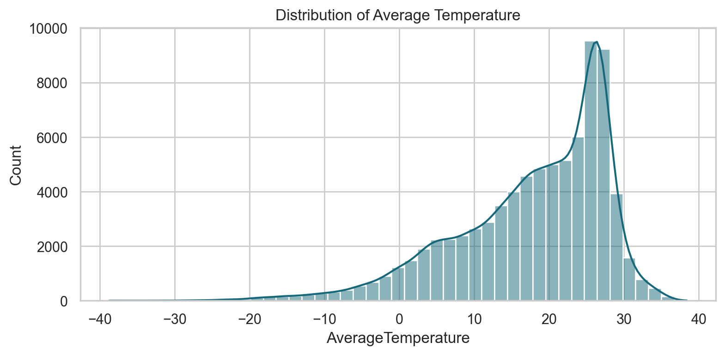
Figure 3: Distribution of average temperature values sampled from the cleaned dataset.
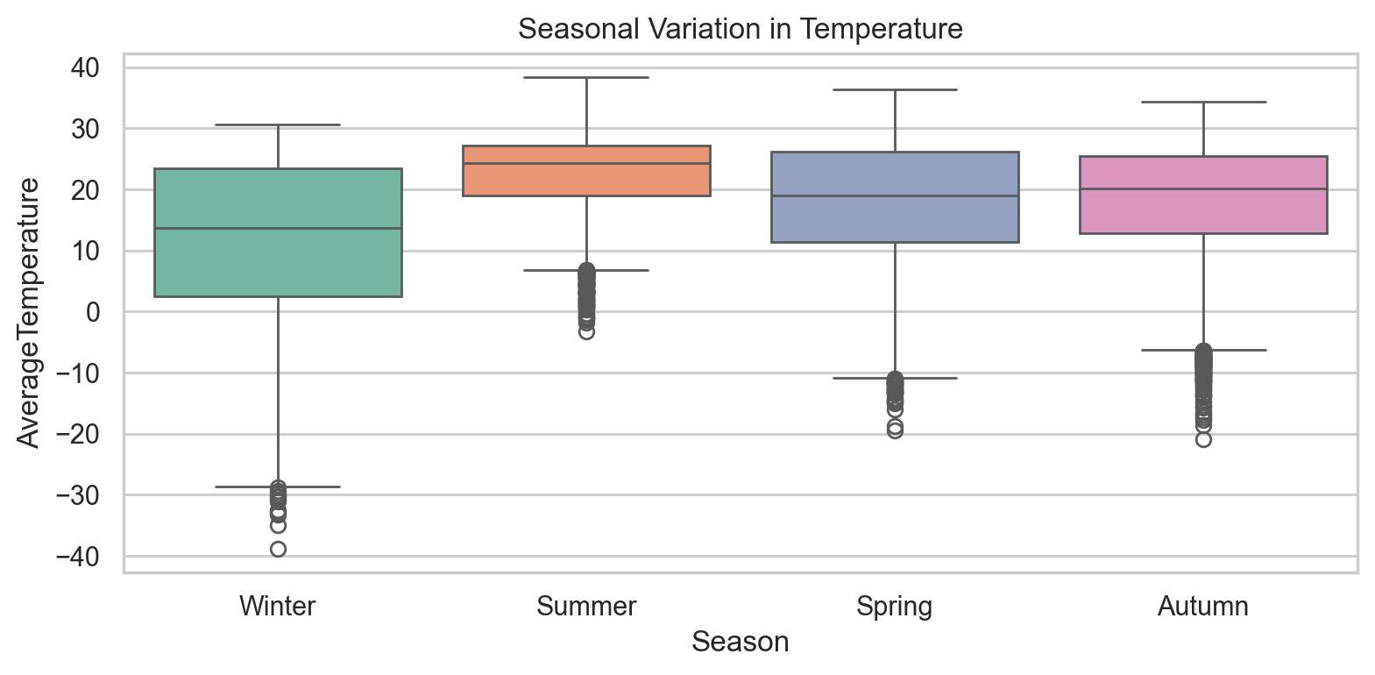
Figure 4: Seasonal boxplot showing temperature variation across Winter, Spring, Summer, and Autumn.
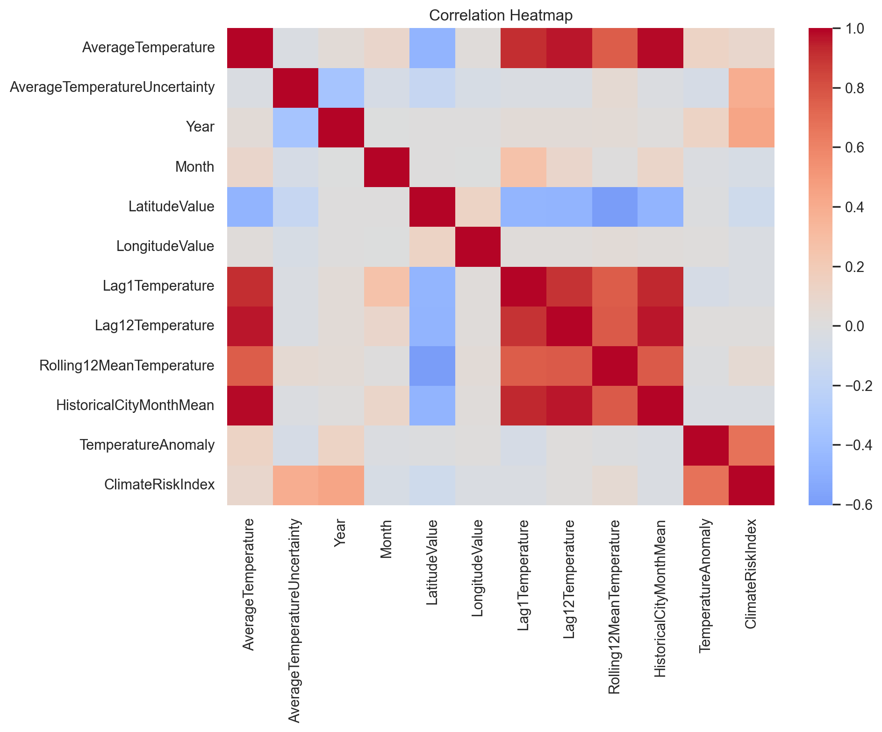
Figure 5: Correlation heatmap for selected numerical climate and engineered features.
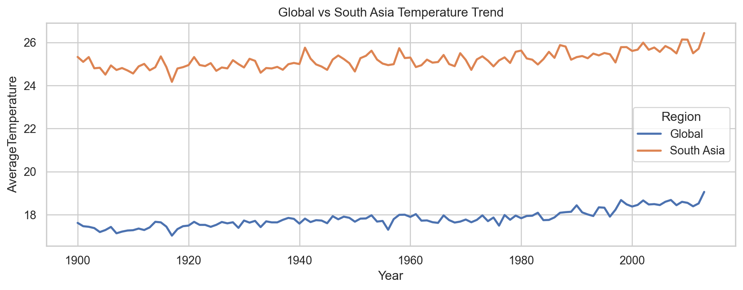
Figure 6: Comparison of global and South Asia yearly average temperature trends.
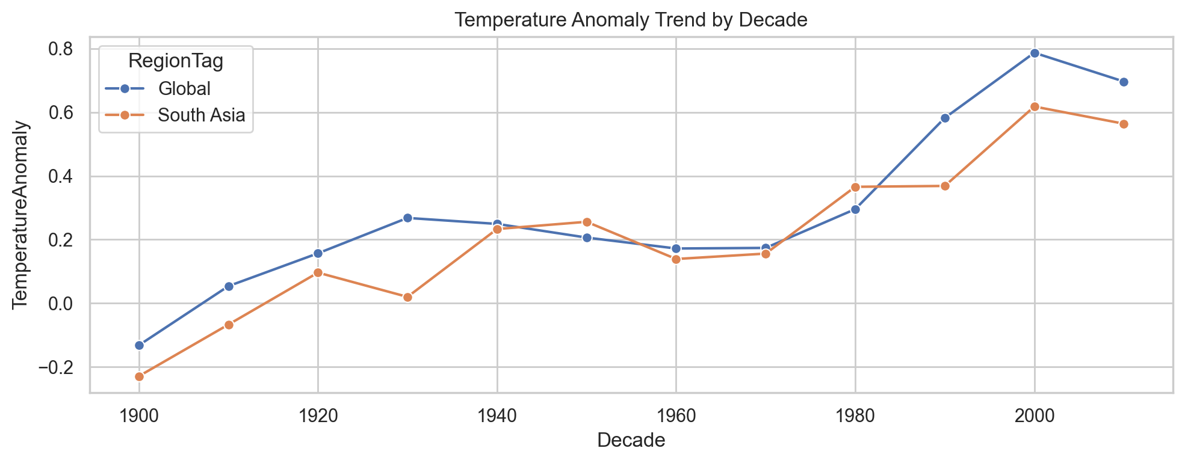
Figure 7: Average temperature anomaly trend by decade.
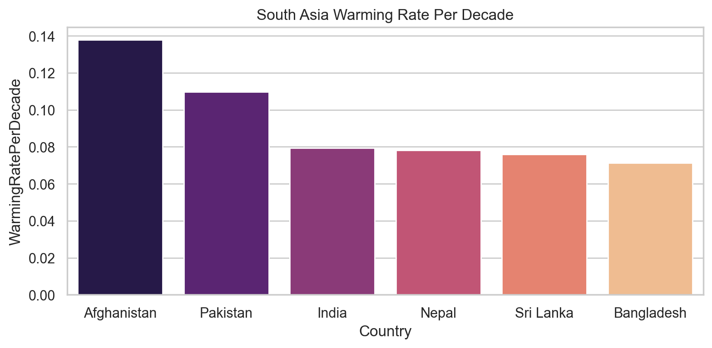
Figure 8: Estimated warming rates per decade for South Asian countries with sufficient data.
6.5 Model Development
Model development was implemented in src/train.py and orchestrated in scripts/run_modeling.py. Five regressors were evaluated under a single preprocessing framework: Linear Regression, Decision Tree Regressor, Random Forest Regressor, Gradient Boosting Regressor, and XGBoost Regressor when the optional dependency was available. The feature pipeline used a ColumnTransformer with median imputation and StandardScaler for numerical columns, and most-frequent imputation plus one-hot encoding for categorical columns. The final model matrix used the numerical predictors Year, Month, Quarter, YearsSince1900, LatitudeValue, LongitudeValue, AverageTemperatureUncertainty, HistoricalCityMonthMean, Lag1Temperature, Lag12Temperature, and Rolling12MeanTemperature, together with the categorical predictors Country, Season, Hemisphere, and RegionTag. Two validation strategies were compared. The random strategy used an 80/20 shuffled split with random_state = 42. The chronological strategy first sorted the 75,000-row modeling sample by dt and then used the earliest 80% of rows for training and the latest 20% for testing, yielding 60,000 training records and 15,000 test records. This time-aware protocol is more appropriate for climate prediction because it simulates forecasting future data from historical evidence.
Table 2: Models Implemented in the Prediction Pipeline
Model | Type | Key Strength
Linear Regression | Parametric regression | Interpretable baseline and coefficient-level explanation
Decision Tree | Non-linear tree model | Simple rule-based structure and visual interpretability
Random Forest | Bagging ensemble | Robustness to noise and strong nonlinear predictive power
Gradient Boosting | Sequential ensemble | Strong bias reduction through additive boosting
XGBoost | Optimized gradient boosting | Efficient tree boosting with strong cross-validation performance
6.6 Hyperparameter Tuning
Hyperparameter tuning was carried out in src/train.py through RandomizedSearchCV and invoked by scripts/run_modeling.py and notebooks/03_modeling.ipynb. In the implementation, tuning was applied to Random Forest and Gradient Boosting only. The search used a three-fold cross-validation objective with negative root mean squared error, n_iter = 4, and a sampled training subset capped at 18,000 rows for efficiency. For Random Forest, the search space covered n_estimators in {150, 220, 300}, max_depth in {12, 16, None}, min_samples_leaf in {2, 4, 8}, and max_features in {sqrt, 0.8, None}. The best saved Random Forest configuration was max_depth = 12, max_features = None, min_samples_leaf = 4, and n_estimators = 220, with best CV RMSE = 1.4889. For Gradient Boosting, the search covered n_estimators in {120, 180, 240}, learning_rate in {0.03, 0.05, 0.08}, max_depth in {2, 3, 4}, and subsample in {0.8, 1.0}. The best saved Gradient Boosting configuration was learning_rate = 0.08, max_depth = 4, n_estimators = 120, and subsample = 0.8, with best CV RMSE = 1.4225. Tuning results were exported to best_hyperparameters.csv.
6.7 Evaluation Pipeline
Model evaluation combined reusable metric computation in src/train.py with output formatting in src/evaluate.py and final diagnostics in scripts/run_final_evaluation.py. The metric suite included mean absolute error, mean squared error, root mean squared error, mean absolute percentage error, and the coefficient of determination. MAPE was implemented with a denominator floor of 1e-3 to avoid division-by-zero failures, which is relevant for monthly temperature observations close to zero. All principal results were saved as CSV files for reproducibility: model_comparison_results.csv for model metrics across split strategies, cross_validation_summary.csv for five-fold cross-validation scores, error_by_decade.csv for chronological holdout diagnostics, split_strategy_summary.csv for average split-level comparison, best_hyperparameters.csv for tuning outcomes, and tuning_before_after_comparison.csv for baseline-versus-tuned contrast. Final evaluation also generated actual-versus-predicted, residual, RMSE comparison, and feature-importance figures for the best chronological model.
7. EXPERIMENTAL SETUP
The project was executed in a Python 3.x environment on a standard CPU-based local machine. The main libraries used were pandas, numpy, scikit-learn, xgboost, matplotlib, seaborn, and joblib, matching the dependency structure of the source code. Reproducibility was enforced through random_state = 42 in dataset sampling, train-test splitting, baseline tree ensembles, and randomized hyperparameter search. The workflow was modularized into scripts/run_preprocessing.py, scripts/run_eda.py, scripts/run_modeling.py, and scripts/run_final_evaluation.py, with corresponding notebooks for inspection and explanation. The cleaned analytical dataset contained 4,788,080 rows, the South Asia subset contained 672,452 rows, the modeling dataset contained 75,000 rows, and the final chronological split produced 60,000 training rows and 15,000 testing rows. Results were written to CSV and image files inside outputs/tables and outputs/figures so that the paper could be regenerated directly from artifacts rather than manual transcription. This design directly satisfies the course requirement for implementation, experimental evaluation, and reproducible comparative analysis.
8. RESULTS AND DISCUSSION
8.1 Main Model Comparison Table
Table 3 reports the exact chronological split results from model_comparison_results.csv. Random Forest delivered the strongest chronological holdout performance with RMSE = 1.372 and R2 = 0.980, narrowly outperforming XGBoost, which achieved RMSE = 1.376 and the same rounded R2 value. The linear and single-tree baselines were consistently weaker than the ensemble methods.
Table 3: Model Performance Comparison - Chronological Split
Model | MAE | MSE | RMSE | MAPE | R2
Linear Regression | 1.009 | 2.391 | 1.546 | 56.321 | 0.975
Decision Tree | 1.040 | 2.425 | 1.557 | 76.755 | 0.975
Random Forest | 0.927 | 1.882 | 1.372 | 48.649 | 0.980
Gradient Boosting | 0.965 | 2.126 | 1.458 | 47.808 | 0.978
XGBoost | 0.932 | 1.894 | 1.376 | 42.640 | 0.980
Note: MAPE is reported for completeness, but it is less reliable for this dataset because temperature values can be near zero in cold months, causing percentage errors to become inflated. RMSE and R2 are therefore treated as the primary comparison metrics for model selection.
8.2 Cross-Validation Table
Table 4 summarizes the leading cross-validation RMSE results from cross_validation_summary.csv. XGBoost achieved the best average five-fold CV RMSE of 1.4029, while Random Forest followed at 1.4672. This difference is important because it shows that the model ranking depends on the evaluation design: XGBoost generalized slightly better on randomized folds, but Random Forest remained best on the more deployment-relevant chronological test.
Table 4: Cross-Validation RMSE Summary
Model | CV RMSE
XGBoost | 1.4029
Random Forest | 1.4672
8.3 Decade-Wise Error Table
Table 5 reports decade-specific chronological holdout error for the selected best model. The RMSE rises from 1.3062 in the 1990s to 1.3794 in the 2000s and 1.4997 in the 2010s, indicating that recent decades are harder to predict accurately than earlier portions of the test window.
Table 5: RMSE by Decade - Random Forest
Decade | RMSE
1990s | 1.306
2000s | 1.379
2010s | 1.500
8.4 Before vs After Tuning Table
Table 6 uses the saved tuning_before_after_comparison.csv output to compare baseline and tuned performance on the chronological test set. In the saved results, Random Forest changed from RMSE 1.3719 to 1.4935, while Gradient Boosting changed from 1.4581 to 1.4582. This outcome is still informative because it shows that a search procedure optimized on sampled cross-validation folds does not guarantee better future-period performance.
Table 6: Hyperparameter Tuning Impact
Model | RMSE Before Tuning | RMSE After Tuning | Change
Random Forest | 1.3719 | 1.4935 | 0.1216
Gradient Boosting | 1.4581 | 1.4582 | 0.0001
8.5 Discussion
Random Forest was the best overall model under chronological validation, achieving MAE = 0.927, MSE = 1.882, RMSE = 1.372, MAPE = 48.649%, and R2 = 0.980. These values indicate a highly accurate fit on the held-out future window and show that the model captured a large share of variance in city-level monthly temperatures. XGBoost was extremely competitive, with RMSE = 1.376 and the strongest average cross-validation RMSE at 1.4029, which suggests that boosted trees remain an excellent candidate when fold-level generalization is the primary criterion.
The MAPE value for Random Forest, 48.649%, appears high relative to its low RMSE. This is not contradictory; it reflects a known weakness of MAPE on temperature data when actual values approach zero. In cold-city winter months, a small absolute deviation can translate into a very large percentage error because the denominator is extremely small. The implementation partly stabilizes this by flooring the denominator at 1e-3, but the metric can still remain inflated compared with scale-dependent measures such as MAE and RMSE. For this reason, RMSE and R2 are more reliable indicators of comparative model quality in this setting.
The split-strategy comparison also validates the importance of time-aware evaluation. Averaging across saved model results, the random split produced mean RMSE = 1.4228, mean MAPE = 48.296%, and mean R2 = 0.9798, whereas the chronological split produced mean RMSE = 1.4657, mean MAPE = 51.421%, and mean R2 = 0.9776. The random split therefore appears slightly more optimistic. This is expected because shuffled splitting can expose the model to patterns from later periods during training, while chronological splitting prevents future information from influencing the fitted model.
The decade analysis provides another meaningful diagnostic layer. RMSE increased from approximately 1.306 in the 1990s to 1.379 in the 2000s and 1.500 in the 2010s. This pattern suggests that the most recent climate conditions in the holdout period were less stable or less easily explained by historical monthly patterns than earlier decades. Such behavior is consistent with the broader climate-change context, where warming interacts with regional variability, urbanization, and anomaly frequency to make recent observations harder to model with simple historical relationships alone.
Feature importance for the selected Random Forest model further clarifies what the system learned. The dominant predictor by far was HistoricalCityMonthMean, with an importance of about 0.9854, followed by Lag12Temperature, Lag1Temperature, and Rolling12MeanTemperature. Geographic variables such as longitude and latitude also contributed, though at much smaller magnitudes, while seasonal and country one-hot indicators appeared in the lower-ranked features. An important implementation detail is that TemperatureAnomaly and ClimateRiskIndex were engineered in the cleaned dataset for analysis and downstream use, but the final model matrix relied on historical mean, lags, rolling statistics, and geographic-seasonal context. As shown in Figures 9 through 12, the best model tracks actual temperature values closely, exhibits residuals concentrated around zero, outperforms other models by RMSE, and is driven primarily by history-aware features.
The South Asia track adds local relevance and supports the real-world application requirement of the course. The saved warming-rate table shows that Afghanistan has the highest estimated warming rate among the analyzed South Asian countries at 0.138 degrees Celsius per decade, followed by Pakistan at 0.110 degrees Celsius per decade. This regional comparison does not replace the global predictive task, but it strengthens the climate interpretation of the project by linking model-driven analysis with geographically meaningful warming patterns.
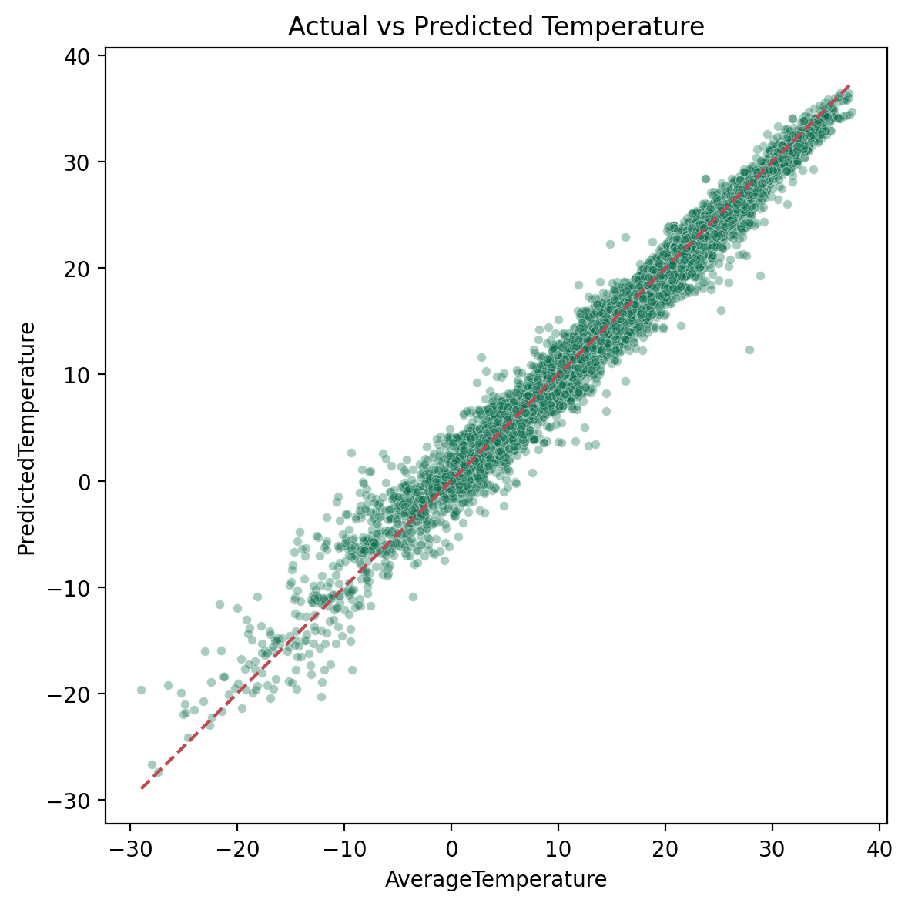
Figure 9: Actual versus predicted temperatures for the best chronological model.
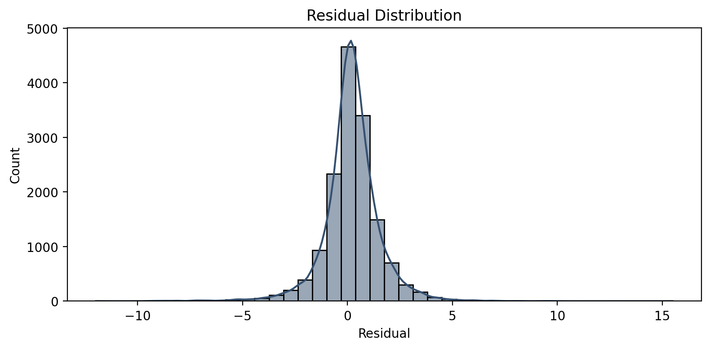
Figure 10: Residual distribution for the best chronological model.
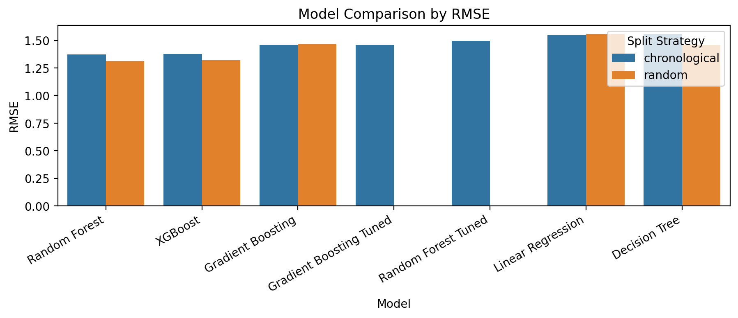
Figure 11: RMSE comparison across models and split strategies.
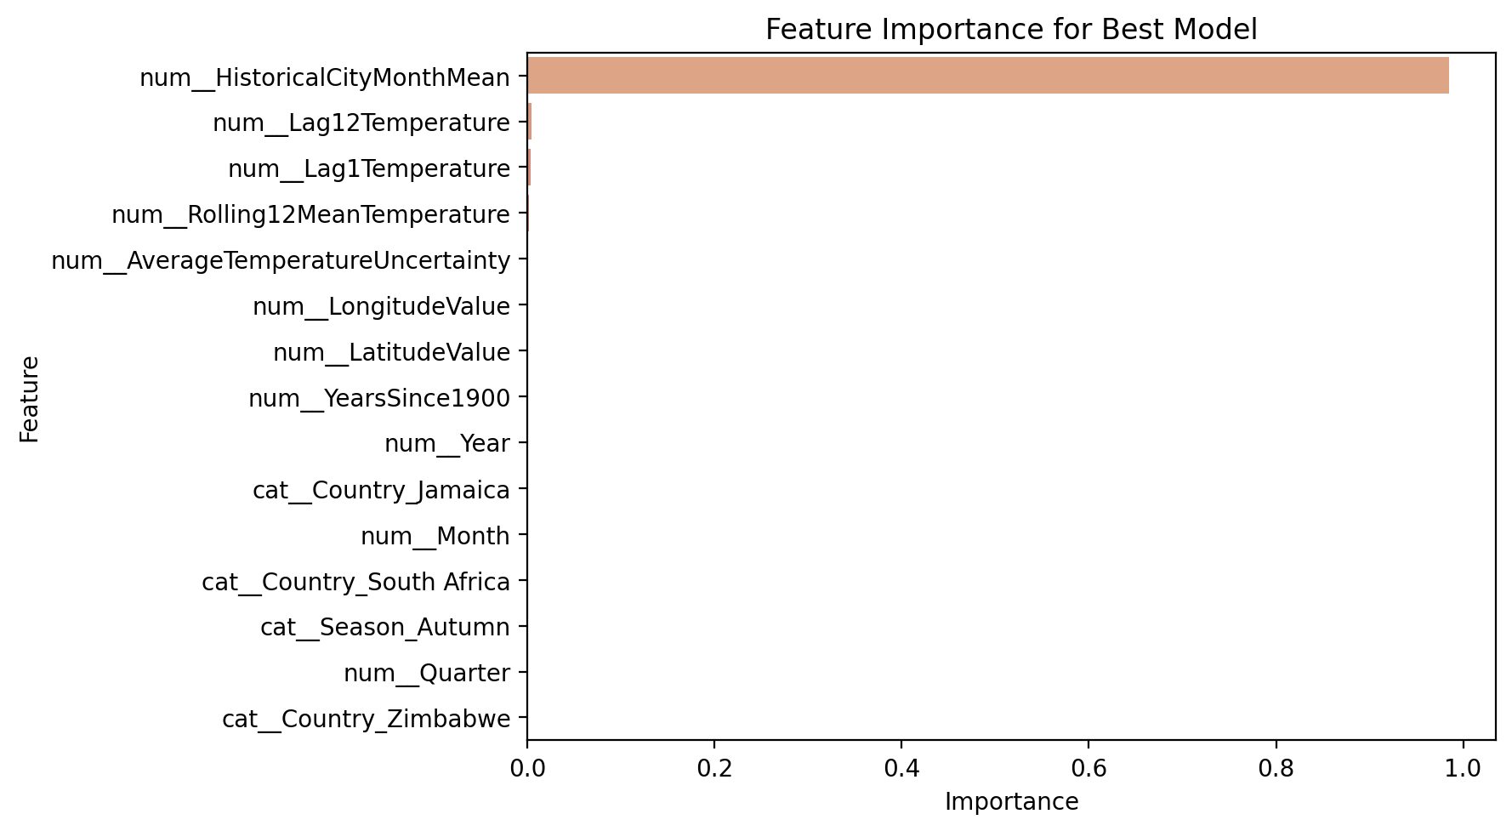
Figure 12: Top feature importances for the selected Random Forest model.
9. COMPARATIVE ANALYSIS
Across predictive accuracy, Random Forest was the strongest performer on the chronological test set with RMSE = 1.372 and R2 = 0.980, while XGBoost remained very close at RMSE = 1.376. The difference between these two models is only 0.004 RMSE, so they should be interpreted as practically similar on the chronological test set rather than as a large performance separation. Gradient Boosting followed with RMSE = 1.458, and the weakest chronological baseline was Decision Tree at RMSE = 1.557, only slightly worse than Linear Regression at RMSE = 1.546. The broad pattern supports the literature in [7] and [8], where nonlinear ensemble methods generally outperform simpler linear baselines because they better capture interaction effects, seasonal variation, and geographically heterogeneous responses.
Interpretability, however, follows a different ranking. Decision Tree is the most transparent because its rules can be visualized directly, and Linear Regression also offers coefficient-level interpretability that can be appealing for explanatory analysis. Random Forest and XGBoost are less transparent internally, but both still support feature-importance diagnostics and partial dependence style follow-up analysis. From a generalization standpoint, XGBoost leads under five-fold cross-validation with CV RMSE = 1.4029, while Random Forest is stronger on the chronological test. This divergence mirrors the conclusion of Mishra et al. [2] that no single method is universally best in every validation setting. It also aligns with the methodological concern raised around evaluation realism in [5]: a model that appears best under randomized folds may not remain best when future-period holdout is enforced. For practical recommendation, Random Forest is the strongest production choice for this project because the target use case is future prediction from historical observations. XGBoost is the preferred alternative when cross-validation performance is prioritized, and Decision Tree remains the best explainability-oriented option despite its weaker predictive strength.
From the perspective of the teacher's rubric, the comparative analysis demonstrates four required dimensions. First, it identifies the best predictive model using appropriate regression metrics rather than inappropriate classification scores. Second, it compares baseline and advanced models under the same preprocessing and feature-engineering framework, which makes the comparison fair. Third, it examines generalization through both cross-validation and chronological holdout, showing that model quality depends on evaluation protocol. Fourth, it analyzes practical trade-offs among accuracy, interpretability, tuning response, and climate relevance, which is more academically meaningful than reporting a single best score.
10. CONCLUSION
This paper presented a complete machine learning workflow for climate change analysis and monthly city-level temperature prediction using the Berkeley Earth dataset. The project integrated reproducible preprocessing, leakage-aware feature engineering, exploratory visualization, comparative modeling, cross-validation, and final chronological diagnostics. Starting from the raw GlobalLandTemperaturesByCity.csv file, the pipeline cleaned and transformed the data, engineered temporal and geographic predictors, generated a South Asia subset, and trained five regression models under both random and chronological validation strategies. The best chronological result was achieved by Random Forest with RMSE = 1.372, MAE = 0.927, MSE = 1.882, MAPE = 48.649%, and R2 = 0.980, while XGBoost delivered the best average five-fold cross-validation RMSE of 1.4029. Decade-wise analysis showed that error increased from the 1990s to the 2010s, indicating that more recent climate conditions were harder to predict. The study also showed that chronology-aware evaluation is more realistic than random splitting and that historical city-month means, lagged temperatures, and rolling signals are especially powerful predictors. The South Asia outputs further confirmed measurable warming trends across several countries. Overall, the project contributes a compact but rigorous comparative framework for climate-oriented regression on historical city-level temperature data.
In terms of course expectations, the work satisfies the required data science components of implementation, experimental results, evaluation, and comparative analysis, while also showing novelty through better validation strategy, stronger feature construction, and climate-focused regional interpretation. The contribution is therefore not only a best-model result but a defensible methodological argument about how climate prediction should be evaluated on historical city-level data.
11. FUTURE WORK
Several clear extensions emerge from the current study. First, sequential deep learning models such as LSTMs and Transformer-based architectures should be tested because they can represent longer temporal dependencies more explicitly than tabular regressors. Second, the dataset should be extended beyond 2013 by integrating newer NASA or NOAA climate products so that the model can be evaluated on more recent warming dynamics. Third, additional explanatory variables such as atmospheric CO2 concentration, humidity, rainfall, sea-surface temperature, and elevation could be joined to the city-level records to improve causal richness. Fourth, the best-performing model can be deployed through a lightweight Streamlit application for interactive prediction and visualization. Fifth, future work should examine alternatives to MAPE for near-zero temperature months, including symmetric percentage error or scaled absolute error metrics. Finally, the regional analysis can be expanded from South Asia to the Middle East and Africa so that cross-region transferability and warming heterogeneity can be studied under the same reproducible pipeline.
12. REFERENCES
[1] Berkeley Earth, "Climate Change: Earth Surface Temperature Data," Kaggle, 2017. [Online]. Available: https://www.kaggle.com/datasets/berkeleyearth/climate-change-earth-surface-temperature-data
[2] P. Mishra, S. Ray, P. Lal, S. B. Nair, A. Matuka, Y. Tashkandy, and W. Emam, "Climate modeling for South Asia: statistical and deep learning for rainfall and temperature prediction," Scientific Reports, vol. 15, no. 1, 2025, doi: 10.1038/s41598-025-22149-1.
[3] M. Zanchi, S. Zapperi, and C. A. M. La Porta, "Harnessing deep learning to forecast local microclimate using global climate data," Scientific Reports, vol. 13, 2023, doi: 10.1038/s41598-023-48028-1.
[4] S. S. Khan and R. Al-Hajj, "Multi-output deep learning for high-frequency prediction of air and surface temperature in Kuwait," Scientific Reports, vol. 15, 2025, doi: 10.1038/s41598-025-23455-4.
[5] J. V. Ratnam, H. A. Dijkstra, T. Doi, Y. Morioka, M. Nonaka, and S. K. Behera, "Improving seasonal forecasts of air temperature using a genetic algorithm," Scientific Reports, vol. 9, 2019, doi: 10.1038/s41598-019-49281-z.
[6] I. A. Adeniran, M. Nazeer, M. S. Wong, and P.-W. Chan, "An improved machine learning-based model for prediction of diurnal and spatially continuous near surface air temperature," Scientific Reports, vol. 14, 2024, doi: 10.1038/s41598-024-78349-8.
[7] M. Abdelsattar, A. AbdelMoety, and A. Emad-Eldeen, "Comparative analysis of machine learning techniques for temperature and humidity prediction in photovoltaic environments," Scientific Reports, vol. 15, 2025, doi: 10.1038/s41598-025-98607-7.
[8] A. Elbeltagi et al., "Air temperature estimation and modeling using data driven techniques based on best subset regression model in Egypt," Scientific Reports, vol. 15, 2025, doi: 10.1038/s41598-025-06277-2.
[9] M. L. Nirere, K. Jayavel, and A. Ngenzi, "IoT-based climate change prediction system," in Proc. 2023 12th Int. Conf. Software and Computer Applications (ICSCA), Kuantan, Malaysia, 2023, doi: 10.1145/3587828.3587862.

