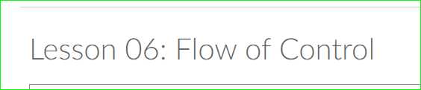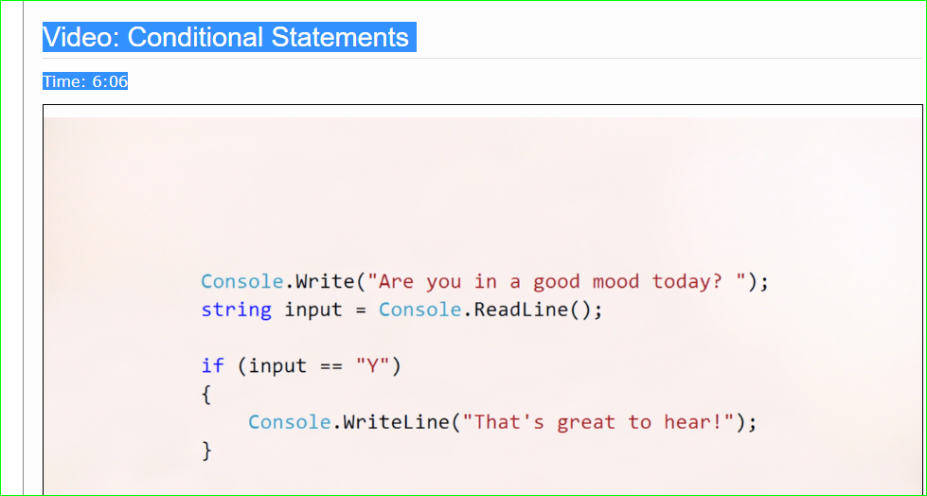

09.02.2018 Section one through to this spot in Lesson six – second video.

Yesterday

Today moving on with Lesson six

Roadblocks none

09.03.2018

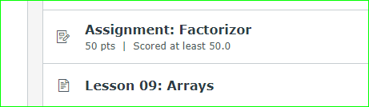

Up to lesson nine.

09.04.2018

Yesterday

Factorizer

Today Factorizer

Road blocks reusing code.

09.08.2018

Factorizer

Today

FizzBuzz

Debugging now onto Alumni version lesson 13

Working on updated guessing game

Roadblocks

Getting Git installed and repo set up.

Go back to lesson 9

09.09.2018

Yesterday FizzBuzz and Factorizer

Today Arrays 9-10-11

I don’t understand this

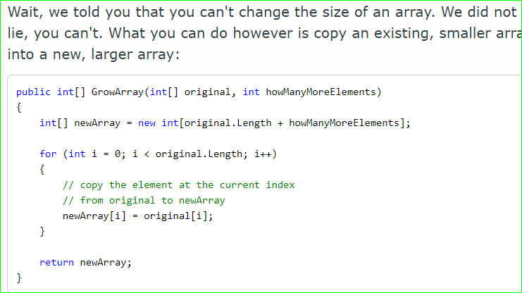

09.10.2018

Yesterday:

Finished all level one lectures

Did the following adds to upgraded guessing game:

Counting the guesses and writing it to the console

Add victory message if guess count = 1

Did all console color changes

Today

Need only mode selection added.

Start Warmups

Roadblocks – none

Stopped here:

