**BUSINESS ANALYSIS PROJECT**

**Linxsly ALEXIS**

**Gothie Ridgina PASTEUR**

**Raphael ALEXANDRE**

**Jackyvens CAMILLE**

**Business Analysis**

**Introduction**

Business analysis is the practice of enabling change in an enterprise by defining needs and recommending solutions that deliver value to stakeholders. It’s also a disciplined approach for introducing and managing change to organizations, whether they are for-profit businesses, governments, or non-profits.

It allows organizations to structure how they make decisions to change their strategy in order to reach their desired objectives.

**Define the problem**

**Context**

The leading telecom company has a massive market share but one big problem: several rivals that are constantly trying to steal customers. Because this company has been the market leader for so many years, there are not significant opportunities to grow with new customers.

The telecommunication company that holds the monopoly of the telecom market is now facing competitors that work every day to steal customers. The latter is in the limit of increasing the number of its customers. Therefore, this analysis consists in finding the profiles of the customers who have left the company, so that the marketing and customer departments can convince them to stay.

**Problematic**

The problem of the telecom is that the competitors try every day to steal its customers. And indeed the telecom has lost many of its customers.

**Background of the problem**

Who identified there was a problem? Have there been any other attempts to solve this problem?

The marketing and customer teams have identified the problem but each for different purposes. So they called us to analyze the data so they could set up strategies to address the problem.

**The stakeholders involved in the problem:**

* The customers
* The competitors
* The partners, the shareholders
* The employees

The main stakeholders are the shareholders who risk to lose their investment, the employees specifically the teams of customer and marketing.

After that, the problem affects the clients because they churn. Finally, it can affect all the employees because they risk losing their jobs if the telecom goes bankrupt.

**Measures of Performance**

**How do the client, organization and other stakeholders measure the Business Problem?**

The Team of customer and marketing measure the performance on the quantity of client who churn. They have information on the different category and client who churn.

**Importance of the problem**

This problem is important for the company because it can make it go bankrupt. Any company that is losing customers at a constant rate is confronted with it. It is effectively the case of the telecom company.

**Methodology**

To realize this work, we used the data given the team of the telecom. Then we did the processing and analysis of the data using python (pandas, numpy, spicy, seaborn, matplotlib).

We looked at transactions by gender, category and merchant to see if there was one group more likely to be defrauded than another

Firstly, we will collect data for the analysis. We will use the data related to the customer and churn of the company.

Secondly, we will start by treating the data with python (pandas, numpy, scipy,) and then we will look for the quantity of churn and the profile of the churn customers. We will evaluate losses with the total charge.

And then, we will use mathematics and statistics tools such as average, sum, to see the churn by category and gender based on the churn information.

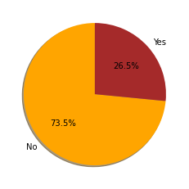**Results**

So we have about 27% of monthly churners. Let's see how much the revenues are affected.

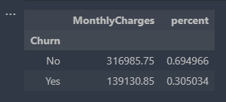

So because of the Churn, the company has lost about 30.5% of the revenue it makes from montly charges.

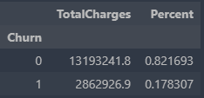

**Customer demographics like age and gender**

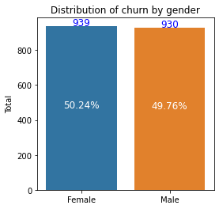

Among the dataset, we can notice that 50.24% of the female clients have churned. And 49.76% of the male clients have churned. This is not so significative because there a no greater difference between the two groups.

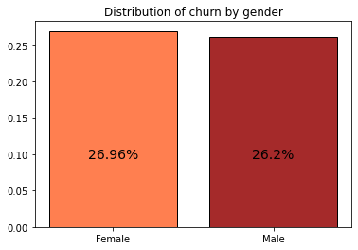

That means, more than 25% of the two genders (26.96% female, 26.2% male) represented in the dataset have churned. This is not a great insight because it won't help us to take better decision because there is no greater difference between the two groups. Let's confirm this with a t-test on the difference of both independent proportions:

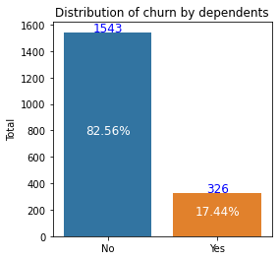

In this graph we can see that more than 82.55% of the customer who doesn't have dependents has churned instead of 17.44% of the one who has dependents. It's relevant because, there are more than 80% of churn in the class of the customers who doesn't have dependents. Let's see how important it is to the category.

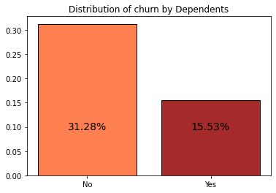

Among the customer who doesn't have dependents the percentage of churn is 31.28%, and for the others only 15.53%. The churn is two time bigger for the customer who has no dependents than the one who has dependent. This is relevant!

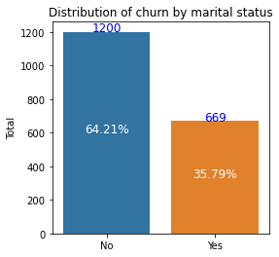

In this graph we can see that 64.2% of the customer who doesn't have a partner have churned instead of 35.8% of the one who has a partner. It's relevant because, there are more than 60% of churn in the class of the customers who doesn't have a partner. Let's see how important it is to the category.

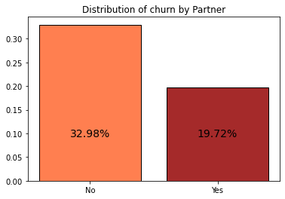

Among the customer who doesn't have a partner the percentage of churn is 32.98%, and for the others only 19.72%. The churn is so important for the customer who doesn't have a partner, because more than a quarter of them have churned. This is interesting!

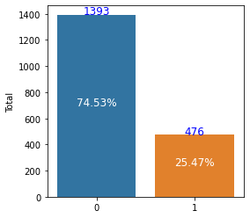

We know that 0 represents No, and 1 equals to Yes. This graph let us see that more than 74.53% of the customer who are not senio citizens have churned. And for the one who are senior citizens, only 25.47% of them have churned. It's relevant! Can we say that the more a customer is senior citizen, the less he tends to churn?

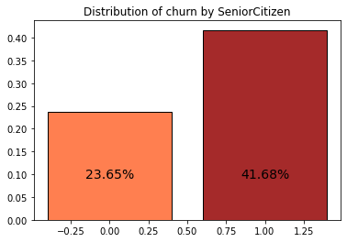

The percentage of churn represents 23.65% of the customer who are not senior citizen. But for the customer who are senior citizens, it represents 41.68%. It's significant!

The marketing team wants to find out who the most likely people to churn are and create content that suits their interests:

After our analysis, we can conclude that people who tend to unsubscribe are those who are not dependents (31%), do not have partners (33%) and are senior citizens (42%).

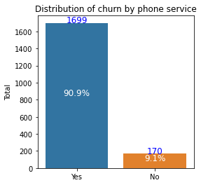Does this mean that single people, who are not dependents and who are senior ci, are more likely to unsubscribe than those who are in a relationship?

More than 90.90% of the customer who have a phone service have churned. Instead of 9.09% of churns between the customers who don't have a phone service. It's interesting. Let's see how important is that for the category

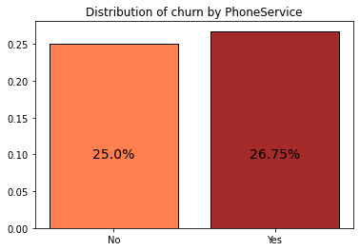

The percentage of churn for the cutomers who have phone service is 26.75%, and for the ones who don't have phone service 25%. It's not so relevant.

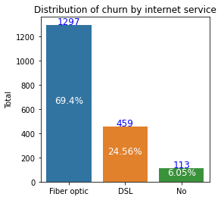

More than 69.39% of the customers who have an internet service especially a fiber optic has churned and 24.55% of them have a DSL. Instead of 6.04% of churns between the customers who don't have an internet service. It's interesting. Let's see how important is that for each category

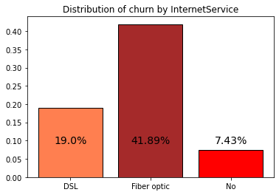

We can see that more than 19% of the customers who have an internet service especially DSL service have churned and 41.89% of the ones who have Fiber optic have churned. On the other hand, only 7.43% of the one who don't have phone service churned. It's very relevant! Most of the people who have churned have an internet service. Can we say that, having an internet service tends to increase the number of customer churn? If so, what can we do to fix that?

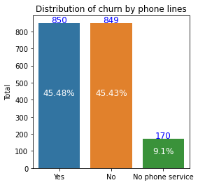

This graph shows the percentage of customer churn wheter they are unsing multiple lines or not. We can notice that more than 54% of the customers who don't have multiple lines have churned. Among the customers who don't have multiple lines we can identify the one who don't have a phone service and the one who have a phone service but doesn't uses multiple lines. On the other hand, 45.47% have churned.

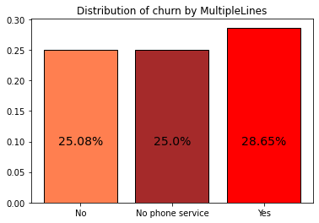This graph shows the percentage of churn for each groups. It's not so pertinent! We can see in the category of customers who uses multiples lines services there are more than 20% who churned. The percent of customers who did not churn is almost the same as the customers who have no phone service.

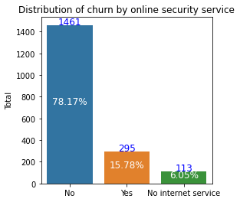

In this graph we can noticce that there are 78.17% of churn customer who don't use an online security. It's a great insight. But 15.78% use it and 6.05% don’t have internet. That’s mean, most of customer who churn do not use an online security, but the percentage of customers who use it and have churned is still significant.

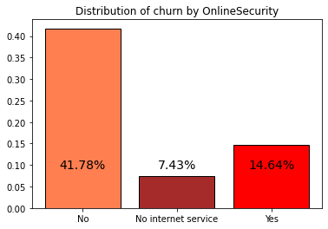

Among this category, we have 41.77% of customer who don't use an online security are churn customers and 14.64% are not.

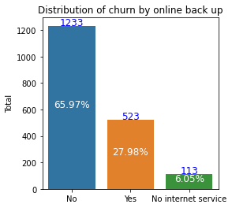

Again 65.97% of churn customer don't use an online backup. It's interesting because, this means that more than 60% of the customers who have churned are not interested in the online backup service. and less than half (27.98%) are interested in this service.

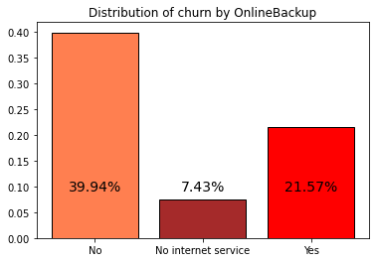

We can see that 39.94% is the percentage of customer churn who don't use an online backup. 7.43% of the total customer in the online backup service don’t have internet and 21.57% of this category did not churn.

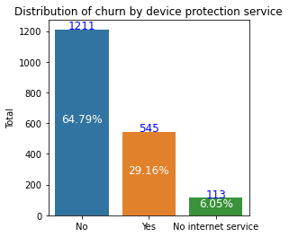

This graph shows that between the customer who churn in the device protection service is 64,79% and 29,26% are not in the service and the rest do not have internet.

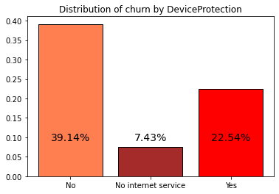

The customer who do not use the device protection service are more to churn (39.14%), but if we look at the customer who churn and take this service, we can say that the percent is important like 22.54%.

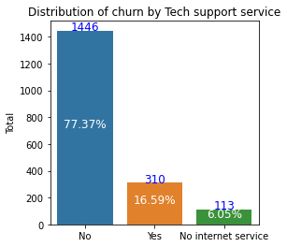

There is 77.37 percent of total customer who churned are not in the tech support service. 16.59% of this customer take this service and the percent of customer who don’t have internet stay the same as below.

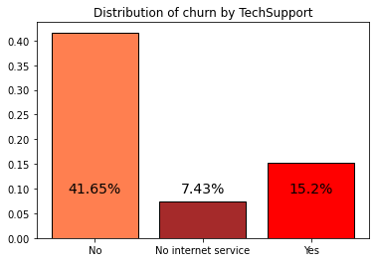

Among the costumer who churn 41,65% Customer who don't have the service of tech Support are more to churn, 41.65% of customer who don't have a tech support are churn customer.

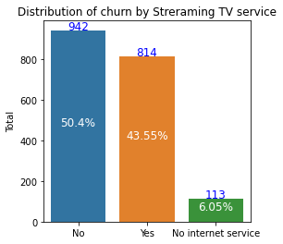

There are 50.4% of Churn customer who don't use streamingTV, beside 43.55% who use it.

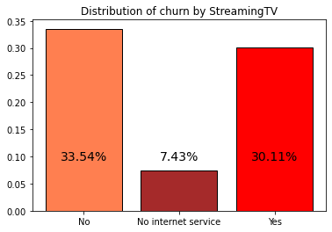

Customers who don't use streaming TV are more to churn than customers who use it, though the difference is not really great, 33.54% and 30.11% respectively

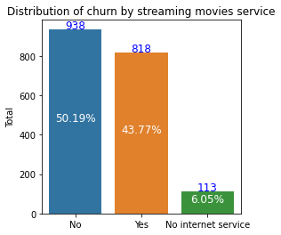

 There are 50.19% of Churn customer who don't use streamingMovies, beside 43.77% who use it and the percent of customer who do not have internet is the same as below.

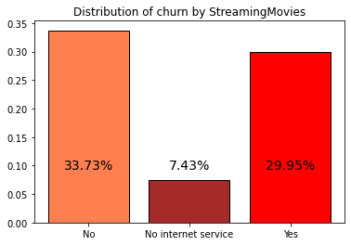

This graph shows that 33.73% of customer who churn among the 50.19% don’t use streaming movies service and 29.95% use the streaming movie service. The difference between the two groups is not very big so this information is important for the category of streaming service customers who have churn

Each category by churned costumers gave a different information but what you need to remember the percent of customers who is in each category and churned are.

|  |  |  |  |  |  |  |  |  |  |  |  |
| --- | --- | --- | --- | --- | --- | --- | --- | --- | --- | --- | --- |
| Category | Phone service | Internet service | | | Phone lines | Online security service | Online backup | Device protection service | Tech support service | Streaming TV service | Streaming movies |
| Percent of customer who churn | 90.9 | Fiber optic | DSL | No | 45.48 | 78.17 | 65.97 | 64.79 | 77.37 | 50.4 | 50.19 |
| 69.4 | 24.56 | 6.01 |

**Discussion & Proposed Solution**

**SWOT Methodology**

SWOT (strengths, weaknesses, opportunities, and threats) analysis is a framework used to evaluate a company’s competitive position and to develop strategic planning. SWOT analysis assesses internal and external factors, as well as current and future potential.

**Strengths**

Massive market share

Record of each customer

Multiple services

…

**Weaknesses**

No significant opportunities to grow with new customers

The services don’t really affect the customers

Lack of information on the market

**Opportunity**

Organize a market research based on a survey to segment the market

They can use the result of the business analysis to improve their services and create new services

Adjust their business to the market trends

**Threats**

Negative impact of the new services

A considerable loss

The lack of business analysis

Bankruptcy

**Main solution**

By analyzing the data to propose a solution, we can conclude that the Telco has a churn problem. There are some marketing and customer service problems. The churn percentage is 25.6%. It is very difficult for an organization to survive without management in general. For this reason, we can believe that with great marketing and an amelioration of customer services or a drop of a certain services, the enterprise can survive much longer. In that case, there are our recommendations.

**Solution 1**

The enterprise has to upgrade some important services. The churn and these services are dependent but we can’t stop them because they are useful:

1- They have to upgrade the phone service because more than 90% of the customer who were using this service have churned, even when the churn is independent of this service. But I think it generates the majority of the profit of the company.

**Strength of this solution**

The phone service, which is one of the most common and most used service will help them retain more customers. This will increase their revenue.

**Weaknesses of the organization**

Lack of information on the market

We can consider the lack of information on the market as a weakness. If they don’t do market research, they won’t have pertinent data.

There will be more charges due to the upgrading.

2-For the internet service, we can see that more than 41% of the customer who were using Fiber Optic have churned. For this service we recommend that they delete this service and to upgrade the DLS service.

**Strength**

It will increase their profit and they will manage better

**Weaknesses**

Clients who use fiber optic for internet service might get upset. Especially because DLS could be more inexpensive.

3- People who are using multiple lines and fiber optic for their internet service tends to churn more than the others. They have to put in place some policies to retain the customers. Such as put in place politics to decrease the number of customer using both of the services

More than 45% of the customers who are using electronic check have churned. So I will recommend them to reduce the number of transactions.

**References**

[www.marketsandmarketsblog.com](http://www.marketsandmarketsblog.com)

[What is Business Analysis? | Global Standard for Business Analysis Certification | IIBA®](https://www.iiba.org/professional-development/career-centre/what-is-business-analysis/)

[Strength, Weakness, Opportunity, and Threat (SWOT) Analysis Definition (investopedia.com)](https://www.investopedia.com/terms/s/swot.asp)