Task | APPLICATION DEPLOYMENT | Sub-Task
Request # / Incident # / Auth. # | SR18/150488 | Mode | UAT
Source Code Version : | 1.3.3.0 | Remark | web-dnc-ui-01.tisconetuat.com

Seq. | Job Description | Required | Remark
Task | Application Server Deployment on web-dnc-ui-01.tisconetuat.com
Sub-Task | Log in Jenkins
1 | Log in to Jenkins :  - URL : http://192.168.26.69:8080/  - User : <$TISCOGROUP_Domain_User> [example. wittawinra]  - Passwod : <$password>  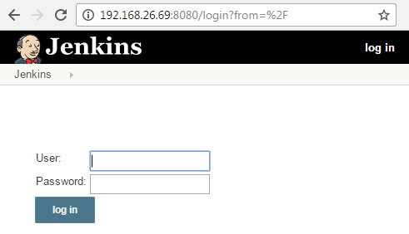
Sub-Task | Build and deployment
2 | Go to Project and Build
2.1 | Select UAT Tab :  - Click item name : UAT-dnc-ui  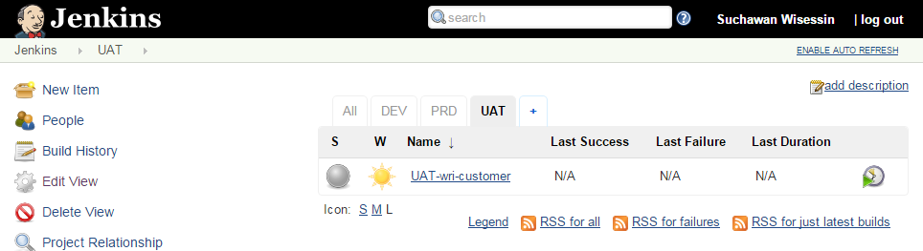  C
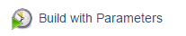  2.2 | Click : Build with Parameters
2.3 | Select TAG_VERSION: 1.3.3.0  Click : Build  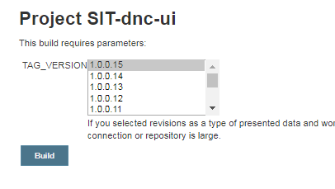
Sub-Task
3 | Verify Deployment Log
3.1 | Select Latest Build History : Click version item : #latest_number  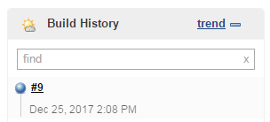
3.2 | Click : Console Output  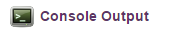
3.3 | Scoll down to the end of lines must be show : Finished: SUCCESS  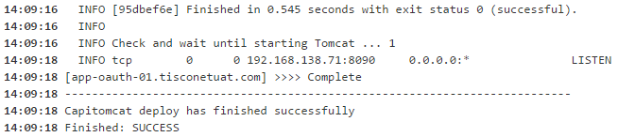
Sub-Task
4 | Verify Application
4.1 | Enter url : http://web-dnc-ui-01.tisconetuat.com:8090/dnc-portal/
4.2 | Enter url : https://lb-dnc-01.tisconetuat.com/dnc-portal/
4.3 | Enter url : https://corporate-portal.tisconetuat.com/dnc-portal/
4.4 | Response must be show like :  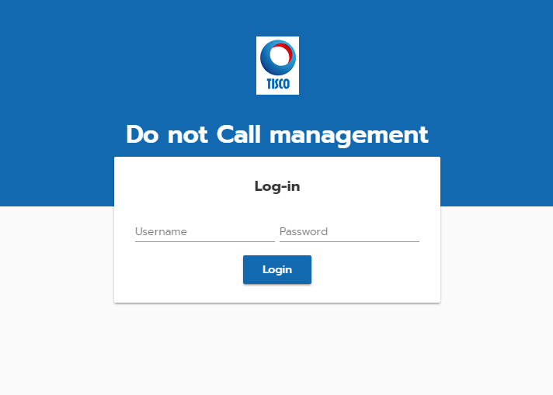
 | ---------------------------------------------------------------------- End of Document --------------------------------------------------------------------------

