Task | RUNDECK APPLICATION DEPLOYMENT | Sub-Task
Request # / Incident # / Auth. # | SR18/150488 | Mode | UAT
Source Code Version : | 1.3.0.1 | Remark | Import Rundeck Script

Seq. | Job Description | Required | Remark
Task | RUNDECK Server Deployment
Sub-Task | 1. Get the source project : dnc-webservice from GIT Tag 1.3.0.1
1.1 Double Click Icon : Git Bash
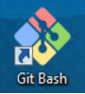
1.2 Run Git Command :
git clone -b 1.3.0.1 https://apollo.tisconet.com/DNC/dnc-webservice.git D:\Projects\DNC\Eclipse\Workspace\dnc-webservice

1.3 Run replace script.
1.3.1 Open CMD (Dos command program).
1.3.2 cd D:\Projects\DNC\Eclipse\Workspace\dnc-webservice\src\environments\Rundeck\
1.3.3 Run replace script by use command : rundeck-DNC_UAT.bat
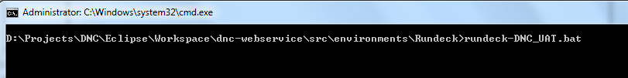
1.3.4 Check result by you can see new file in same folder. (New file = DNC_RUNDECK_UAT.jar)
Sub-Task | 2. Delete Project : DNC_UAT
 | 2.1 Login to RUNDECK URL : https://uat-job-scheduler.tisconet.com:4443/menu/home
 | 2.2 Select Project name : DNC_UAT
 | 2.3 Select Tab bar : Project > Delete Project...
2.4 Click button : Delete this Project... X
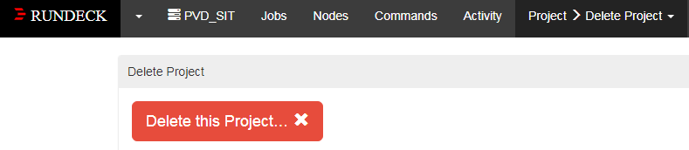
2.5 Click button : Delete Project now
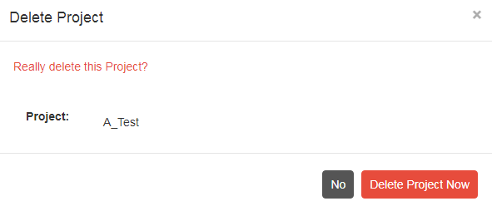
Sub-Task | 3. Create a new Project : DNC_UAT
 | 3.1 Login to RUNDECK URL : https://uat-job-scheduler.tisconet.com:4443/menu/home
3.2 Create a new Project : DNC_UAT

3.2.1 Click Button : New Project +
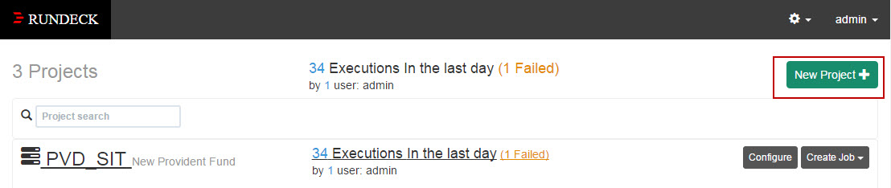
3.2.2 Input Project Name : DNC_UAT
Description : DO NOT CALL

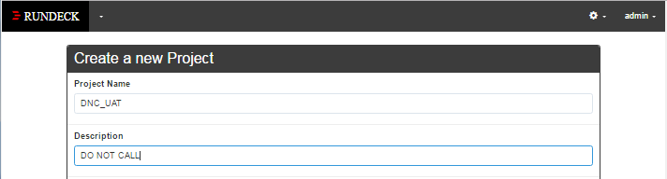
3.2.3 Select on Check box → Project Home Page
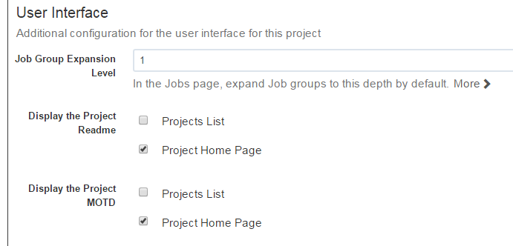

3.2.4 Input value on Label : SSH Key Storage Path
Value : /home/pamsvc/esbserver.pem
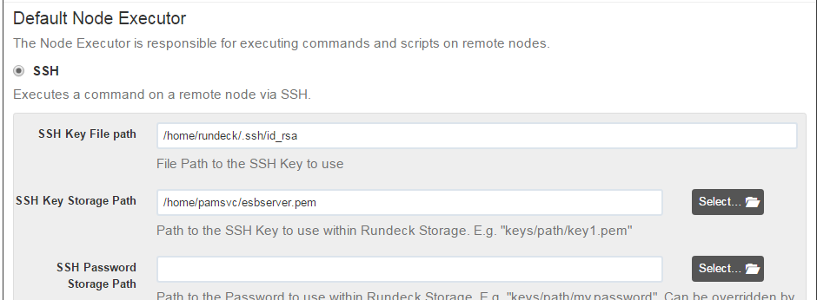
3.2.5 Input value on Label : SSH Key Storage Path
Value : /home/pamsvc/esbserver.pem
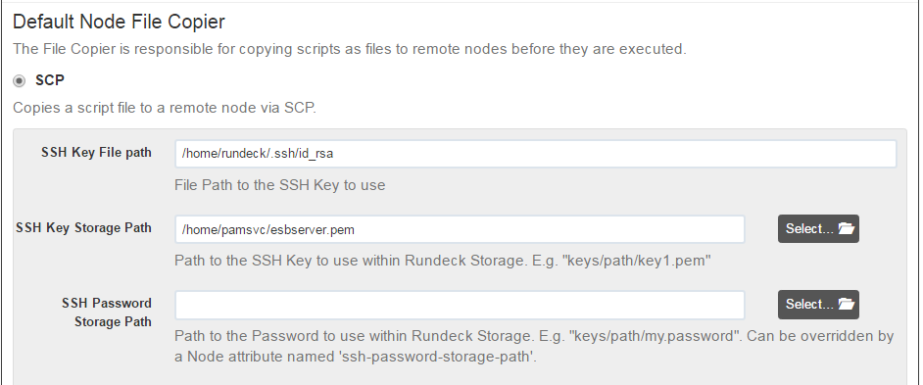
 | 3.2.6 Scroll down and click Create button. And then click Save button.
Sub-Task | 4. Import Archive file to Project : DNC_UAT
 | 4.1 Select Project name : DNC_UAT
4.2 Select Tab bar : Project > Import Archive...

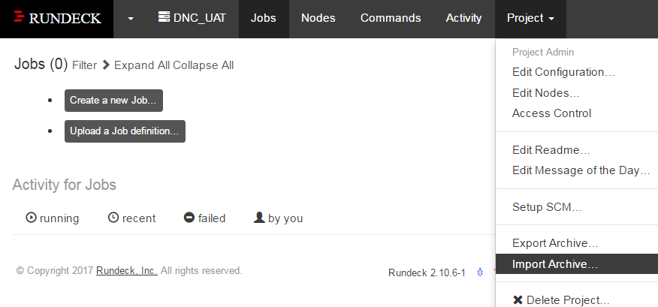
4.3 Click Choose File button and then Select :
D:\Projects\DNC\Eclipse\Workspace\dnc-webservice\src\environments\Rundeck\DNC_RUNDECK_UAT.jar
at Section : Imported Jobs, please select : Remove UUIDs , scroll down and click Import button
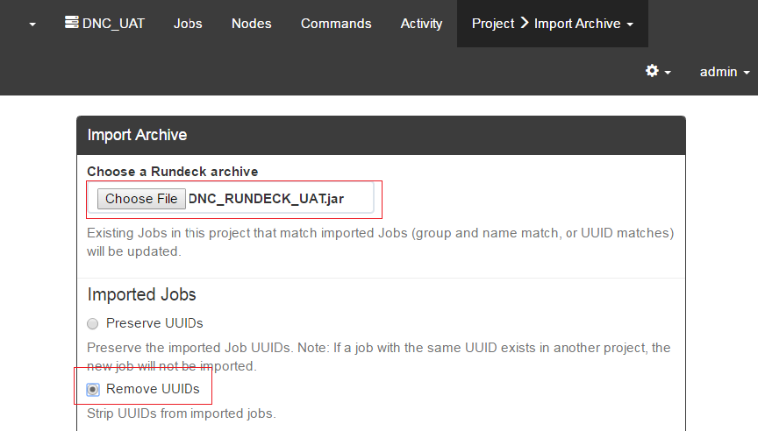
 | 4.4 Wait until show message : Archive successfully imported
Sub-Task | 5. Verify Jobs
5.1 Select Project name : DNC_UAT and select Tab : Jobs
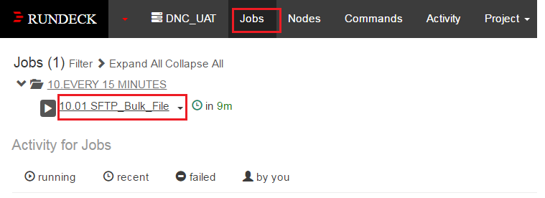
5.2 Click Jobs name : 10.01 SFTP_Bulk_File and Click Tab : Definition
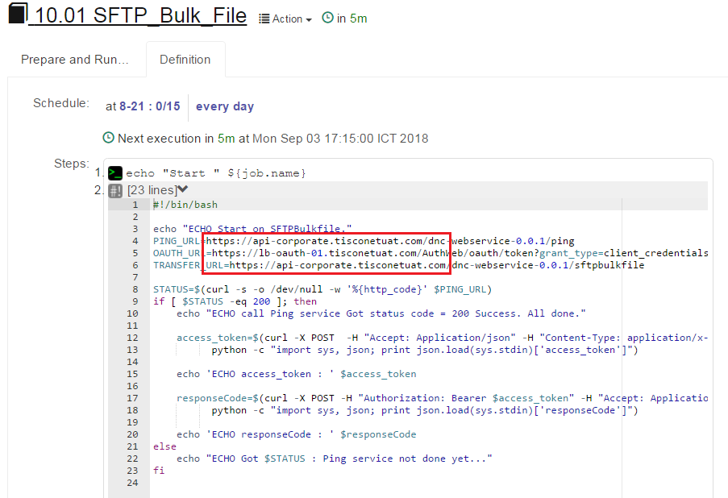
Verify URL :
PING_URL=https://api-corporate.tisconetuat.com/dnc-webservice-0.0.1/ping
OAUTH_URL=https://lb-oauth-01.tisconetuat.com/AuthWeb/oauth/token?grant_type=client_credentials
TRANSFER_URL=https://api-corporate.tisconetuat.com/dnc-webservice-0.0.1/sftpbulkfile
 | --------------------------------------------------------------- End of Document -------------------------------------------------------------

