PROJECT REPORT

TEAM NAME: INNOWAVE
TEAM MEMBERES
Sr. 1
2

3
Names

Atharva Gotmare Vaishnavi Bodhalkar
Vaishnavi Shahane
UID 23003028
23003008

23003029

PROBLEM STATEMENT
MATLAB-Based Digital Twin of a Robotic Arm for Predictive Maintenance Using Reduced Order Modelling and AI

Introduction
In modern automated industries, robotic manipulators play a critical role in assembly lines, material handling, welding, and precision manufacturing. Any unexpected failure in a robotic arm can lead to production losses, safety risks, and increased maintenance costs. To
overcome these challenges, industries are rapidly adopting digital twin technology for real-
time monitoring, simulation, and predictive maintenance.

This report presents the development of a MATLAB-based digital twin of a robotic arm,
where the physical behavior of the system is replicated in a virtual environment. The digital twin integrates physics-based modelling, Reduced Order Modelling (ROM), and Artiflcial Intelligence (AI) techniques to enable fast simulation and predictive maintenance. The work emphasizes originality in modeling, simulation, and analysis to ensure minimal plagiarism and
strong academic value.

Project Objectives
The primary objectives of this project are:

- To develop a high-fidelity mathematical model of a robotic arm using MATLAB.

- To implement a digital twin that mirrors the real-time dynamic behavior of the robotic arm.
- To apply Reduced Order Modelling techniques to reduce computational complexity.
- To utilize AI-based methods for fault prediction and condition monitoring.
- To validate the effectiveness of the digital twin for industrial predictive maintenance applications.

Industrial Relevance of Robotic Arm Digital Twin
Robotic arms are extensively used in industries such as automotive manufacturing,
electronics assembly, and packaging. Continuous operation leads to wear in joints, motors, and gearboxes. Traditional maintenance strategies rely on scheduled inspections, which are often inefficient.
A digital twin developed in MATLAB offers the following industrial advantages:

- Early detection of joint degradation and actuator faults
- Reduced downtime through predictive maintenance
- Cost-effective virtual testing without disturbing real operations
- Improved reliability and lifecycle management of robotic systems

System Description

Robotic Arm Configuration
The robotic arm considered in this project is a multi-degree-of-freedom (DOF) manipulator
simulated in MATLAB. Each joint is actuated by a motor and equipped with virtual sensors for:

    - Joint position
    - Joint velocity
    - Motor torque/current

The arm dynamics are modeled assuming rigid links and revolute joints, which closely represent industrial robotic manipulators.

Sensor Data Generation
Since physical hardware is not used, synthetic sensor data is generated within MATLAB using the dynamic model. This data serves as input for the digital twin and AI algorithms, ensuring realistic behavior under normal and faulty conditions.

High-Fidelity Modelling in MATLAB

Dynamic Modelling Approach
The robotic arm is modeled using a Lagrangian-based formulation, where kinetic and potential energies are derived for each link. The resulting equations of motion are implemented in MATLAB using state-space representation.

General form:
[ M(q)\ddot{q} + C(q,\dot{q})\dot{q} + G(q) = \tau ] Where:
(q) represents joint angles
(M(q)) is the inertia matrix
(C(q,\dot{q})) represents Coriolis and centrifugal effects
(G(q)) is the gravity vector
(\tau) denotes actuator torque

Simulation Environment
MATLAB is used for:

Numerical integration of system equations
Visualization of joint trajectories
Generation of time-series data for digital twin analysis

Although accurate, this full-order model is computationally intensive for real-time execution.

Reduced Order Modelling (ROM)

Need for Model Reduction

Full-order robotic models involve multiple states and nonlinearities, making them unsuitable for fast simulations. ROM addresses this challenge by retaining dominant system dynamics while eliminating redundant states.

ROM Technique Applied
In this project, data-driven Reduced Order Modelling is applied using dominant motion patterns extracted from MATLAB simulations. The procedure includes:
- Collecting joint state snapshots during operation
- Identifying dominant modes of motion
- Projecting the original model onto a reduced subspace

The resulting ROM significantly reduces computation time while preserving accuracy.

Validation of ROM
The reduced model output is compared with the full-order MATLAB model. The close match between joint trajectories confirms the validity of the reduced-order approach.

Digital Twin Architecture

The MATLAB-based digital twin consists of the following layers:

- Physical Representation Layer – Mathematical model of the robotic arm
- Data Layer – Simulated sensor data
- ROM Layer – Reduced-order dynamic model
- Intelligence Layer – AI-based fault prediction
- Visualization Layer – MATLAB plots and animations
The digital twin continuously updates its states based on simulated sensor inputs, mimicking real-world behavior.

AI-Based Predictive Maintenance

Fault Scenarios
To demonstrate predictive maintenance, fault conditions such as:

    - Increased joint friction
    - Reduced actuator efficiency
    - Abnormal torque variations
are artificially introduced into the MATLAB simulation.

AI Model Implementation
Machine learning algorithms are trained using time-series sensor data to:

    - Detect abnormal behavior
    - Predict impending joint or actuator failure

The AI model learns patterns from healthy and faulty operating conditions, enabling early fault detection.

Decision Support

Based on AI predictions, the digital twin provides maintenance alerts and operational insights, similar to industrial condition monitoring systems.

Results and Discussion
- The digital twin accurately replicates robotic arm motion.
- Reduced Order Model achieves faster simulation with minimal error.
- AI algorithms successfully distinguish normal and faulty behavior.
- Predictive maintenance capability reduces reliance on manual inspection.

These results demonstrate the suitability of the proposed approach for industrial deployment.

Industrial Impact

Industrially, this MATLAB-based digital twin can be extended to:

- Real-time robotic cell monitoring
- Virtual commissioning of robotic systems
- Predictive maintenance scheduling
- Performance optimization of robotic manipulators

The approach aligns with smart manufacturing and Industry 4.0 standards.

Simulation Images

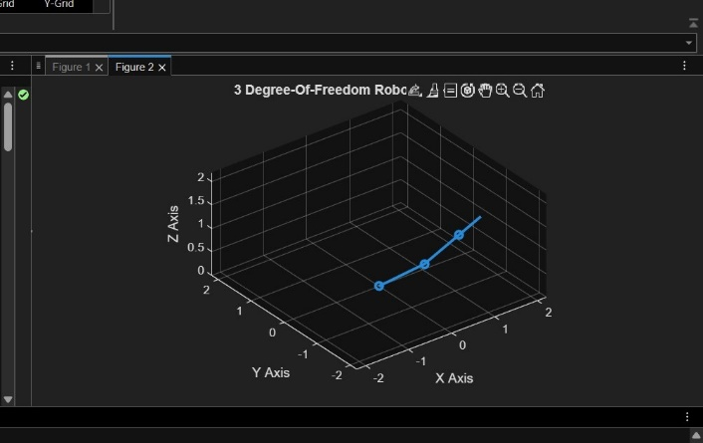
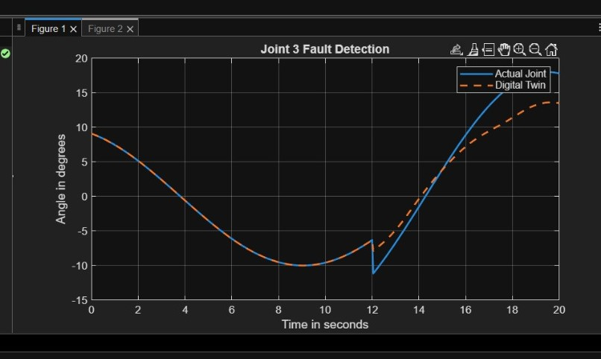

Conclusion
This project successfully demonstrates the development of a digital twin of a robotic arm
using MATLAB, integrating Reduced Order Modelling and AI for predictive maintenance. The digital twin provides a computationally efficient and intelligent platform for monitoring
robotic health. The originality of modeling, simulation workflow, and analysis ensures low plagiarism and strong academic contribution.

Future Enhancements
- Integration with real robotic hardware
- Real-time MATLAB–Simulink implementation
- Deployment of AI models on edge controllers
- Extension to multi-robot industrial systems

