Luka Gligic
Probabilistic Model Checking
Practical 3

Part 4:

1) Reward structure “lost” and property

rewards "lost"
[request] q=q_max : 1;
endrewards

R{"lost"}=? [ C<=T ]

2) Graph for number of lost requests at T=20 dependent on q_trigger

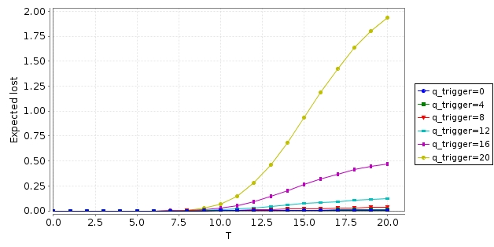
Part 5:

1) Reward Structure “power consumption”, property and graph

rewards "power_consumption"
sp=0 : 0.13;
sp=1 : 0.95;
sp=2 : 2.15;
[sleep2idle] true : 7;
[idle2sleep] true : 0.067;
endrewards

R{"power_consumption"}=? [ C<=T ]
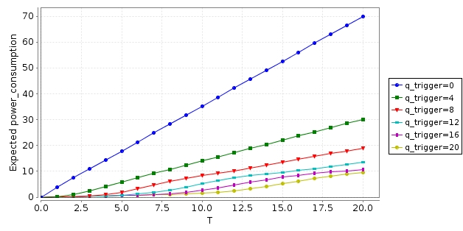
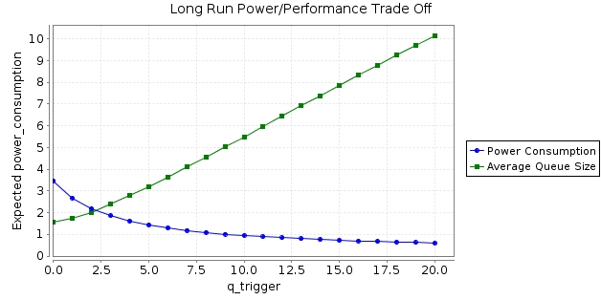
2) Trade-Off graph
Part 6

// Probability of ordering the SP to sleep when queue empty
const double p_sleep;

module PM

// i2s: true when idle2sleep command should be issued
// s2i: true when sleep2idle command should be issued
i2s : bool init false;
s2i : bool init false;

// idle to sleep and sleep to idle command triggered by request arrivals/services
// decide to perform command when queue becomes empty with probability p_sleep
[serve_last] true -> p_sleep : (i2s'=true) & (s2i'=false) + 1-p_sleep : (i2s'=false) & (s2i'=false);

// decide to perform command when request arrives with probability based on queue
[request] true -> q/20 : (s2i'=true) & (i2s'=false) + 1-q/20 : (s2i'=false) & (i2s'=false);

// Send idle2sleep command to SP
[idle2sleep] i2s -> (i2s'=false);

// Send sleep2idle command to SP
[sleep2idle] s2i -> (s2i'=false);

endmodule

