Luka Gligic
Machine Learning
Practical 2

FULL CODE

import cPickle as cp
import numpy as np
import matplotlib.pyplot as plt
import scipy.stats as sci

from sklearn.linear_model import LogisticRegression
from sklearn.preprocessing import Imputer

# NAIVE BAYES CLASSIFIER CLASS
class NBC:

# Initialisation
def __init__(self, feature_types=0, num_classes=0):
self.feature_types = feature_types
self.num_classes = num_classes
self.theta = 0
self.pi = 0

def fit(self, X_train, Y_train):

# Setting classes, number of datapoints, and pi and theta dictionaries
Y_classes = np.unique(Y_train)
N, _ = X_train.shape
pi = {}
theta = {}

# Loops over classes
for cls in Y_classes:

# Index tells us the rows which result in current class
index = Y_train == cls

# Setting the class probability
pi[cls] = float(np.sum(Y_train == cls)) / N

# Theta is a dictionary that holds probability distribution for each class and feature
theta[cls] = range(np.size(self.feature_types))

# Isolating the rows which result in current class
X_cls = X_train[index]

for i in range(np.size(self.feature_types)):

# If the feature is binary it will just hold 1-mean (probability of 0) and mean (probability of 1)
if self.feature_types[i] == 'b':
theta[cls][i] = np.zeros(3)

# If value is unknown we give it probability 1
theta[cls][i][2] = 1

N_2 = np.sum(X_cls[:,i].astype(np.float) == 2)
N_full = np.size(X_cls[:,i])

# Calculating probability so that it excludes any missing values (OPTIONAL)
if N_2 != N_full:
theta[cls][i][0] = 1 - (float(np.sum(X_cls[:,i].astype(np.float) == 1)) / (N_full - N_2))
theta[cls][i][1] = float(np.sum(X_cls[:,i].astype(np.float) == 1)) / (N_full - N_2)

# If all values are missing just set probs to 0.5
else:
theta[cls][i][0] = 0.5
theta[cls][i][1] = 0.5

# If the feature is real it will hold mean and std for the distribution
if self.feature_types[i] == 'r':
theta[cls][i] = np.zeros(2)
theta[cls][i][0] = np.mean(X_cls[:,i].astype(np.float))
theta[cls][i][1] = np.std(X_cls[:,i].astype(np.float))

# If the feature is categorical it will hold the probability of appearance for each category in feature
if self.feature_types[i] == 'c':
theta[cls][i] = {}
for cat in np.unique(X_train[:,i]):
Nc, _ = X_cls.shape
cat_prob = np.sum(X_cls[:,i] == cat) / Nc
theta[cls][i][cat] = cat_prob

self.theta = theta
self.pi = pi

def predict(self, X_test):
N, _ = X_test.shape

# Setting the prediction variable
y_hat = np.chararray(N)

for n in range(N):
max_prob = -float('inf')
cls_hat = 0

for cls in self.pi:
temp_prob = np.log(self.pi[cls])

for feature in range(np.size(self.feature_types)):

# Binary Features
if self.feature_types[feature] == 'b':
temp_prob += np.log(self.theta[cls][feature][X_test[n, feature]])

# Real Features
if self.feature_types[feature] == 'r':
temp_prob += sci.norm.logpdf(X_test[n, feature].astype(np.float), self.theta[cls][feature][0], self.theta[cls][feature][1])

# Categorical Features
if self.feature_types[feature] == 'c':
temp_prob += np.log(self.theta[cls][feature][X_test[n, feature]])

if temp_prob >= max_prob:
max_prob = temp_prob
cls_hat = cls

y_hat[n] = cls_hat
y_hat = np.array(map(str, y_hat))

return y_hat

# Loading Iris Dataset
from sklearn.datasets import load_iris
iris = load_iris()
X, y = iris['data'], iris['target']

print(np.shape(X))
print(np.shape(y))
print('\n')

# Setting number of repetitions
reps=1000

nbc_accuracy = np.zeros((reps, 10))
logreg_accuracy = np.zeros((reps, 10))
datapoints = np.zeros(10)

# Declaring Classifiers
nbc_iris = NBC(['r','r','r','r'], 3)
logreg_iris = LogisticRegression(C = 5.0)

# Loop over repetitions
for i in range(reps):

N, D = X.shape
Ntrain = int(0.8 * N)
shuffler = np.random.permutation(N)
Xtrain = X[shuffler[:Ntrain]]
ytrain = y[shuffler[:Ntrain]]
Xtest = X[shuffler[Ntrain:]]
ytest = y[shuffler[Ntrain:]]

# Setting output to NBC return format so they can be compared
ytest_nbc=np.array(map(str, ytest))

# Loop over increments of data
for j in range(10):

Nbatch = int(0.1 * (j+1) * Ntrain)
Xbatch = Xtrain[:Nbatch]
ybatch = ytrain[:Nbatch]

datapoints[j]=Nbatch

nbc_iris.fit(Xbatch, ybatch)
y_hat = nbc_iris.predict(Xtest)
nbc_accuracy[i, j] = np.mean(y_hat == ytest_nbc)

logreg_iris.fit(Xbatch,ybatch)
y_hat = logreg_iris.predict(Xtest)
logreg_accuracy[i, j] = np.mean(y_hat == ytest)

nbc_accuracy_average=np.mean(nbc_accuracy, axis=0)
logreg_accuracy_average=np.mean(logreg_accuracy, axis=0)

plt.plot(datapoints, nbc_accuracy_average, 'b', datapoints, logreg_accuracy_average, 'r')
plt.title('Accuracies for NBC and LR for Iris dataset')
plt.xlabel('Data size')
plt.ylabel('Accuracy')
plt.show()

# Loading Voting Dataset
X, y = cp.load(open('voting.cPickle','rb'))

print(np.shape(X))
print(np.shape(y))
print('\n')

nbc_accuracy = np.zeros((reps, 10))
logreg_accuracy = np.zeros((reps, 10))
datapoints = np.zeros(10)

# Declaring Classifiers
nbc_vote = NBC(['b','b','b','b','b','b','b','b','b','b','b','b','b','b','b','b'], 2)
logreg_vote = LogisticRegression(C = 5.0)

for i in range(reps):

N, D = X.shape
Ntrain = int(0.8 * N)
shuffler = np.random.permutation(N)
Xtrain = X[shuffler[:Ntrain]]
ytrain = y[shuffler[:Ntrain]]
Xtest = X[shuffler[Ntrain:]]
ytest = y[shuffler[Ntrain:]]

# Setting output to NBC return format so they can be compared
ytest_nbc=np.array(map(str, ytest.astype(np.int)))

for j in range(10):

Nbatch = int(0.1 * (j+1) * Ntrain)
Xbatch = Xtrain[:Nbatch]
ybatch = ytrain[:Nbatch]

datapoints[j]=Nbatch

nbc_vote.fit(Xbatch, ybatch)
y_hat = nbc_vote.predict(Xtest)
nbc_accuracy[i, j] = np.mean(y_hat == ytest_nbc)

logreg_vote.fit(Xbatch,ybatch)
y_hat = logreg_vote.predict(Xtest)
logreg_accuracy[i, j] = np.mean(y_hat == ytest)

nbc_accuracy_average=np.mean(nbc_accuracy, axis=0)
lognreg_accuracy_average=np.mean(logreg_accuracy, axis=0)

plt.plot(datapoints, nbc_accuracy_average, 'b', datapoints, logreg_accuracy_average, 'r')
plt.title('Accuracies for NBC and LR for Voting dataset')
plt.xlabel('Data size')
plt.ylabel('Accuracy')
plt.show()

# Loading Voting Full Dataset
X, y = cp.load(open('voting-full.cPickle', 'rb'))

print(np.shape(X))
print(np.shape(y))
print('\n')

nbc_accuracy = np.zeros((reps, 10))
logreg_accuracy = np.zeros((reps, 10))
datapoints = np.zeros(10)

# Declaring classifiers
nbc_votefull = NBC(['b','b','b','b','b','b','b','b','b','b','b','b','b','b','b','b'], 2)
logreg_votefull = LogisticRegression(C = 5.0)

imp = Imputer(missing_values=2, strategy='mean', axis=0)

for i in range(reps):

N, D = X.shape
Ntrain = int(0.8 * N)
shuffler = np.random.permutation(N)
Xtrain = X[shuffler[:Ntrain]]
ytrain = y[shuffler[:Ntrain]]
Xtest = X[shuffler[Ntrain:]]
ytest = y[shuffler[Ntrain:]]

# Setting output to NBC return format so they can be compared
ytest_nbc=np.array(map(str, ytest.astype(np.int)))

for j in range(10):

Nbatch = int(0.1 * (j+1) * Ntrain)
Xbatch = Xtrain[:Nbatch]
ybatch = ytrain[:Nbatch]

datapoints[j]=Nbatch

nbc_votefull.fit(Xbatch, ybatch)
y_hat = nbc_votefull.predict(Xtest)
nbc_accuracy[i, j] = np.mean(y_hat == ytest_nbc)

imp.fit(Xbatch)

logreg_votefull.fit(imp.transform(Xbatch),ybatch)
y_hat = logreg_votefull.predict(imp.transform(Xtest))
logreg_accuracy[i, j] = np.mean(y_hat == ytest)

nbc_accuracy_average=np.mean(nbc_accuracy, axis=0)
logreg_accuracy_average=np.mean(logreg_accuracy, axis=0)

plt.plot(datapoints, nbc_accuracy_average, 'b', datapoints, logreg_accuracy_average, 'r')
plt.title('Accuracies for NBC and LR for Votefull dataset')
plt.xlabel('Data size')
plt.ylabel('Accuracy')
plt.show()

Handin 1

If we want to set lambda to 0.1 we should pass the parameter C = 5 to logistic regression as per documentations since C = 1/(2*lambda)

Handin 2

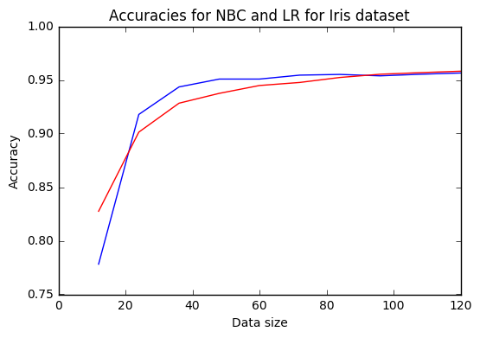

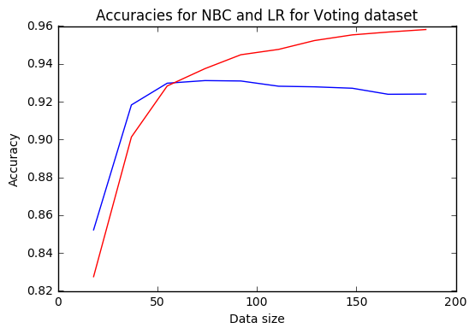

Handin 3 (Optional)

