Url Unshorter
documentation

Thank you for purchasing my script, if you have any questions that are beyond the scope of this documentation, please feel free to email me via the email provided above.
Created: 04/02/2019
By: ApicStudio
Email: apicstudioinc@gmail.com
List Of Contents
- Introduction
- Requirements
- Installation
- User Guide
- Code Structure
- Acknowledgement

Introduction
ApicStudio Url Unshorter is a web-based url Unshorter system implemented using Laravel framework. It uses JQuery and MYSQL database.

Requirements
This Invoice Management System can be installed on any PHP enabled web server that can connect to a MySQL database. This includes shared servers, dedicated servers, and local installations running on Linux, Mac OS X, and Microsoft Windows operating systems. The requirements to have Invoice Management System up and running are: -
- PHP >= 7.1.3
- OpenSSL PHP Extension
- PDO PHP Extension
- Mbstring PHP Extension
- Tokenizer PHP Extension
- XML PHP Extension
- Ctype PHP Extension
- JSON PHP Extension
- CURL PHP Extension

Pre-Installation steps
This Url Unshorter System is a web based solution that needs its relevant files to exist on the web server. The files can be copied to the web server by extracting the download package on your computer and uploading its contents to the web server via FTP, or by copying the download package to the web server directly and extracting its contents there. The contents of the download package need to be copied to the public HTML directory in the web server it is serving from.
Examples of public HTML directories are:
- /home/public_html/
- /srv/www/htdocs/
- /user/local/htdocs/
The contents of the download package once extracted are:
- app (directory)
- bootstrap (directory)
- config (directory)
- database(directory)
- public(directory)
- resources(directory)
- routes(directory)
- storage(directory)
- tests(directory)
- vendor(directory)
- .editorconfig
- .env
- .env.example
- .gitattributes
- .gitignore
- .htaccess
- artisan
- composer.json
- composer.lock
- package.json
- phpunit.xml
- server.php
- webpack.mix.js
- yarn.lock
Installation
The installation process is quick and straight forward, after uploading the files to your web server type your base url.
http://[yourdomain]/[yourfolder]
After entering the above url the install screen should appear as shown below.
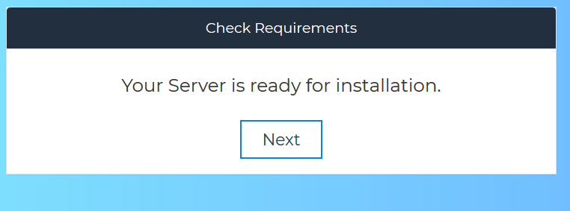
Then Click Next Button.
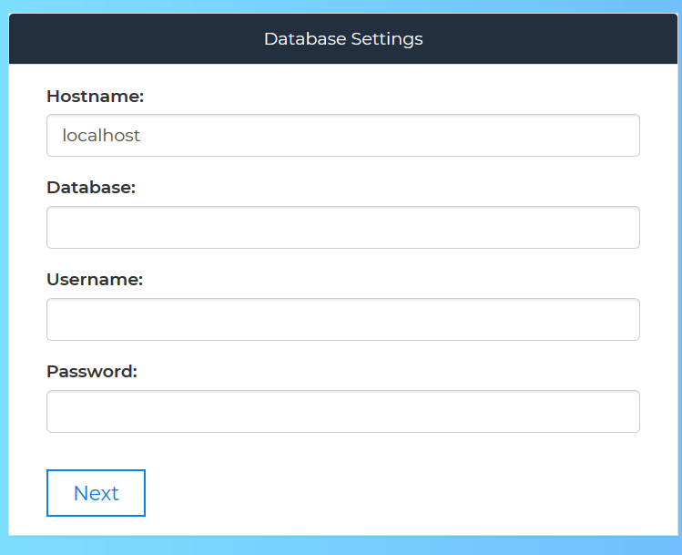
Then Click Next Button.
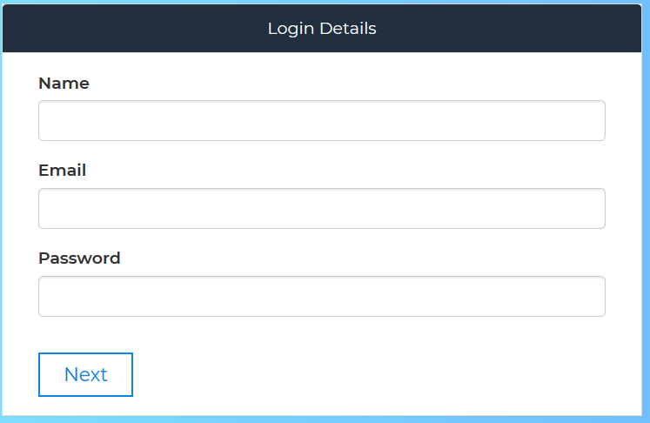
Then Click Next Button.
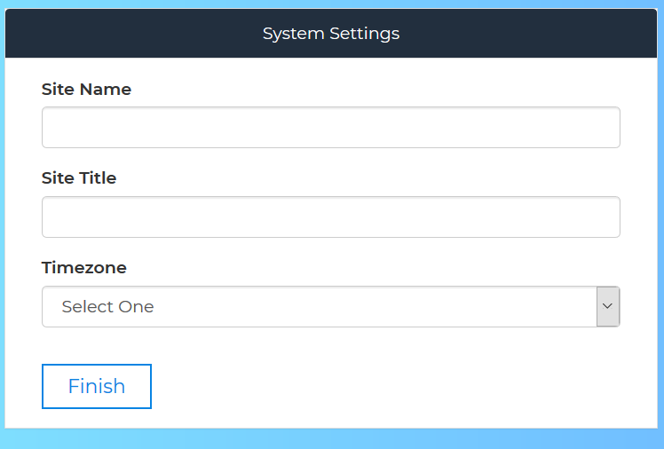
Click Finish Button. Then it will automatic redirect to login page.

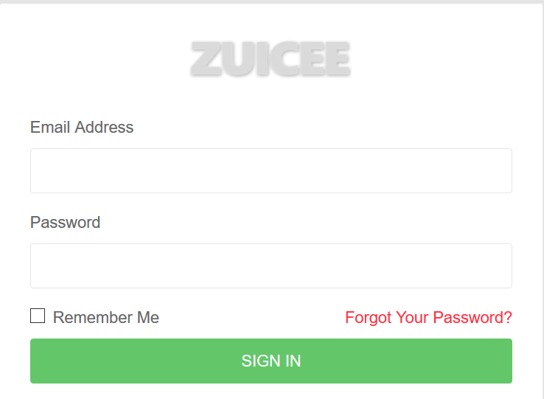

Yessssss, that’s all!!!! Feel free to customize the script in whichever way that suits your requirements

User Guide
Dashboard
The Dashboard is the main screen that appears immediately after logging in. The dashboard mainly contains the links to the different functions that the system user will be performing which include –
- Managing Emails
- Managing Users
- Settings

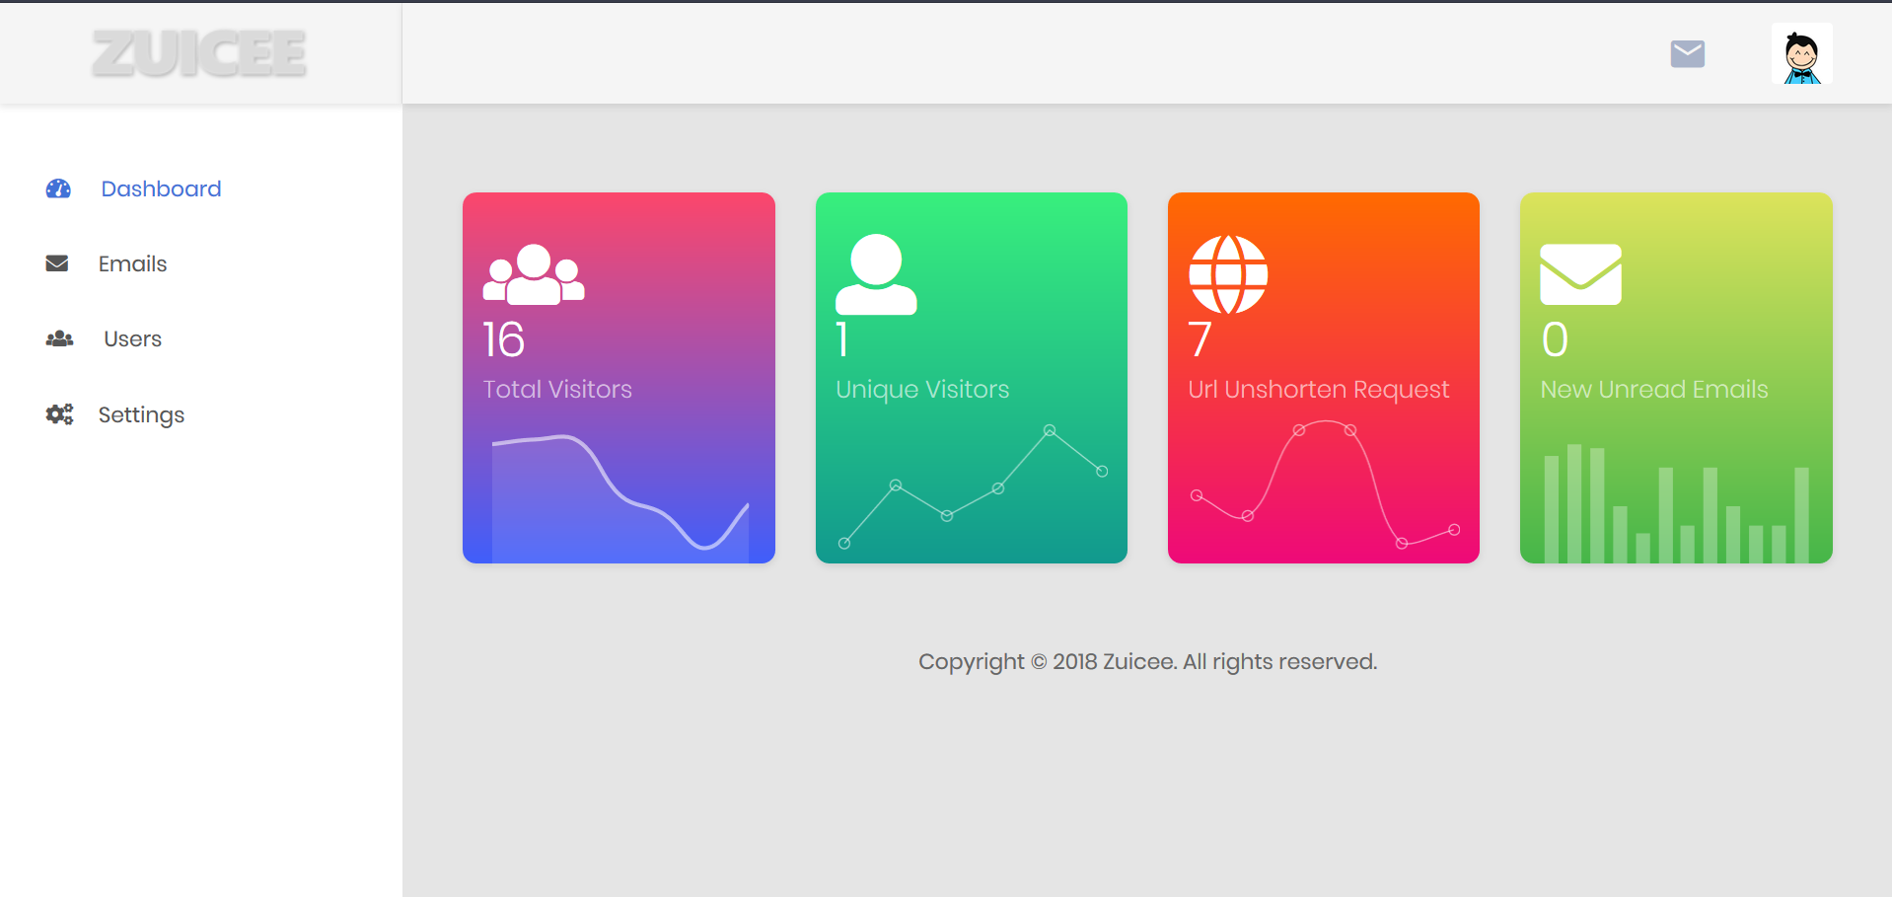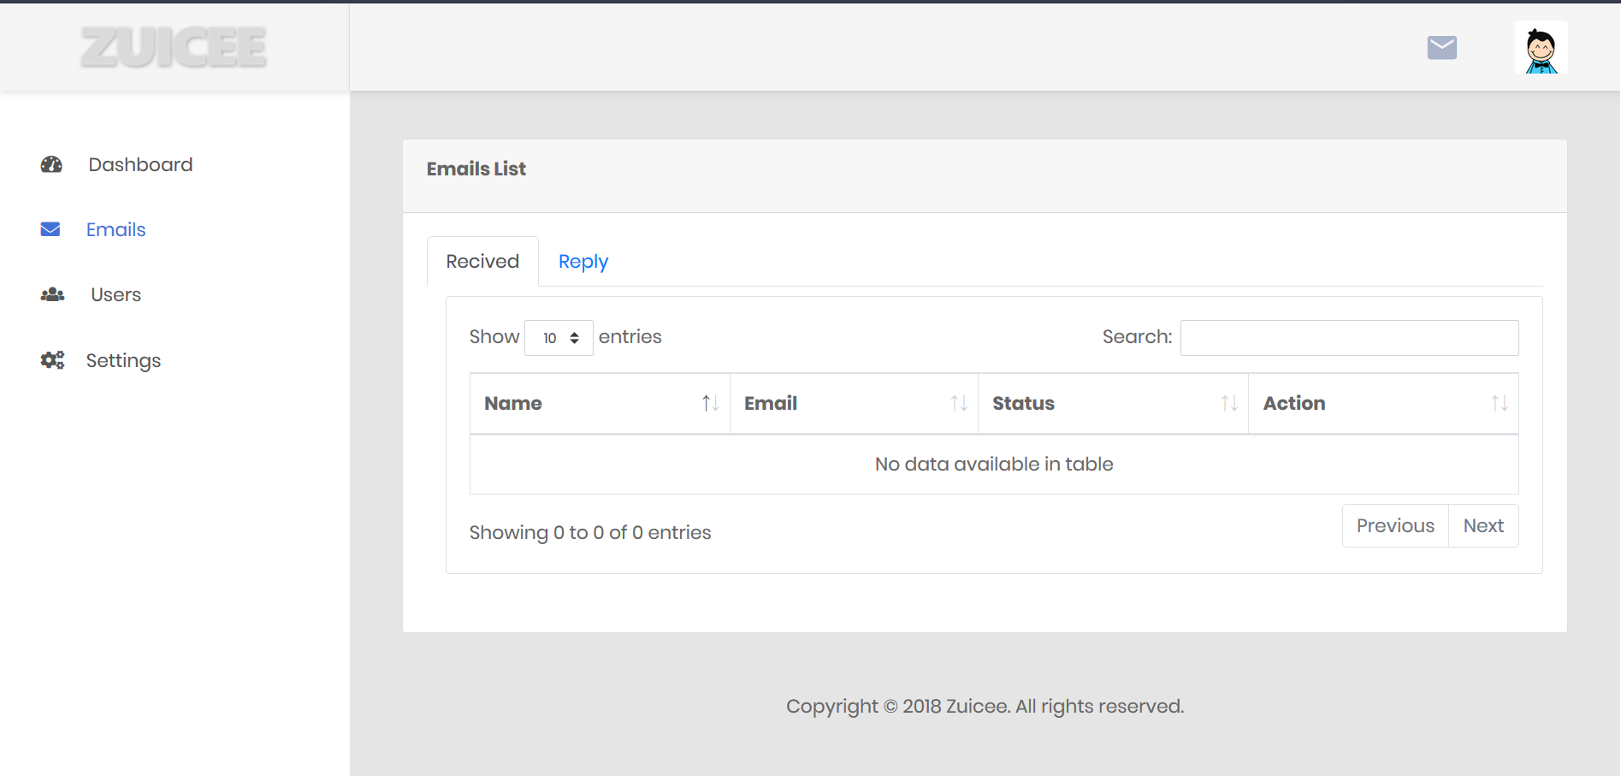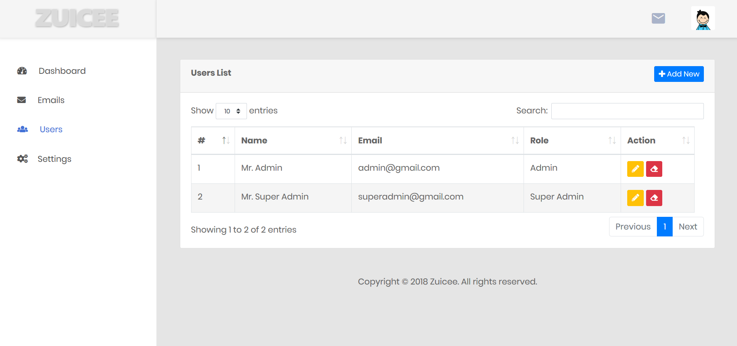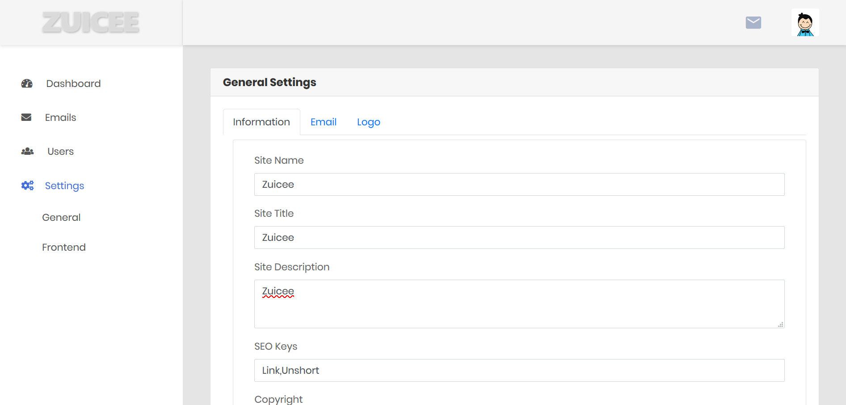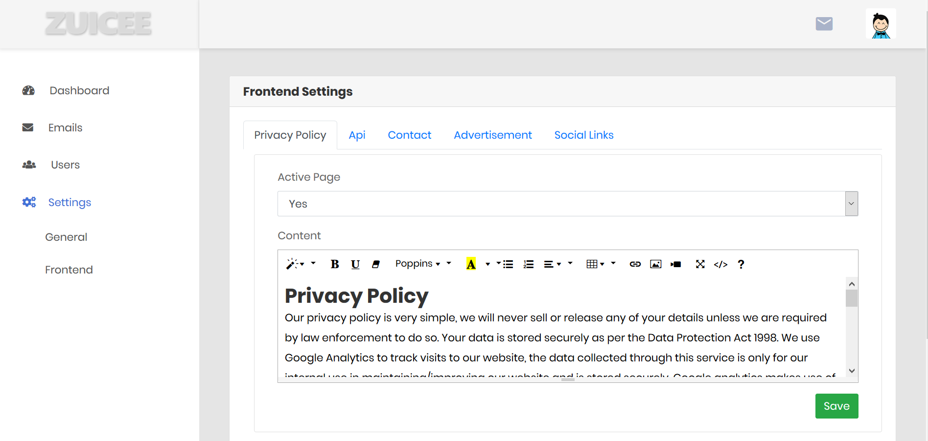

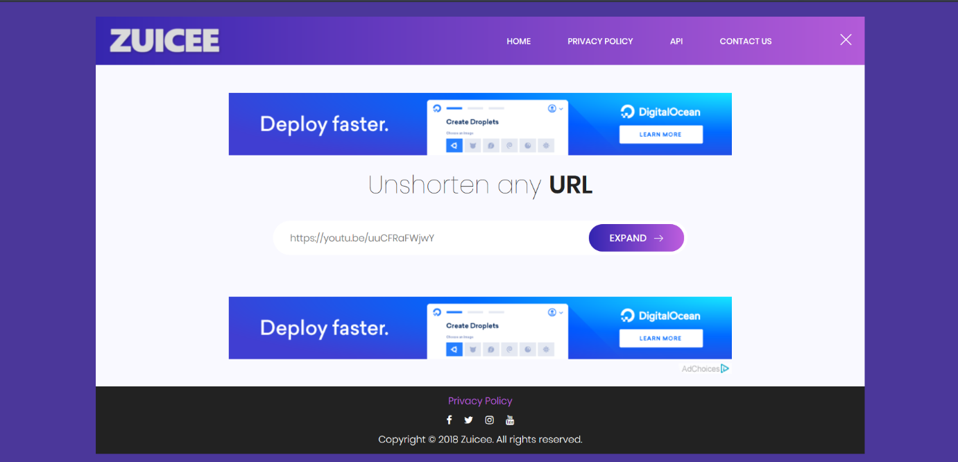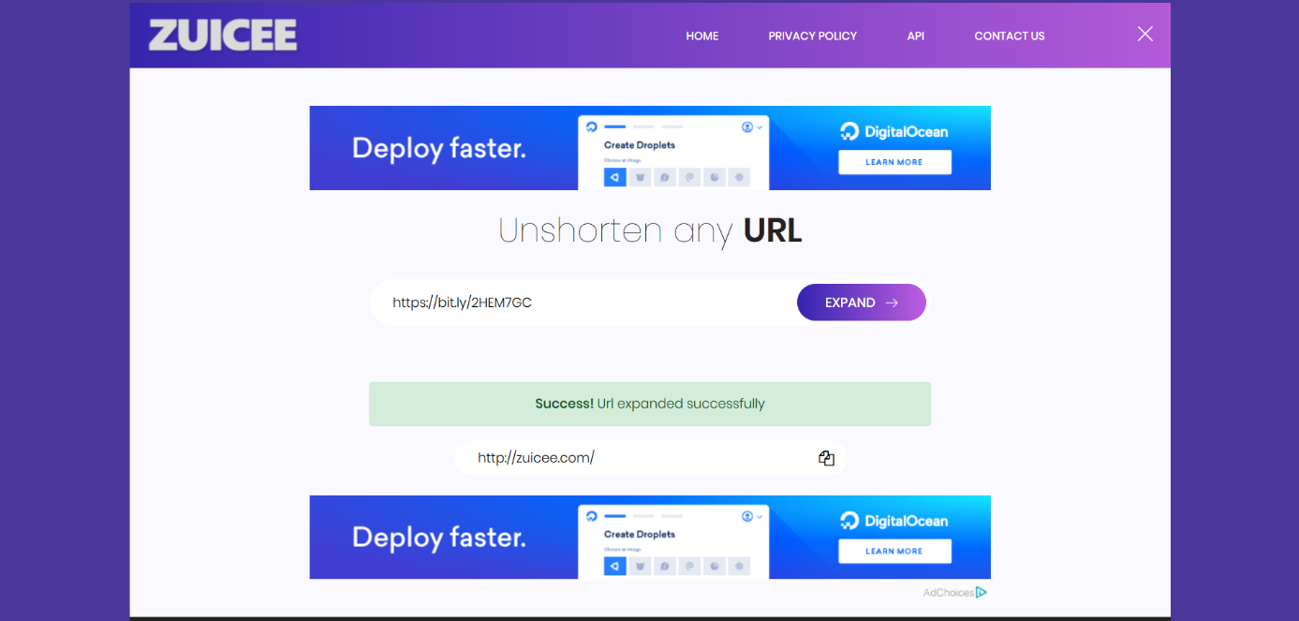

Code Structure
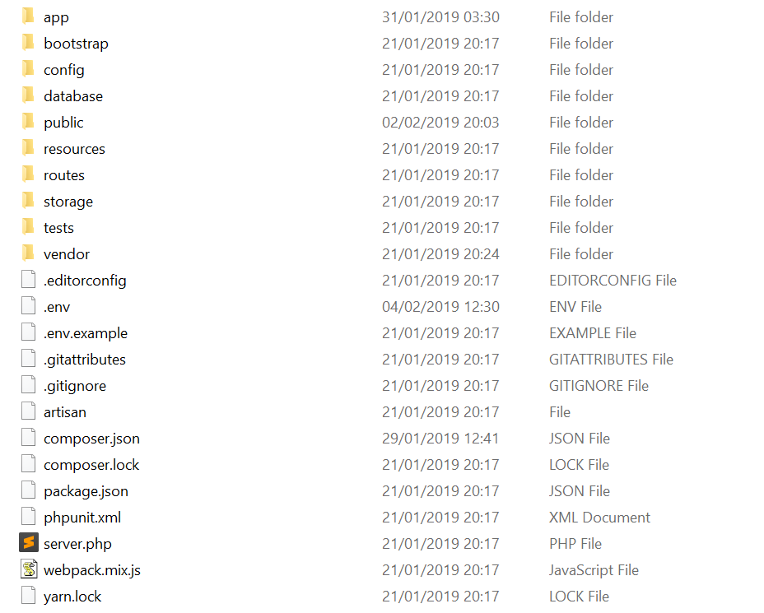
controllers
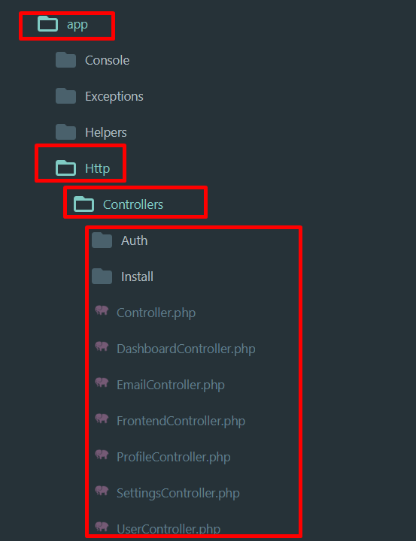
models
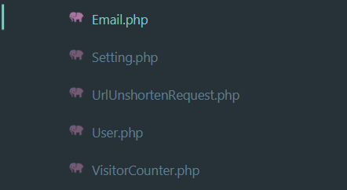

helpers
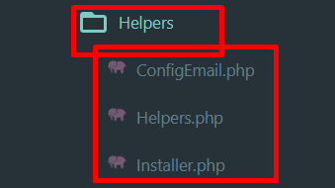
resources
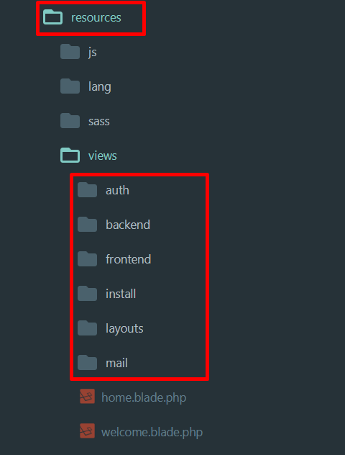
Assets
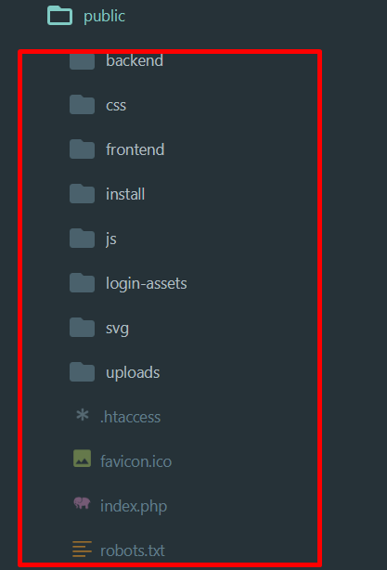
routes
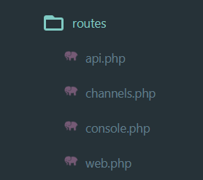

Acknowledgement
I really hope this documentation is detailed enough to get you started on using the system, for any issues that are not covered in this documentation, please contact me via my email. You can also hire me to customize the system for you at a reasonable fee.
Once again, thank you so much for purchasing this script. As I said at the beginning, I'd be glad to help you if you have any questions relating to this script. No guarantees, but I'll do my best to assist. I will also be updating the script every now and then so watch this space ;)
I kindly request you to rate the script on codecanyon.net and I will greatly appreciate.
Enjoy and best of luck!

ApicStudio

