A Privacy-Preserving and Verifiable Cloud Forensic Framework
Using Permissioned Blockchain and Cryptographic Evidence
Provenance
Parth Pusadkar  Department of Computer Science and Engineering,  Symbiosis Institute of Technology, Nagpur  Symbiosis International (Deemed University),  Pune, India | Atharv Sankulwar  Department of Computer Science and Engineering,  Symbiosis Institute of Technology, Nagpur  Symbiosis International (Deemed University),  Pune, India | Abhinav Gunjal  Department of Computer Science and Engineering,  Symbiosis Institute of Technology, Nagpur  Symbiosis International (Deemed University),  Pune, India

Abstract—Digital evidence stored within the cloud should be kept confidential, verifiable and traceable throughout the investigation. This paper presents a prototype solution that uses FastAPI as a service, AES-256-GCM for authenticated encryption, SHA-256 fingerprints, MinIO for object storage, role and policy-based access, and Hyperledger Fabric for audit trails. It stores the evidence contents off-chain as ciphertext, and stores selected metadata and events within the chain. It provides a workflow for registering evidence, verifying user ID and permissions, verifying integrity, and providing audit of granted and denied accesses. A report was provided from the Verification Centre which shows 15 checks were completed successfully within the configured system. An audit report was also provided containing 60 synthetic events that could be reproduced. Finally, a microbenchmark was carried out on SHA-256 and AES-GCM. This ignored the application, object store, database, blockchain and network. As there was no source code provided, there were no baseline or ablation experiments carried out at the application level. The evidence provided gives us evidence that the application behaves as expected with the configured checks. However, it doesn’t give evidence of any performance improvements, scalability, full data privacy or that it is better than other frameworks.
Keywords—Cloud Forensics, Chain Of Custody, Digital Evidence, Hyperledger Fabric, Authenticated Encryption, Access Control, MinIO.

I. INTRODUCTION
Digital evidence can be created within the cloud such as logs, snapshots, object versions and service records. Storing this data can be challenging as it can easily be copied, altered, moved across legal jurisdictions and become lost among multiple tenants. Investigators will need to understand where the evidence was sourced from, how it was kept secure, who had accessed it and confirm that it is the same piece of evidence being investigated. NIST define chain of custody as “a detailed record of the location of evidence from the time it was collected until it is presented in court. This includes who had access to the evidence, at what time, and why they had transferred the evidence [1]. Guidance on digital preservation recommends that verifying integrity and keeping audit trails are core parts of handling digital evidence [2].
While a storage system can be used to keep evidence secure, the administrators have privileged access and will have control over the evidence and audit database. In a distributed ledger, evidence can be independently verified between different organisations. However, it cannot provide evidence that the original evidence was collected correctly and that authorised endpoints were honest. By using encryption, we can keep the contents of a file secure. However, this does not mean all facts are hidden. For example, object IDs, timestamps, size, number of accesses and metadata will still be known. To make strong claims, there needs to be a defined threat model and evidence that the metadata is not being exposed and encryption is being used.
PrivCloud-Chain is a prototype solution for registering evidence and maintaining chain of custody. The application provides a dashboard for submitting requests to the FastAPI backend. Users are authenticated using bcrypt protected credentials and JWT sessions. The application then carries out role and policy based checks, calculates SHA-256 fingerprints and encrypts the evidence using AES-256-GCM. The ciphertext is then stored in MinIO. A Fabric client and Go chaincode is then used to store metadata and access decisions during registration in a permissioned channel. The application has been designed so that plaintext will only be returned once it has passed authorisation and integrity checks. The Verification Centre can be considered as evidence of the scenarios implemented within the application.
This provides a tangible prototype with verification. The workflow has been integrated to ensure encryption, off-chain storage, and permissioned chain events are being recorded. The audit report shows all 15 checks have been passed within the configured system. There was no evidence that the blockchain is providing performance improvements or better data privacy. No baseline, workload sweep, ablation or metadata exposure were provided. This section will look at the related work, threat model, architecture, implementation and testing. An analysis of the limited results will also be performed. Finally, a plan to evaluate this will be proposed.

II. RELATED WORK

A. Evidence Preservation & Cloud Forensics
Evidence can be stored in a system but the chain of custody should be recorded to ensure evidence is tracked from being collected, secured, accessed and presented. This should be done with identifiable people and timestamps [1], [2]. Cryptographic digests can be used but this relies on the digest and handling being trusted. Hashes cannot be used to confirm that logs were complete when collected, who has collected them (without authenticated records) or evidence that all relevant sources have been provided by the provider. Procedures should still be followed.
Cloud forensics introduces additional complexity as there are many elements to consider such as interfaces controlled by providers, distributed locations, SLAs, tenant isolation and volatility. Ruan et al discuss how the nature of the cloud can cause issues with collecting and analysing evidence [3]. Zawoad and Hasan propose a new solution (Secure-Logging-as-a-Service) to keep logs secure within the cloud and make them available to investigators [4]. This demonstrates how collecting evidence and trusting the provider can be an issue.

B. Blockchain Provenance
Lone and Mir propose a proof of concept solution using blockchain to provide chain of custody evidence using Hyperledger Composer. The performance was evaluated [5]. B-CoC provides evidence of custody events using a blockchain to increase traceability [6]. BCFL provides a permissioned blockchain logging system for the cloud, evaluating evidence collection and preservation [7]. Different designs have been used, however claims of superiority require the workloads to be comparable.
Hyperledger Fabric is a permissioned blockchain. Organisations and peers are involved in the blockchain with membership and endorsement policies. Transactions are processed by first executing proposals, then endorsements, ordering and validation by peers [8]. Multiple organisations can be involved using Fabric without having to use public cryptocurrency. This relies on correct identification management, policies and governance. The ordering uses Raft and is crash fault tolerant. It is not Byzantine-fault tolerant as malicious orderers are not a concern [8].

C. Cryptographic Primitives
SHA-256 is a standardised hashing function. This is used to identify any changes in the message if a trusted digest is available [9]. AES-GCM provides encryption and authentication. Nonces must be unique and key management must be correct. During decryption any modifications to ciphertext or authenticated data can be detected. However, this will not help if keys have been leaked, endpoints have been compromised, authorisation has been invalid or a malicious admin.
Blockchain custody, evidence logging within the cloud, are well known areas of research. However, the gap in this project is not the lack of previous frameworks. It can be evaluated as an integration at the application level providing authentication, role/policies, authenticated encryption, object storage and lifecycle audit using Fabric. This provides tangible evidence of the application working as expected with the integration and negative path using an automated suite. Whether it provides improved security, privacy or performance over previous systems is an open question.
Table I shows a qualitative comparison between solutions.
Aspect | Previous approaches | PrivCloud-Chain scope
Payload | Off-chain or Provider logs [4], [7] | Ciphertext stored in MinIO. Plaintext not allowed.
Custody | Blockchain events [5]-[7] | Fabric custody, access, registration events.
Access Control | Varies by framework. | JWT & Application policies. Investigator/Guest access.
Evaluation | System specific | 15 checks. No performance comparisons.

III. PROBLEM DEFINITION AND THREAT MODEL
An evidence object, E, has been collected from a cloud source. Metadata has been collected relating to the case, M. The system should provide confidentiality to the evidence object, identification of changes to the registered object, and control access. There are different actors to consider such as Investigators (registrations and requests), Auditors (checking history), Administrators (configuring users and services) and Guests (restricted access). The exact privileges will depend on the policies set up.

A. Threat Model
The threat could come from an unauthenticated caller, authenticated low privilege user, or someone who can modify the stored object. The suite provided shows that tampered or expired JWTs have been rejected. Spoofed user ID / role are checked. We assume that cryptographic libraries will work as intended, the initial evidence collection will be done by an authorised process, the key will not be revealed, the Fabric identities and endorsement policies will be correctly configured and the audit report provided matches the configured deployment.
Outside of this we are not considering that the administrator may be compromised, organisations may collude on endorsement, malware on host, denial of service, malicious behaviour by the provider prior to registration, incorrect time sources, jurisdiction specific evidence acceptability and side-channel attacks. The evidence will be encrypted in MinIO but cannot be guaranteed that size or access pattern won’t be revealed. Metadata may be exposed in the ledger including case identifiers, frequency of events, pseudonyms or timestamps. This should be identified during evaluation. Mitigations could include reducing data stored in the ledger, pseudonyms, private data sets and encrypted metadata off-chain.
Table II shows the threat requirements and evidence.
Requirement | Mechanism | Evidence / Limitation
Privacy | AES-256-GCM Encryption. Encrypted Object. | Encryption / Plaintext checks. Key lifecycle and metadata not evaluated.
Integrity | SHA-256 & GCM Tag. | Digest / Ciphertext checks. Source not known to be authentic.
Access Control | JWT & Role / Policies. | Investigator access allowed. Guest access denied. Spoofing checks.
Audit | Fabric Events. | Transaction / History checks. Governance not evaluated.
Availability | API / DB / MinIO / Fabric Health. | Health reported.

IV. PROPOSED FRAMEWORK

A. Architecture
The application has been designed with a separation between the UI, application, object store, database and ledger. Requests are sent to the FastAPI backend from the HTML/CSS/JS dashboard. The backend checks JWT claims, enforces access policies, carries out cryptographic processes, stores encrypted objects in MinIO, and communicates with the Fabric client & gateway bridge. The application stores data in a PostgreSQL / SQLite database depending on configuration. MinIO stores the large evidence objects off-chain. Fabric peers, ordering service and Go chaincode (forensics) maintains the ledger state and events. The exact database and ordering service should be reported.
During registration, the backend receives evidence and case metadata. It calculates the digest of the received bytes. Then the payload is encrypted using the AES-GCM key and unique nonce. The ciphertext is uploaded along with required parameters to MinIO. The fingerprint is submitted along with selected metadata to the Fabric. During retrieval, the user is authenticated. Policies are enforced. The access result is recorded. Only ciphertext will be loaded for an approved request. The ciphertext will be authenticated. Only plaintext will be returned if it passes verification. If policies fail or GCM authentication fails, plaintext will not be returned. This can be seen in the tests provided. The source code would need to be reviewed to confirm the exact order of transactions and any exceptions.
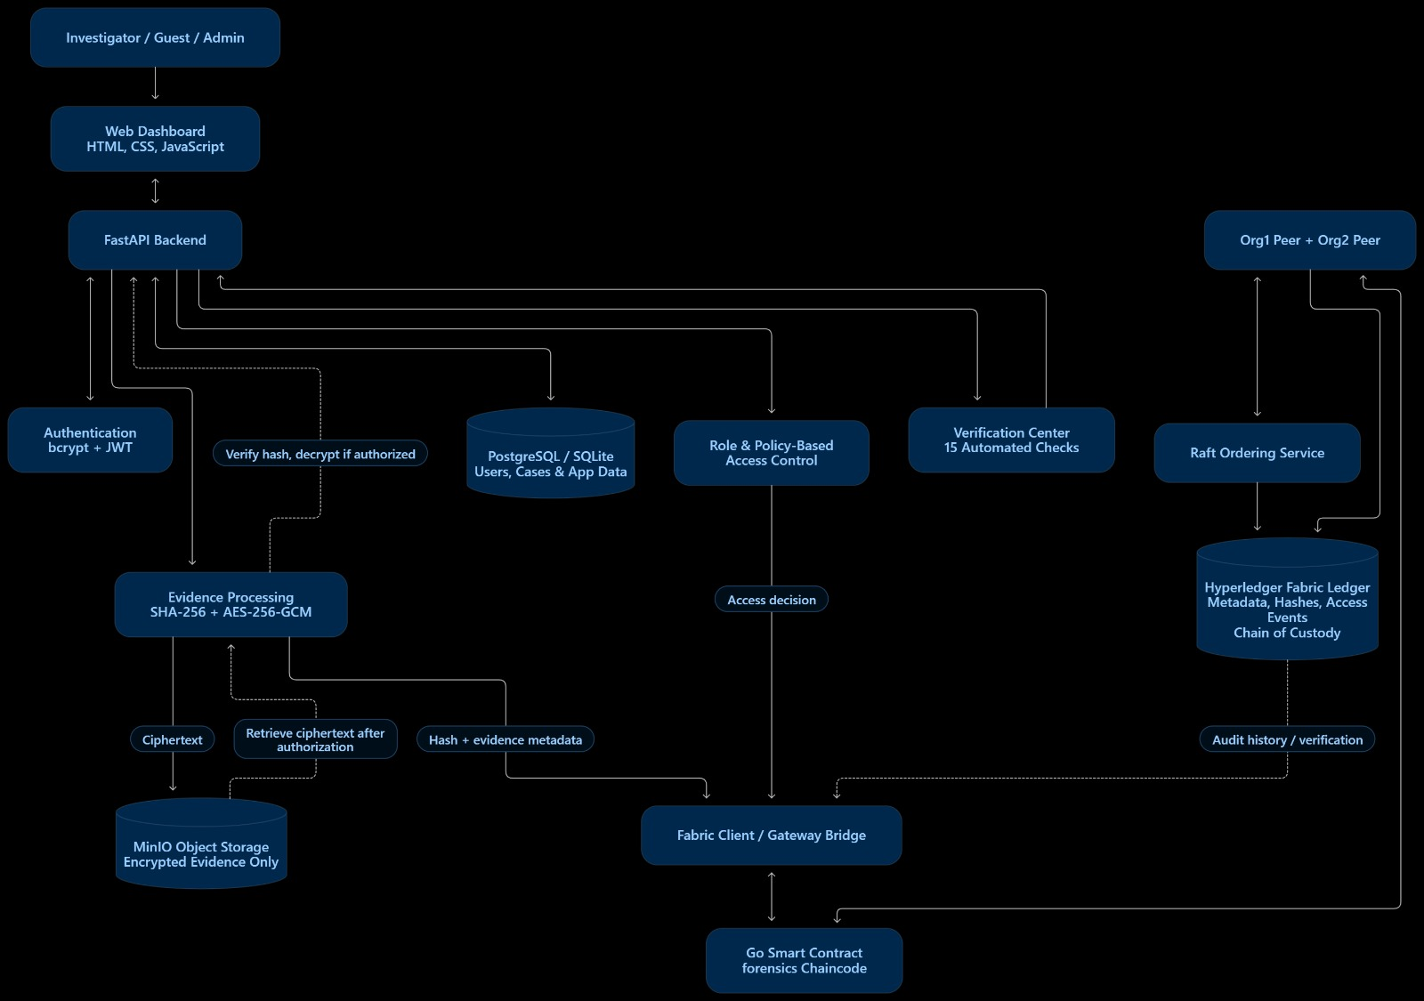
Fig. 1. PrivCloud-Chain architecture and evidence flow.
Large evidence files are stored off-chain to prevent duplication across all participants in the ledger. Digest and life cycle information is stored on the ledger. Metadata may still be visible on the shared ledger. This should be defined clearly to make privacy claims.

B. Cryptographic & Policy Design
The fingerprint for registration of evidence bytes, E, would be:
h_E = SHA-256(E), h_E ∈ {0,1}^256. (1)
AES-GCM encryption using a secret key, K, unique nonce, N, optional associated data, A, and plaintext, E would produce ciphertext and tag:
(C,T) = AES-GCM-Encrypt(K,N,E,A). (2)
Decryption will return plaintext, E, only if the tag is valid:
E = AES-GCM-Decrypt(K,N,C,A,T); otherwise return ⊥. (3)
Associated data may or may not be used. A new nonce must be used each time encryption happens with a key. Keys must be protected and rotated according to a documented policy [10]. The source, storage, backup, rotation, access and response to any compromise should be reported to demonstrate secure key management.
A custody event, e_i can be represented as (id_i, actor_i, action_i, time_i, h_E, context_i). A hash chain would calculate:
h_i = SHA-256(h_{i−1} || Canonical(e_i)), i ≥ 1. (4)
Fabric is used to store event history. The above equation may not be implemented in the chaincode. It is a model of how the evidence would be stored. Fabric has block history and endorsement/commit to provide ordering and validation of the ledger according to network policy [8]. It cannot be claimed to provide additional chaining of events without evidence from the code.
If a user has been authenticated and has a role, r(u), the authorisation would be:
Allow(u,a,x) = 1 if Authenticated(u) ∧ Policy(r(u),a,x); otherwise 0. (5)
Claims must be trusted and policies enforced on the server. The role should not be provided by the user. If denied, no evidence bytes should be returned. This should be audited.

C. Algorithms for Registration & Retrieval
Algorithm 1: RegisterEvidence(E,M,u)1. Check JWT and registration role. 2. Calculate h_E = SHA-256(E). 3. Generate unique nonce, N. Encrypt (C,T) = AES-GCM(K,N,E,A). 4. Store (C,N,T) in MinIO with an opaque ID. 5. Submit selected metadata, h_E, object reference and registration event to Fabric. 6. Store application reference. Return status.
Algorithm 2: RetrieveEvidence(id,u)1. Check JWT signature, expiry, subject and role. 2. Enforce policies on server. 3. Record access decision based on audit policy. 4. If denied return error with no evidence bytes. 5. Retrieve ciphertext and cryptographic parameters. 6. Authenticate/decrypt. If tag fails, don’t return plaintext and raise integrity alert. 7. Check evidence fingerprint. 8. Return evidence if all checks passed.

D. Data Privacy
Evidence contents will be kept private if AES-GCM is used correctly and keys are kept secret. The architecture does not provide anonymity, unlinkability, differential privacy, secure multi-party analysis, or zero knowledge proofs. Role IDs and case metadata may be visible to participants on the ledger. An audit should be performed to identify what fields are stored in the ledger, database, object metadata, application logs and browser responses. Who can see this and if any inference can be made from metadata and access patterns. Key and endpoint compromise are separate to evidence tampering.

V. IMPLEMENTATION & EXPERIMENTAL DESIGN
The project has been implemented using Python FastAPI. A dashboard was created using HTML/CSS/JS. Authentication was provided using bcrypt and JWT. AES-256-GCM and SHA-256 were used for cryptography. MinIO was used for object storage and Hyperledger Fabric v2.5 for the blockchain. Go chaincode was used with name ‘forensics’. The report states a channel called ‘mychannel’ was used, chaincode version 2.2, sequence 4 and Verification Centre. Depending on the component, PostgreSQL or SQLite was used. No conclusions can be drawn about the machine, libraries, nonce size, token lifetime, number of organisations, endorsement policy, MinIO version, network topology or evidence size distribution.
Table III shows the configuration used.
Component | Configuration
API/UI | FastAPI, HTML, CSS, JS.
Authentication | bcrypt, JWT.
Cryptography | AES-256-GCM, SHA-256.
Object Storage | MinIO, Bucket Name: forensic-evidence.
Ledger | Fabric v2.5, Channel: mychannel, Go Chaincode: forensics.
Chaincode | v2.2, Sequence: 4.
Database | PostgreSQL or SQLite depending on component.
Audit | 15 checks, 38.658s.

A. Verification
The report shows tests have been carried out for functional, security, cryptographic and integration aspects. Functional tests have been carried out for registration, authorisation, denial and history. Security tests have been carried out for tampered tokens, expired tokens, spoofed user ID / role, Guest access and no plaintext returned. Cryptographic tests have been carried out for encryption/decryption, deterministic SHA-256 and ciphertext tamper. Integration tests have been carried out for MinIO, Fabric connection, transactions, chain of custody, health and lifecycle. The raw results, repeated tests, timings for each case, evidence sizes, scripts for workloads and instructions to repeat tests were not provided.
Table IV shows the test cases carried out.
ID | Test | Result
T01 | Authentication & JWT lifecycle. | PASS.
T02 | Spoofed Role & User ID. | PASS.
T03 | Investigator. | PASS.
T04 | Guest Denied. | PASS.
T05 | No Plaintext Returned. | PASS.
T06 | AES-GCM Encryption / Decryption. | PASS.
T07 | SHA-256 Digest. | PASS.
T08 | MinIO encrypted object & no plaintext. | PASS.
T09 | Ciphertext Tamper. | PASS.
T10 | Fabric Connectivity. | PASS.
T11 | Evidence Registration Transaction. | PASS.
T12 | Fabric Authorised / Denied. | PASS.
T13 | Custody History. | PASS.
T14 | Database / MinIO / Fabric Health. | PASS.
T15 | End-to-end evidence lifecycle. | PASS.

B. Metrics & Validity
The functional tests passed at 100% (P/T = 15/15 = 1.00). The suite took 38.658s to complete. This is the total time taken to complete all of the tests. Not latency to upload, transaction, throughput or per file. The tests all use the same services and fixtures so are not independent samples. No confidence interval or significance can be calculated for the results from the Verification Centre as only one run was carried out.
A small set of test data has been added to this package. This consists of 60 synthetic fictional events. There are 20 normal events, 20 denied access events and 20 tamper alerts. This has been provided with a manifest and deterministic generator. The 70/15/15 labelling has been applied for ease of test coverage. This is not used for train/test data for Machine Learning. No evidence has been collected for cases. This should not be considered as representative of a forensic dataset. This has been synthetically generated. It has been documented in the dataset card including schema, seed, split and limitations.
The experiment has defined 3 baselines and 4 ablations at the application layer. However, these have not been measured as the source for this project was not available. The baselines separate the audit to a centralised SQL database, audit log using hash chaining and Fabric registration without on-chain access decisions. The ablations remove AES-GCM, Fabric, on-chain access decisions or role/policy enforcement. All tests should be carried out with matching software, source versions, same host, workload, object store, cryptographic settings and concurrency. Raw results should be recorded for each operation. Median and p95 latency should be reported. Throughput, resources, storage increase, unauthorised access and tamper detection should be reported. Controls should not be disabled in a live system.

VI. RESULTS AND DISCUSSION

A. Results
The verification centre report provided shows 15 checks were carried out. 15 were passed, 0 failed, 0 blocked and 0 pending. The total time taken was 38.658s. The dashboard rounds this to 38.7s. Test cases have been carried out for expected positive and negative outcomes. This includes investigator access, guest denied, evidence not returned on denial, GCM rejection on tampered ciphertext, MinIO object stored, and Fabric registration, access and history. Four records have been recorded during the custody history scenario.
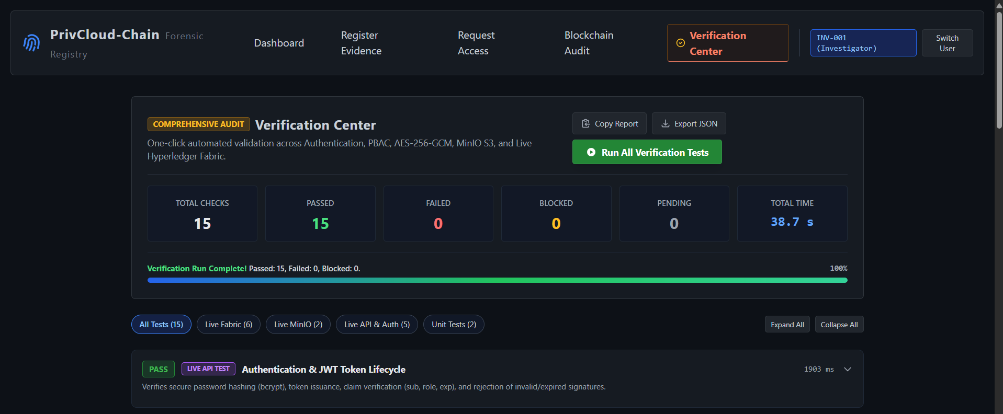
Fig. 2. Verification Center dashboard showing the reported 15-check run.
Table V shows the information from the single verification run.
Metric | Value | Meaning
Configured Checks | 15 | Number of checks in suite.
Passed / Failed / Blocked | 15 / 0 / 0 | Results of tests carried out.
Pass % | 100% | 15 passed in 1 run.
Suite Duration | 38.658s | Duration of all checks in suite.
History Scenario | 4 Records | Records during history scenario.

B. Local Microbenchmark
A separate microbenchmark was carried out using SHA-256 and AES-256-GCM. This was carried out for 3 warmups and 30 runs. Sizes of 1KiB, 64KiB, 1MiB and 10MiB were used. The median timing for SHA-256 with 10MiB was 5.532ms (p95: 5.977ms). The median encryption time for AES-GCM was 5.119ms, median decryption time was 5.732ms and median time for encryption/decryption was 10.991ms (p95: 12.511ms). All 30 runs for each size rejected the tampered ciphertext. The output from decryption matched the input. This was carried out on Windows 11 with Python 3.12.14 and cryptography 50.0.2. Details of the host and raw data can be found in the metadata and CSV. This only measures the local primitives and does not take into account FastAPI, MinIO, Fabric, database, network or baseline. Do not interpret this as performance of the complete system.

C. Conclusions
In summary, it has been shown that the integrated deployment meets the claims made in the verification centre run provided. The suite covers authorised and denied scenarios. The MinIO and Fabric are integrated.

AUTHOR AND DATA AVAILABILITY STATEMENTS
Author contributions (proposed; confirm with all authors): Parth Pusadkar—project conception, system architecture, and paper coordination; Atharv Sankulwar—verification plan, test-data preparation, and results collation; Abhinav Gunjal—related-work review, figures, and reproducibility documentation. All authors should review and approve the final manuscript. Funding: To be confirmed by the authors. Conflicts of interest: To be confirmed by the authors. Ethics and privacy: The attached synthetic corpus contains fictional records; authors must confirm the status of any other test artifacts. Data and code availability: The synthetic corpus, scripts, and supplied verification summary are included in this package. The public repository is https://github.com/gotr0oted/privcloud-chain-research; it currently contains the paper, synthetic corpus, scripts, supplied verification summary, and experiment protocols. The application source was not available for inclusion.

REFERENCES
[1] National Institute of Standards and Technology, “Chain of custody,” CSRC Glossary. [Online]. Available: https://csrc.nist.gov/glossary/term/chain_of_custody. Accessed: Oct. 29, 2026.
[2] B. Guttman, D. R. White, and T. Walraven, Digital Evidence Preservation: Considerations for Evidence Handlers, NIST Interagency Rep. 8387, 2022, doi: 10.6028/NIST.IR.8387.
[3] K. Ruan, J. Carthy, T. Kechadi, and M. Crosbie, “Cloud forensics,” in Advances in Digital Forensics VII, ser. IFIP Advances in Information and Communication Technology. Berlin, Germany: Springer, 2011, pp. 35–46, doi: 10.1007/978-3-642-24212-0_3.
[4] S. Zawoad, A. K. Dutta, and R. Hasan, “SecLaaS: Secure logging-as-a-service for cloud forensics,” in Proc. 8th ACM SIGSAC Symp. Information, Computer and Communications Security, 2013, pp. 219–230, doi: 10.1145/2484313.2484342.
[5] A. H. Lone and R. N. Mir, “Forensic-chain: Blockchain based digital forensics chain of custody with PoC in Hyperledger Composer,” Digital Investigation, vol. 28, pp. 44–55, 2019, doi: 10.1016/j.diin.2019.01.002.
[6] S. Bonomi, M. Casini, and C. Ciccotelli, “B-CoC: A blockchain-based chain of custody for evidences management in digital forensics,” in Proc. 1st Workshop on Blockchain and Cryptocurrency (Tokenomics 2018), 2019, Art. no. 12, doi: 10.4230/OASIcs.Tokenomics.2019.12.
[7] K. Awuson-David, T. Al-Hadhrami, M. Alazab, N. Shah, and A. Shalaginov, “BCFL logging: An approach to acquire and preserve admissible digital forensics evidence in cloud ecosystem,” Future Generation Computer Systems, vol. 122, pp. 1–13, 2021, doi: 10.1016/j.future.2021.03.001.
[8] Hyperledger Foundation, “The ordering service,” Hyperledger Fabric Documentation. [Online]. Available: https://hyperledger-fabric.readthedocs.io/. Accessed: Oct. 29, 2026.
[9] National Institute of Standards and Technology, Secure Hash Standard (SHS), FIPS PUB 180-4, Aug. 2015, doi: 10.6028/NIST.FIPS.180-4.
[10] M. Dworkin, Recommendation for Block Cipher Modes of Operation: Galois/Counter Mode (GCM) and GMAC, NIST SP 800-38D, Nov. 2007, doi: 10.6028/NIST.SP.800-38D.

