**GPIO**

* [RM0008 Reference Manual (STM32F101/2/3/5/7 Series)](https://www.st.com/resource/en/reference_manual/rm0008-stm32f101xx-stm32f102xx-stm32f103xx-stm32f105xx-and-stm32f107xx-advanced-armbased-32bit-mcus-stmicroelectronics.pdf)
* [DS5319 Datasheet (STM32F101/2/3/5/7 Series)](https://www.st.com/resource/en/datasheet/stm32f103rb.pdf)
* 1.Architecture
* 2.MemoryMap
* 3.Register
* 4.Test

**Architecture**

[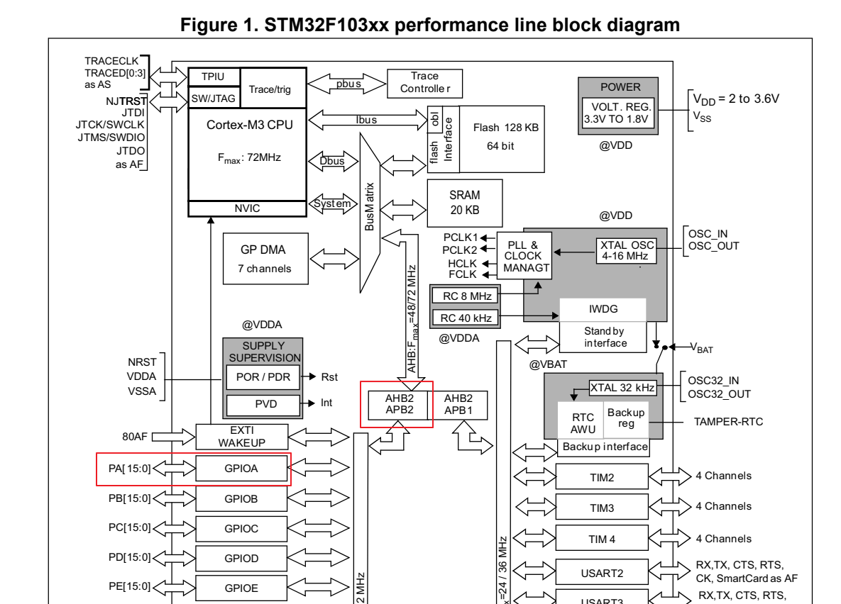](https://private-user-images.githubusercontent.com/49811923/489217607-45a3773c-c552-4388-b9bb-01d889790867.png?jwt=eyJ0eXAiOiJKV1QiLCJhbGciOiJIUzI1NiJ9..gLBP6a4bzj0UlKI4__7_OYZkVnkcg1gff3_3CCZ9QkI)  
[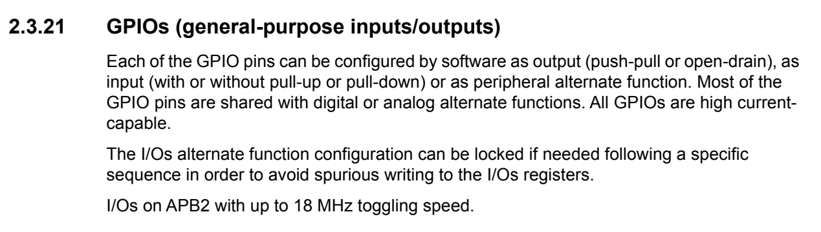](https://private-user-images.githubusercontent.com/49811923/489217585-2eb0bbf5-16f7-4f15-a5b5-51e834e80615.png?jwt=eyJ0eXAiOiJKV1QiLCJhbGciOiJIUzI1NiJ9..Co72Ec8D9oRyDnDgLGmxns9BxI3POKSdvHpHdrkNKPc)  
\* 각 GPIO 핀은 소프트웨어로 출력(푸시풀 또는 오픈 드레인), 입력(풀업 또는 풀다운 여부 선택), 또는 주변 장치의 대체 기능으로 구성할 수 있습니다.  
\* 대부분의 GPIO 핀은 디지털 또는 아날로그 대체 기능과 공유됩니다. 모든 GPIO는 고전류를 지원합니다.  
\* I/O의 대체 기능 구성은 필요 시 특정 순서를 따라 잠글 수 있으며, 이는 I/O 레지스터에 불필요한 기록이 이루어지는 것을 방지하기 위함입니다.  
\* I/O는 APB2 버스에 연결되어 있으며, 최대 18 MHz의 토글 속도를 지원합니다.  
  
[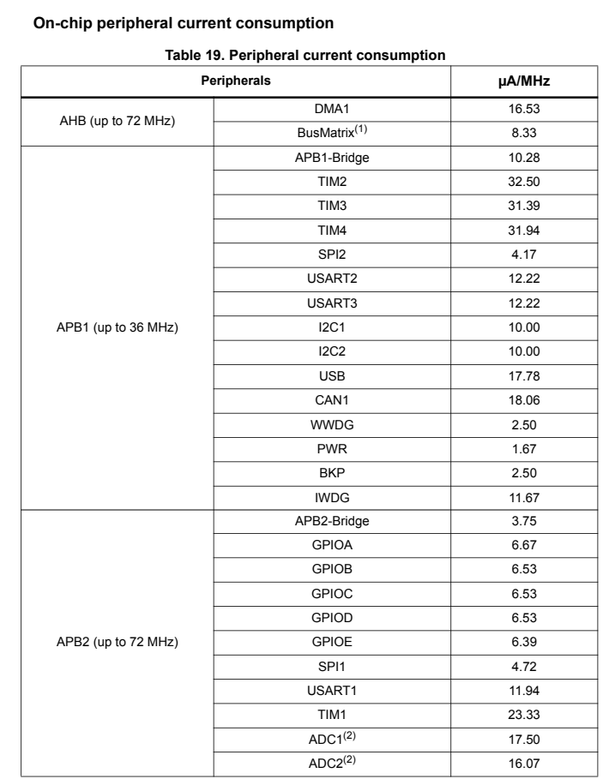](https://private-user-images.githubusercontent.com/49811923/489218087-b48ca11a-e702-4809-b98a-dbe8e864ecfa.png?jwt=eyJ0eXAiOiJKV1QiLCJhbGciOiJIUzI1NiJ9..AIOOzFTQ8cOHWybwVSOJlT2YoBg1pK5NA66WnrmzVOs)  
[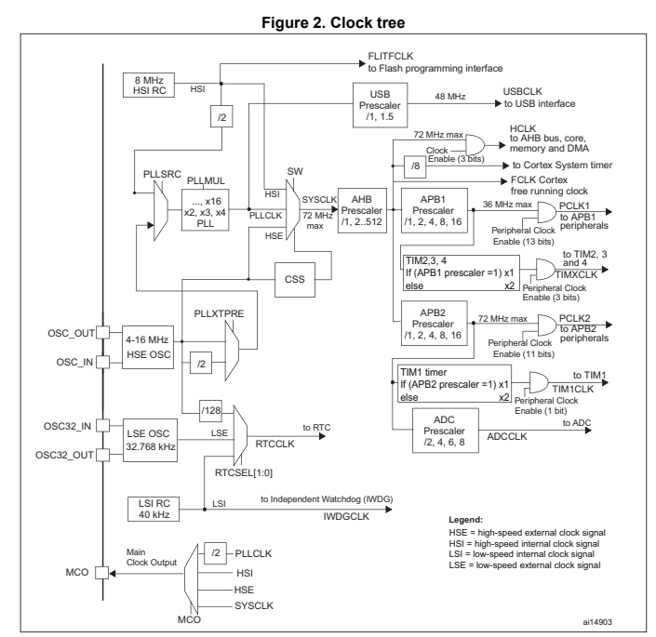](https://private-user-images.githubusercontent.com/49811923/489224641-416aed77-6d31-471f-b18d-dee1bc57e469.png?jwt=eyJ0eXAiOiJKV1QiLCJhbGciOiJIUzI1NiJ9..QM_hB-a8RPKJ7bSibK1jD8iswE-d-Po8w-SV9Bis3YE)

**MemoryMap**

[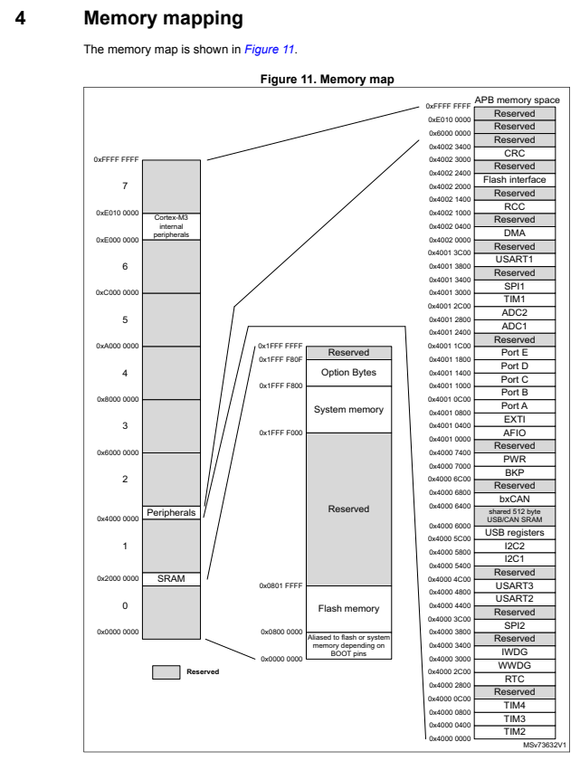](https://private-user-images.githubusercontent.com/49811923/489224638-61b183dc-5844-4e6e-af76-f233ff1be6e5.png?jwt=eyJ0eXAiOiJKV1QiLCJhbGciOiJIUzI1NiJ9..Ia3dWC9rUjS7bg1wefMEJkqQn3dhknO5Ky4oAvfpk-Q)  
[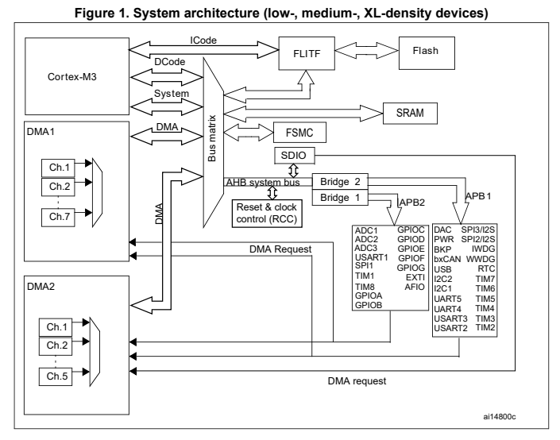](https://private-user-images.githubusercontent.com/49811923/489224369-484f6555-89aa-4b1e-8b21-b2d93045dc71.png?jwt=eyJ0eXAiOiJKV1QiLCJhbGciOiJIUzI1NiJ9..EufXfe1zsTioaf-0fjLhp9h1Y53TkVZt-2AG1T_Pqf8)  
[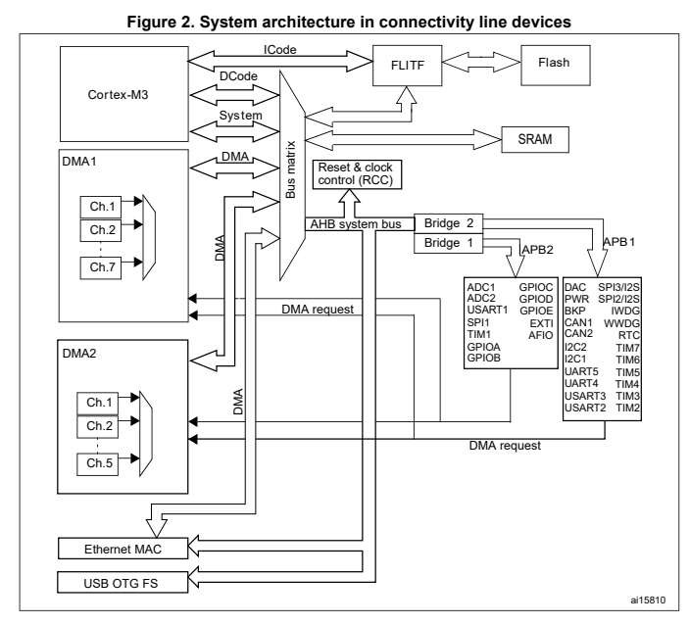](https://private-user-images.githubusercontent.com/49811923/489224372-72cf784d-3cc2-4f82-af47-cb56706edd09.png?jwt=eyJ0eXAiOiJKV1QiLCJhbGciOiJIUzI1NiJ9..hYCo4GDR4LehSvDtlVzk2LDMDUrnPBLS0hYSPAYBZIk)  
[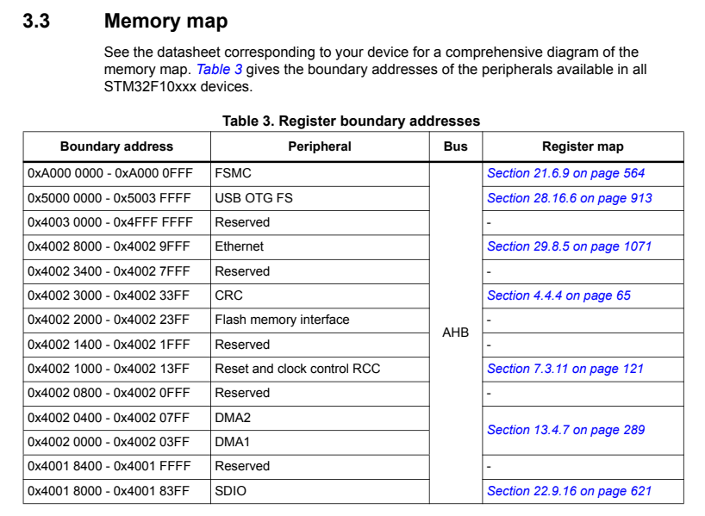](https://private-user-images.githubusercontent.com/49811923/489224373-058abfec-9e1a-47d2-8387-a5e3f275a2ba.png?jwt=eyJ0eXAiOiJKV1QiLCJhbGciOiJIUzI1NiJ9..g5qstweskYn9Wv4LM4aYUsctf0db9DCDFwEvoNq20Xo)

[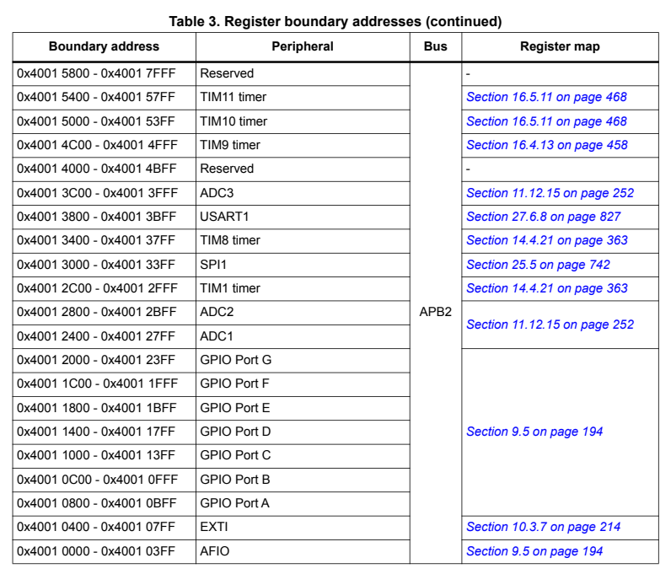](https://private-user-images.githubusercontent.com/49811923/489224374-9ead6b79-6af2-4b08-8dd5-e46634ac0314.png?jwt=eyJ0eXAiOiJKV1QiLCJhbGciOiJIUzI1NiJ9..tqxtKmdBJZ1cUPbfNqxoLa9lQjj_WzCYLHXVGmIaW1U)  
[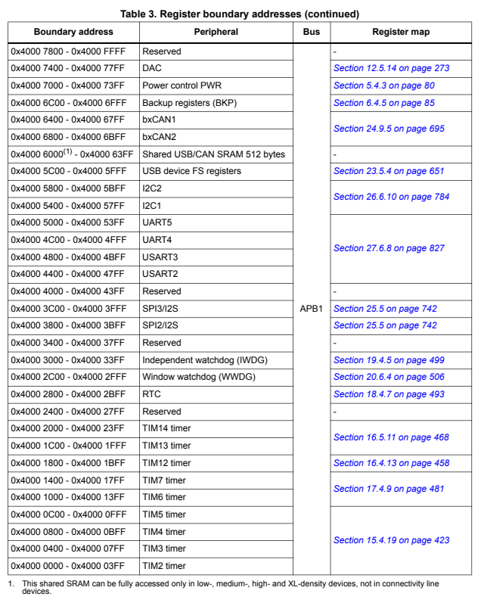](https://private-user-images.githubusercontent.com/49811923/489224375-02d6abe9-3942-4416-9c25-0f624d0352b0.png?jwt=eyJ0eXAiOiJKV1QiLCJhbGciOiJIUzI1NiJ9..uUTmxotg3QQSsIelHe6v3yqjzjGTrjQ23CnGW3vmrOk)  
[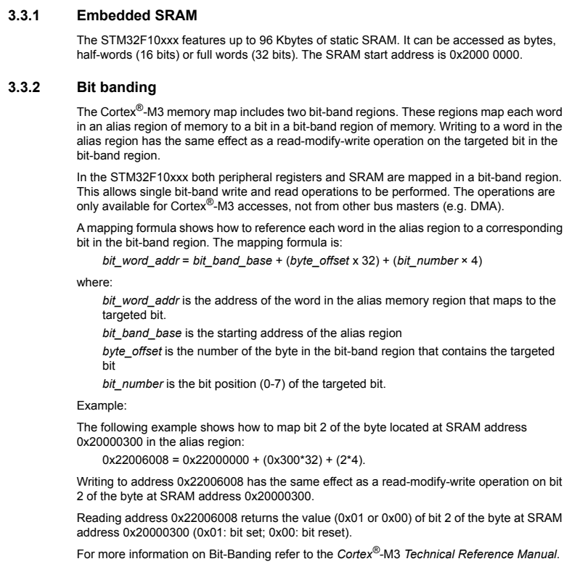](https://private-user-images.githubusercontent.com/49811923/489224376-595e60d5-ad9e-4091-b8a6-6aecc00cfdc4.png?jwt=eyJ0eXAiOiJKV1QiLCJhbGciOiJIUzI1NiJ9..MMIME0eMCDfzIhKZxLWGBx2A4UjZe8immkp1ldP4Smk)  
[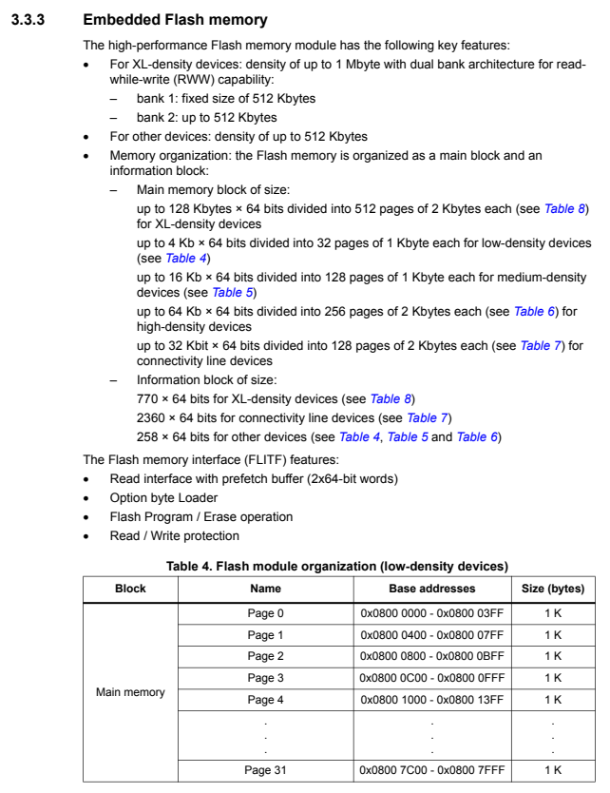](https://private-user-images.githubusercontent.com/49811923/489224377-95f81606-7960-477c-ac24-2c0f2a77c976.png?jwt=eyJ0eXAiOiJKV1QiLCJhbGciOiJIUzI1NiJ9..3S_pD9Vf3YR5cQhyKKzm39IANWPvS0LB5XAlAdi1B1Y)  
[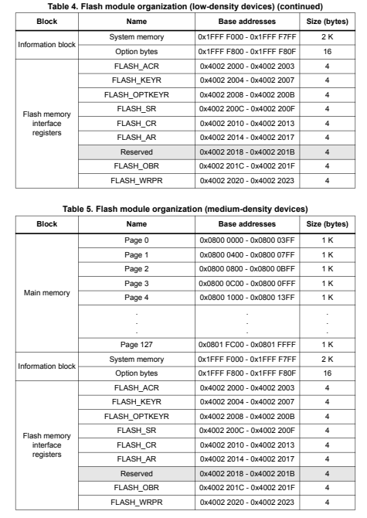](https://private-user-images.githubusercontent.com/49811923/489224378-7d815b4c-e36b-4469-9396-7dadfe013d79.png?jwt=eyJ0eXAiOiJKV1QiLCJhbGciOiJIUzI1NiJ9..il_zlHIZnu5aJgaAXH3vhY_14GqW2tIy9dq5Dqgw_cQ)  
[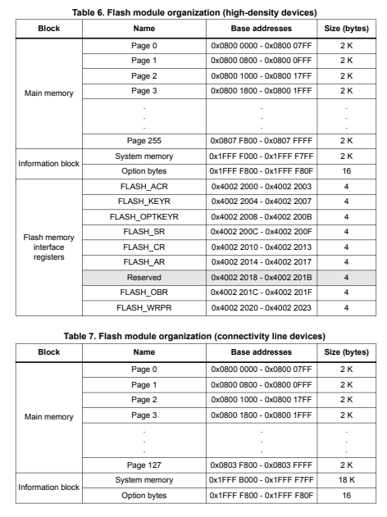](https://private-user-images.githubusercontent.com/49811923/489224379-ff78b8af-c6df-44b6-8b46-f83db18ba049.png?jwt=eyJ0eXAiOiJKV1QiLCJhbGciOiJIUzI1NiJ9..kvMxMtpIxREM0RrW_4olP7EkquToXrtfkWE3S9g04tY)  
[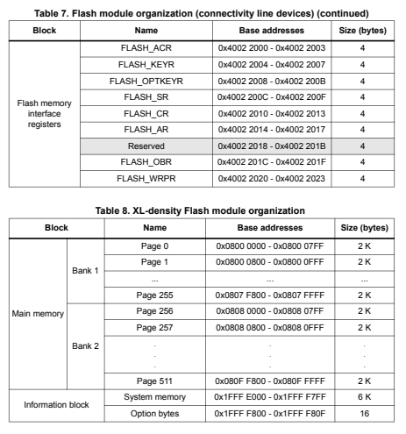](https://private-user-images.githubusercontent.com/49811923/489224381-e2354241-30d5-4466-9b4a-d8c7a74369fc.png?jwt=eyJ0eXAiOiJKV1QiLCJhbGciOiJIUzI1NiJ9..Md31aw7FLdrxxoPprewxzUPh4bIVN2wjQuAFWFHRpOQ)  
[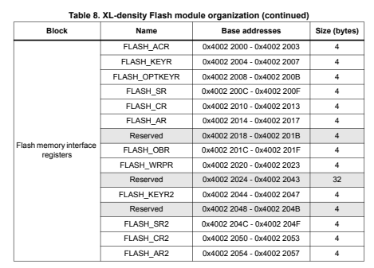](https://private-user-images.githubusercontent.com/49811923/489224382-1705425a-930b-49b5-9602-48708ed5360e.png?jwt=eyJ0eXAiOiJKV1QiLCJhbGciOiJIUzI1NiJ9..FTu8jNyF_Ig5hj54d3KgkusyZfrlzGus-Q-XeZjlIYs)

**Register**

[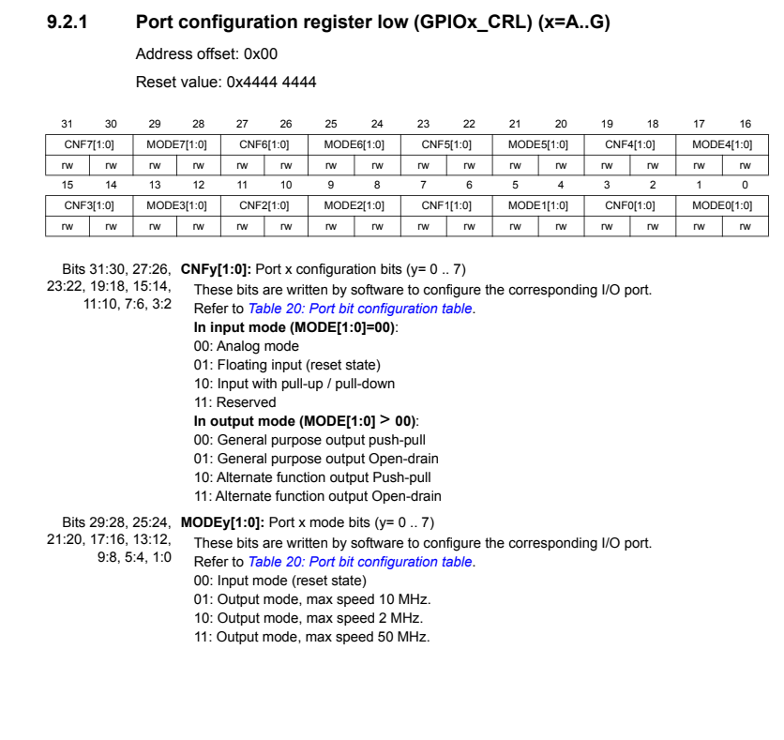](https://private-user-images.githubusercontent.com/49811923/489221657-8bdea1c9-775c-49a1-9edc-1561dbcb336a.png?jwt=eyJ0eXAiOiJKV1QiLCJhbGciOiJIUzI1NiJ9..BYRRl57JYwyirpNeoj95beysJqYL34z3AOUKOsUDOJ8)  
[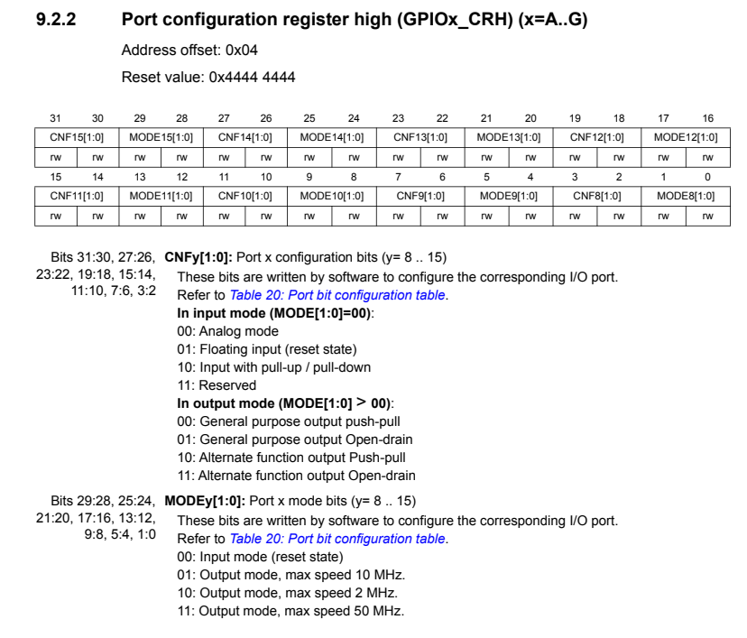](https://private-user-images.githubusercontent.com/49811923/489221658-4f3f19c2-9a94-42b4-a0b5-114d87a409a4.png?jwt=eyJ0eXAiOiJKV1QiLCJhbGciOiJIUzI1NiJ9..05GfJZXIy9PIY_Wv-kfLXojgaUYfOdtEKSOJADi3NAU)  
[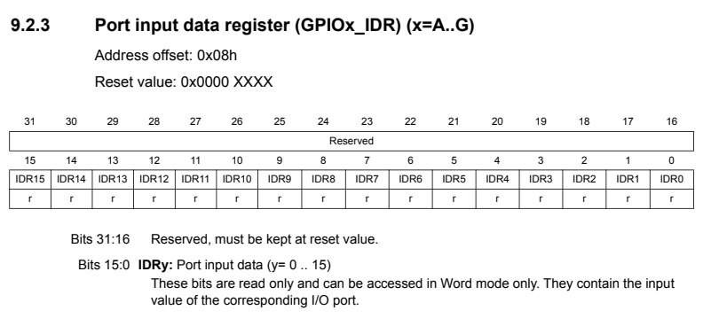](https://private-user-images.githubusercontent.com/49811923/489221659-45f106f2-e432-4dcb-bf74-c4dd08d2fef7.png?jwt=eyJ0eXAiOiJKV1QiLCJhbGciOiJIUzI1NiJ9..BLfqsAwTUmZxFNEQXj5rl5_LUnOzv-SmtwsPtbP7pTs)  
[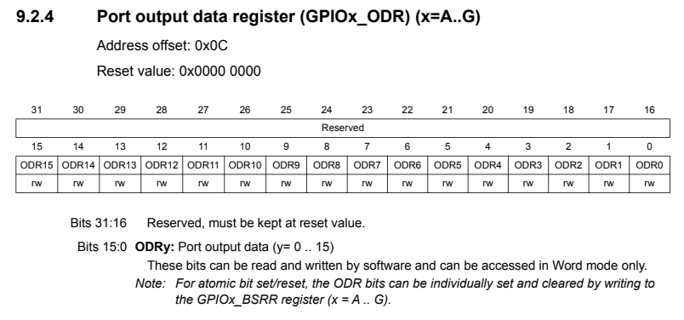](https://private-user-images.githubusercontent.com/49811923/489221660-6c4b1f8f-dbe2-4374-8908-ee492f53d153.png?jwt=eyJ0eXAiOiJKV1QiLCJhbGciOiJIUzI1NiJ9..f4F7_OnXIj73oL1Q1ouijjzHBw3Hzc5hGMtUwr0rgxM)  
[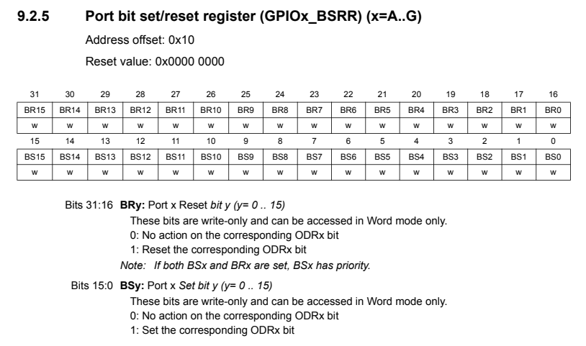](https://private-user-images.githubusercontent.com/49811923/489221662-07bf0f6b-c3d9-465c-a002-17d2ac9a41b5.png?jwt=eyJ0eXAiOiJKV1QiLCJhbGciOiJIUzI1NiJ9..J29H5lQ2JajL4RL6EYk2Qb5saxHUiOeKMdUO9j9TT2I)  
[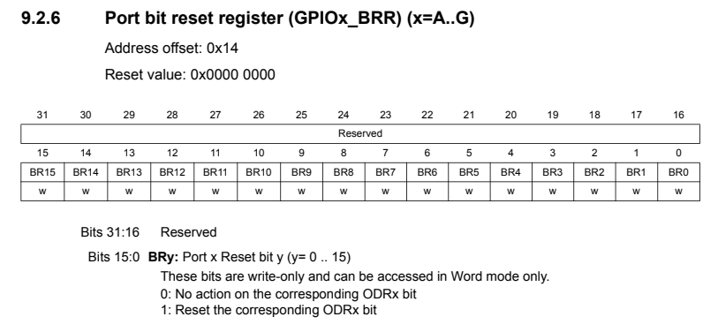](https://private-user-images.githubusercontent.com/49811923/489221663-48daf395-3145-41ca-b3a3-8a4fb0201697.png?jwt=eyJ0eXAiOiJKV1QiLCJhbGciOiJIUzI1NiJ9..WFr38F9GqBgNbwkZxAIdbi0AuH8TIIu5vgNmwtyngvA)  
[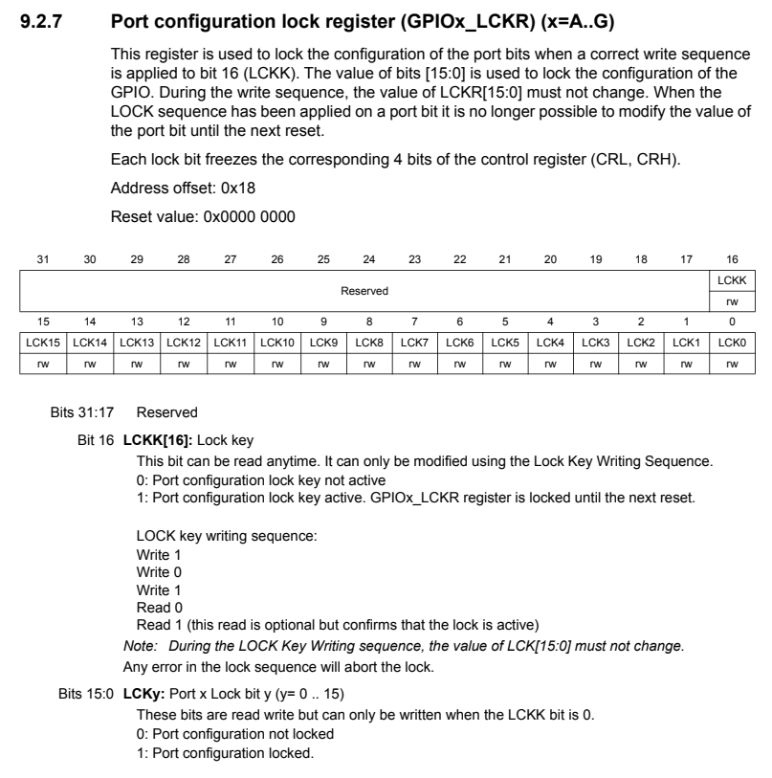](https://private-user-images.githubusercontent.com/49811923/489221655-01aab0d6-81dd-4590-b46d-19f6201a8980.png?jwt=eyJ0eXAiOiJKV1QiLCJhbGciOiJIUzI1NiJ9..0cmSU34A0_wMbXO6U0teMwC7DrIA3a7AWcPn_lTaPiQ)

**Test**

1. **LED test 프로그램을 작성합니다.**[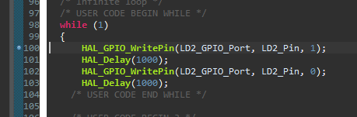](https://private-user-images.githubusercontent.com/49811923/489217591-46223b7e-ec0a-41c5-86ec-ef612250b98a.png?jwt=eyJ0eXAiOiJKV1QiLCJhbGciOiJIUzI1NiJ9..OTRbOIdRiSQtp6QhG_GDFAyY_rnpag6qjc4_vn5d2i8)
2. **디버그를 시작합니다.**  
   [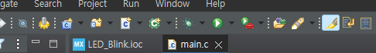](https://private-user-images.githubusercontent.com/49811923/489217592-43a3d8b7-8d07-493e-a005-b04296b30bb5.png?jwt=eyJ0eXAiOiJKV1QiLCJhbGciOiJIUzI1NiJ9..QAh7pcS1hfvgVBXXnRIYbwtWJ1eH9QumnZFeQwiWQvQ)
3. 디버그 메뉴에서 실행을 시작합니다.  
   [GPIO_Register_003](https://private-user-images.githubusercontent.com/49811923/489217594-3919a347-9f9f-4f1a-b11f-37045c2d3514.png?jwt=eyJ0eXAiOiJKV1QiLCJhbGciOiJIUzI1NiJ9..QiHU7s6LwEIEd8BP93-EuhQoyy4xJB-SoJeqyq1S5_c)
4. LD2\_GPIO\_Port 위에 마우스를 올리면 관련 정보들이 나옵니다.  
   [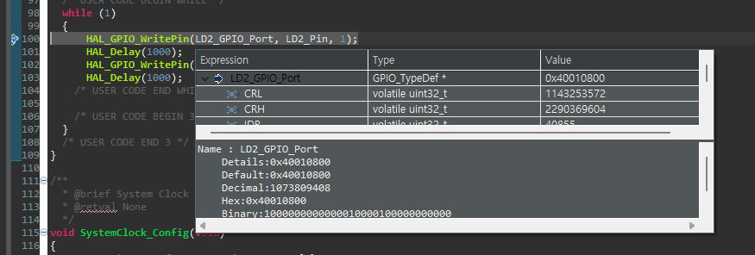](https://private-user-images.githubusercontent.com/49811923/489217596-5ad41fc9-1d63-43a1-a5d6-01bf8adaabff.png?jwt=eyJ0eXAiOiJKV1QiLCJhbGciOiJIUzI1NiJ9..MEz102uYsOiwEHVQhyTMAsmWjCsqBh_YWCSp0sy3Wi4)

[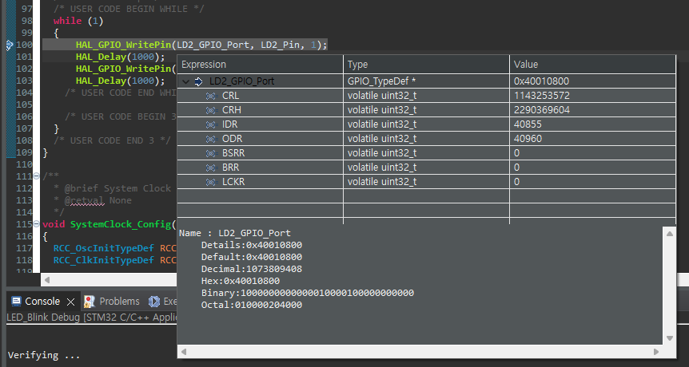](https://private-user-images.githubusercontent.com/49811923/489217600-7c0644bb-55dc-4072-a00f-57b6e5544b2f.png?jwt=eyJ0eXAiOiJKV1QiLCJhbGciOiJIUzI1NiJ9..Gj-X5HyJOZOlmkt5iaUJBeLbM4EEiG6RtaW1oZbVX7M)

1. GPIO A 관련 정보를 위에서 확인하면 관련 레지스터 및 주소 옵셋을 확인할 수 있습니다.

[](https://private-user-images.githubusercontent.com/49811923/489217600-7c0644bb-55dc-4072-a00f-57b6e5544b2f.png?jwt=eyJ0eXAiOiJKV1QiLCJhbGciOiJIUzI1NiJ9..Gj-X5HyJOZOlmkt5iaUJBeLbM4EEiG6RtaW1oZbVX7M)

1. 메모리 값을 확인 및 접근하기 위해서 아래에서 Memory 탭을 누릅니다.  
     
   [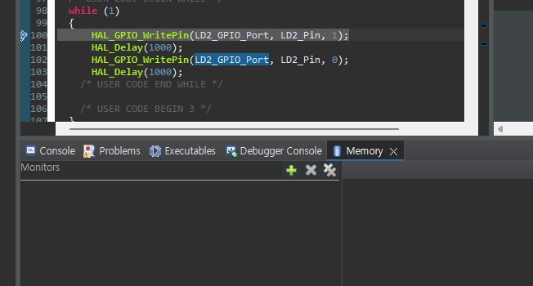](https://private-user-images.githubusercontent.com/49811923/489217602-70b06a32-57ff-41a0-bfba-7a708df195d7.png?jwt=eyJ0eXAiOiJKV1QiLCJhbGciOiJIUzI1NiJ9..JMptTQhB8eVQ6TL1pufj5jjqsDxrkVAjs20bwE1ntPw)
2. 플러스 버튼을 눌러서 관련 번지를 입력합니다.  
   값을 0x40010800을 입력합니다.

[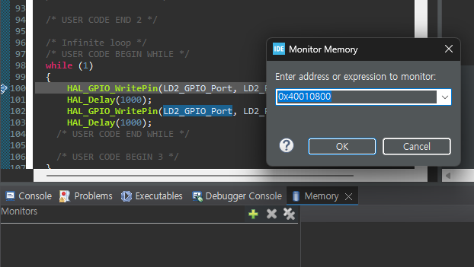](https://private-user-images.githubusercontent.com/49811923/489217604-bddee6a3-5078-4ec3-966a-f55926d10c72.png?jwt=eyJ0eXAiOiJKV1QiLCJhbGciOiJIUzI1NiJ9..yMRf77RlJUNHaiumL8QDs7sEd2RVND5W62ekx2bYjnM)

1. 오른쪽에 관련 메모리 범위와 값이 표현됩니다.  
   [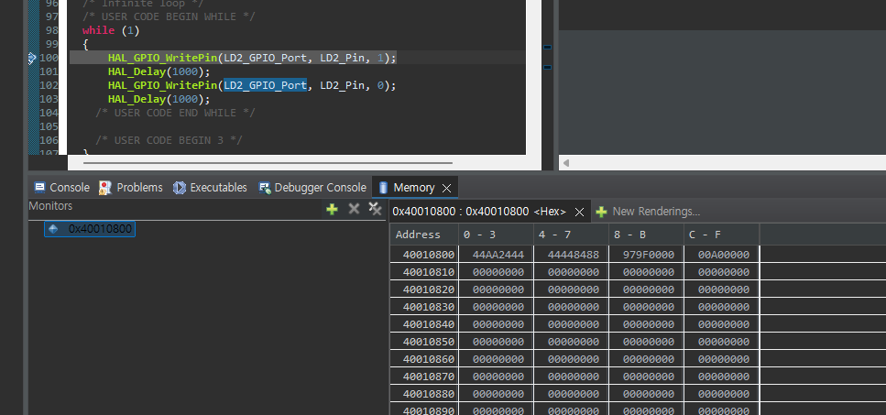](https://private-user-images.githubusercontent.com/49811923/489217605-2258a120-7b56-4842-919f-4b8f4af537ad.png?jwt=eyJ0eXAiOiJKV1QiLCJhbGciOiJIUzI1NiJ9..HkHGRPohXR1zqvhbKV4Yws2YHJW8r0DrhAjh4Lt4uj4)
2. 우선은 값들의 변화를 확인하기 위해서 브레이크 포인트 부터 한단계씩 실행하면서 값의 변화를 확인합니다.

[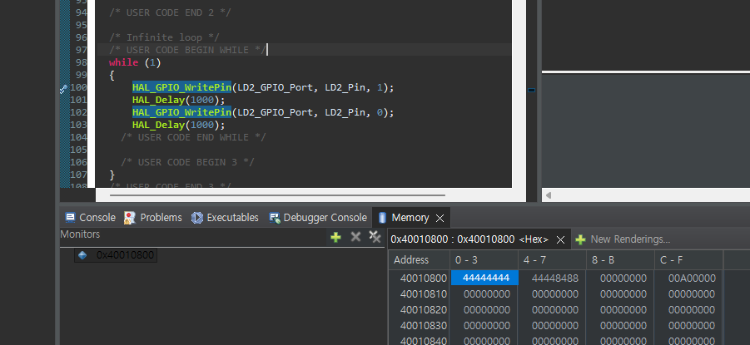](https://private-user-images.githubusercontent.com/49811923/489221952-f5b0951f-8288-4978-8622-63b2873af74c.png?jwt=eyJ0eXAiOiJKV1QiLCJhbGciOiJIUzI1NiJ9..81F1MXts2L4VsyEwKDzpdTOlUPYMp2SKjkKBdIdNIi8)

1. 우선은 값들의 변화를 확인하기 위해서 브레이크 포인트 부터 한단계씩 실행하면서 값의 변화를 확인합니다. (**HAL\_GPIO\_WritePin**(LD2\_GPIO\_Port, LD2\_Pin, 1 실행전);

[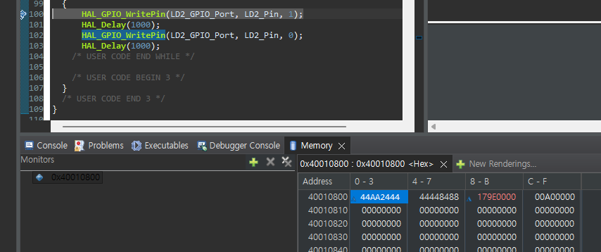](https://private-user-images.githubusercontent.com/49811923/489221954-aea09dcf-1953-46b5-97f3-3e0d9f0572d5.png?jwt=eyJ0eXAiOiJKV1QiLCJhbGciOiJIUzI1NiJ9..ko7DrTVEGcoI0-Y1bbuknasDySPZxnFU3FsFh3nwQ_k)

1. 우선은 값들의 변화를 확인하기 위해서 브레이크 포인트 부터 한단계씩 실행하면서 값의 변화를 확인합니다. (**HAL\_GPIO\_WritePin**(LD2\_GPIO\_Port, LD2\_Pin, 0);

[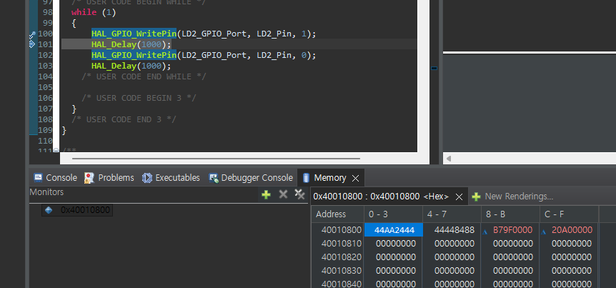](https://private-user-images.githubusercontent.com/49811923/489221955-7c4257d6-a1ca-4d63-b56d-22b2201cd2ea.png?jwt=eyJ0eXAiOiJKV1QiLCJhbGciOiJIUzI1NiJ9..2XqZlDruI8NxlYWv55tNhVMtMfx1yt7TxoaciN0HVbY)

1. 우선은 값들의 변화를 확인하기 위해서 브레이크 포인트 부터 한단계씩 실행하면서 값의 변화를 확인합니다. (**HAL\_GPIO\_WritePin**(LD2\_GPIO\_Port, LD2\_Pin, 0);

[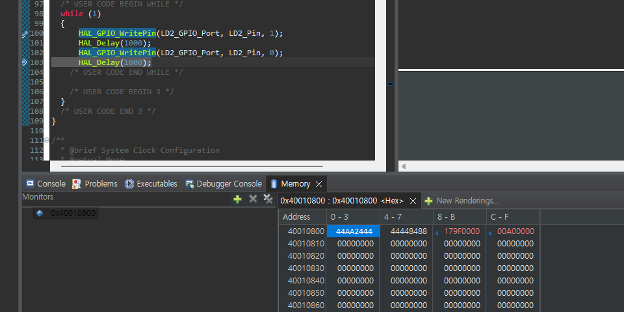](https://private-user-images.githubusercontent.com/49811923/489221958-e06ae1a8-5137-46f3-adfe-0fb37fa52d46.png?jwt=eyJ0eXAiOiJKV1QiLCJhbGciOiJIUzI1NiJ9..pVC2-SHpYiauCBSIL_xBLTdwMb5H0j00-nrNi2fNnV0)

1. C-F 위치의 레지스터에서 값을 직접 입력하면서 LED의 상태를 확인하고,  
   레지스터의 위치와 비교해보면서 동작시켜 봅니다.

[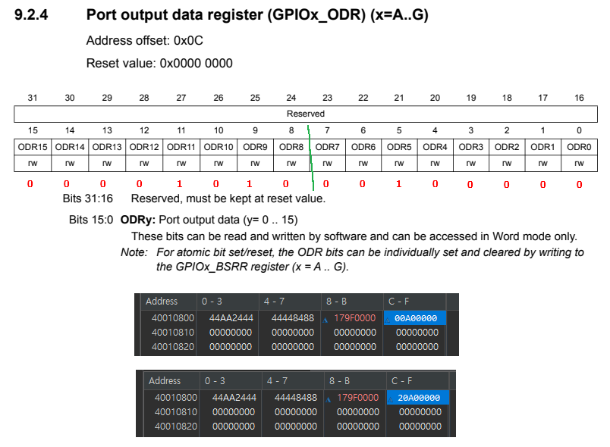](https://private-user-images.githubusercontent.com/49811923/489223347-85cb1220-d9d6-44d6-9d2a-4e46640ce6ca.png?jwt=eyJ0eXAiOiJKV1QiLCJhbGciOiJIUzI1NiJ9..pGi0rFkt0O8QOccp4mhfS-RJFoqZh5XZF4ptWV9g5zI)