CSVy
Get the most of your CSV files, directly inside Launchy!

What is it?
CSVy is a Launchy plugin capable of indexing CSV files, and provide configurable actions to apply on the items of the CSV file.

Installation
Copy the archive content in the \plugins folder of your Launchy installation.
Go in the Launchy Plugins tab, and activate the Launchy# plugin, and the CSVy plugin.
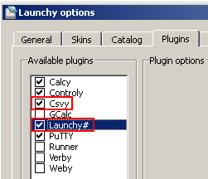

Adding a referential
In order to work, CSVy needs something called a referential.
A referential is composed of:
- a path to a CSV file
- a trigger word
- a display name for the catalog items
- a display path for the catalog items
- a list of actions. Actions are composed of:
  - a display name
  - an action type
  - arguments, as a string separated by commas
In order to create a new referential, click on the button.

General options
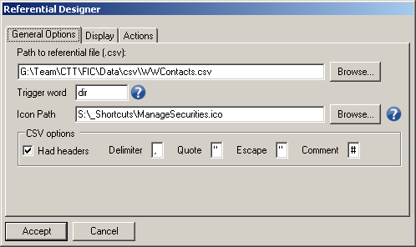
Each referential refers to a CSV file, just specify the path to the file you want to use.
In addition, you can configure the CSV options in case your CSV file is not following the standard format.
The trigger word is used to browse the referential when using Launchy.
You can have multiple referentials using the same trigger word, in which case the referential items returned by a search will be the ones of both referentials, but each item will only offer the actions of its own referential.

Display
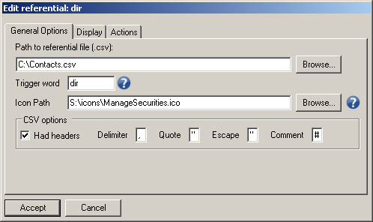
The display name is shown below in Orange. When searching items, the display name is used.
The display path is shown below in Blue.
The display path is just here for information. It is always prefixed by 2 numbers:
- the hash code of the referential, used internally
- the catalog item number, in case 2 identical items are present in the referential
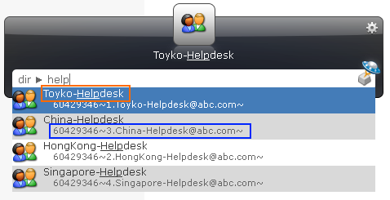
Note that the display path will only be displayed if you chose to activate the option in Launchy.
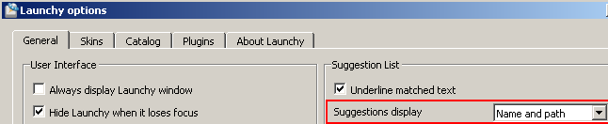
The display name and path can be composed of elements from the referential, by the use of tokens of the form %HEADER%. Use the Expression Designer to help you design the mask you want to use, just click on the Design button to bring up the Designer dialog.
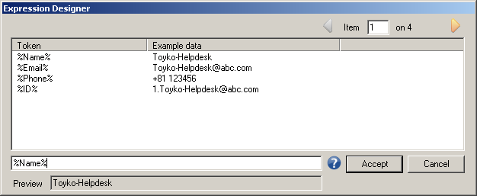
In the Expression designer, just double click on any line to add the token in the mask.
The preview field will show the result of the mask with the current item. You can use the arrows at the top-right to browse the items of the referential and see how the mask behaves.
In addition to the %HEADER% tokens, you can use the following $FUNCTION:
- $env(VAR): returns the content of the environment variable VAR
- $if(CONDITION,VALUE1,VALUE2): if CONDITION is empty, returns value2, else returns value1
- $regex(SOURCE,"REGEXP","REPLACEMENT"): replaces all strings in SOURCE that match the regular expression pattern REGEXP with the specified REPLACEMENT string
- $json: return the JSON representation of the item
The parameters of those functions can also be %HEADER% tokens.
Example:
- $env(USERNAME)
- $if(%username%,%username%,$env(username))
- $regex($env(username),"([a-z]{1,8})\w*","$1_prd")

Actions
You can configure multiple actions onto the referential items, and use any of the field of the CSV file as arguments of the actions.
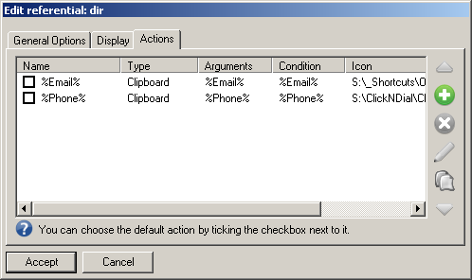
You can add actions using the button.
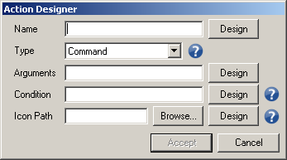
The name is used for the display.
Actions are self-contained DLLs which can be created by third party developers.
CSVy ships with 3 built-in actions:
- Clipboard
- Mstsc
- Command
Just hover the mouse on the to get information on how to configure the arguments.
You can use the Expression Designer to help you.
You can define the default action of your referential by ticking the tick box next to the action.
Condition can be used to hide the action from the list if the condition result is empty for this particular item.

Icons
You can setup a path to an .ico file for multiple elements in CSVy:
- Referential
- Referential items
- Action
When displaying an item, CSVy will use the icon if it is specified. If not it will use the icon of the parent item.
Let’s say you specify an icon for your referential, but nor for your items and actions, then CSVy will use the referential icon for all the items and actions of this referential.

Usage
Type a trigger word and hit TAB. After that, each keystroke will return a set of results with all the items matching the referential, using the Display Name you specified.
Example:
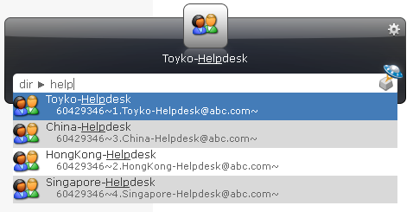
Once you have found an item, you can either:
- Hit ENTER to launch the default action
- Hit TAB to get the list of available actions
