Rapport mac

2.1 Understanding the Lucene API
- What are the types of the fields in the index?
- StringField used to store the path
- LongPoint used for the LastModified date
- TextField for the file’s content

- What are the characteristics of each type of field in terms of indexing, storage and tokenization?
- StringField is Indexed but not tokenized and can either store the content or not
- LongPoint is Indexed but doesnt store the value
- TextField is Indexed and tokenized and can either store the content or not

- Does the command line demo use stopword removal?
It doesn’t. The search for « the world » had 3680 matches while the one for « world » only had 18

- Does the command line demo use stemming?
It doesn’t. Searches for « test », « testing » and « tester » gave us different numbers of matches

- Is the search of the command line demo case insensitive?
No, searches for « world », « WORLD » and « World » gave the exact same matches

- Does it matter whether stemming occurs before or after stopword removal?
??

3.1 Indexing

1. Find out what is a “term vector” in Lucene vocabulary?
It stores, for each term, its frequency, position and offset
2. What should be added to the code to have access to the “term vector” in the index?
We should use a fieldType and configure it with setStoreTermVectors(true)

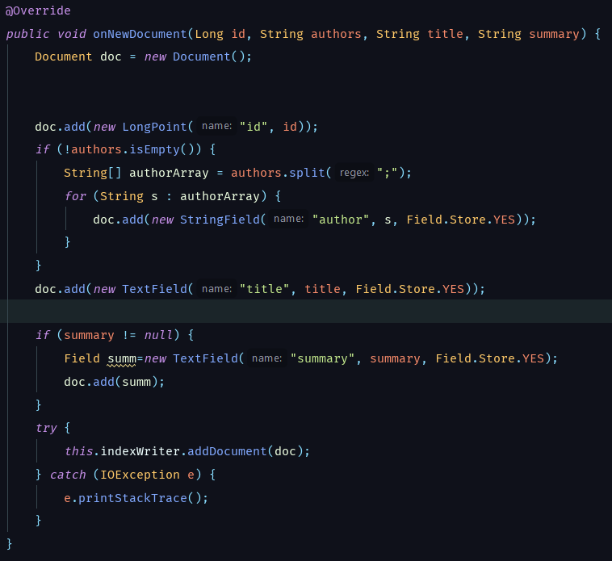
3.3 Reading index
1. What is the author with the highest number of publications? How many publications does he/she have?
Thacher Jr., H. C. with 38 publication
2. List the top 10 terms in the title field with their frequency.
of
algorithm
a
for
the
and
in
on
an
computer
