Resultados:
1322 samples
16 predictor
2 classes: 'skj', 'yft'

Random Forest: el mejor modelo es el modelo 3

-Modelo_1
seed = 123, con tuneLength = 5 (parámetros aleatorios)
The final values used for the model were mtry = 9, splitrule = gini and min.node.size = 1.
mtry splitrule Accuracy Kappa
2 gini 0.9496165 0.8745628
2 extratrees 0.9364601 0.8368620
5 gini 0.9506805 0.8778298
5 extratrees 0.9442518 0.8584056
9 gini 0.9518100 0.8806344
9 extratrees 0.9494678 0.8727676
12 gini 0.9513589 0.8792915
12 extratrees 0.9494684 0.8731580
16 gini 0.9511316 0.8783304
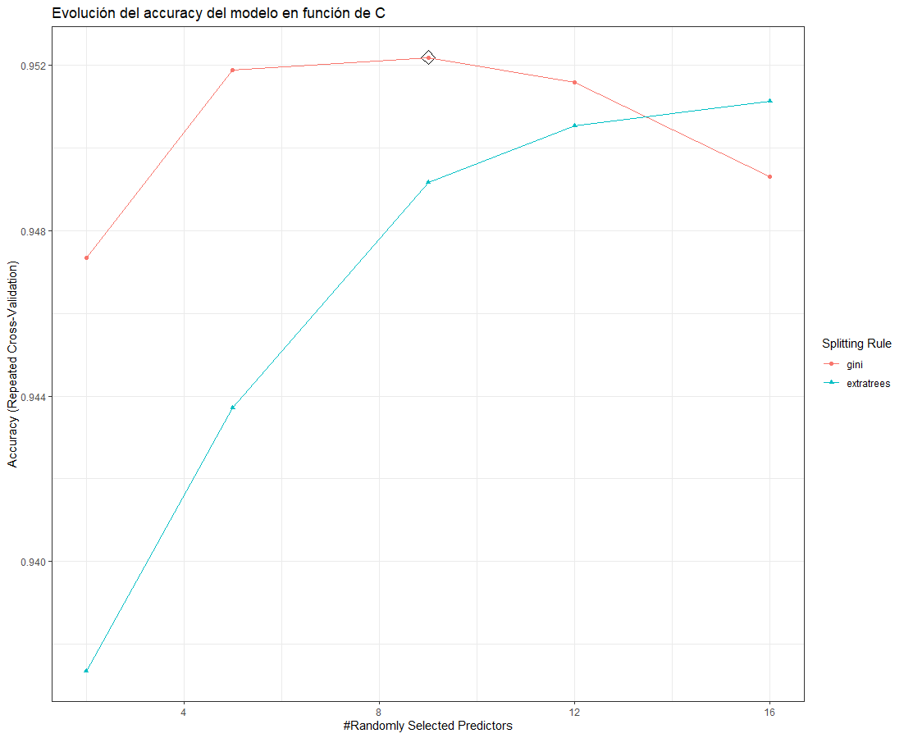
16 extratrees 0.9502197 0.8752929

-Modelo_2
Se ha probado con tuneLength = 10 para asegurarnos de que no mejore el accuracy con mayor extratrees, y efectivamente, los resultados:
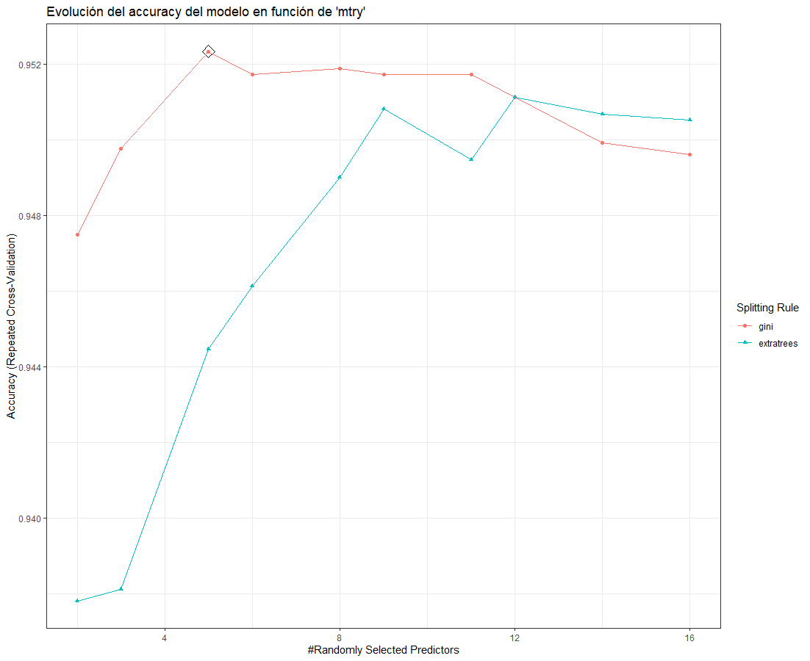

Ahora empezamos a afinar parámetros.
-Modelo_ 3: este es el mejor modelo RF
Seed = 123 , con tuneGrid (parámetros asignados a mano)
The final values used for the model were mtry = 8, splitrule = gini and min.node.size = 1.
mtry Accuracy Kappa
6 0.9526477 0.8832064
7 0.9521943 0.8819322
8 0.9529484 0.8838813
9 0.9526483 0.8831422

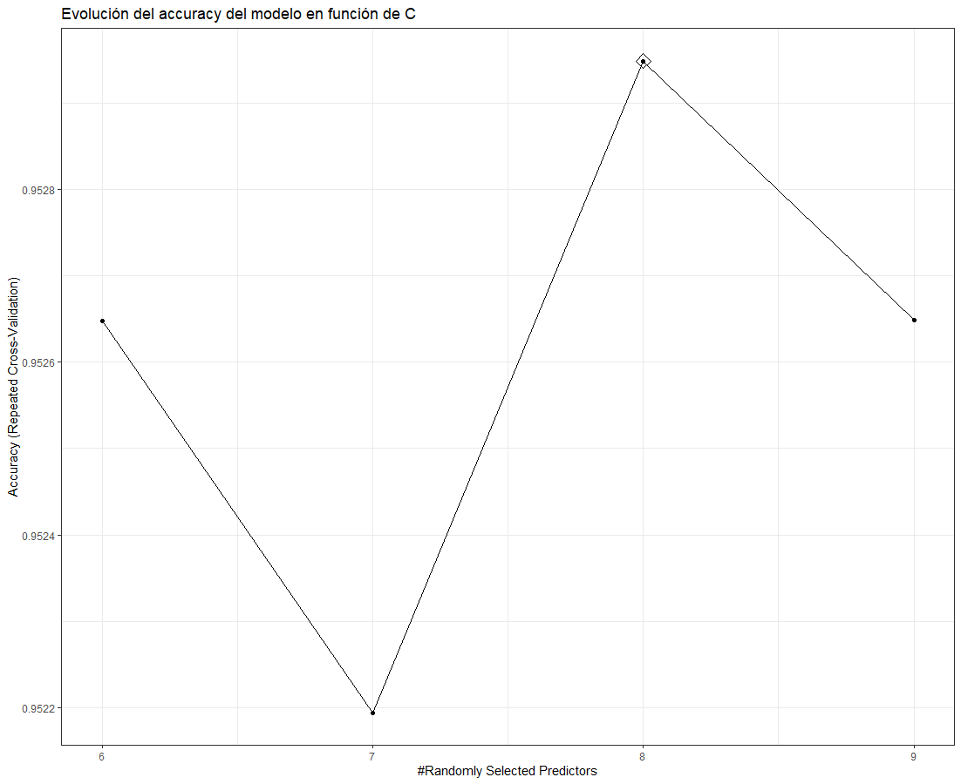
Haciendo otra prueba con más particiones y más repeticiones, el resultado de mejores parámetros ha sido el mismo,
The final values used for the model were mtry = 8, splitrule = gini and min.node.size = 1.

mtry Accuracy Kappa
4 0.9505232 0.8773357
5 0.9512797 0.8794144
6 0.9509038 0.8785006
7 0.9512034 0.8791492
8 0.9516608 0.8802860
9 0.9512837 0.8793624

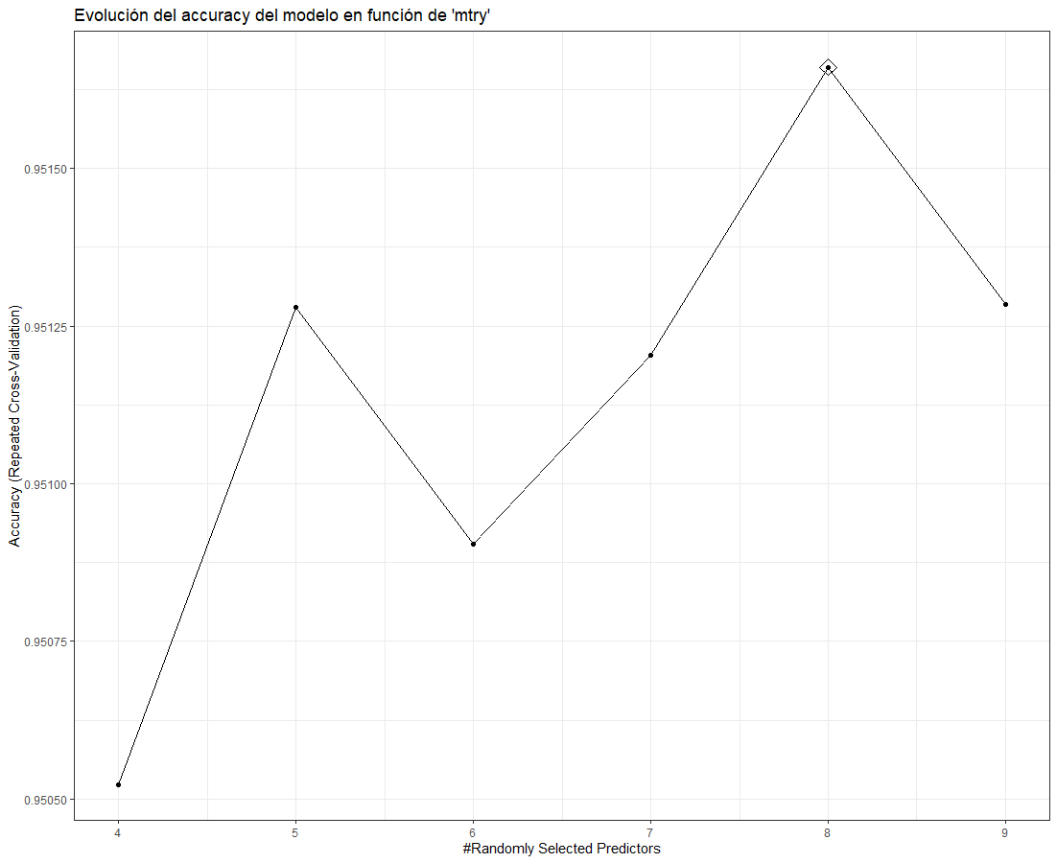

Gradien boosting: El mejor modelo es el modelo_4

-Modelo_1:
Seed = 123, tuneLength = 5 (parámetros aleatorios).

interaction.depth n.trees Accuracy Kappa
1 50 0.9454095 0.8633992
1 100 0.9491894 0.8736342
1 150 0.9482815 0.8712475
1 200 0.9466216 0.8671235
1 250 0.9446461 0.8622995
2 50 0.9502603 0.8761672
2 100 0.9513084 0.8791006
2 150 0.9500905 0.8758179
2 200 0.9490333 0.8730816
2 250 0.9493306 0.8739247
3 50 0.9499527 0.8753515
3 100 0.9499492 0.8753977
3 150 0.9501065 0.8756691
3 200 0.9490413 0.8728037
3 250 0.9484376 0.8712715
4 50 0.9504038 0.8764627
4 100 0.9499470 0.8755815
4 150 0.9491905 0.8732384
4 200 0.9494901 0.8740419
4 250 0.9496405 0.8746633
5 50 0.9500962 0.8757224
5 100 0.9503981 0.8763448
5 150 0.9499447 0.8750023
5 200 0.9496382 0.8742920
5 250 0.9491814 0.8730738
The final values used for the model were n.trees = 100, interaction.depth = 2, shrinkage = 0.1 and n.minobsinnode = 10.

-Modelo_2:
Seed = 123, parámetros a mano,
interaction.depth n.trees Accuracy Kappa
1 80 0.9477928 0.8698999
1 100 0.9476447 0.8695233
1 120 0.9477973 0.8701322
2 80 0.9497522 0.8750782
2 100 0.9497522 0.8747930
2 120 0.9480935 0.8707262
3 80 0.9508163 0.8777809
3 100 0.9496064 0.8744869
3 120 0.9506671 0.8772570
The final values used for the model were n.trees = 80, interaction.depth = 3, shrinkage = 0.1 and n.minobsinnode = 10.
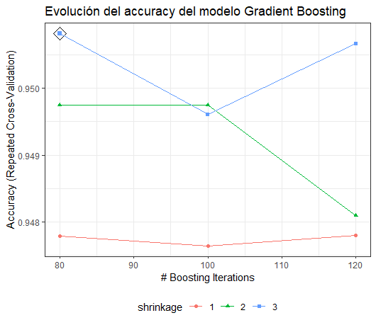
-Modelo_3:
interaction.depth n.trees Accuracy Kappa
1 60 0.9462991 0.8654594
1 80 0.9494787 0.8743037
1 100 0.9493295 0.8739941
2 60 0.9502352 0.8765450
2 80 0.9516011 0.8795718
2 100 0.9503901 0.8766583
3 60 0.9494787 0.8743111
3 80 0.9484215 0.8717362
3 100 0.9487234 0.8723958
The final values used for the model were n.trees = 80, interaction.depth = 2, shrinkage = 0.1 and n.minobsinnode = 10.

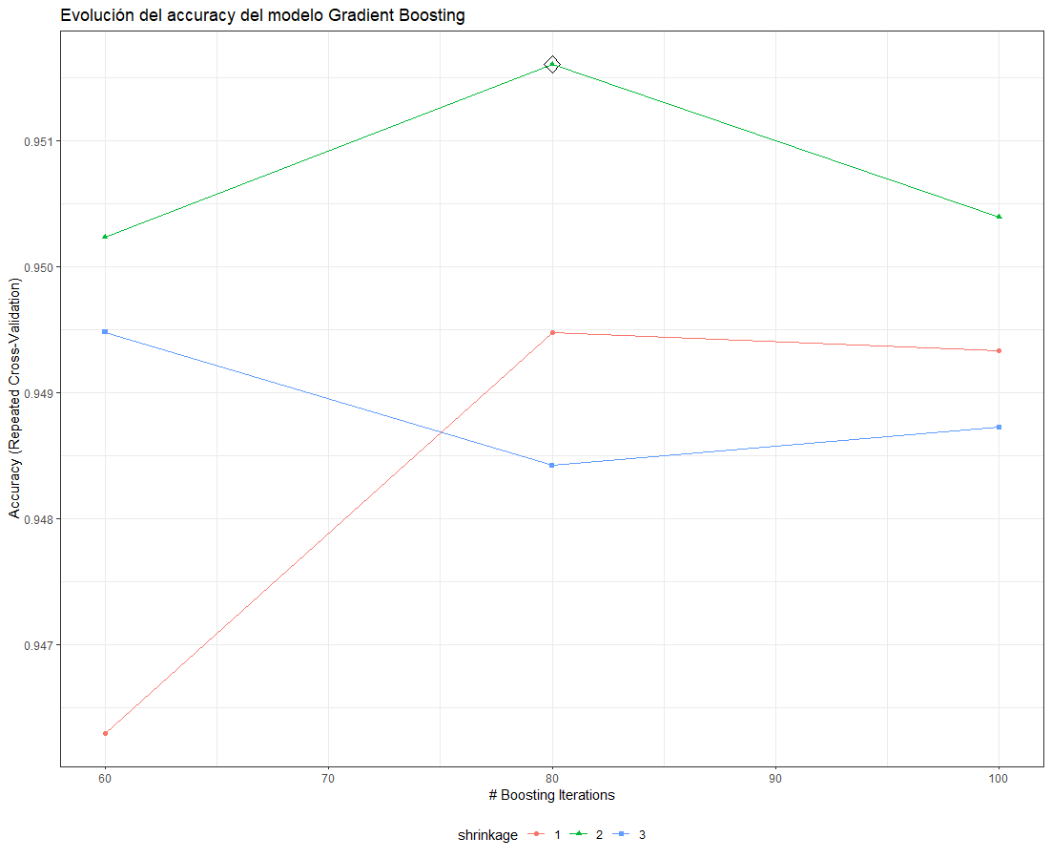
-Modelo _ 4:
interaction.depth n.trees Accuracy Kappa
1 70 0.9485650 0.8718102
1 80 0.9494787 0.8743037
1 90 0.9499299 0.8754286
2 70 0.9516011 0.8796674
2 80 0.9516011 0.8795718
2 90 0.9506943 0.8772241
3 70 0.9485719 0.8721355
3 80 0.9484215 0.8717362
3 90 0.9479681 0.8705389
The final values used for the model were n.trees = 70, interaction.depth = 2, shrinkage = 0.1 and n.minobsinnode = 10.
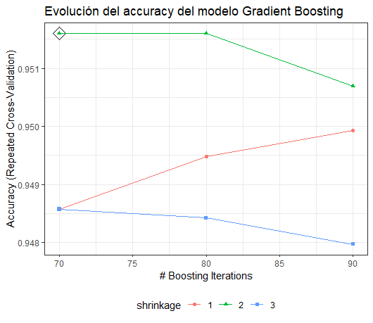
Support Vector Machine:

Modelo_ 1:
The final values used for the model were sigma = 0.01 and C = 20.
sigma C Accuracy Kappa
0.010 20 0.9497626 0.873712341
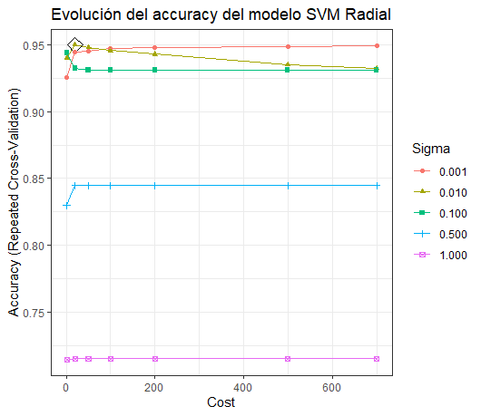
-Modelo_ 2:
sigma C Accuracy Kappa

